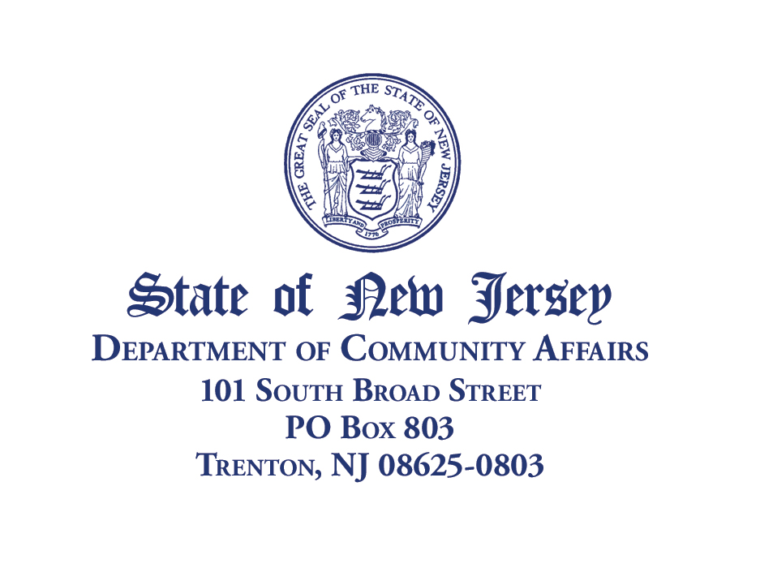

MEMORANDUM

TO: Sponsors, Continuing Education Credit (Revised 12/2014)

FROM: Certification Unit
Division of Local Government Services

SUBJECT: Instructions for Completion of Continuing Education Sponsor Agreement
Attached is a Continuing Education Sponsor Agreement. This agreement is to be used for applying for continuing education credit for programs directed toward those local officials for which the Division of Local Government Services administers certification programs. Completed forms may be emailed to the attention of the Certification Unit at the Division at daniel.kaminski@dca.nj.gov, faxed to 609-633-6243, or sent by regular mail to the Division of Local Government Services, P.O. Box 803, Trenton, New Jersey 08625-0803. If the program is to be repeated on several different dates, please note each date and location on a single Sponsor Agreement form or, if the program is to be repeated multiple times over the course of a year, please note this on the form.
It is strongly recommended that applications be submitted in a timely manner prior to the date of the program. Applications submitted retroactively may be denied credit at the discretion of the Division.
As sponsor, you are responsible for supplying attendees with some proof of attendance, either directly after a program, or shortly thereafter by regular or electronic mail. At a minimum, the proof must contain the name and date of the program, the name of the sponsor organization, the course number assigned by the Division, and the applicable contact hours.
Sample sign-in and evaluation sheets are available at the Division website, http://www.nj.gov/dca/divisions/dlgs/; click on the right side link for Professional Certification Programs. Evaluation sheets are optional for attendees to complete, however, they must be made available for those who wish to utilize them. Upon conclusion of a program, please maintain sign-in sheets and any evaluation sheets on file for a period of three years. The documentation may be maintained in an electronic file format. After three years they may be discarded. Unless requested to do so, do not submit sign-in sheets and evaluation sheets to the Division.
By signing page one of the Continuing Education Sponsor Agreement, as the Authorized Representative, you agree to abide by the provisions noted in these instructions.
Thank you for your interest in providing continuing education. If you have any questions, please contact the Certification Unit at (609) 292-4656 or by email at drichardson@dca.nj.gov.
Attachment

Part 1 — Sponsoring Organization Information
Name:
Address:
City: State: Zip:
Program Contact Name:
Telephone number:

Part 2 — Program Details
Title of Program:
Date(s) of Session: Time of Session:
Location of Session:
Summary of Course Content (attach detailed syllabus):

Names of Instructors (if DLGS instructors are involved, attach completed Staff Instruction Request):

If Page 2 has been completed and is attached, check here:
The sponsor agrees to comply with Division procedures for continuing education programs.
Signature of Authorized Representative:
Name: Position:
Date:
Send completed applications to: Certification Unit, Division of Local Government Services,
P.O. Box 803, Trenton, NJ 08625. If you have any questions please call the Division at:
609-292-4656.

Allocation of Certification Program, Curriculum Areas and Hours
Certification Program | Curriculum Area | Proposed Contact Hours |  | Approved Contact Hours  (DLGS use only)
Municipal Financial Officer | Accounting
 | Budgeting
 | Financial and Debt Management
 | Office Management and
 | Ancillary Subjects
 | Ethics
 | Information Technology
County Finance Officer | Accounting
 | Budgeting
 | Financial and Debt Management
 | Office Management and
 | Ancillary Subjects
 | County Fiscal Operations
 | Ethics
 | Information Technology
Tax Collector | Enforcement
 | Legislation
 | Reporting/Billing/Collection
 | General/Secondary
 | Ethics
 | Information Technology
Public Works Manager | Technical
 | Management
 | Government
 | Ethics
 | Information Technology
Municipal Clerk | Elections
 | Finance
 | Licensing
 | Records
 | Professional Development
 | Ethics
 | Information Technology
Qualified Purchasing Agent | Procurement Procedures
 | Office Admin./General Duties
 | Ethics
 | Information Technology
 | Green Purchasing
For DLGS Use Only: Date Received: Date Approved:
Course #
Comments:

Reviewer |  | App. |  | Comments
Title of program:

Speaker # 1 Name:
Material to be covered:

Speaker #2 Name:
Material to be covered:

Speaker # 3 Name:
Material to be covered:

