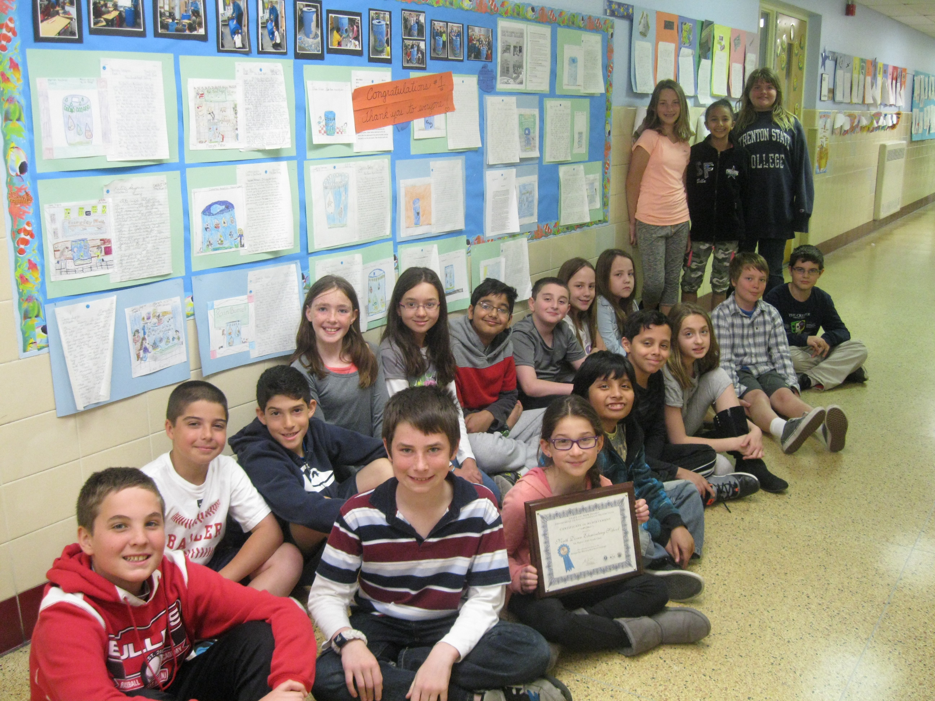 July 17, 2014

Dear Tanya,

I hope you are enjoying your summer! I have been thinking about school as I work at home getting ready for September and how much fun the Rain Barrel project was for my students. It generated so many educational and social connections for them and for the students throughout our school. I am looking at the beautiful program schedule that you made for us and marveling at how smoothly everything went that day. Thank you for making all of that learning possible for so many students on the same day! It was absolutely amazing!

What an exciting day June 17th was at North Dover’s DEP Water Festival! My class and I reflected all week about the very beginning of the Rain Barrel Blitz from
designing the barrel to the voting, winning, attending the Cattus Island Ceremony of Awards and finally celebrating the amazing Water Festival at our school. Thank you so much for all of your planning and organization of the workshop and presenters. Your interest and emails kept us up to date on all the progress of the big day and created an atmosphere of excitement in Room 416 and a spark of anticipation in the students’ eyes. Thank you so much for all of your hard work, time, and energy in making the Water Festival a wonderful educational experience for our whole school. The presenters were exceptional and made the hands-on learning experiences so meaningful to the children. Thank you for all the special information, stickers, books, and goodies that you gave the students to remember their special day. We enjoyed every minute of the project from the start to finish.

It was an honor to be a part of DEP Rain Barrel Blitz and all of us are so grateful to you and the presenters for such an outstanding program. I have been looking over the photos of that great day and just wanted you to know how much I appreciate all of your efforts and the opportunity to participate in such a creative endeavor. It has been a privilege meeting and working with you.

Please share this letter of appreciation to all the presenters who were inspirations to all of us. I hope you have a great 2014-15 year.

Most appreciatively,
Rosa A. Fisher
Gr. 5 Room 416 Teacher

