(**INSERT SCHOOL DISTRICT NAME)**

**LEAD DRINKING WATER TESTING**

**SAMPLING PLAN**

**(ADD DATE)**

**Project Manager – Enter School District Employee and Title**

Contents

1. INTRODUCTION 4

2. OBJECTIVE 4

3. SAMPLING PROJECT COORDINATION 4

3.1 School District Program Manager (Program Manager) 4

3.2 Sampling Project Manager (Project Manager) 5

Project Manager Responsibilities 5

3.3 Individual School Sampling Project Officers (Project Officers) 6

Project Officer Responsibilities 6

3.4 Individual School Protocols 7

4. SCHOOL SAMPLING PRIORITY 7

5. PLUMBING SURVEY 7

5.1 Plumbing Profile 7

5.2 Filter Inventory (If Applicable) 8

6. PLANNING 8

6.1 Walk –Through 8

6.2 Floor Diagram 8

7. SAMPLE LOCATIONS 9

7.1 Sample Locations 9

7.2 Sample Location Codes 9

7.3 Sampling Location Inventory 10

8. SAMPLING PROCEDURES 10

8.1 Timeline 10

Prior to Sampling 10

Day of Sampling 10

8.2 Sample Collection 11

Sample Collection Highlights 11

Sample Collection Method 11

Additional Sampling Event 13

8.3 New Jersey Certified Laboratories 13

Laboratory Responsibilities 13

Sampling Personnel Responsibilities 14

8.4 Sampling Results 14

8.5 Intermediate Remedial Measures 14

Glossary 16

Attachment A - List of (INSERT SCHOOL DISTRICT NAME) Schools 18

Attachment B – Plumbing Profile 19

Attachment B.i: Plumbing Profile Instructions 23

Attachment C – Drinking Water Outlet Inventory 30

Attachment D - Filter Inventory 31

Attachment E – Flushing Log 32

Attachment F - Pre – Sampling Water Use Certification 32

Attachment G - Example of a Sample Flush Tag 33

Attachment H – Sampling Toolkit 35

H.i: Recalled Water Cooler List 35

H.ii: Ice Machines Sample Collection Procedure 37

H.iii: School Wide Flushing Procedure 37

H.iv: Sampling Event Checklist 39

H.v: Sample Signs 40

H.vi: School Sampling Package Review Checklist 42

H.vii: FOLLOW-UP SAMPLING INVENTORY 45

H.viii: FOUNTAINS / DRINKING WATER COOLERS ON EPA’S RECALL LIST 46

H.ix: OUTLETS WITH FILTERS INSTALLED - RESULTS 47

H.x_ Data Review Summary 48

H.xi: Complete Sampling Package Example 50

# 1. INTRODUCTION

This Lead Drinking Water Testing Sampling Plan (Sampling Plan) was developed by the (**INSERT SCHOOL DISTRICT NAME)**, (District), based on guidance developed by the New Jersey Department of Environmental Protection (NJDEP) and the United States Environmental Protection Agency (USEPA), to establish a plan for sampling lead at drinking water outlets used for consumption or food preparation in every school within the District (See Attachment A for full school listing). The data collected through the execution of this Sampling Plan will determine if immediate remedial measures are necessary and will assist in the prioritization of future water testing for lead in accordance with this Sampling Plan.

This Sampling Plan is based on the USEPA publication, “The 3Ts for Reducing Lead in Drinking Water in Schools” and NJDEP guidance.

The District has also developed a Quality Assurance Project Plan (QAPP) for the sampling program which is available under separate cover.

# 2. OBJECTIVE

The 1988 Lead Contamination Control Act (LCCA) is aimed at identifying and reducing lead (Pb) in drinking water in schools and child care facilities. In response, the USEPA prepared guidance documents to assist school districts in meeting the requirements of the LCCA. The guidance documents were used as a resource in developing this Sampling Plan.

It should be noted, for the purpose of determining immediate remedial measures (i.e. taking drinking water outlets out of service and notifying parents/guardians of results), the District is required to utilize the lead action level established in the SDWA rules by the USEPA at 40 CFR 141.80 for lead in drinking water. At the time of development of this Sampling Plan, the lead action level is 15 µg/L, which is more stringent than the guidance provided by USEPA in their Lead in Schools Guidance which recommends action be taken at drinking water outlets greater than 20 µg/L. Schools in New Jersey that are served by their own well (not public water), which are regulated pursuant to the Federal and New Jersey SDWA, must adhere to the 15 µg/L value for determining compliance.

# 3. SAMPLING PROJECT COORDINATION

Testing for lead in schools requires a coordinated effort especially when multiple schools are to be included in the testing effort. Designated personnel and set protocols are essential to ensuring a coordinated effort.

## 3.1 School District Program Manager (Program Manager)

(**INSERT SCHOOL DISTRICT NAME) Program Manager:**

(Program Manager NAME)

(CONTACT INFORMATION)

The School District Program Manager (Program Manager) is the overall authority in the execution of the District’s lead sampling project. He/she is responsible for the initial notification to the District of the testing program, obtaining funds for testing, assigning the Sampling Project Manager, requesting/enlisting the assistance from other District departments if needed, approving the District’s QAPP(s), approving the Final Report for each school and coordinating with other District officials to make the results of the testing available to the public.

## 3.2 Sampling Project Manager (Project Manager)

(**INSERT SCHOOL DISTRICT NAME) Sampling Project Manager:**

(Project Manager NAME)

(CONTACT INFORMATION)

The Sampling Plan Project Manager (Project Manager) is responsible for overseeing the execution of lead sampling at each of the district’s schools. This involves the prioritization of schools to be sampled, and adherence with the District’s Sampling Plan and QAPP. He/she serves as the liaison between the District, State agencies, local Health Departments, laboratories and public water systems (if applicable). He/she reports to the Program Manager.

### Project Manager Responsibilities

* Prepare the District’s Specific Quality Assurance Project Plan (QAPP) and Sampling Plan;
* Manage the Sampling Plan and QAPP;
* Oversight of Individual School Project Officers (Project Officers) to ensure that they adhere to the Sampling Plan procedures and the QAPP;
* Purchase of equipment needed for district lead sampling;
* Coordinate with New Jersey laboratories certified for lead testing in drinking water;
* Coordinate with Project Officers to establish sampling schedules;
* Ensure properly signed QAPPs are in place prior to initiation of sampling;
* Verify that officials from each school are aware when sampling is scheduled and the expected duration;
* Review of the School Field Sampling Summary Reports prepared by Project Officers;
* Review of Laboratory Data Reports (LDR) from Laboratory Managers;
* Review of Final Project Reports prepared by Project Officers;
* Identify limitations in the use of any laboratory data due to information provided in the accompanying School Field Sampling Summary Report;
* Maintain the original signed QAPP(s);
* Maintain documents, reports and records listed in QAPP, including:
  + Laboratory Data Reports (LDR)
  + Copy of Field Sampling Summary Report with copies of field logbooks,
  + Field Walk-Through reports including Attachments B, C, D E and F of this Sampling Plan,
  + Chain of custody forms and flush tags.
  + Copy of Final Project Report
* Maintenance of other relevant records, such as:
  + Purchase orders for analytical costs (copy).
  + Agreement with laboratory to sample, analyze, and report with details for payment
  + Receipts (originals or copies)

## 3.3 Individual School Sampling Project Officers (Project Officers)

An Individual School Sampling Project Officer (Project Officer) is assigned for each school. A Project Officer should be someone who is familiar with the school building layout and plumbing system. See District’s QAPP for a list of the Project Officers.

### Project Officer Responsibilities

* General project oversight for assigned school(s).
* Generate field log book for each assigned school. Document field activities including any changes to procedures outlined in the Sampling Plan or QAPP.
* Ensure proper completion of the Plumbing Profile Form for assigned school(s) - See Attachment B.
* Oversight of completion of the following reports found in the Sampling Plan which require sign–off by Project Officer:
  + Water Outlet Inventory (Attachment C)
  + Filter Inventory (Attachment D)
  + Flushing Log (Attachment E)
  + Pre Sampling Water Use Certification (Attachment F).
* Prepare labels for outlets to be sampled.
* Prepare for Walk-Through including acquisition of School Floor Plan.
* Attend school Walk-Through.
* Ensure proper completion of Walk-Through documentation including identification of outlets on Floor Plan, and Sampling Location Inventory with coding according to the Sampling Plan (Attachment C).
* Supervision of field activities such as Walk- Through, flushing (if required), locking school prior to sampling, and sample collection.
* Identify low use water outlets requiring flushing and attach flush tag (Attachment G).
* Ensure that Field Sampling Team has all relevant sampling supplies including sampling bottles, labels, proper reagent water and chain of custody forms prior to collection of samples.
* Ensure that all water outlets to be sampled prior to sampling event are labeled.
* Ensure that all low use outlets identified for sampling had been flushed.
* Remove flush tags from outlet once sampling is completed.
* Responsible for ensuring water remains motionless for a minimum of eight hours (last to leave the school) prior to sampling event by following procedures in Section 8.
* Verify that the Sampling Plan was followed prior to initiating sampling by completing the Pre-Sampling Water Use Certification (Attachment F).
* Provide supervision of sampling event.
* Document issues during sampling event in field log book.
* Prepare Field Walk-Through Report, School Field Sampling Summary Report and Final Project Report for assigned school(s).
* Maintain field log books for each school.
* Prepare samples for shipment and delivery to laboratory per certified laboratory instructions.
* Ensure that samples are delivered to laboratory within the time period specified by the certified laboratory

## 3.4 Individual School Protocols

A separate log book and supporting documentation shall be kept for each school. The contents of the log book are to include the Attachments A through F found at the end of this plan. A field log book should include but not be limited to: a material evaluation, filter log, drinking water outlet inventory, flushing log, and label identification codes.

# 4. SCHOOL SAMPLING PRIORITY

The District developed a list of all school facilities scheduled for sampling. See Attachment A for the school sampling listing. Please note that the list may be updated based on conditions at the school, which prevent sampling from occurring or scheduling issues. Accordingly, the list should include a revision date.

Districts may need to prioritize the sampling schedule. For those cases, development of criteria is required and the criteria needs to be included in the Sampling Plan.

(District to insert prioritization criteria if applicable:)

[Example:

District Schools were prioritized based on:

* The presence of lead plumbing or infrastructure as determined in the Plumbing Profile;
* Age of the students; and
* Student population.]

# 5. PLUMBING SURVEY

Prior to a sampling event, documentation of various aspects of each school’s water system needs to be completed. This following information needs to be compiled and the attachments completed including:

## 5.1 Plumbing Profile

The purpose of a Plumbing Profile (Attachment B) is to identify and categorize plumbing and infrastructure in order to prioritize schools/outlets for testing, and to identify potential sources of lead (i.e. lead service lines, or lead piping or solder). The results of the Plumbing Profile determine the sampling locations and priority within the individual school facilities.

A Plumbing Profile should include all of the following:

* Year school built and dates of any additions
* Building blue prints and floor diagrams
* Service line material;
* Material of internal plumbing, this is an important part of a plumbing profile, and whether it meets the current New Jersey “lead-free” plumbing code;
* Point-of-entry or point-of-use treatment being used;
* All drinking water outlets including fountains that are permanently out of service;
* All drinking water outlets including fountains that are temporarily out of service;
* All drinking water outlets including drinking water fountains that are leaking or evidence of staining and in need of repair;
* Type (make and model) and location of all drinking water fountains, including detailed description that identifies of whether they are lead-lined or if they have been involved in any recalls, (See USEPA Fact Sheet at <http://nepis.epa.gov/Exe/ZyPDF.cgi?Dockey=30005UPU.txt> );
* Locations of all drinking water outlets including fountains;
* All plumbing repairs and replacements needed for internal plumbing;
* All plumbing repairs and replacements conducted within the past year;
* Locations of any electrical wires grounded to water pipes

## 5.2 Filter Inventory (If Applicable)

A Filter Inventory (Attachment D) shall be prepared, including the following information:

* Location (school and outlet);
* Make and model;
* Installation date (last replaced);
* Replacement frequency;
* Documentation of repairs; and
* Contaminants the filter is capable of and/or NSF-certified for the removing e.g. lead and others

# 6. PLANNING

## 6.1 Walk –Through

A Walk-Through must be conducted by the Project Officer prior to sampling as part of the planning process. The Walk-Through must include every room (including but not limited to classrooms, offices, bathrooms, kitchens and recreational areas) in the facility. During the Walk- Through, all drinking water and food preparation outlets to be sampled will be labelled by the Project Officer on the Floor Diagram (6.2).

The Project Officer will also conduct an onsite assessment of each sample outlet to document (using Attachment C) specific characteristics of the outlet (e.g. leaking outlets; staining). During this assessment, the water should be turned on to determine the spray pattern, whether there is adequate flow to collect samples or if any odor or color differences are present and whether the cold water faucet is functioning properly. Only cold water faucets are to be sampled. For motion sensor and metered sinks, the hot water valve will be shut off on the day of sampling. All outlets in need of repair must be repaired prior to sampling or documented on the temporary out of service list in the Plumbing Profile (Attachment B).

## 6.2 Floor Diagram

Each drinking water outlet shall be identified on the school schematic (floor diagram). The floor diagram should have the classroom numbers and the following locations labeled:

* Service Line = SL
* Point of Entry[1]
* Food preparation outlets (i.e. cafeteria, kitchen and home economics class faucets);
* Drinking Water Fountains; and
* Other drinking water outlets to be sampled (i.e. nurse’s office, teacher’s lounge, home economics, etc.), and any other room or outside facility used for water consumption.

The Project Officer must date and sign the floor diagram.

# 7. SAMPLE LOCATIONS

## 7.1 Sample Locations

The following locations shall be identified and labeled for each school:

* Kitchen outlets
* Food Preparation outlets
* Teacher Lounge outlets
* Nurse’s Office outlets
* Home Economic Sink outlets
* Drinking Water Fountains – Bubblers and Water Coolers
* Outside drinking water fountains and food preparation areas
* Ice Machines
* Other drinking water outlets used for consumption

Examples of outlets that do not need to be sampled include utility sinks, outside spigots, bathroom sinks and classroom sinks, unless any of these sinks are used routinely for consumption.

## 7.2 Sample Location Codes

Each sampling location shall be identified by its location and type using the following coding system (Note additional codes as needed):

KC = Kitchen Outlet, Cold

CT= Cafeteria Outlet

FP= Food Preparation Sink

TL= Teacher Lounge Sink

NS = Nurse’s Office Sink

EC = Home Economics Outlet, Cold

DW= Drinking Water Bubbler

WC = Water Cooler (Chiller Unit)

IM = Ice Machine

## 7.3 Sampling Location Inventory

Attachment C shall be used to develop a detailed inventory of each drinking water outlet in the school to be sampled. The inventory must be completed and signed by the Project Officer.

The Drinking Water Outlet Inventory shall include the following information:

* All drinking water outlets in the school
* The type, location, and sample location code of each drinking water outlet
* If the drinking water outlet has a chiller unit
* If the drinking water outlet has an aerator/screen
* If the drinking water outlet is motion activated, in which the hot water at the outlet must be turned off prior to sampling
* If the drinking water outlet is operational
* If the drinking water outlet has not been used frequently
* If the drinking water outlet is leaking
* If the drinking water outlet has a filter
* The make and model of all drinking water fountains and water coolers

# 8. SAMPLING PROCEDURES

## 8.1 Timeline

Samples should be collected before the facility opens in the morning and before any water is used in the building. The water shall sit in the pipes unused for at least 8 hours, but no more than 48 hours, before a sample is collected.

**At no time should filters, aerators and screens be removed prior to or during the sampling event.**

### Prior to Sampling

* For buildings that have not been used for more than 48 hours, the District will perform systematic flushing 48 hours prior to the sampling event, as described in the USEPA’s “3Ts For Reducing Lead in Drinking Water in Schools” (revised October 2006, see page 56). This flushing event and locations shall be documented in a log (Attachment E).
  + The flushing log must be completed and signed by the Project Officer.
* The Project Officer will contact the laboratory to confirm sample bottles, weatherproof labels, chain of custody forms and coolers are available and ready for the sampling event.
* Every drinking water outlet to be sampled (previously identified in Attachment C) will be labeled with a specific Sample Location Code in indelible marker on the underside of the sampling fixture in the event the District has to re-visit the sample location.
* A communication will be sent out to all staff in schools being sampled explaining what time all staff must exit the building.
* After this time, signs shall be posted to indicate that water should not be used and access to the building shall be restricted to ensure that water sits undisturbed for a minimum of 8 hours.
* Turn off all irrigation and outdoor water features.

### Day of Sampling

The Project Officer will use Attachment F to document when the water was last used and when sampling began.

## 8.2 Sample Collection

### Sample Collection Highlights

* All samples shall be collected in a pre-cleaned HDPE 250mL wide mouth single use rigid sample container.
* Identify on the Sampling Plan the outlet closest to the water service line(s) entry point to be collected first, then identify the next closest outlet as second, and move away from the water service line(s) entry point until the outlet farthest away is identified to be sampled last on the sampling plan. This will minimize the chance that a sampling location will be flushed by an upstream fixture. Sampling will begin at the outlet closest to the point of entry and continue to the furthest outlet to ensure the water remains motionless in the plumbing.

### Sample Collection Method

USEPA recommends a two-step sampling process be followed for identifying lead contamination. Lead in a water sample taken from an outlet can originate from the outlet fixture (the faucet, bubbler etc.), plumbing upstream of the outlet fixture (pipe, joints, valves, fittings etc.), or it can already be in the water that is entering the facility. The two-step sampling process helps to identify the actual source(s) of lead.

In Step 1, initial samples are collected to identify the location of outlets providing water with elevated lead levels and to learn the level of the lead in the water entering the facility (i.e., at the service connection). In Step 2, follow-up flush samples are taken only from outlets identified as problem locations to determine the lead level of water that has been stagnant in upstream plumbing, but not in the outlet fixture. Sample results are then compared to determine the sources of lead contamination and to determine appropriate corrective measures.

Schools may wish to collect both initial and follow-up samples at the same time. This is more convenient and may save time and money; however, using this approach creates a trade-off between convenience and confidence. The confidence in the sample results will decrease since flushing water through an outlet immediately after taking the initial sample could compromise the flushed locations depending on the interior plumbing of buildings. Protocols for both options are provided below. School districts can decide which option works best for their situation.

All sampling must be conducted in accordance with this Sampling Plan and the District’s QAPP.

**Choose the Sample Collection Method Protocol the District will follow**

**Option 1- Sample Collection for First Draw and Follow-up Flush Sampling Conducted on Different Days**

1. For each drinking water outlet sampled, a new pair of non-colored latex or nitrile gloves shall be used. This is to minimize the potential for cross contamination of sample outlets by sampling personnel.
2. First draw samples (i.e. samples collected from outlets where water sat undisturbed for a minimum of 8 hours) will be collected from a cold water outlet at each location identified in 7.3 above. The sample must be collected by placing the bottle under the drinking water outlet before turning the cold water outlet on. No water should be allowed to run prior to collecting a sample. For motion-activated faucets, the hot water valve must be turned off prior to sampling.
3. Each sample collected will be properly identified on the sample bottle and chain of custody using the Sample Location Code previously identified by the District (as identified on the label on the outlet and on the floor diagram).
4. Upon receiving the testing results, the District will conduct a second sample event collecting a follow-up flush sample at any drinking water outlet with an initial result of greater than 15 µg/L (as defined as greater than or equal to 15.5 µg/L).
5. The following planning will take place prior to the follow-up sampling event:
   1. The drinking water outlets requiring a flushed sample shall be listed on a Follow-Up Sampling form (See Attachment H.vii for example), labelled with an indelible marker, and identified on the floor diagram.
   2. Procedure for ensuring the water remains stagnant for a minimum of 8 hours shall be followed.
6. The drinking water outlet will be turned on and allowed to run for 30 seconds then the water will be captured in a pre-cleaned 250 mL container. Note: If the drinking water outlet is a water cooler with a cooler unit then allow the water to run for 15 minutes prior to collecting a flushed sample in a pre-cleaned 250 mL container.
7. Each sample collected will be properly identified on the sample bottle and chain of custody using the Sample Location Code previously identified by the District (as identified on the label on the outlet and on the floor diagram). Additionally, the follow-Up flush samples will be identified by noting “FLUSH” after the Sample Location Code on the sample bottle and on the chain of custody (e.g. MM-2F-DW-01 and MM-2F-DW-01 FLUSH).

**Option 2- Sample Collection For First Draw and Follow-up Flush Sampling Conducted on Same Day**

1. For each drinking water outlet sampled, a new pair of non-colored latex or nitrile gloves shall be used to collect both the first draw and flush follow-up samples. This is to minimize the potential for cross contamination of outlets by sampling personnel.
2. First draw samples (i.e. samples collected from outlets where water sat undisturbed for a minimum of 8 hours) will be collected from a cold water outlet at each location identified in 7.3 above. The sample must be collected by placing the bottle under the outlet before turning the cold water on. No water should be allowed to run prior to collecting a sample. For motion-activated faucets, the hot water valve must be turned off prior to sampling.
3. Immediately after the first draw sample is collected, the sampler will collect a follow-up flush sample.
4. When collecting the follow-up flush sample, the outlet will be turned on and allowed to run for 30 seconds then the water will be captured in a pre-cleaned 250 mL container.
5. If the drinking water outlet is a water cooler with a cooler unit, DO NOT COLLECT A FOLLOW-UP FLUSH SAMPLE UNTIL ALL FIRST DRAW SAMPLES ARE COLLECTED IN THE SCHOOL.
6. After all sampling is completed, return to the water coolers to collect a follow-up flush sample, again starting at the water cooler located in closest proximity to the POE and then move outward. Allow the water to run for 15 minutes, then sample the drinking water outlet utilizing a pre-cleaned 250 mL container.
7. Each sample collected shall be properly identified on the sample bottle and chain of custody using the Sample Location Code previously identified by the District (as identified on the label on the outlet and on the floor diagram). In addition, follow-up flush samples shall be identified by noting “FLUSH” after the Sample Location Code on the sample bottle and on the chain of custody (e.g. MM-2F-DW-01 and MM-2F-DW-01 FLUSH).

### Additional Sampling Event

Upon receiving the results of the initial and follow-up flush samples at all outlets, the District will conduct additional sampling events for the following situations: any location required to be sampled previously but was not sampled (not operational during initial sampling event), where there was a possible lab error or sample collection error, and any location that was not sampled but could help pinpoint the source of lead in a sampled outlet.

## 8.3 New Jersey Certified Laboratories

### Laboratory Responsibilities

Certify to the District that they have received, and will follow, the Sampling Plan and QAPP.

* Each laboratory must document that laboratory personnel have previous experience sampling for lead and have been properly trained to conduct USEPA Method 200.8 or other methods that are approved sampling methods. Approved sampling methods are USEPA methods for the analysis of lead in drinking water (USEPA Method 200.9, USEPA Method 200.5, SM3113B, ASTM3559-D) provided that the reporting limit used by the laboratory for that method is less than or equal to 2 µg/L.
* The laboratory will conduct analysis of a laboratory fortified blank (Field Blank) to assess the accuracy. The acceptance criteria for accuracy for the results will be within plus or minus 15% recovery of the known value.
* Laboratories must provide the results to the District within timeframe required under contract (14 day is average).
* Laboratories will report in µg/L (ppb) and to at least three significant figures.

### Sampling Personnel Responsibilities

Each sampler will be responsible for the following:

* Preparation of pre-printed waterproof labels, which will include, the sampler’s name, the school name, the Sample Location Code, parameter to be analyzed (lead), date of collection and any preservation technique used;
* Preparation of a chain of custody to include the field sample information;
* Obtaining from the laboratory, prior to the sampling event, ASTM Type I reagent-grade water (RGW) to be used as Field Reagent Blanks (FRB). The sampler will transport this RGW to the school to be sampled. Before the first sample is collected the RGW collected at the Laboratory will be transferred to a sample container near the first sample location inside the school building. This FRB sample will be stored and transported in the same cooler, handled and preserved in the same manner as samples collected at that school.
* Documentation of any and all observations such as automatic sensors, odors, change in water color, low water flow, water outlet leaks (i.e. 1 second drip), irregular water spray, attached filter(s), if the screen/aerator is on/off the water outlet or if the water becomes warm/hot.
* Minimizing the potential for cross contamination of sample outlets by sampling personnel. The water will be collected from the outlet directly into each container.
* Following all of the sampling procedures outlined in the Sampling Plan and QAPP.

## 8.4 Sampling Results

The laboratories will provide the lead sample results to the District in electronic format within the timeframe required under the contract. A spreadsheet of all results, the analytical results report, and the chain of custody forms must be included.

Within 24 hours after the District has reviewed and verified the final laboratory results, the District shall make the test results of all water samples publicly available at the school facility and on the District’s website. If any results exceed the lead action level, the District must also provide a written notification to the parents/guardians of all students attending the facility, facility staff, and the Department of Education (DOE).

## 8.5 Intermediate Remedial Measures

Upon receiving sample results, the District will turn off all outlets with results that exceed 15 µg/L (as defined as greater than or equal to 15.5 µg/L). If these locations must remain on for non-drinking purposes, a “DO NOT DRINK – SAFE FOR HANDWASHING ONLY” sign will be posted (Attachment H.v).

# Glossary

**Drinking Water Outlet-** an outlet that can be used for the consumption of water, such as, water fountains, water coolers, bubblers, kitchen sinks and food preparation sinks; however, classroom, bathroom, and outlets used for washing dishes are not drinking water outlets.

**Action Level (AL)-** The lead level established by the USEPA at 40 CFR 141.80 for lead in drinking water.

**Bottled Water-** includes sealed purchased water from an external company (individual bottles or dispensers). Drinking water dispensers that utilize purchased water are not required to be sampled.

**First Draw Sample –** a sample that is collected from outlets where water sat undisturbed for a minimum of 8 hours.

**Follow-up Flush Sample -** sample that is collected from outlets after they have been manually flushed.

**Low-Use Outlets**- outlets that are not used routinely and may sit for periods of time with minimal or no use. Examples include those outlets in a wing of a school that is temporarily closed off and are not being used, or fountains and food preparation outlets that are only used during sporting or other events.

**Out of Service Outlets**- drinking water outlets as identified on Attachment C that are not operational.

* 1. **Permanently Out of Service Outlets**- outlets that are not being used and the District plans to decommission.
  2. **Temporarily Out of Service Outlets**- outlets that require repair or replacement and will be put back in service once they are repaired. For example, an outlet with a broken handle.

**Point of entry (POE)-** The point at which the service line enters the building. For the purposes of sample collection, the POE sample location is the closest water outlet to the entrance of the service line into the school.

**Quality Assurance Project Plan (QAPP) Template-** describes the planning, implementation, and evaluation steps that will be consistently applied by those involved in a School District’s Sampling Plan. The QAPP will provide a high level of confidence in the results of this sampling and aide in meeting the overall goal of ensuring any appropriate remediation measures are quickly identified and implemented.

**Sampler-** personnel responsible for collecting the drinking water outlet samples for a school. The individual is required to review and understand their roles and responsibilities under the District’s Quality Assurance Program Plan and be able to collect samples in accordance with the District’s Sampling Plan.

**Service Line-** the pipe that carries water to the school from the public water system’s main in the street.

**School Wide Systematic Flush-** system flushing is required if the school has been dormant for greater than 48 hours (holiday or seasonal break). A Flushing Log (Attachment E) needs to be completed for each school flushed.

**Water Cooler-** any mechanical device affixed to drinking water supply plumbing that actively cools water for human consumption. The reservoir can consist of a small tank or a pipe coil.

## Attachment A - List of (INSERT SCHOOL DISTRICT NAME) Schools

Priority for Sampling

| **SCHOOL NAME** | **DATE OF SAMPLING** | **CERTIFIED LABORATORY** | **NOTES** |
| --- | --- | --- | --- |
| *Add rows as needed* |  |  |  |
|  |  |  |  |
|  |  |  |  |
|  |  |  |  |
|  |  |  |  |
|  |  |  |  |
|  |  |  |  |
|  |  |  |  |
|  |  |  |  |
|  |  |  |  |
|  |  |  |  |
|  |  |  |  |
|  |  |  |  |
|  |  |  |  |
|  |  |  |  |
|  |  |  |  |
|  |  |  |  |
|  |  |  |  |
|  |  |  |  |
|  |  |  |  |
|  |  |  |  |
|  |  |  |  |
|  |  |  |  |
|  |  |  |  |
|  |  |  |  |
|  |  |  |  |
|  |  |  |  |
|  |  |  |  |
|  |  |  |  |
|  |  |  |  |
|  |  |  |  |

## Attachment B – Plumbing Profile

***Note****: Complete for each school. For additional information see the USEPA publication, “The 3Ts for Reducing Lead in Drinking Water in Schools”*

Name of School:____________________________________________ Grade Levels: _______________

Address: ______________________________________________________________

Individual school project officer Signature: ___________________________ Date: ___________

| **Questions** | **Answers** | |
| --- | --- | --- |
| **Background Information** | | |
| 1. What year was the original building constructed?  Were any buildings or additions added to the original facility? |  | |
| 2. If the building was constructed or repaired after 1987, was lead-free plumbing and solder utilized?  What type of solder was used?  Document all locations where lead solder was used. |  | |
| 3. Where are the most recent plumbing repairs and replacements? | Location: | Description: |
| 4. With what materials is the service connection (the pipe that carries water to the school from the public water system’s main in the street) made?  Where is the Service Line located? (This is the POE location.) | Material:  Location: | |
| 5. Is there point of entry (POE) or point of use (POU) treatment in use? | Y / N  Type: | Location: |
| 6. Are there tanks in your plumbing system (pressure tanks, gravity storage tanks)? | Y / N | |
| 7. Does the school have a filter maintenance and operation program?  If so, who is responsible for this program?  What is the process for adding filters? |  | |
| 8. Have accessible screens or aerators on outlets that provide drinking water been cleaned?  Does the school have a screen or aerator maintenance program? | Y / N | |
| 9. Have there been any complaints about bad (metallic) taste?  Note location(s). | Y / N  Location: | |
| 10. Review records and consult with the public water supplier to determine whether any water samples have been taken in the building for any contaminants. If so, identify:   * Name of contaminant(s) * Concentrations found * pH level   Is testing done regularly at the building? |  | |
| 11. Other plumbing background questions include:   * Are blueprints of the building available? * Are there known plumbing “dead-ends”, low use areas, existing leaks or other “problem areas”?   Are renovations planned for any of the plumbing system? |  | |
| **Walk-Through**  *These questions should be addressed during the walk-through of the facility, while Attachment C- Drinking Water Outlet Inventory is being completed*. | | |
| 1. Confirm the material of Service Line visually. |  | |
| 2. Confirm the presence of POE or POU treatment. |  | |
| 3. What are the potable water pipes made of in your facility?   * Lead * Plastic * Galvanized Metal * Cast Iron * Copper * Other   Note the water flow through the building and the areas that receive water first, and which areas receive water last. |  | |
| 4. Are electrical wires grounded to Water Pipes?  Note location(s). | Y / N  Location: |  |
| 5. Are brass fittings, faucets, or valves used in your drinking water system?  Note that most faucets are brass on the inside.  Document the locations of any brass water outlet to be sampled. | Complete in “Brass” Column in Attachment C- Water Outlet Inventory. | |
| 6. Locate all drinking water outlets (i.e. water coolers, bubblers, ice machines, kitchen/ food prep sinks, etc.) in the facility. | Complete in Attachment C-Water Outlet Inventory. | |
| 7. Have the brands and models of the water coolers in the school been compared to the list of recalled water coolers in the Toolkit?  Recalled Drinking Water Fountains  Make and Model | Y / N  Type | |
| 8. Have signs of corrosion, such as frequent leaks, rust-colored water, or stained fixtures, dishes, or laundry been detected?  Note the locations of water outlets. | Complete in “Signs of Corrosion” column in Attachment C- Drinking Water Outlet Inventory. | |
| 9. Are there any outlets that are not operational and therefore out of service? Permanently? Temporarily?  Permanently  Temporarily | Y / N  Complete “Operational Column” in Attachment C- Drinking Water Outlet Inventory.  Type/ Location | Description |

### Attachment B.i: Plumbing Profile Instructions

| **Plumbing Profile Questions** | | **What Your Answers to the Plumbing Profile Questions Mean** | |
| --- | --- | --- | --- |
| *The questions in this column will help you determine whether lead is likely to be a problem in your facility, and will enable you to prioritize your sampling effort.* | | *This column discusses the significance of possible answers to the plumbing profile questions.* | |
| **Background Information** | |  | |
| 1. When was the original building constructed?  Were any buildings or additions added to the original facility? If so, complete a separate plumbing profile for each building, addition, or wing. | | Older Buildings – Through the early 1900s, lead pipes were commonly used for interior plumbing in certain parts of the country in public buildings and private homes. Plumbing installed before 1930 is more likely to contain lead than newer pipes. Between 1920 and 1950, galvanized pipes were also used for plumbing. After 1930, copper generally replaced lead as the most commonly used material for water pipes. Up until the mid- to late-1980s (until the lead-free requirements of the 1986 Safe Drinking Water Act Amendments took effect), lead solder was typically used to join these copper pipes. The efforts of your public water supplier over the years to minimize the corrosiveness of the water may have resulted in mineral deposits forming a coating on the inside of the water pipes (passivation). This coating insulates the water from the plumbing and results in decreased lead levels in water. If the coating does not exist or is disturbed, the water is in direct contact with any lead in the plumbing system.  Newer Buildings – New buildings are not likely to have lead pipes in their plumbing systems, but they are very likely to have copper pipes with solder joints. Buildings constructed prior to the late 1980s, before the lead-free requirements of the 1986 Safe Drinking Water Act Amendments (adopted in New Jersey in 1987), may have joints made of lead solder. Buildings constructed after this period should have joints made of lead-free solders. Even if “lead-free” materials were used in new construction and/or plumbing repairs, lead leaching may occur. | |
| 2. If built or repaired after 1987, were lead-free plumbing and solder used in accordance with the lead-free requirements of the 1986 Safe Drinking Water Act Amendments? What type of solder has been used?  Was lead solder used in your plumbing system? Note the locations of lead solder. | | The 1986 Amendments to the Safe Drinking Water Act (adopted in New Jersey in 1987) banned plumbing components that contained elevated levels of lead. Lead-free solder and flux (not more than 0.2% lead) and pipe, pipe fittings, and fixtures (not more than 8% lead) must now be used. The leaching potential of lead-free (i.e., tin- antimony) solder is much less than lead solder. The leaching potential of lead-free pipe, pipe fittings, and fixtures is also less, but leaching is still possible.  If lead-free materials were not used in new construction and/or plumbing repairs, elevated lead levels can be produced. If the film resulting from passivation does not exist or has not yet adequately formed, any lead that is present is in direct contact with the water.  In some areas of the country, it is possible that high-lead materials were used until 1988 or perhaps even later. Your local plumbing code authority or building inspector may be able to provide guidance regarding when high-lead materials were last used on a regular basis in your area. | |
| 3. When were the most recent plumbing repairs and replacements made (note locations)? | | Corrosion occurs (1) as a reaction between the water and the pipes and (2) as a reaction between the copper and solder (metal-to-metal). This latter reaction is known as galvanic corrosion, which can be vigorous in new piping. If lead solders were used in the piping or if brass faucets, valves, and fittings containing alloys of lead were installed *(see response to Walk Through Question 5 below for further discussion of brass)*, lead levels in the water may be high. After about 5 years, however, this type of reaction (galvanic corrosion) slows down and lead gets into water mainly as a result of water being corrosive. If the water is non-corrosive, passivation is likely to have occurred and to have reduced opportunities for lead to get into the water system.  For these reasons, if the building (or an addition, new plumbing, or repair) is less than 5 years old and lead solder or other materials (e.g., brass faucets containing lead alloys) were used, you may have elevated lead levels. If water supplied to the building is corrosive, lead can remain a problem regardless of the plumbing’s age. | |
| 4. With what materials is the service connection (the pipe that carries water to the school from the public water system’s main in the street) made? Note the location where the service connection enters the building and connects to the interior plumbing. (This is the POE location) | | Lead piping was often used for the service connections that join buildings to public water systems. The service connection is the pipe that carries drinking water from a public water main to a building. Some localities actually required the use of lead service connections up until the lead-free requirements of the 1986 Safe Drinking Water Act Amendments took effect (adopted in New Jersey in 1987). Although a protective layering of minerals may have formed on these pipes, vibrations can cause flaking of any protective build-up and, allowing lead contamination to occur. | |
| 5. Is there point of entry (POE) or point of use (POU) treatment in use? | | Are there water treatment units in your plumbing system? Treatment units could be, but are not limited to, ion exchange units, filter cartridge, reserve osmosis, etc. | |
| 6. Do you have tanks in your plumbing system (pressure tanks, gravity storage tanks)?  Note the location of any tanks, and any available information about the tank; e.g., manufacturer, date of installation. | | Some older tanks may contain coatings that are high in lead content.  Tanks may accumulate sediment that could be flushed back into the plumbing system under certain circumstances. You may wish to contact the supplier or manufacturer to obtain information about coatings. You may also wish to hire a plumber or tank service contractor to inspect your tanks, especially gravity storage tanks that are located outside of the building. | |
| 7. Does the school have a filter maintenance and operation program?  If so, who is responsible for this program?  What is the process for adding filters? | | A program for the maintenance and the upkeep of filters on drinking water outlets is necessary to ensure the effectiveness of the filters. Most filters recommend replacement after six months. If the filters need replacement every six months, the program will include a procedure for ensuring that every six month old filter is replaced. An individual should be responsible for ensuring that this filter maintenance program is followed.  If the school would like to add a filter to a water outlet, what is the process? Does a request form have to be completed and submitted to the individual in charge of maintenance? Do all filters need to be added at a certain time of year to follow the maintenance program? | |
| 8. Do outlets that provide drinking water have accessible screens or aerators? (Standard faucets usually have screens. Many coolers and bubblers also have screens.) Note the locations.  Have these screens been cleaned? Note the locations. | | Lead-containing sediments that are trapped on screens can be a significant source of lead contamination. Sediments should be tested for the presence of lead, and your facility should create a routine maintenance program to clean the screens frequently. If sediment has been a reoccurring problem regular cleaning of the screens and additional investigating into why the debris is accumulating is appropriate. However, the manufacturer or water service provider should be contacted to obtain instructions. | |
| 9. Have there been any complaints about water taste (metallic, etc.) or rusty appearance? Note the locations. | | Although you cannot see, taste, or smell lead dissolved in water, the presence of a metallic taste or rusty appearance may indicate corrosion and possible lead contamination. | |
| 10. Check building files to determine whether any water samples have been taken from your building for any contaminants (also check with your public water supplier).   * Name of contaminant(s)? * What concentrations of these contaminants were found? * What was the pH level of the water? * Is testing done regularly at your facility? | Lead testing may have previously been done voluntarily under the Lead Contamination Control Act. Results of analyses of general water quality, such as measures of pH, calcium hardness, and carbonate alkalinity, can provide important clues about the corrosiveness of the water. Generally, the higher the values of these parameters, the less likely it is that your water is corrosive. If you have no data from your school, your public water system should at least be able to provide information about the general water quality. | | |
| 11. Other plumbing questions:   * Are blueprints of the building available? * Are there known plumbing “dead• ends,” low use areas, existing leaks or other “problem areas”? * Are renovations being planned for part or all of the plumbing system? | You should incorporate this information into decisions regarding sample locations and sampling protocol. You may wish to note the direction of water flow and the location of fixtures, valves, tanks, areas of sediment accumulation, areas of corrosion, etc., on a sketch or blueprint of the plumbing. | | |
| **Walk-Through** |  | | |
| 1. Confirm the material that the service line is made of visually | | See Background Information Question #4. | |
| 1. Confirm the presence of POE or POU treatment. | | See Background Information Question #5 | |
| 3. Specifically, what are the potable water pipes made of in your facility (note the locations)?   * Lead * Plastic * Galvanized Metal * Cast Iron * Copper * Other   Note the location of the different types of pipe, if applicable, and the direction of water flow through the building. Note the areas of the building that receive water first, and which areas receive water last. | | Survey your building for exposed pipes, preferably accompanied by an experienced plumber who should be able to readily identify the composition of pipes on site. Most buildings have a combination of different plumbing materials:   * Lead pipes are dull gray in color and may be easily scratched by an object such as a knife or key. Lead pipes are a major source of lead contamination in drinking water. * Galvanized metal pipes are gray or silver-gray in color and are usually fitted together with threaded joints. In some instances, compounds containing lead have been used to seal the threads joining the pipes. Debris from this material, which has fallen inside the pipes, may be a source of contamination. * Copper pipes are red-brown in color. Corroded portions may show green deposits. Copper pipe joints were typically joined together with lead solders until the lead-free requirements of the 1986 Safe Drinking Water Act Amendments took effect (adopted in New Jersey in 1987). * Plastic pipes, especially those manufactured abroad, may contain lead. If plastic pipes are used, be sure they meet NSF International standards. *(Note: NSF International is an independent, third-party testing organization. Product listings can be obtained by visiting their Web site at* [*http://www.nsf.org/*](http://www.nsf.org/) *business/search_listings/index/asp.)* | |
| 4. Is any electrical equipment grounded to water pipes? Note the locations. | | If electrical equipment, such as telephones, has been installed using water pipes as a ground, the electric current traveling through the ground wire will accelerate the corrosion of any interior plumbing containing lead. The practice should be avoided, if possible. However, if existing wires are already grounded to water pipes, the wires *should not be removed* from the pipes unless a qualified electrician installs an alternative grounding system. Check with your local building inspector on this matter. Your state or local building code may require grounding of the wires to the water pipes. Improper grounding of electrical equipment may cause severe shock. | |
| 5. Are brass fittings, faucets, or valves used in your drinking water system? (Note: Most faucets are brass on the inside.)  You may want to note the locations on a map or diagram of your facility and make extensive notes that would facilitate future analysis of lead sample results. | | Brass fittings, faucets, and valves are golden yellow in color, similar to copper in appearance, or are plated with chrome. Brass is composed primarily of two metals, copper and zinc. Most brasses contain lead ranging from 2 percent to 8 percent. That lead can contaminate the water contact surface when it is smeared on the machined surfaces during production. After 1996, brass fittings installed in drinking water outlets such as faucets and water coolers must meet NSF standards for lead content. While this percentage is considered lead-free under the 1986 Safe Drinking Water Act Amendments, some contamination problems still may occur. Older brass faucets may contain higher percentages of lead and lead solder in their interior construction and pose contamination problems. Note that your state or local government may have imposed this standard prior to 1988.  The degree to which lead will leach from brass products containing alloys with less than 8 percent lead is dependent upon the corrosiveness of the water and the manufacturing process used to develop the product. A study revealed that fabricated faucets tend to contribute less lead to the water than faucets manufactured by the permanent mold process, regardless of the amount of lead in the alloy.  In response to a requirement of the 1996 SDWA, EPA worked with the plumbing industry and NSF International to develop a voluntary industry standard that is designed to minimize the amounts of lead being leached from these products. This standard is NSF/ANSI Standard 61, Section 9. Since 1998, all plumbing fixtures for use as drinking water supply must meet this standard. You should require NSF/ ANSI 61 certification on all drinking water system products purchased. Include a copy of the NSF/ ANSI 61 certificate as a requirement on your purchase orders. The distributor or manufacturer can provide you with a list of certified products. You should require NSF/ANSI 61 certification on all drinking water system products used in new construction and inform your architects and revise your building specifications. | |
| 6. How many of the following outlets provide water for consumption? Note the locations.   * Water Coolers * Bubblers * Ice Makers * Kitchen Taps * Drinking Fountains or Taps | | In addition to lead components in the plumbing system, lead solders or lead in the brass fittings and valves used in some taps, bubblers, and refrigerated water coolers may be sources of lead. It is important to identify the locations of all such drinking water outlets. Faucets in restrooms should not be used to obtain water for drinking. Although they may be adequate for washing hands, they may not be appropriate for drinking purposes. You may consider posting “do not drink” signs. | |
| 7. Has your school checked the brands and models of water coolers and compared them to the list of recalled water coolers in Appendix H.i Note the locations of any recalled coolers. | | Water coolers may be a major source of lead contamination. The Federal Consumer Product Safety Commission negotiated an agreement with Halsey Taylor through a consent order agreement published in June 1990 to provide a replacement or refund program that addresses all the water coolers listed by EPA as having lead-lined tanks. Halsey Taylor was the only company identified by EPA as manufacturing some water coolers with lead-lined tanks. Additionally, some coolers manufactured by EBCO had a bubbler valve and one soldered joint that contained lead.  See Attachment H.i of this document for a summary of EPA’s list of water coolers found to contain lead. Use the list to help prioritize your sampling. If your water cooler is listed as having a lead-lined tank, you should not use the water for drinking, and you should remove the cooler immediately as these coolers pose the highest risk of contamination. | |
| 8. Are there any signs of corrosion, such as frequent leaks, rust-colored water, or stained dishes or laundry? Note the locations. | | Frequent leaks, rust-colored water, and stains on fixtures, dishes, and laundry are signs of corrosive water. Blue-green deposits on pipes and sinks indicate copper corrosion; brown stains result from the corrosion of iron. Where such signs occur, high levels of lead, copper, and iron may be present in the water. Lead can accumulate with iron, which can form sediments that are hard to remove. | |
| 9. Are there any outlets that are not operational and therefore out of service? Permanently? Temporarily? | | Permanently out of service water outlets are outlets that are no longer being used and the facility plans to decommission in the future.  Temporarily out of service water outlets are outlets that require repair or replacement and will be put back in service once they are operational. | |

## Attachment C – Drinking Water Outlet Inventory

(Complete for each school)

Name of School: _______________________________________ Address: ____________________________________

Grade Levels: _____ Year School Constructed: ______ Renovated/Additions: __________________________________

Individual school project officer Name/Signature: _____________________________ Date Completed: ______________

|  |  |  |  |  |  |  |  |  |  |  |  |  |  |
| --- | --- | --- | --- | --- | --- | --- | --- | --- | --- | --- | --- | --- | --- |
| #[2] | Type | Location | Code | Operational[3]  (Y/N) | Signs of Corrosion[4]  (Y/N) | Filter[5]  (Y/N) | Brass Fittings, Faucets or valves?  (Y/N) | Aerator/ Screen  (Y/N) | Motion Activated  (Y/N) | Chiller  (Y/N) | Water Cooler | | Comments |
| Make | Model |
|  |  |  |  |  |  |  |  |  |  |  |  |  |  |
|  |  |  |  |  |  |  |  |  |  |  |  |  |  |
|  |  |  |  |  |  |  |  |  |  |  |  |  |  |
|  |  |  |  |  |  |  |  |  |  |  |  |  |  |
|  |  |  |  |  |  |  |  |  |  |  |  |  |  |
|  |  |  |  |  |  |  |  |  |  |  |  |  |  |
|  |  |  |  |  |  |  |  |  |  |  |  |  |  |
|  |  |  |  |  |  |  |  |  |  |  |  |  |  |
|  |  |  |  |  |  |  |  |  |  |  |  |  |  |
|  |  |  |  |  |  |  |  |  |  |  |  |  |  |
|  |  |  |  |  |  |  |  |  |  |  |  |  |  |

## Attachment D - Filter Inventory

(Complete for each school as applicable)

Name of School: ____________________________________ Grade Levels: ________

Address: ______________________________________________________________

Individual School Project Officer Signature: ___________________Date: ___________

|  |  |  |  |  |  |
| --- | --- | --- | --- | --- | --- |
| Sample Location / Code | Brand | Type (Make & Model) | Date Installed or Replaced | Replacement Frequency | NSF Certified for Lead Reduction  Y/N |
|  |  |  |  |  |  |
|  |  |  |  |  |  |
|  |  |  |  |  |  |
|  |  |  |  |  |  |
|  |  |  |  |  |  |
|  |  |  |  |  |  |
|  |  |  |  |  |  |
|  |  |  |  |  |  |
|  |  |  |  |  |  |
|  |  |  |  |  |  |
|  |  |  |  |  |  |
|  |  |  |  |  |  |
|  |  |  |  |  |  |
|  |  |  |  |  |  |
|  |  |  |  |  |  |
|  |  |  |  |  |  |
|  |  |  |  |  |  |
|  |  |  |  |  |  |
|  |  |  |  |  |  |
|  |  |  |  |  |  |
|  |  |  |  |  |  |
|  |  |  |  |  |  |
|  |  |  |  |  |  |
|  |  |  |  |  |  |

## Attachment E – Flushing Log

(Complete for each school as applicable)

Name of School: ________________________________________________________

Address: _____________________________________________________________

Grade Levels: __________________________________________________________

Individual School Project Officer Signature: ____________________ Date: _________

|  |  |  |  |  |  |
| --- | --- | --- | --- | --- | --- |
| Sample Location Description | Sample Location Code | Date | Time | Duration of Flushing | Reason for Flushing |
|  |  |  |  |  |  |
|  |  |  |  |  |  |
|  |  |  |  |  |  |
|  |  |  |  |  |  |
|  |  |  |  |  |  |
|  |  |  |  |  |  |
|  |  |  |  |  |  |
|  |  |  |  |  |  |
|  |  |  |  |  |  |
|  |  |  |  |  |  |
|  |  |  |  |  |  |
|  |  |  |  |  |  |
|  |  |  |  |  |  |
|  |  |  |  |  |  |
|  |  |  |  |  |  |
|  |  |  |  |  |  |
|  |  |  |  |  |  |
|  |  |  |  |  |  |
|  |  |  |  |  |  |
|  |  |  |  |  |  |
|  |  |  |  |  |  |
|  |  |  |  |  |  |

## Attachment F - Pre – Sampling Water Use Certification

(Complete for each school)

|  |  |  |
| --- | --- | --- |
| **TO BE COMPLETED BY THE <<SCHOOL NAME>> DISTRICT REPRESENTATIVE:** | | |
| School Name: _____________  Sample collection address: |  |  |
| Water was last used: | Time: | Date: |
| Sample commencement: | Time: | Date: |
| I have read the (**INSERT SCHOOL DISTRICT NAME)** Lead Drinking Water Testing Sampling Plan and Quality Assurance Project Plan and I am certifying that samples were collected in accordance with these plans. | | |
| Signature | | Date |

## Attachment G - Example of a Sample Flush Tag

FLUSH TAG

**Water outlet sampling in progress. Please do not use water**

School District Name: _ (**INSERT SCHOOL DISTRICT NAME)** Date Flushed:

School Name: Flushing Process

School Address: Start Time:

Location of flushed outlet: End Time:

Is the fountain front cover removed for the sampler to determine the reservoir type (circle one): YES / NO

Person responsible for the flushing process (print name): _______________________

Signature: _____________________________________________________________

* Water within the school distribution system should sit in the pipes unused for at least eight (8) hours after flushing but not more than 48 hours before a sample is taken.*

*Note to the person responsible for the flushing process:*

A. Turn-off lawn sprinkler outlet(s) until water sampling is complete.

B. Make sure sampling outlets are accessible.

## Attachment H – Sampling Toolkit

### H.i: Recalled Water Cooler List

**USEPA’s Water Cooler Recall List**

*Tables from EPA’s 3Ts for Reducing Lead in Drinking Water in Schools Revised Technical Guidance*

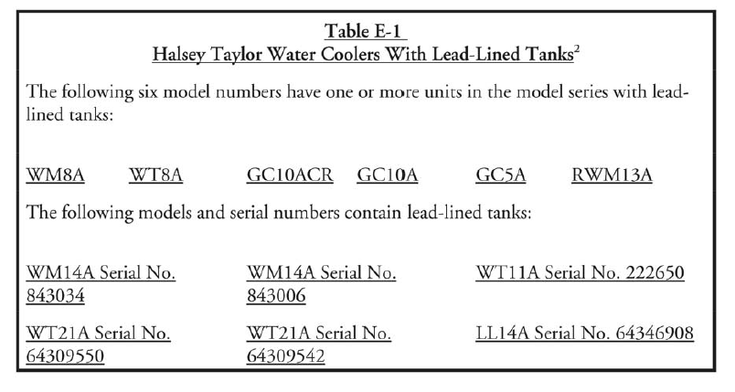

2Based upon an analysis of 22 water coolers at a US Navy facility and subsequent data obtained by EPA, EPA believes the most serious cooler contamination problems are associated with water coolers that have lead-lined tanks.

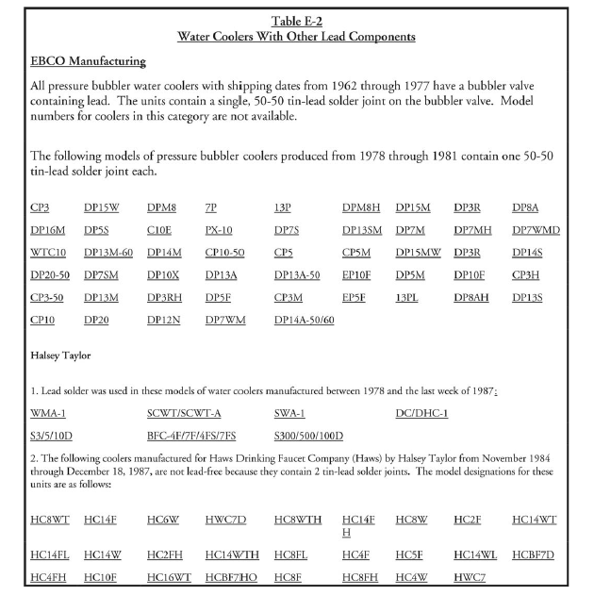

.

### H.ii: Ice Machines Sample Collection Procedure

Sample Collection Procedures:

• Initial Screening Sample 1E

Fill a suitable container (250 mL or larger, wide-mouthed bottle or other container) provided by the laboratory at least three- quarters full of ice. Do not touch the ice with your hands. Use the non-metal scoop or disposable plastic gloves provided by the laboratory to place the ice in the container.

If the lead level in Sample 1E exceeds 15 µg/L (ppb), collect a follow-up sample to determine if the source of the lead is the plumbing or the ice machine itself.

• Follow-Up Sample 2E

Disconnect the ice machine from the plumbing and look for a screen at the inlet. Remove the screen. If debris is present, forward a sample of the debris to the laboratory for analysis and clean out the remaining debris. The laboratory will determine whether lead solder is present. Clean the screen routinely to avoid accumulations of debris.

Collect the sample from the disconnected plumbing as close to the ice machine as possible. Fill the sample container with 250 mL of water. If no outlet is available, contact the ice machine manufacturer for recommendations that will minimize disruption of existing plumbing. Adding outlets or valves could add new sources of lead to the plumbing, even if the new devices are lead-free and meet NSF Standard 61, section 8. If a sample outlet or valve is available, collect the sample immediately after opening the outlet or valve.

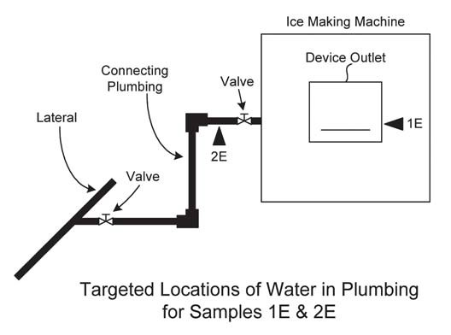

### H.iii: School Wide Flushing Procedure

Each drinking water outlet should be flushed individually; flushing a toilet will not flush your water fountains. All flushing should be recorded in the Flushing Log (Attachment E) for each school and completed prior to sampling.

• Locate the faucet furthest away from the service line on each wing and floor of the building, open the faucets wide, and let the water run for 10 minutes. This 10-minute time frame is considered adequate for most buildings.

• Open valves at all drinking water fountains without refrigeration units and let the water run for roughly 30 seconds to one minute, or until cold.

• Let the water run on all refrigerated water fountains for 15 minutes.

• Open all kitchen faucets (and other faucets where water will be used for drinking and/or food preparation) and let the water run for 30 seconds to one minute, or until cold.

### H.iv: Sampling Event Checklist

*Complete on the day of sampling*

**Before Beginning Sampling:**

* Review and Sign QAPP.
* Review School packet prior to sampling- including floor plan with sample locations, outlet inventory including all outlets to be sampled, filter inventory including which water coolers & drinking water fountains have filters, and if applicable pre-sampling event flushing schedule [includes which outlets were flushed, the duration of flushing, and when they were flushed].
* Perform a walk-through of the facility prior to sampling. Identify all outlets to be sampled, and label each outlet with its unique sample location code as it is found in the water outlet inventory.
* Verify that the water has been stagnant for at least 8 hours, but no longer than 48 hours.

**Sampling:**

* Field Blank.
* Start sampling at the outlet closest to the point of entry.
* For each sampling location record the time that sampling begins.
* Wearing gloves, collect samples into a 250 ml pre-cleaned bottle.
* Record the time all samples are collected.
* AFTER all other samples have been collected, for follow-up flush sampling, collect fifteen minute flushed samples from water coolers.
* Indicate on the Chain of Custody (COC) if the outlet is leaking, the water is discolored, the outlet is turned on, the outlet is not working, or the outlet has a filter.
* Label all Follow-Up Flush Samples with “FLUSH” after their unique sample location code. (e.g. WHS- and WHS - ---FLUSH).

**After Sampling:**

* Record the time that sampling ends.
* Count sampling bottles to make sure all water outlets on the inventory were sampled.

Project Officer:

Print Name Signature Date

Sampler:

Print Name Signature Date

### H.v: Sample Signs

[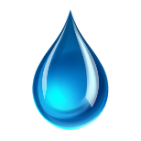](https://www.google.com/url?sa=i&rct=j&q=&esrc=s&source=images&cd=&cad=rja&uact=8&ved=0ahUKEwje56bxjbnNAhXHJB4KHbeRBk0QjRwIBw&url=https://play.google.com/store/apps/details?id%3Dcom.schulermobile.puddledrops&bvm=bv.124817099,d.dmo&psig=AFQjCNFDg5Si4oyTUh5IArx9Fgc5mKtHSg&ust=1466598118379337)

WATER TESTING IN PROGRESS

PLEASE DO NOT USE ANY WATER SOURCES – SINKS, FOUNTAINS, TOILETS, ETC.

DO NOT DRINK

[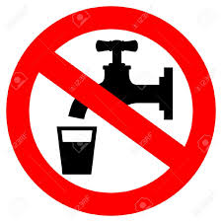](https://www.google.com/url?sa=i&rct=j&q=&esrc=s&source=images&cd=&cad=rja&uact=8&ved=0ahUKEwjOvPbIjLnNAhXCGh4KHeYYCl4QjRwIBw&url=https://www.123rf.com/photo_21550198_do-not-drink-water-sign.html&psig=AFQjCNHE1SFWP35lyWue57VV2nOlNQJzDg&ust=1466597766265534)

SAFE FOR HANDWASHING

[](http://www.google.com/url?sa=i&rct=j&q=&esrc=s&source=images&cd=&cad=rja&uact=8&ved=0ahUKEwiCmKiCjbnNAhUIdR4KHdxbCdUQjRwIBw&url=http://www.safetysign.com/hand-washing-signs&psig=AFQjCNG_-pNZ2IMsG36DjMk8FQ8Qo4q68A&ust=1466597886865441)

### H.vi: School Sampling Package Review Checklist

Review performed by: ______________________________ Date: _____________________

Name/Title

Name of NJ Certified Laboratory who performed the analytical testing and certification number:

Name:______________________________________ Certification Number: ______________

1. QAPP signed by all parties involved in sampling (Program Manager, Project Manager, Individual School Project Officers, Laboratory Manager, Laboratory QA Officer):

**Y or N**

If N, obtain.

1. Completed Plumbing Profile (Attachment B):

**Y or N**

If N, provide details on what is missing.

If Y, should include:

1. Material of Service line: **Y or N**
   1. Is the school served by a lead service line? **Y , N , or Unknown**
      1. Must provide documentation for either Y or N answer. If Unknown need to provide a plan for getting this information.
2. Material of potable water pipes: **Y, N , or Unknown**
   1. Was lead solder used in the plumbing system? **Y , N , or Unknown**

If Unknown, need to provide a plan for getting this information.

* 1. Are brass fittings, faucets, or valves used in the drinking water system? **Y or N**

1. Make and Model of Drinking Water Fountains/ Water Coolers: **Y or N**
   1. Checked all the drinking water fountains and coolers against the EPA list of recalled fountains: **Y or N**
      1. If Y, any fountains that were on the list were taken out of service and the information was recorded in the school file.
2. ‘Low use’ areas in the drinking water system: **Y or N**
   1. If Y, identify where. Verify that these areas were flushed properly.
3. Out-of-Service Outlets : **Y or N**
   1. If Y, identify where. Verify that these areas are still out of service.
4. Plumbing repairs and replacements performed within the last year: **Y or N**
   1. If Y, identify where.
5. Is Water Outlet Inventory (Attachment C) for the school completed with all information filled in? **Y or N**

If N, provide details on what is missing.

1. Completed Filter Inventory (Attachment D): **Y or N**

If N, provide details on what is missing.

1. Completed Flushing Log (Attachment E): **Y, N or NA**

Only applicable for facilities or specific locations in a facility that are not routinely used e.g. concession stands.

If Y, does it include duration and location of flushes? **Y or N**

If N, provide details.

1. Completed data packages for each sampling event including Chain of Custody sheets, field notes, results report and Excel spreadsheet: **Y or N**

If N, provide details on what is missing.

**Data Package Review**

1. Is the data package complete: **Y or N**
   1. If N, provide details on what is missing and contact lab if necessary.
2. Does the number of samples on the results report from the laboratory match the number of samples on the Chain of Custody? **Y or N**
   1. If N, identify which sample(s) are missing. Add these sampling locations to the Follow-Up Sampling list.
3. Is there a field blank? **Y or N**
4. Are results reported in µg/l? **Y or N**
   1. If N, remind lab to report in µg/l.
5. Any results not reported to at least 3 significant figures? **Y or N**
   1. If Y, contact lab.
6. Any results above 100 µg/l? **Y or N**
   1. If Y, have lab verify the results.
7. Compared field notes/ Chain of Custody notes with sampling results? **Y or N**
   1. If Y, are there any notes and sampling results that appear to need re-sampling? Add those sampling locations to the Follow-Up Sampling list. (i.e. notes indicate outlet was leaking or water was discolored)
8. Are there outlets that could not be sampled because they were not operational? **Y or N**
   1. If Y, outlets will be need to be sampled as part of follow-up sampling. Add these outlets on the Follow-Up Sampling list.
9. Are there sample codes not identified on the Key Code? **Y or N**
   1. If Y, contact sampler and individual school coordinator to identify.
10. Verify that water outlets requiring flushing were properly flushed: **Y or N**
    1. Are there outlets that were sampled and after reviewing the field notes it is apparent they were not operational prior to sampling and/or were not flushed? **Y or N**
    2. If Y, these outlets need to be resampled as part of follow-up sampling. Add these outlets on the Follow-up sampling list.
11. Compared first draw samples with follow-up flush samples (if collected): **Y or N**
12. Are there outlets where the follow-up flush sample is required but was not collected? **Y or N**
    1. If Y, these outlets need to be sampled as part of the follow-up sampling. Add these outlets to the Follow-up Sampling list.
13. Are there any follow-up flush sample outlets higher than the first draw? **Y or N**
    1. If Y, identify the internal plumbing material.
14. Match up the filters with the exact locations they are installed. Determine the following:
    1. Exact date installed: **Y, N, or Unknown**
    2. If N, return to location and identify.
    3. If Unknown, assume the filter will need to be replaced.

### H.vii: FOLLOW-UP SAMPLING INVENTORY

**School Name_________________________________________________________________**

**Individual School Project Officer: ________________________________________________**

**Date Completed: __________________**

|  |  |  |
| --- | --- | --- |
|  | | |
| SAMPLE ID/  LOCATION | REASON FOR FOLLOW-UP SAMPLING* | DATE RESAMPLED |
|  |  |  |
|  |  |  |
|  |  |  |
|  |  |  |
|  |  |  |
|  |  |  |
|  |  |  |
|  |  |  |

### H.viii: FOUNTAINS / DRINKING WATER COOLERS ON EPA’S RECALL LIST

**School Name__________________________________________________________________**

**Individual School Project Officer: ________________________________________________**

**Date Completed: __________________**

|  |  |  |  |  |
| --- | --- | --- | --- | --- |
|  | | | | |
| SAMPLE ID/  LOCATION | MAKE | MODEL | TAKEN OUT OF SERVICE  (DATE) | INITIALS |
|  |  |  |  |  |
|  |  |  |  |  |
|  |  |  |  |  |
|  |  |  |  |  |
|  |  |  |  |  |
|  |  |  |  |  |
|  |  |  |  |  |
|  |  |  |  |  |

If N/A, provide signature below indicating that the school does not have any drinking water fountains/water coolers on the EPA Recall list.

____________________________________________ Date__________________________

### H.ix: OUTLETS WITH FILTERS INSTALLED - RESULTS

**School Name_________________________________________________________________**

**Individual School Project Officer: ________________________________________________**

**Date Completed: __________________**

|  |  |  |  |  |
| --- | --- | --- | --- | --- |
|  | | | | |
| SAMPLE ID/  LOCATION | FILTER | | Results (µg/l)  Pre-Filter | Results (µg/l)  Post-filter |
| Make | Model |
|  |  |  |  |  |
|  |  |  |  |  |
|  |  |  |  |  |
|  |  |  |  |  |
|  |  |  |  |  |
|  |  |  |  |  |
|  |  |  |  |  |
|  |  |  |  |  |
|  |  |  |  |  |

### H.x_ Data Review Summary

School: ________________________________________________

Date Sampled: __________________________________________

Individual School Project Officer: _____________________________________

* Verify number of samples.
  + Make sure there are results for each sample taken.

Number of outlets sampled: ______________________

Number of first draw: _________________________

Number of follow-up flush: ___________________

* Confirm all results are reported with no less than three significant figures and are in units of µg/l or ppb.
* Confirm follow-up flush samples are collected at all water outlets that require a flush sample.

Number of samples >15.5 µg/l first draw: ___________________

Number of samples >15.5 µg/l follow-up flush: ___________________

Total Number of samples >15.5µg/l: _________________

For samples >15.5 µg/l

* Compare first draw samples with follow-up flush samples.

Number of outlets with decreased result between first draw and follow-up flush (> 15.5 µg/l and now < 15.5 ppb): __________

Number of outlets increased between first draw and follow-up flush (< 15.5 µg/l and now > 15.5 µg/l):____________

Number of outlets that remained > 15.5 µg/l (both results greater than 15.5 µg/l):_____________

* Verify follow-up flush samples that are higher than the first draw sample.
  + Check field notes and chain of custody for notes on the collection of these samples.
  + Check with lab to verify the sample result of these samples.
* Verify results > 100 µg/l
  + Call the lab to verify the results .
  + Make sure the lab report indicates that the sample was diluted.
* Verify sample results with field notes and chain of custody.
  + Use the field notes on the Chain Custody to provide insight on what may have caused certain high results.

The following information is based on field notes and the chain of custody:

Number of outlets not sampled: __________________________

Sample ID of outlets that do not work/broken: ________________________________________

______________________________________________________________________________

______________________________________________________________________________

Number of outlets leaking/dripping (not repaired): ________________________

Sample ID of outlets leaking/dripping: ______________________________________________

______________________________________________________________________________

______________________________________________________________________________

Number of outlets with low pressure/slow flow: __________________

Sample ID of outlets with low pressure/slow flow: _____________________________________

______________________________________________________________________________

______________________________________________________________________________

Number, description, and Sample ID of other outlet issues (i.e. color, odor, plumbing turned off, etc.):_________________________________________________________________________

______________________________________________________________________________

______________________________________________________________________________

______________________________________________________________________________

______________________________________________________________________________

* Verify the water outlets requiring pre-sampling flushing were flushed.
  + Check the low use outlet flush log located in the school package to verify that outlets were flushed properly prior to sampling.
* Verify Drinking Water Fountain & Water Cooler Filters.
  + Use the filter inventory in the school package to document whether or not drinking water fountains and water coolers have a filter.
* Verify unknown sample codes.
  + Make sure that ALL sample IDs used are included in the District’s outlet coding list.
  + Identify all sample IDs that are not listed on the coding list.

Additional information: __________________________________________________________

______________________________________________________________________________

______________________________________________________________________________

______________________________________________________________________________

### H.xi: Complete Sampling Package Example

Floor plan

Anytown Childcare/Pre-K

12 Joy Drive

Anytown, NJ

http://www.drinkingwaterfountains.com/wp-content/uploads/2010/03/drinking-water-fountain-bubbler.jpghttp://www.drinkingwaterfountains.com/wp-content/uploads/2010/03/drinking-water-fountain-bubbler.jpghttp://www.drinkingwaterfountains.com/wp-content/uploads/2010/03/drinking-water-fountain-bubbler.jpg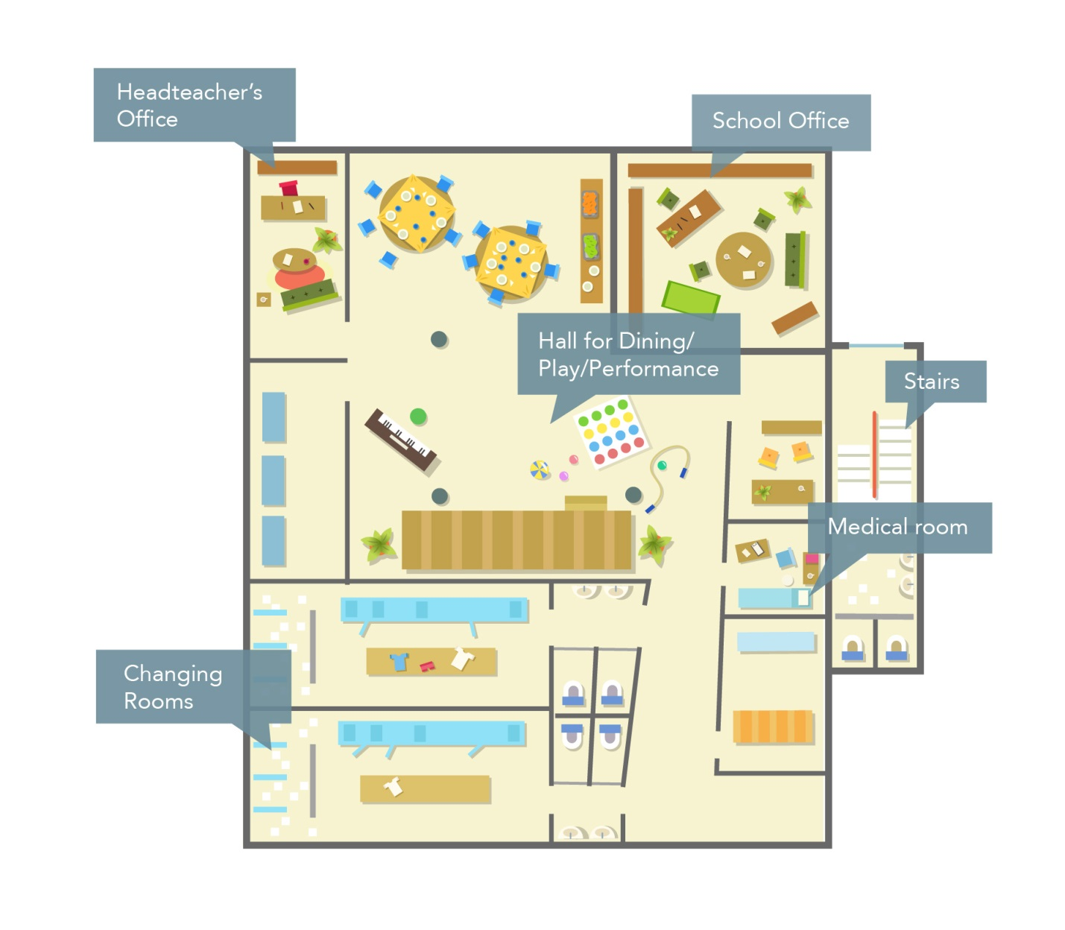

ACK-WC-1FL-CHANGINGRM

ACK-NS-1FL

ACK-WC-1FL-Office

ACK-SB-1FL- MAINRM

WM

POE

1st Floor

Anytown Childcare/Pre-K

12 Joy Drive

Anytown, NJ

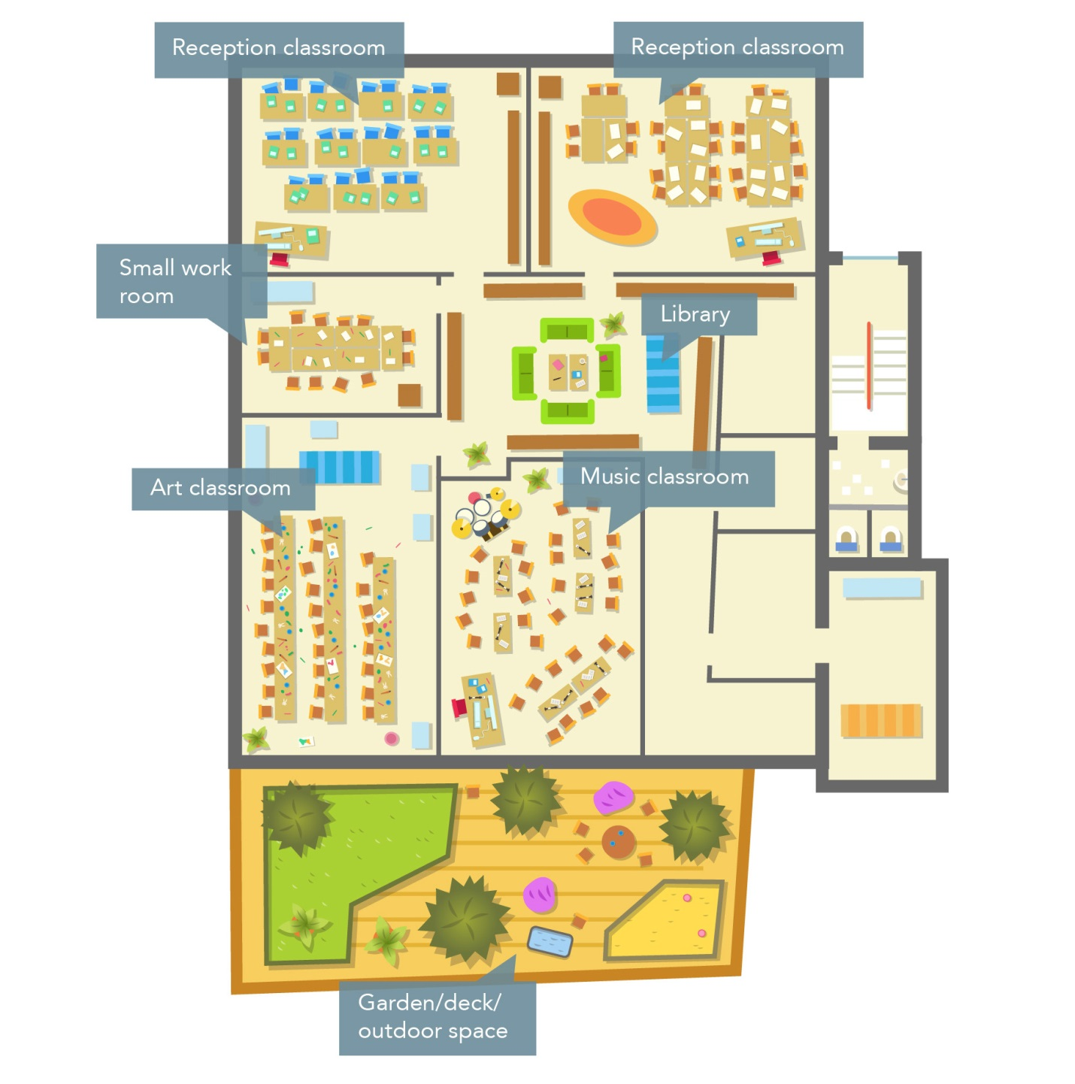

ACK-SB-2FL-Deck

ACK-WC-2FL-Deck

ACK-WC-2FL-Library1

2nd Floor

ACK-WC-2FL-Library2

WM

**Attachment B – Plumbing Profile**

***Note****: To be completed for each school. For additional information on completing this document see the USEPA publication, “The 3Ts for Reducing Lead in Drinking Water in Schools”*

Name of School: Anytown Childcare/ Pre-K__________________________________

Address: _12 Joy Drive , Anytown, NJ_____________________________________

Grade Levels: _Infant- Pre-K__________

Individual school project officer Signature: _____ ______________________ Date: ___________

| **Questions** | **Answers** | |
| --- | --- | --- |
| **Background Information** | | |
| 1. What year was the original building constructed?  Were any buildings or additions added to the original facility? | 2008  There have been no additions to the original building. | |
| 2. If the building was constructed or repaired after 1987, was the plumbing and solder lead-free?  What type of solder was used?  Document all locations where lead solder was used. | Lead-free solder and plumbing was used in the building. | |
| 3. Where are the most recent plumbing repairs and replacements? | Location:  None Identified | Description: |
| 4. What is the material of the Service Line?  Where is the Service Line located? (This is the POE location.) | Material: 4” Cast Iron Pipe  Location: 1st Floor in the Utility Closet across from the Changing Room. | |
| 5. Is there point of entry (POE) or point of use treatment in use? | Y / N  Type: | Location: |
| 6. Are there tanks in your plumbing system (pressure tanks, gravity storage tanks)? | Y / N | |
| 7. Does the school have a filter maintenance and operation program?  If so, who is responsible for this program?  What is the process for adding filters? | Yes, there is a filter maintenance program. Once every 6 months a maintenance worker comes and replaces all the filters. Water outlets came with filters and no filters had to be added. | |
| 8. Have accessible screens or aerators on outlets that provide drinking water been cleaned?  Does the school have a screen or aerator maintenance program? | Y / N  Yes, the aerators or screens are cleaned when maintenance replaces filters. | |
| 9. Have there been any complaints about bad (metallic) taste?  Note location(s). | Y / N  Location: | |
| 10. Review records and consult with the public water supplier to determine whether any water samples have been taken in the building for any contaminants. If so, identify:   * Name of contaminant(s) * Concentrations found * pH level   Is testing done regularly at the building? | * Lead * Three outlets were sampled results were <2ppb, <2ppb, <2ppb.   This building is tested every 5 years. | |
| 11. Other plumbing background questions include:   * Are blueprints of the building available? * Are there known plumbing “dead-ends”, low use areas, existing leaks or other “problem areas”? * Are renovations being planned for part or all of the plumbing system? | * Blue prints are available. * There are no known dead-ends, low-use areas or any existing leaks. * No renovations are being planned for the plumbing system. | |
|  |  | |
| **Walk-Through**  *These questions should be addressed during the walk-through of the facility, while Attachment C- Water Outlet Inventory is being completed*. | | |
| 1. Confirm the material of Service Line visually. |  | |
| 2. Confirm the presence of POE or POU treatment. |  | |
| 3. What are the potable water pipes made of in your facility?   * Lead * Plastic * Galvanized Metal * Cast Iron * Copper * Other   Note the water flow through the building and the areas that receive water first, and which areas receive water last. | Chlorinated polyvinylchloride (CPVC) | |
| 4. Are electrical wires grounded to Water Pipes?  Note location(s). | Y / N  Location: | |
| 5. Are brass fittings, faucets, or valves used in your drinking water system?  Note that most faucets are brass on the inside.  Document the locations of any brass water outlet to be sampled. | Complete in “Brass” Column in Attachment C- Water Outlet Inventory. | |
| 6. Locate all drinking water outlets (i.e. water coolers, bubblers, ice machines, kitchen/ food prep sinks, etc.) in the facility. | Complete in Attachment C-Water Outlet Inventory. | |
| 7. Have the brands and models of the water coolers in the school been compared to the listing of banned water coolers in Tool Kit?  Recalled Drinking Water Fountains  Make and Model | Y / N  Type | |
| 8. Have signs of corrosion, such as frequent leaks, rust-colored water, or stained fixtures, dishes, or laundry been detected?  Note the locations of water outlets. | Complete in “Signs of Corrosion” column in Attachment C- Water Outlet Inventory. | |
| 9. Are there any outlets that are not operational and therefore out of service? Permanently? Temporarily?  Permanently | Y / N  Complete “Operational Column” in Attachment C- Water Outlet Inventory.  Type/ Location | Description |
| Temporarily |  |  |

**Attachment C - Water Outlet Inventory**

(To be completed for each school)

Name of School: Anytown Childcare/ Pre-K___ Address: _12 Joy Drive, Anytown, NJ___________________________

Grade Levels: Infant- Pre-K___ Year School Constructed: 2008__ Renovated/Additions: __N/A____________________



Individual school project officer Name/Signature: _____________________________ Date Completed: ___________

|  |  |  |  |  |  |  |  |  |  |  |  |  |  |
| --- | --- | --- | --- | --- | --- | --- | --- | --- | --- | --- | --- | --- | --- |
| #[6] | Type | Location | Code | Operational[7]  (Y/N) | Signs of Corrosion[8]  (Y/N) | Filter[9]  (Y/N) | Brass Fittings, Faucets or valves?  (Y/N) | Aerator/ Screen  (Y/N) | Motion Activated  (Y/N) | Chiller  (Y/N) | Water Cooler | | Comments |
| Make | Model |
| 1 | WATER COOLER | Outside of Changing Room | ACK-WC-1FL-CHANGINGRM | Y | N | Y | N | N | N | Y | Elkay | LZ8LF |  |
| 2 | SINK | Medical Room | ACK-NS-1FL | Y | N | Y | N | Y | Y | N |  |  |  |
| 3 | SINK WITH BUBBLER | Main Room | ACK-SB-1FL-MAINRM | Y | N | Y | N | Y | N | N | Lustertone | DRKADQ371755RC |  |
| 4 | WATER COOLER | Outside of School Office | ACK-WC-1FL-OFFICE | Y | N | Y | N | N | Y | Y | Elkay | EMABFDWSLK |  |
| 5 | WATER COOLER | Entrance of Deck | ACK-WC-2FL-DECK | Y | N | Y | N | N | N | Y | Elkay | LZ8LF |  |
| 6 | SINK WITH BUBBLER | Entrance of Deck | ACK-SB-2FL-DECK | Y | N | Y | N | Y | N | N | Lustertone | DRKADQ371755RC |  |
| 7 | WATER COOLER | Entrance of Library | ACK-WC-2FL-LIBRARY1 | Y | N | Y | N | N | Y | Y | Elkay | EMABFDWSLK |  |
| 8 | WATER COOLER | Inside Library | ACK-WC-2FL-LIBRARY2 | Y | N | Y | N | N | Y | Y | Elkay | EMABFDWSLK |  |
|  |  |  |  |  |  |  |  |  |  |  |  |  |  |
|  |  |  |  |  |  |  |  |  |  |  |  |  |  |

**Attachment D - Filter Inventory**

(To be completed for each school if applicable)

Name of School: _Anytown Childcare/ Pre-K__________________________________

Address: _12 Joy Drive, Anytown, NJ_______________________________________

Grade Levels: _Infant- Pre-K___________



Individual School Project Officer Signature: ___________________ Date: ___________

|  |  |  |  |  |  |  |
| --- | --- | --- | --- | --- | --- | --- |
| Sample Location / Code | Brand | Type (Make & Model) | Date Installed or Replaced | Replacement Frequency | Capable of Removing Lead? Y/N | NSF Certified  Y/N |
| ACK-WC-1FL-ChangingRm | WaterSentryVII | 51299C | 5/5/2016 | 6 months | Y | Y |
| ACK-NS-1FL | OMNIPURE | CL10HP | 5/5/2016 | 6 months | Y | Y |
| ACK-SB-1FL-MainRoom | OMNIPURE | CL10HP | 5/5/2016 | 6 months | Y | Y |
| ACK-WC-1FL-Office | WaterSentry VII | EWF3000 | 5/5/2016 | 6 months | Y | Y |
| ACK-WC-2FL-Deck | WaterSentryVII | 51299C | 5/5/2016 | 6 months | Y | Y |
| ACK-SB-2FL-Deck | OMNIPURE | CL10HP | 5/5/2016 | 6 months | Y | Y |
| ACK-WC-2FL-Library1 | WaterSentry VII | EWF3000 | 5/5/2016 | 6 months | Y | Y |
| ACK-WC-2FL-Library2 | WaterSentry VII | EWF3000 | 5/5/2016 | 6 months | Y | Y |
|  |  |  |  |  |  |  |
|  |  |  |  |  |  |  |
|  |  |  |  |  |  |  |
|  |  |  |  |  |  |  |
|  |  |  |  |  |  |  |
|  |  |  |  |  |  |  |
|  |  |  |  |  |  |  |
|  |  |  |  |  |  |  |
|  |  |  |  |  |  |  |
|  |  |  |  |  |  |  |
|  |  |  |  |  |  |  |
|  |  |  |  |  |  |  |
|  |  |  |  |  |  |  |
|  |  |  |  |  |  |  |

**Attachment E – Flushing Log**

(To be completed for each school if applicable)

Name of School: __Anytown Childcare/ Pre-K________________________________

Address: _12 Joy Drive, Anytown, NJ_______________________________________

Grade Levels: _Infant – Pre-K_____________________________________________



Individual School Project Officer Signature: ___________________ Date:

|  |  |  |  |  |  |
| --- | --- | --- | --- | --- | --- |
| Sample Location Description | Sample Location Code | Date | Time | Duration of Flushing | Reason for Flushing |
| Outside of Changing Room | ACK-WC-1FL-CHANGINGRM | 07/07/16 | 6:00pm | 15 Minutes | Facility was closed for 4th of July week. |
| Medical Room | ACK-NS-1FL | 07/07/16 | 6:17pm | 30 Seconds | Facility was closed for 4th of July week. |
| Main Room | ACK-SB-1FL-MAINRM | 07/07/16 | 6:19pm | 30 Seconds | Facility was closed for 4th of July week. |
| Outside of School Office | ACK-WC-1FL-OFFICE | 07/07/16 | 6:38pm | 15 Minutes | Facility was closed for 4th of July week. |
| Entrance of Deck | ACK-WC-2FL-DECK | 07/07/16 | 7:00pm | 15 Minutes | Facility was closed for 4th of July week. |
| Entrance of Deck | ACK-SB-2FL-DECK | 07/07/16 | 7:16pm | 30 Seconds | Facility was closed for 4th of July week. |
| Entrance of Library | ACK-WC-2FL-LIBRARY1 | 07/07/16 | 7:20pm | 15 Minutes | Facility was closed for 4th of July week. |
| Inside Library | ACK-WC-2FL-LIBRARY2 | 07/07/16 | 7:36pm | 15 Minutes | Facility was closed for 4th of July week. |
|  |  |  |  |  |  |
|  |  |  |  |  |  |
|  |  |  |  |  |  |
|  |  |  |  |  |  |
|  |  |  |  |  |  |
|  |  |  |  |  |  |
|  |  |  |  |  |  |
|  |  |  |  |  |  |
|  |  |  |  |  |  |
|  |  |  |  |  |  |
|  |  |  |  |  |  |

1. Point of entry is the closest water outlet to the entrance of the service line into the school.
2. Number outlets starting at the closest outlet to the Point of Entry (POE).
3. Document if permanently or temporarily out of service on the Attachment B- Plumbing Profile.
4. Signs of corrosion detected, such as but not limited to frequent leaks, rust-colored water, or stained fixtures, dishes, or laundry.
5. Document on Attachment D- Filter Inventory.
6. Number outlets starting at the closest outlet to the Point of Entry (POE).
7. Document if permanently or temporarily out of service on the Attachment B- Plumbing Profile.
8. Signs of corrosion detected, such as but not limited to frequent leaks, rust-colored water, or stained fixtures, dishes, or laundry.
9. Document on Attachment D- Filter Inventory.