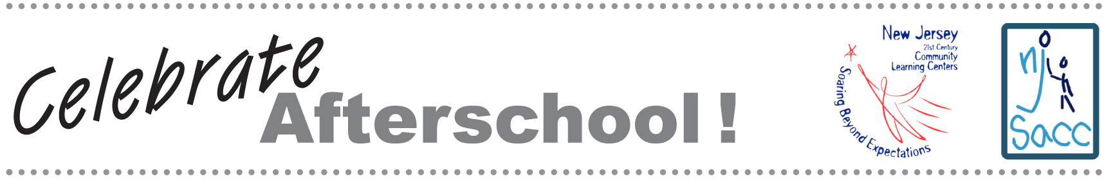

VIP INVITATION

Dear Friend,

On XXX, NAME afterschool program will open its doors to the entire community at NJ Celebrates Afterschool! This event will be both fun and educational, with hands-on activities for all ages. It is our opportunity to share some of the wonderful programs developed through our designation as a New Jersey 21st Century Community Learning Center.

Please join us to learn more about our program, meet our staff, and interact with the children and families who participate in our programs. In addition to seeing our programs in action, I hope you will join us for a special photo of community leaders at our center.

New Jersey’s 21st Century Community Learning Centers are more than holding zones that safeguard children while their parents work. They are incubators of learning, where children grow academically, socially, and emotionally. Study after study shows that high-quality afterschool programs can improve the odds of success, particularly for children whose personal circumstances put them at higher risk for school failure. Children in afterschool programs score higher on standardized tests, exhibit more positive social behavior, and are less likely to use drugs.

We look forward to seeing you on XXX. Please RSVP to CONTACT INFO.

Sincerely,

This packet was funded in its entirety with federal Elementary and Secondary Education Act, as amended by No Child Left Behind, Title IV, Part B, 21st Century Community Learning Center grant funds awarded to the New Jersey Department of Education.

