Division of Mental Health and Addictions Services
Trauma Informed Care
Universal Screening

Approximately 50–60% of the general population has experienced a high-magnitude, potentially traumatic event (e.g., serious accident, natural disaster, or witnessing a trauma) (Kessler, Sonnega, Bromet, Hughes, & Nelson, 1995.) Adults in psychiatric hospitals have high rates of physical and/or sexual abuse, ranging from 43% to 81%. Up to 2/3 of men and women in substance abuse treatment suffer from posttraumatic stress disorder, acute stress disorder or other trauma related symptoms; and up to 80% of women in prison and jails were victims of sexual and physical abuse. Unrecognized, unaddressed trauma related symptoms and behaviors can lead to poor engagement in treatment, premature termination, and greater risk for relapse of psychological symptoms or substance use, and worse outcomes.

Universal Trauma Informed screening can prevent misdiagnosis and inappropriate treatment planning: people with histories of trauma often display symptoms that meet criteria for other disorders. Without screening, trauma histories and related symptoms often go undetected, and we may provide services for symptoms and disorders that may only partially explain the individuals’ distress. Universal screening for trauma history and trauma-related symptoms can identify individuals at risk of developing more pervasive and severe symptoms of traumatic stress.

Screening
Screening is the process by which an individual is determined to be appropriate and eligible for admission to services. Trauma-informed screening is an essential part of the intake evaluation and the treatment planning process. Screening occurs at intake unless the individual is unable to answer the questions due to symptoms (if this is the case trauma screening should be deferred to a later time.) The presence of trauma symptoms in screening does not necessarily say anything about severity, nor does a positive screen indicate that a disorder exists. If someone acknowledges a trauma history, further assessment is necessary to determine the extent of trauma-related symptoms. The tool used for screening must come from those recommended by the Substance Abuse and Mental Health Services Administration (see TIP 57, Trauma-Informed Care in Behavioral Health Services Appendix D—Screening and Assessment Instruments, 2014.)

Screening Tools
DMHAS recommends two screening tools for use throughout the system of care:
- The Stressful Life Events Screening Questionnaire (SLE)
Developed as a general traumatic events questionnaire, this tool is a 20 question self-report measure that includes the individuals’ view of the impact of those events. The SLE questions past exposure to DSM–IV PTSD Criterion A traumatic events. The SLE is recommended for research and general screening purposes, and is available in English and Spanish.
- The Trauma Assessment for Adults (TAA) is a 17-item self-report that inquires about numerous potentially traumatic events that an individual may have experienced and/or different types of stressful life events using a yes/no format.

Screening Implementation
As a part of the intake process, agencies should choose one of the tools recommended herein to be used with each individual who is admitted as a service recipient.

Once a person reveals that they are experiencing or have had adverse or traumatic life experiences, it is appropriate to use an assessment tool that could uncover signs of related stress, functional difficulties and/or PTSD.

Both of these tools use a self-report method: self-reporting is the preferred method for trauma screening. Agencies should be cautioned to sit with an individual as they complete a self-screening to create a caring environment and in the event the individual needs assistance with reading, writing or interpreting the questions. It is also important to realize that the screening process can be a potential trigger, so consideration should be given to staying with an individual after screening takes place to create safety and well-being.

Scripts are below to assist staff in introducing the screening tool:

Recommended Script to Introduce SLE Screening:
It is recommended that staff who perform trauma screening use the following script as a guide for how to introduce the trauma screening process:

“It is common for people to have experienced stressful and upsetting events. Even if those events happened to you a long time ago, those events can still effect how a person thinks and feels today. Things that happen to us can affect how we react to other people and situations many years later.

People who have experienced a traumatic event, a series of traumatic events, or certain kinds of stress over time can have different needs than people who have not. Because of this, it is helpful for us to be aware of your past experiences, and the way in which those events may still affect you. This questionnaire asks about many different types of stressful life events.

We would like you to answer the following questions on your own to see if any of these things have happened to you. These kinds of events can be frightening or distressing to almost everyone. I am here to help if you have any questions, or need assistance with completing this questionnaire, and I will stay with you afterward if you would like.”

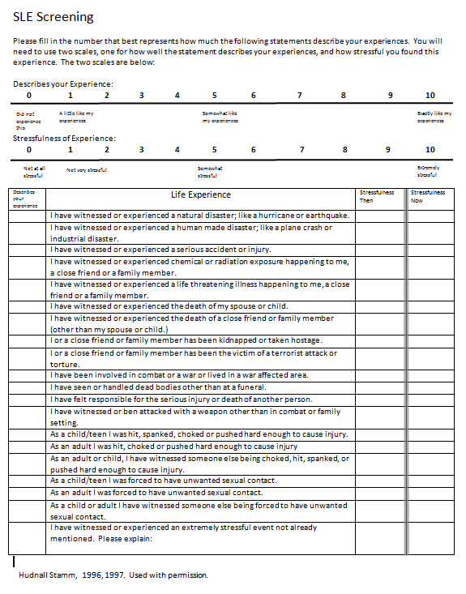
Recommended Script to Introduce TAA Screening:
It is recommended that staff who perform trauma screening use the following script as a guide for how to introduce the trauma screening process:

“It is common for people to have experienced stressful and upsetting events. Even if those events happened to you a long time ago, those events can still effect how a person thinks and feels today. Things that happen to us can affect how we react to other people and situations many years later.

People who have experienced a traumatic event, a series of traumatic events, or certain kinds of stress over time can have different needs than people who have not. Because of this, it is helpful for us to be aware of your past experiences, and the way in which those events may still affect you.

We would like you to answer the following questions on your own to see if any of these things have happened to you. I am here to help if you have any questions, or need assistance with completing this questionnaire.

You will check the box for yes or no in response to each question about things that may have happened to you. If a particular type of event has not happened to you, mark ‘no’ and move on to the next numbered question.

I will stay with you after you have finished if you would like.”

