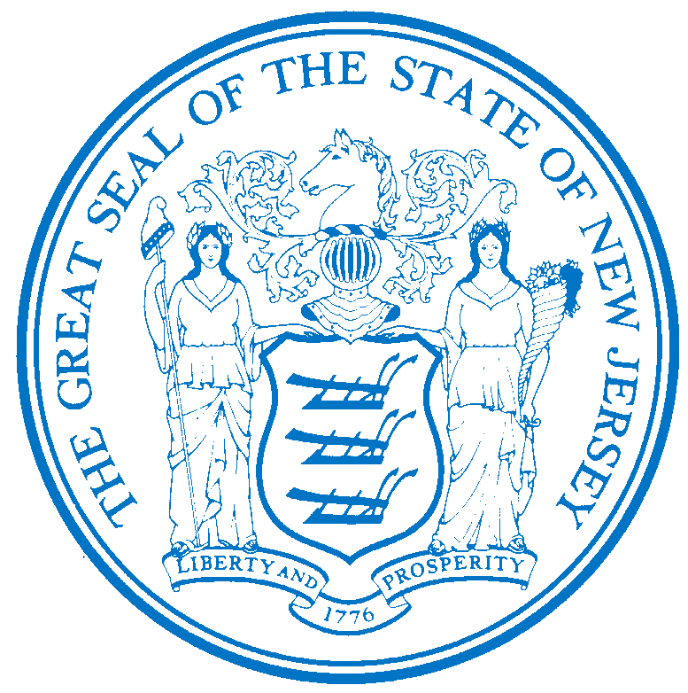


Department of Human Services
OFFICE OF THE ASSISTANT COMMISSIONER FOR
HUMAN RESOURCES
PO Box 700
Trenton, NJ 08625-0700
CHRIS CHRISTIE Elizabeth connolly
Governor Acting Commissioner

KIM GUADAGNO Christina Mongon Lt. Governor Assistant Commissioner
Human Resources

OPEN TO: Permanent State employees as a promotional or lateral opportunity, pending the rescission of applicable promotional and hiring restrictions.

STATE-WIDE DISTRIBUTION
JOB OPPORTUNITY #226-16
DATE: August 2, 2016

TITLE: Clinical Director Medical

SALARY: $214,424.00

LOCATION: Greystone Park Psychiatric Hospital
59 Koch Ave
Morris Plains, NJ 07950

POSITION INFORMATION

DEFINITION: Under administrative direction of the Chief Executive Officer in a state hospital within the Division of Mental Health and Hospitals, Department of Human Services, is responsible within the framework of level of functioning for unified services, normalization, and advocacy, and the overall direction of clinical and rehabilitation programs and services; ensures hospital compliance with all medical policies, directions, rules, and regulations, and performance standards of the state, the Division of Mental Health and Hospitals, the Chief Executive Officer, hospital bylaws, and accrediting bodies; serves as the ultimate facility authority on medical issues; does related work as required.

LICENSURE/CERTIFICAITON: Full licensure to participate in medicine and surgery in the State of New Jersey. Certification in Psychiatry by the American Board of Psychiatry and Neurology.

EXPERIENCE: Five (5) years of experience in clinical, academic, or administrative psychiatry following completion of psychiatric training.

NOTE: APPLICABLE SPECIAL RE-EMPLOYMENT LISTS ESTABLISHED AS A RESULT OF A LAYOFF WILL BE USED BEFORE ANY APPOINTMENTS ARE MADE.

RESUME SUBMITTAL

Interested candidates possessing the requirements listed, should forward resumes with the job opportunity # as indicated below:

SUBMIT TO: Michelle Battle
Personnel Assistant 2
Greystone Park Psychiatric Hospital
59 Koch Ave
Morris Plains, NJ 07950
E-mail Resumes to: Mhsgph.Resume@dhs.state.nj.us

RESPOND BY: August 16, 2016

DHS-CO REVIEW: DAB 08/02/2016

IMPORTANT NOTICES
(1) RESIDENCY - Effective 9/1/11, NJ PL 70 (NJ First Act), requires all State employees to reside in New Jersey, unless exempted under the law, or current employees who live out-of-state and do not have a break-in service of more than 7 calendar days, as they are “grandfathered.” New employees or current employees who were not grandfathered and who live out-of-state have one year after the date of employment to relocate their residence to New Jersey or request an exemption. Current employees who reside in NJ must retain NJ residency, unless he/she obtains an exemption. Employees who fail to meet the residency requirements or obtain an exemption will be removed from employment.
(2) DRUG SCREENING - If you are a candidate for a position that involves direct client care in one of the Department of Human Services’ hospitals or developmental centers, you may be subject to pre and/or post-employment drug testing/ screening. The cost of any pre-employment testing will be at your expense. Candidates with a positive drug test result or those who refuse to be tested and/or cooperate with the testing requirement will not be hired. You will be advised if the position for which you’re being considered requires drug testing and how to proceed with the testing.

