AFRICAN AMERICAN HISTORY
SCAVENGER HUNT

How to participate:
Start by looking at the images carefully, and then read the clues next to each for hints as to where to start. As you read each clue, think about whether it points you in the direction of a particular
exhibition within the Museum’s main building. The clues help you ﬁnd the object within an exhibition; maybe you will recognize the image as you walk around and explore.
Hint: to answer some of the questions, read the object labels.

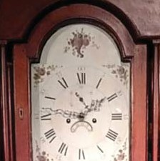
1) Some slaves were taught trades by their masters, and in some cases, were paid for their work which would make it possible for them to buy their freedom. The artist of this big clock was born in 1767 and was the former slave of a Quaker from New Jersey. He worked as an
assistant clockmaker until he was 27 years old, bought his freedom, and started his own clock business. The artist is now known as the ﬁrst African American clockmaker.
What is the name of this artist? What exhibit is this clock located in?

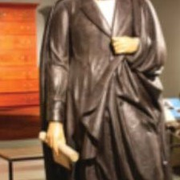
2.) This statue of President Lincoln is quite a big thing. In his hand, Lincoln holds a very important document that was issued in 1863 during the Civil War which proclaimed those enslaved in Confederate states to be forever free.
What exhibit is the statue in? What is Lincoln holding?

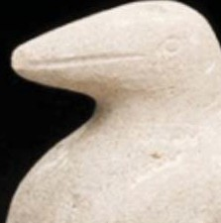
- This self-taught artist was the ﬁrst African American to have a solo exhibition
at the Museum of Modern Art (MOMA) in 1937. The son of freed slaves, he lived and worked in Nashville, TN.
Who is the artist? What kind of bird did he carve?

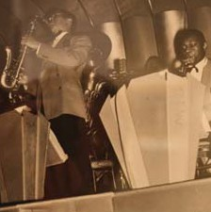
- The rise of the Harlem Renaissance and the “Jazz Age” coincided with the spread of photography. As a result, the rich history of Harlem has been documented with some of the ﬁrst candid photographs. The photo titled, “Harlem” hangs among other works that together focus on images of the everyday lives of African Americans.
Who is the artist? What exhibit is the photograph in?

DISCOVER. LOOK. LEARN.

For a complete list of the Museum’s exhibitions, educational programs, events, and planetarium shows, please visit: WWW.STATEMUSEUM.NJ.GOV
New Jersey State Museum
Chris Christie, Governor
Kim Guadagno, Lt. Governor/Secretary of State Margaret O’Reilly, Executive Director
AFRICAN AMERICAN SCAVENGER HUNT

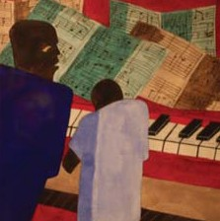
- This artist became nationally famous while still in his 20’s after the debut of his “Migration” series documenting the migration of African Americans from the South. This musical painting inspired by the art movement known as cubism depicts two ﬁgures at an instrument.
Who is the artist? What is the instrument?

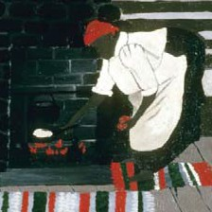
- This painting by the artist Horace Pippin is an example of folk art style, as he draws
from his culture to depict his mother over an open stove. Pippen enjoyed a short but highly acclaimed career, championed by patrons such as N.C. Wyeth and Albert C. Barnes. He is known for painting the American scene.
What is the name of the painting? What exhibit is it in?

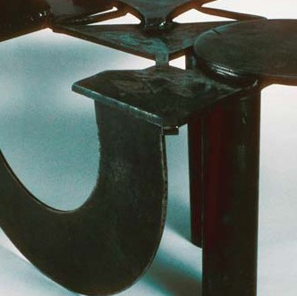
- This sculpture is by Melvin Edwards, an artist who taught for many years at Rutgers Uni- versity in New Jersey. Edwards gets a lot of inspiration for his artwork from his ancestral home of Africa and reveals his thoughts, perspective and identity through simple shapes like he does in this particular sculpture.
What artistic movement is represented by this sculpture?

DISCOVER. LOOK. LEARN.

