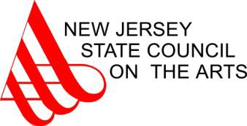

2014 Fellowship Recipients

Choreography | City | County | Award
Ms. Erin Carlisle-Norton | South Hackensack | Bergen | 8,400
Mr. Randy James | Highland Park | Middlesex | 8,400
Ms. Lydia Johnson | South Orange | Essex | 8,400

Music Composition  Ms. Amanda Harberg | Glen Ridge | Essex | 8,400
Mr. Kenneth Lampl | East Brunswick | Middlesex | 8,400
Mr. David Sampson | Morristown | Morris | 8,400
Mr. John Sichel | Mountainside | Union | 8,400
Mr. Matthew Slocum | Paterson | Passaic | 8,400
Mr. Joshua Stamper | Collingswood | Camden | 8,400
Mr. Joseph Turrin | Clifton | Passaic | 8,400
Poetry
Ms. Nicole Cooley | Glen Ridge | Essex | 10,000
Ms. Barbara Daniels | Sicklerville | Camden | 8,400
Mr. Stuart Greenhouse | Highland Park | Middlesex | 8,400
Ms. Meghan Privitello | Ventnor City | Atlantic | 8,400
Mr. Joseph Rathgeber | Clifton | Passaic | 8,400
Mr. Christopher Salerno | Caldwell | Essex | 10,000
Sculpture
Ms. Betty Beaumont | Oak Ridge | Morris | 8,400
Mr. Scott Pellnat | Somerset | Somerset | 8,400
Ms. Lisa Sanders | Montclair | Essex | 8,400
Ms. Christina Tenaglia | Wildwood Crest | Cape May | 8,400

The New Jersey State Council on the Arts is a division of the NJ Department of State. It receives funding in direct appropriations from the State of New Jersey through a dedicated Hotel/Motel Occupancy fee and grants from the National Endowment for the Arts. Since 1966, its volunteer members and professional staff have worked to improve the quality of life in New Jersey
by helping the arts to flourish. To learn about the Council, please visit www.artscouncil.nj.gov. For more information about what's happening in the arts statewide, visit www.jerseyarts.com.

