NJ State Council on the Arts
Staff Contact List
Main Number: 609-292-6130
NJ Relay: 711
Fax: 609-989-1440
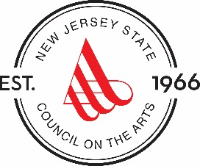

Executive Staff
Nicholas Paleologos
Executive Director
609-633-1218
nicholas.paleologos@sos.nj.gov

Irene Wells
Assistant to the Executive Director
609-984-7127
irene.wells@sos.nj.gov

Communications
Allison Tratner
Director of Communications
609-292-4524
allison.tratner@sos.nj.gov

Operations
Patricia Hamilton-Ross
Assistant to the Director of Operations
609-633-1273
patricia.hamilton-ross@sos.nj.gov

Nancy Sawasky
Office Manager
609-633-1221
nancy.sawasky@sos.nj.gov

Programs & Services

Tammy R. Herman
Director of Programs & Services
609-292-4435
tammy.herman@sos.nj.gov

Danielle Bursk
Director of Arts Education
609-633-1184
danielle.bursk@sos.nj.gov

Mary Eileen Fouratt
Program Officer
609-984-6815
MaryEileen.Fouratt@sos.nj.gov
Kim Nguyen
Program Officer - Folk Arts
609-292-4495
kim.nguyen@sos.nj.gov

Paula Stephens
Program Officer – Arts in Communities
609-633-1244
paula.stephens@sos.nj.gov

Artists' Services
Don Ehman
Director of Artists' Services and
Access Coordinator
609-984-7023
donald.ehman@sos.nj.gov
Eileen Peterson
Support Specialist - Artists' Services/Arts Education
609-633-1251
eileen.peterson@sos.nj.gov

