Problem Statement Screening Report
Problem Statement: XXXX
Database # XXXXX
XX Municipality, XX County
Bureau of Capital Program Development

Executive Summary

This report investigates a problem statement submitted by XXXX located in XXXX, XXXX County. The problem statement identifies XXXXXX.

Score requests were made to relevant Management System for the problem statement. A search for any completed or existing projects in the area of the problem statement was also done.

The Problem Statement Screening identified XXXX conditions that require additional investigation. It is recommended that the Problem Statement advance to XXXX phase to further investigate the issues stated in this report.

Improvements of the problem may advance the goals and objectives of the CURRENT YEAR (2013-2022) Statewide Capital Investment Strategy by XXXX (ex. reducing the total square footage of deficient decks by approximately 0.2%

 | Deck Area | Estimated Cost (Preliminary)
Total | 9,979.2 SF | $4,510,000

Table of Contents

Executive Summary 1
Table of Contents 2
Problem Statement Description 3
Proposed Project Need 3
Location Map 4
Problem Statement Screening Process Overview 5

Problem Statement Name
Video Log/Straight Line Diagram 6
Problem Statement Area Map 7
Summary Table 8

Risk Analysis 9
Problem Statement Screening Recommendations 10
Attachments Overview 11

Problem Statement Description:

Proposed Project Need:

** See TP-1 Form for more detailed information.

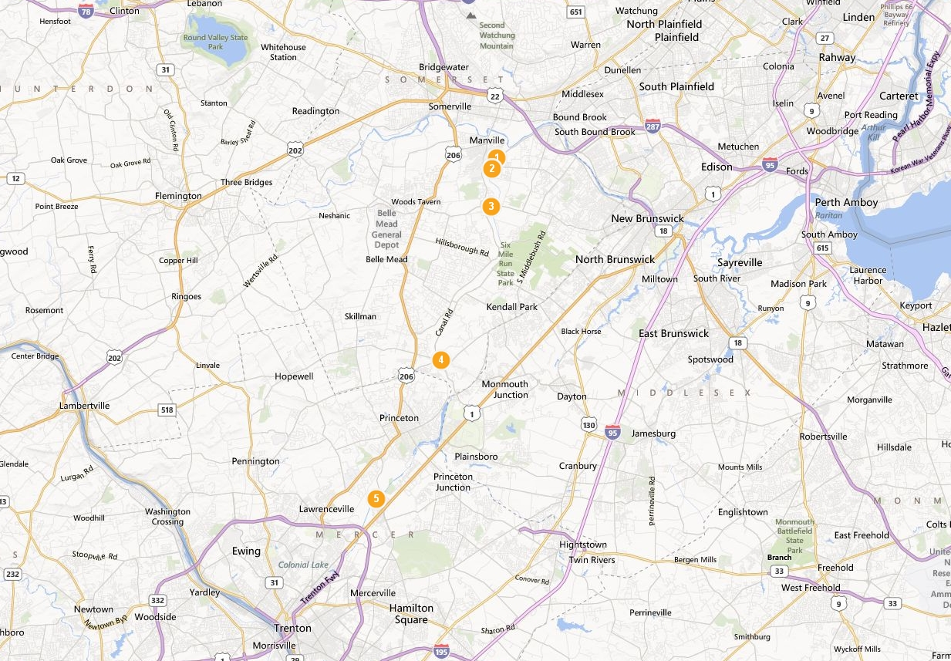
D & R Canal Bridges (5)
Franklin Township, Somerset County
Princeton Township, Mercer County
LOCATION MAP

Problem Statement Review Process Overview

As stated by the Capital Project Delivery Process:

“When a problem statement is initiated, the Division of Capital Investment Planning and Development (CIPD) facilitates a Problem Statement Review process. Problem Statement Review is undertaken in order to conduct a preliminary review of a problem statement and weigh its merit against other competing problem statements statewide using information contained in the Department’s appropriate management systems. The outcome of a Problem Statement Review can be the following:
- Determine if problem statement can be eventually advanced in the project development process, provided funding is available and it is consistent with CIS goals and objectives;
- Terminate problem statement because of a lack of need or because the recommendation within a problem statement is already being addressed by an existing project;
- Determine that a quick fix by means of a maintenance work order is appropriate based on SME evaluations and;
- Table the problem statement for potential future pipeline advancement. When appropriate, a problem statement can be reassigned to a different jurisdiction, such as a toll road authority or other agency.

For each problem statement, CIPD updates the problem statement database and notifies the original sender of the resolution.”

Management System Overview

Bridge Management System (BMS)
- Priority Rank: Ranges from 1 to 5
  - 1 - High priority.
  - 5 - Low/no priority repair.
- Sufficiency Rating: Ranges from 1 to 100.
  - 100 - Meets the most up to date bridge standards.
  - 0 - In need of immediate repair or replacement.
  - A score of 0-50 and deemed structurally deficient qualifies a bridge for replacement funds.
  - A score of 50-80 and deemed structurally deficient or functionally obsolete qualifies a bridge for rehabilitation funds.

Congestion Management System (CMS)
- Score: Ranges from 1 to 10, 1 being a low priority and 10 being a high priority.
Low | Medium-Low | Medium | Medium-High | High
< 4 | 4 – 4.99 | 5 – 5.99 | 6 – 6.99 | 7+

Drainage Management System (DMS)
- Rank: From 1 to 232.
  - 232 - Low priority drainage repair location.
  - 1 - High priority drainage repair location.
- The DMS is not reflective of current conditions, yet new problems that are evaluated using current data are then ranked against the static pool of screened problem statements.

Pavement Management System (PMS)
- Score: From 1 to 10.
  - 1 - Low/no need for pavement repair.
  - 10 - High need for pavement repair.

Safety Management System (SMS)
- Score: Ranges from 1 to 10.
  - 1 - Low crash rate compared to the state average of similar road geometry.
  - 10 - High crash rate compared to the state average of similar road geometry.

Smart Growth Management System
- Score: Ranges from 0 to 100.
  - 100 - An area with criteria that strongly promotes smart growth.
  - 0 - An area with no criteria contributing to smart growth.
- It is important to look at individual rating criteria to see what type of factors are within the area.

Integrated Management System (IGMS)
- Score: Ranges from 1 to 10.
  - 1 - Low priority project with respect to departmental priorities.
  - 10 - High priority project with respect to departmental priorities.
- The score is calculated using weighted Management System scores to assess their priority against other projects.
- The BMS and bridge projects are not included in this scoring.

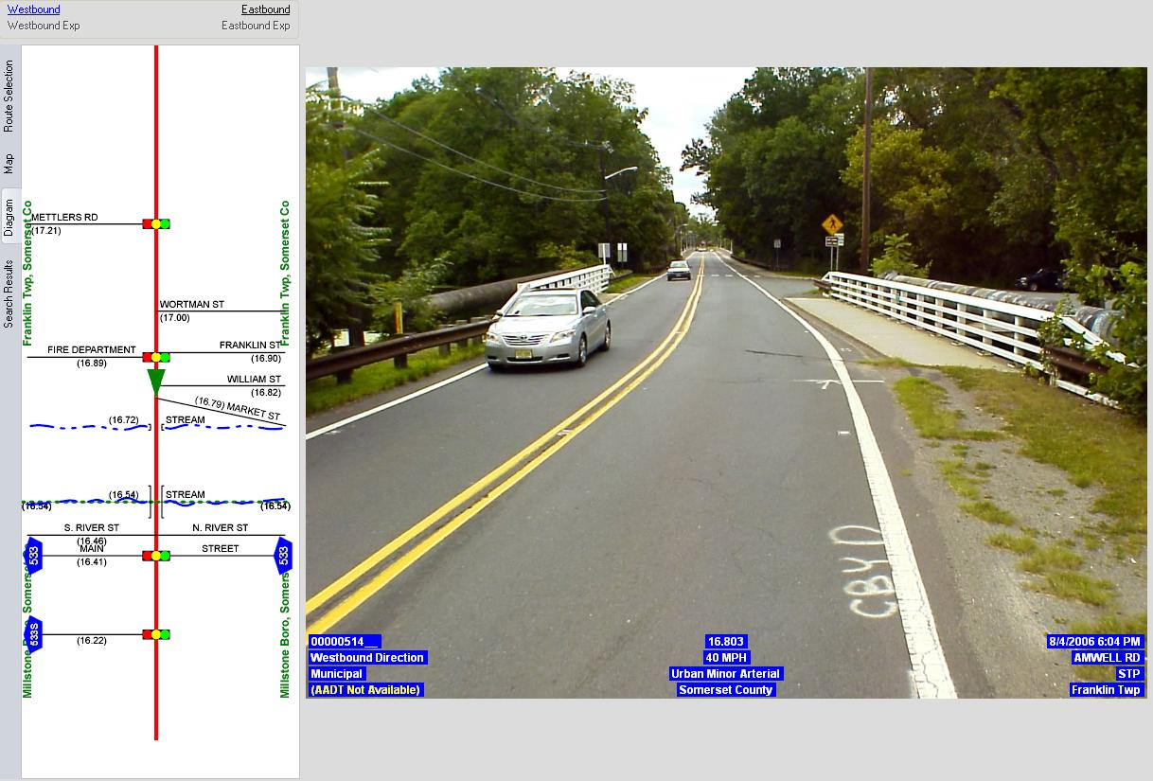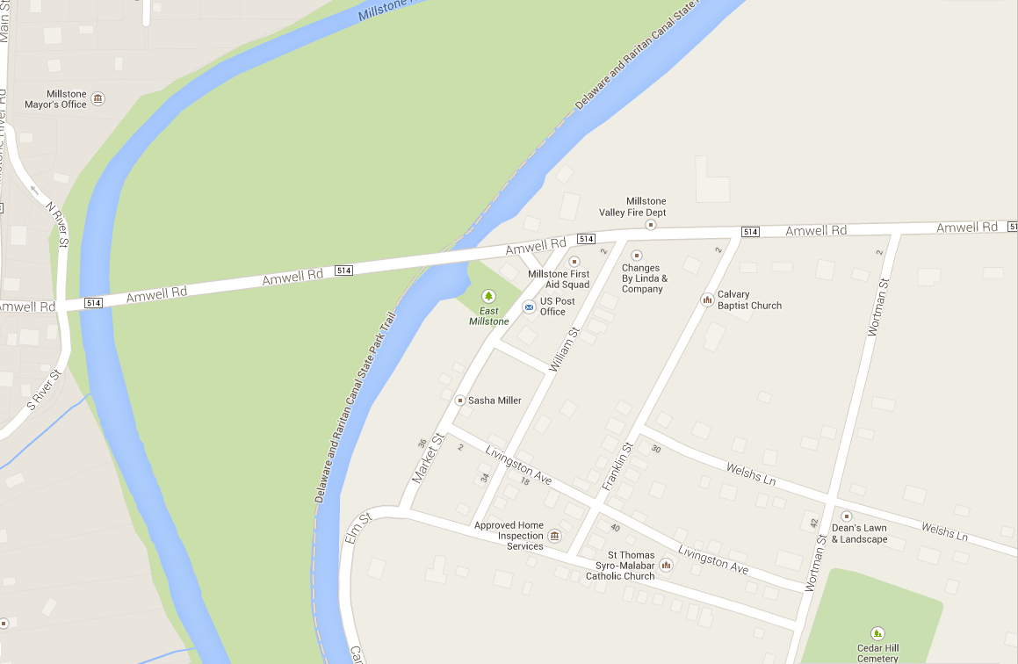
Insert Location Map , SLD, Videolog Photos

Problem Statement Screening: Management System Evaluation: | UPC#: XXXXXX (DB XXXXX)  Problem Statement Name  XXXX Township, XXXX County
Asset Category :
Description :
Initiator :
Length (Max. Span) :
Year Built :
Duplication: Potentially Overlapping Projects
BMS :
CMS :
DMS :
SMS (Prelim.) :
Smart Growth Mgmt System (SGMS) :
Complete Streets Policy Evaluation :
SCIS Conformance – BMS :
Estimated Value (Preliminary) :

Risk Analysis

The purpose of the Risk Mitigation strategy proposed by the Bureau of Capital Project Delivery is to help reduce the likelihood of unexpected time and cost overruns. A risk register table was created for the problem screening delivery phase to help identify potential risks as early in the process as possible.
It is important that future phases develop, modify, and address the risks outlined in the Problem Screening Risk Register. The project manager should develop a risk register using the standard methods.
The most significant observed risks are XXXXX. It is important to address these risks as early as possible to eliminate any undesirable changes to cost and/or schedule.
Problem Statement Screening Recommendations:

- XXXX Group initiate XXXX phase (Concept Development/maintenance work order/ etc.) addressing the deficiencies described in the TP-1 Form.
- Review and address the risks identified in the Problem Screening Risk Register (Appendix A).
- Coordinate with XXXX Management Systems and subject matter experts.

The 2013-2022 SCIS has asset management goals related to the investment category of XXXX Assets. The following Goals are applicable to the Problem Statement:
XXXXX
Attachments Overview: In addition to the TP-1 Form, refer to supporting documentation provided by the TP-1 initiator and the various management systems attached to this report:
Problem Screening Risk Register
Appendix A

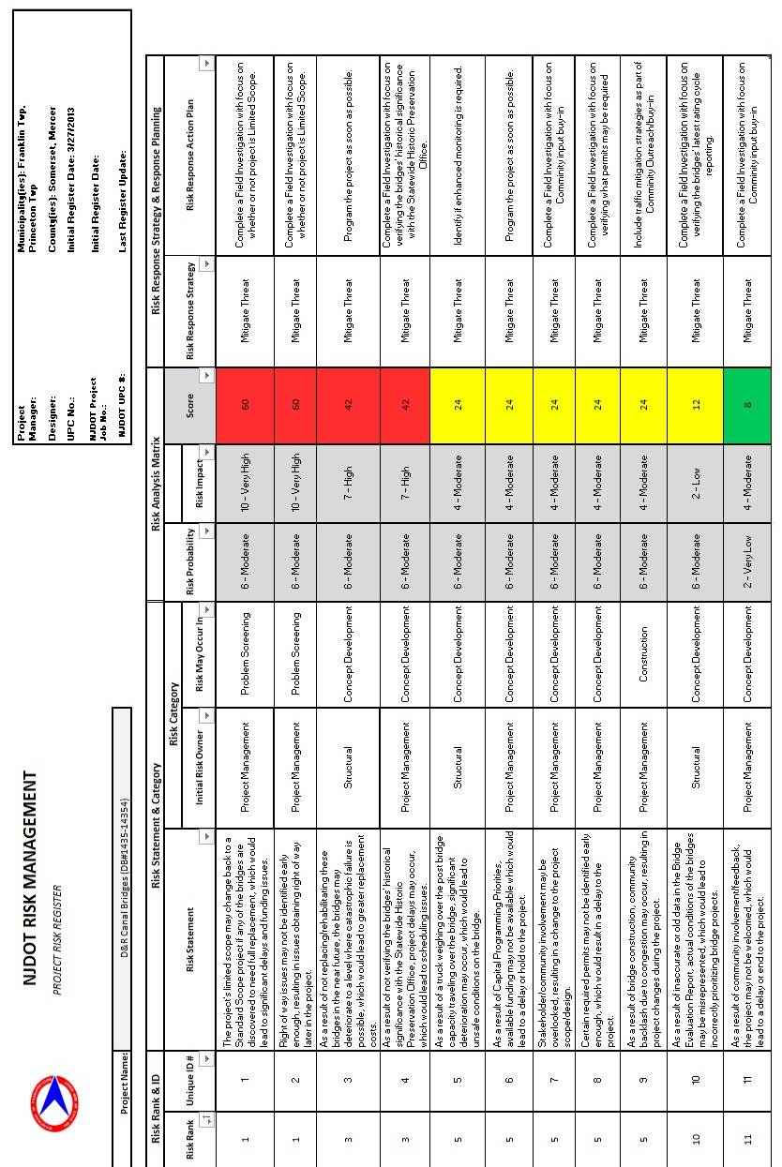
Appendix B

