Welcome To The NJDOT’s New GDMS Viewer

To get started please review the below guide on the changes and new tools available to you in this new viewer.

Starting in the top left you will see the navigation tools below.
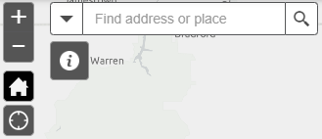
These are your basic navigation tools, the plus
minus will allow you to zoom in and out, the
house button will reset the map view back to
default extent, the crosshair button will place
your current location on the map, and the
search bar will let you locate by address or
place.

In the upper right you will see the map tools pictured below.
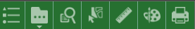

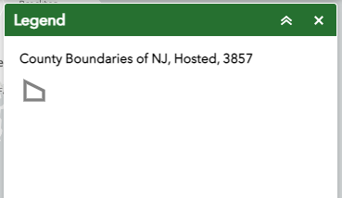
The legend tab will show all active/viewable layers in the map,
Providing a brief description and symbolization.
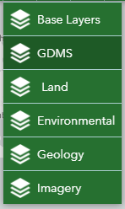
The layer list will contain all available data that can be displayed in this
viewer. As you will see in addition to the original GDMS data you now
have additional categories to select from.

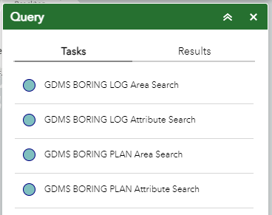
The query tab will allow you to refine your search parameters
to either search for feature by area or extent of another feature
or search by specific attributes.

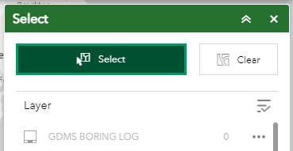
The select tool will display all of the selected features in the
map, either as a result of directly clicking on one in the map or
as a result of a query search. You may also clear your selection as well.

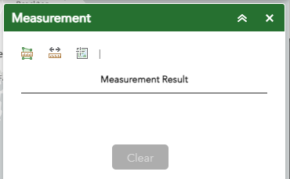
The measurement tool allows you to draw lines between
features and receive measurements/distances in various units.

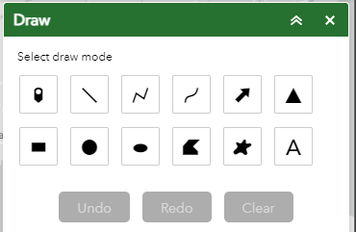
The draw tool allows you to add point, line, polygon, and
annotation to the curret view, these illustrations will be visible in
the map created from the print tab.

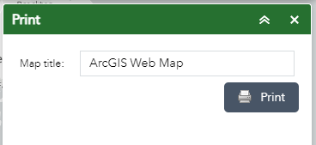
The print tab will allow you to export the current extent of
the map with all active layers in view. You will be able to
customize this with titles, legends, scale bars, and north arrows.

For content support: DOT.GdmsHelp@dot.nj.gov
For technical support: DOT.GIS@dot.nj.gov

