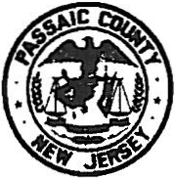
COUNTY OF PASSAIC
ADMINISTRATION BUILDING
401 GRAND STREET. PATERSON, NEW JERSEY 07505

DEPARTMENT OF HUMAN SERVICES.R00M 506

Passaic County Interagency Council on Homelessness
Application for Membership

Name of Organization:

Agency’s Address:

Agency Services Available to Homeless:

Primary Voting Member Information:

Name:

Email Address:

Phone Number:

Voting Member’s Designee Information:

Name:

Email Address:

Phone Number:

Additional Persons who should be included on PCICH Mailing List:

Name Email

