Survey Instructions for Tidelands Grant Applications on Man-made Lagoons Based on the Tidelands Resource Council Policies Adopted June 5, 2019 and February 5, 2020.
The Tidelands Resource Council (TRC) approved changes to the terms and conditions for certain grants on man-made lagoons which results in required changes to the grant language, the corresponding survey drawings, and associated metes and bounds descriptions included in the grant. This document summarizes the reason for the change and provides instructions for survey preparation. These changes include conditions for future fill (where applicable) and a requirement for a separate grant whenever Tidelands are being conveyed for sites located within the man-made lagoon beyond the record title of the applicant’s property boundary.
Background:
The term “Tidelands” as it pertains to this document refers to any area currently or formerly flowed by the tide which is claimed by the State of New Jersey which has not been previous conveyed. Typically, within a man-made lagoon complex, the claimed area only applies to the Tidelands claim area depicted on the adopted Tidelands claim map (impacting both the land and water areas of the community). In a lagoon situation, these maps often show the location of the former natural creeks that existed prior to the development of the lagoon community. In general, for tidally flowed water areas throughout the State, the presumption is that if an area is currently flowed by the tide, it may be claimed by the State, unless the area in question has been previously conveyed (via a Tidelands grant) and/or the area in question is man-made and legally constructed. Please contact the Bureau of Tidelands Management if there are any questions about the location of the Tidelands claim area impacting the site in question.
A recent change under current TRC policy, when issuing any new grants (even on man-made lagoons or other man-altered waterbodies such as artificially widened canals), the TRC generally will not convey the right to place additional solid fill within any tidally flowed Tidelands. Going forward, under the new policy, these grants will approve the site within the boundaries of the grant based on the current site conditions (specifically the limit of solid fill at the time of issuance). Therefore, the survey must clearly and accurately depict the area(s) being granted and distinguish the current limit of solid fill versus any existing water area, and clearly define what portions of those areas are impacted by formerly and currently flowed Tidelands as derived from the adopted Tidelands claims map.
Another change concerns the way the grant is depicted when fill or docks (or similar type structures) extend beyond the record title property boundary on certain man-made or man-altered waterbodies, particularly within a man-made lagoon. This applies to grant applications which include not only the area within the lagoon claimed by the State, but also the area outside of the claim where additional fill (such as a bulkhead extension) or dock (or similar type structure) have been constructed beyond record title. The TRC has agreed that the State and the TRC should not convey title (or the appearance of conveying title) to property that is not “Tidelands” located outside of the applicant’s record title.
This is consistent with the New Jersey Supreme Court ruling in Panetta v Equity One, 190 N.J. 307 (2007), wherein Tidelands Grants were confirmed to be separate titles, not appurtenant to the upland property and specific reference to same must be included in all subsequent deeds to affirm conveyance of same. Due to this ruling, there is a concern that by creating a new tract of land (or the appearance of a new tract of land such as by simply extending the property side lines), for which there is no basis in the record title, it “would place in jeopardy the stability of titles to real property throughout the State”.
Therefore, the TRC established this policy for grants in man-made lagoons that include claim areas outside of record title. These grants will require the creation of a new metes and bounds description and a completely new title description (part of which would not be claimed by the State of NJ) with sufficient language so that it will not be misconstrued as establishing fee title ownership to any portion of the lagoon outside record title beyond that which is claimed by the State.
In response to this concern, on November 6, 2019, the TRC formed a special sub-committee to review the proposed changes and make a policy recommendation for TRC approval. On February 5, 2020, the TRC (with input from other stakeholders including agents and attorneys representing applicants) approved the new policy along with specific standard grant template language and associated survey requirements that clearly describe and define the area subject to the grant and the State’s intention to convey only “limited ownership interest to any Tidelands claim area” that is currently flowed and disclaiming the transfer of title “outside of any Tidelands claim area.”
As a result, the TRC’s new policy for man-made lagoons (approved by Council February 5, 2020) requires the following revised survey requirements along with new metes and bounds description requirements for lands underwater within the lagoon outside record title so it will not be misconstrued as establishing fee title ownership to a portion of the lagoon beyond that which is claimed by the State.
When issuing a grant within a man-made lagoon that includes an area that is beyond record title, the TRC is only conveying title rights to the claim area itself and not to any area outside of the claim as noted above. In the past, the grant exhibit would depict a “box” for the entire area subject to the grant, including the area within record title. Generally, this box would extend out from the side lines of the property beyond record title to include any additional claim areas being granted with the condition that any area of the grant beyond record title would be subject to the rights of the lagoon owner. As noted in the meeting minutes, the TRC had concerns that this could be misconstrued and wanted to make it abundantly clear that the grant was only conveying rights to the claim area itself outside of record title. Therefore, under the revised policy, Tidelands is also avoiding using the term “boundary area” and the new boundary or “box” depicted on the survey (and associated metes and bounds description) for the area outside of record title will be referred to as the “Surrounding Envelope” for the purposes of the grant. The language makes it clear that the State is conveying title to the claim area only within the “Surrounding Envelope” and not to the limits of the “Surrounding Envelope”.
The “Surrounding Envelope” would only be required to be wide enough and large enough to encompass the claim area impacted by the legally existing fill or structures and allowing for enough space or buffer around the Tidelands claim area being conveyed. This will be dependent on the specific site conditions, and the size and location of the mapped claim being conveyed.
Survey Instructions for Man-made Lagoon Properties:
This document provides additional details and guidance for the preparation of a property survey for grant applications specifically on man-made lagoons. For general survey requirements, please see the “Survey Requirements Checklist” on the Department’s website at https://www.nj.gov/dep/landuse/forms.html under the Tidelands Program Tab.
There are 5 common scenarios (described below as 1a, 1b, 2a, 2b, and 2c) for properties within a man-made lagoon community where the mapped Tidelands claim from former natural tidal creeks that may have intersected the property in question. This claim could impact both the currently filled land as well as the currently flowed portion of the lagoon. Note that the examples for scenarios 1a and 1b are for proposed grants that are wholly within record title (the property or lot boundary per the deed description), whereas examples 2a, 2b and 2c include areas outside of record title (which will be defined by the “Surrounding Envelope”). All the scenarios listed below have example drawings on pages that follow.
The references below to “formerly flowed claim area” means those mapped claim areas that have been filled, and “tidally flowed claim area” means those mapped claim areas that have not been filled (as of the date of the grant) and are still flowed by the tide (aka claimed water areas).
Also note, that although a separate grant document (and associated exhibit drawing) will be required if the site includes both areas within record title and outside record title, only one survey drawing will be required to be submitted with the application showing the applicant’s record title in relation to any other adjacent areas being conveyed. However, the survey information must satisy the requirements described below depending on the specific scenario:

Record Title – Scenarios 1a and 1b:
The proposed grant for Scenarios 1a and 1b are to clear title to claim areas that are located wholly within record title.
1a. For this scenario, the existing bulkhead/fill limit is located at the property boundary line. The proposed grant would clear title to any claim to the current limit of fill within record title only. The boundary of the grant would be defined by the same metes and bounds description as record title and the survey must clearly identify the location of the current mean high water line (usually at the current bulkhead/fill limit). The survey must also depict the “formerly flowed claim area” within the boundary of the grant. The survey must provide the overall square footage of the site within record title, and the square footage of the intersecting “formerly flowed claim area”. A separate metes and bounds is not required to define the claim area. One grant document would be issued to “sweep” the property to record title with language conveying all Tidelands ownership interest to the formerly flowed claim area;
1b. For this scenario, the boundary of record title extends out into the water and includes both fill and water areas impacted by a claim and where “tidally flowed claim area” is occupied by a dock (or similar type structure). The proposed grant boundary would follow record title, however, the survey must distinguish between the filled area vs the water area within record title. In addition to the overall lot boundary, the survey must provide a metes and bounds description along the current mean high water line (which is usually at the bulkhead/fill limit). The survey must provide the total square footage of the filled portion of the lot vs the water portion of the lot. The survey must depict the “formerly flowed claim area” and the “tidally flowed claim area” and provide the square footage of each. A separate metes and bounds is not required to define the claim area(s). One grant document would be issued with terms and conditions concerning future filling within the “tidally flowed claim area”;

Outside Record Title – Scenarios 2a, 2b, and 2c:
The proposed grant for Scenarios 2a, 2b, and 2c include areas beyond record title extending into a man-made lagoon that is not owned by the applicant where a separate grant document will be required for the area outside record title. Usually this would be in conjunction with a grant for the area within record title (see Scenarios 1a and 1b above). The survey for a grant beyond record title will be defined and described by a “Surrounding Envelope” so as not to be misconstrued as establishing fee title ownership to any portion of the lagoon outside of record title beyond that which is not claimed as Tidelands. If there is no claim impacting record title, the survey must still depict the adjacent upland lot owned by the applicant, and tie the “Surrounding Envelope” to said lot.
2a. For this scenario, the proposed grant will only include “formerly flowed claim area” (such as a bulkhead bumpout and associated fill) extending beyond the boundary of record title and does not include any “tidally flowed claim area” occupied by a dock (or similar type structure). The survey must show the record title in relation to the area beyond record title, depict and define the current mean high water line (fill limit) outshore of the record title, and provide the total square footage of all fill beyond record title (both claimed and unclaimed fill). The survey for a grant beyond record title will be defined and described by a “Surrounding Envelope” around the “formerly flowed claim area” and provide the total square footage of the claim area within the surrounding envelope. A metes and bounds description will be required for the “Surrounding Envelope” but a separate metes and bounds description is not required to define the claim area. Grants for this scenario will use the standard language conveying all ownership interest to the “formerly flowed claim area”;
2b. For this scenario, the proposed grant includes only “tidally flowed claim area” (i.e., claimed water area) outside record title occupied by dock (or similar type structure) and does not include any “formerly flowed claim area”. The survey must show the record title in relation to the area beyond record title. The survey for a grant for the area beyond record title will be defined and described by a “Surrounding Envelope” around the “tidally flowed claim area” and provide the total square footage of the claim area within the surrounding envelope. The Council has also ruled that they will require a purpose or need for granting any “tidally flowed claim area” (i.e., water) and therefore any structures have to be legally existing (see footnote 8) to include “tidally flowed claim area” (i.e., calimed water area). Therefore the in-water strucures are required to be depicted on the plan. The “Surrounding Envelope” can extend out far enough and wide enough to provide a sufficient buffer around the structues. A metes and bounds description is required for the “Surrounding Envelope” but a separate metes and bounds description is not required to define the claim area. The lanuage of the grant will have terms and conditions concerning future fill.;
2c. For this scenario, the grant includes both “formerly flowed claim area” and “tidally flowed claim area” (i.e., water area occupied by a dock or similar type structure), both of which extend beyond record title. The survey must meet the separate requirements for the filled vs water areas listed in 2a and 2b above. The survey must show the record title in relation to the area beyond record title. The survey for a grant beyond record title will be defined and described by a “surrounding envelope” around the “formerly flowed claim area” and “tidally flowed claim area” and provide the total square footage of each claim area within the surrounding envelope. Grants for this scenario use the standard language conveying all ownership interest to the “formerly flowed claim area” and terms and conditions concerning future fill (see footnote 9).

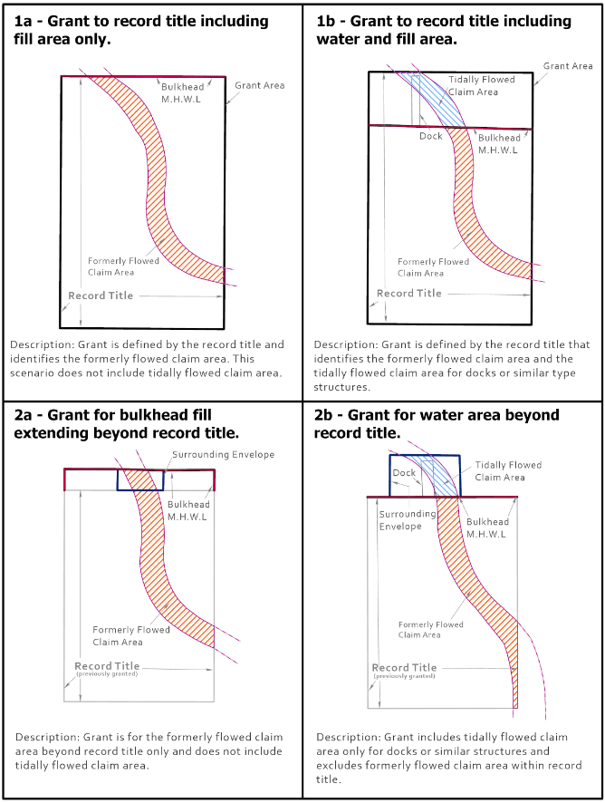

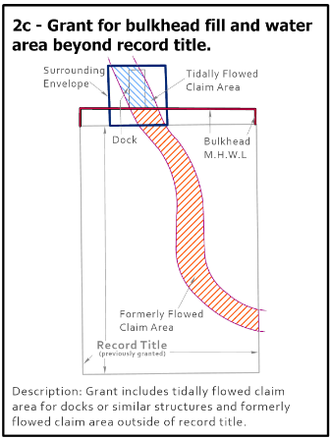

This guidance pertains to any grant document not finalized and approved as of March 9, 2020 when the February 5, 2020 TRC meeting minutes were approved by the Commissioner and thereby made effective. This guidance document may be modified or revised based on future guidance from the TRC, and the TRC has the right to change its policies at any time. Any decision on any individual application is at the sole discretion of the TRC with the approval of the Commissioner of the NJDEP and the Attorney General and is not bound by any prior policy or other cases.
The State’s claim includes the mapped claim line and/or may extend to the current mean high water line inshore of the mapped claim where there has been a change in the shoreline due to erosion, subsidence, sea level rise or other natural processes.
This typically applies to lagoon communities created by excavating and filling former marsh lands that had former natural creeks and streams intersecting the property(ies) as depicted on the appropriate Tidelands claim map. It would not apply within other lagoon communities constructed by creating artificial land that is entirely built upon former Tidelands where all the water area outshore of the fill limits is Tidelands and is not considered man-made waterbodies. Some lagoon communities may include both types of areas and will depend on the specific location of the applicant’s property and what type of waterbody is outshore. Each application is site specific, therefore, while one property may qualify for a grant extending out into the water, other properties within the same community may not qualify for a grant to include currently flowed water areas since it may be part of a natural waterbody.
See the May 1, 2019 TRC meeting minutes for the Steven Brown grant, file #0116-13-0008.1 TDG150001.
See the May 1 and June 5, 2019 TRC meeting minutes for file #1506-17-0042.1 TDG170001 John & Nancy Langione.
See the November 6, 2019 TRC meeting minutes for File #0508-17-0014.1 TDG170001 Michael & Heather James for the background, and the February 5, 2020 minutes for the final approved language.
See the February 5, 2020 TRC meeting minutes.
For the purposes of this document, “legally existing” structures or fill means those structures or fill that are legally pre-existing according to the Department’s Land Use Rules or have been constructed in compliance with the required Land Use regulatory permit issued by the Department. If a structure or fill is not legal, the structure or fill will have to be removed, modified, and/or permitted (as applicable) to bring them into compliance before a Tidelands conveyance can be issued. A license and back rent may also be required prior to issuance of a grant depending on the site-specific circumstances.
Note that depending on the specific location of the property in question, the water area outshore of record title may be within a natural waterbody and not a wholly artificial lagoon. The State will typically not issue a grant to currently flowed natural waterbodies. Contact the Bureau of Tidelands Management if there is any question about a specific site location.

