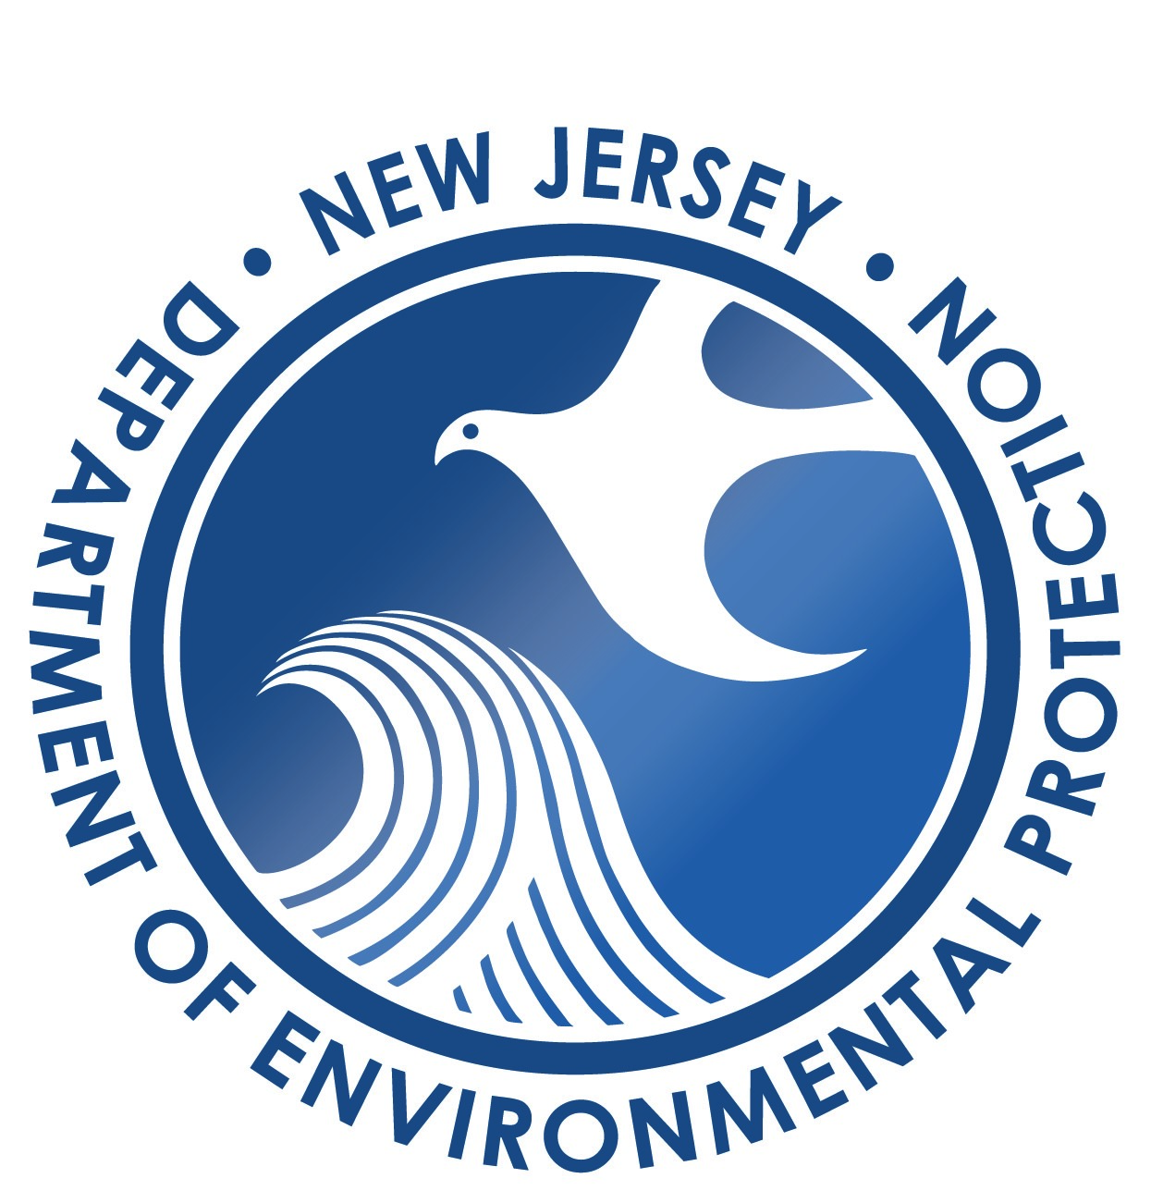
CONTINUOUS RADON MONITOR

NJDEP USE ONLY
Date Received _________________

Database updated by __________

Approval date _________________

AMENDMENT FORM

New Jersey Department of Environmental Protection
Radon Section
Mail Code 25-01
PO Box 420
Trenton, New Jersey 08625-0420
Phone: (609) 984-5425
Fax: (609) 984-5595

Business Name:
Business Certification # (for amendments and renewals):
- Complete and sign this document (attach a spread sheet as necessary, with the same column headers shown below) and
- Submit this form and a copy of the current calibration certificate for each monitor in the order listed below.
- The device number must be one that is listed on either the NRPP or NRSB device list.

Device # | Manufacturer | Model | Serial # | Add CRM | Remove CRM

Testing with a device may begin as of the date specified in DEP’s written approval confirmation. The business will be held responsible for QA for devices requested for removal until the date specified in DEP’s written approval confirmation.

The individual responsible for the business’s application agrees to the following and signs the amendment below in accordance with N.J.A.C. 7:28-27.4:

I verify that each affiliate who owns or will use devices listed in this amendment request has passed the required authorized proficiency test. I certify under penalty of law that I have personally examined and am familiar with the information submitted in this application and all attached documents. I believe that the submitted information is true, accurate and complete. I am aware that there are significant civil and criminal penalties for submitting false, inaccurate, or incomplete information, including the possibility of fine and/or imprisonment. I am aware that the certification for which this business is applying requires compliance with N.J.A.C. 7:28-27A at all times when the business and affiliates are providing radon services under that certification.

Print Name Date

Signature

