Certification Amendment Request Form
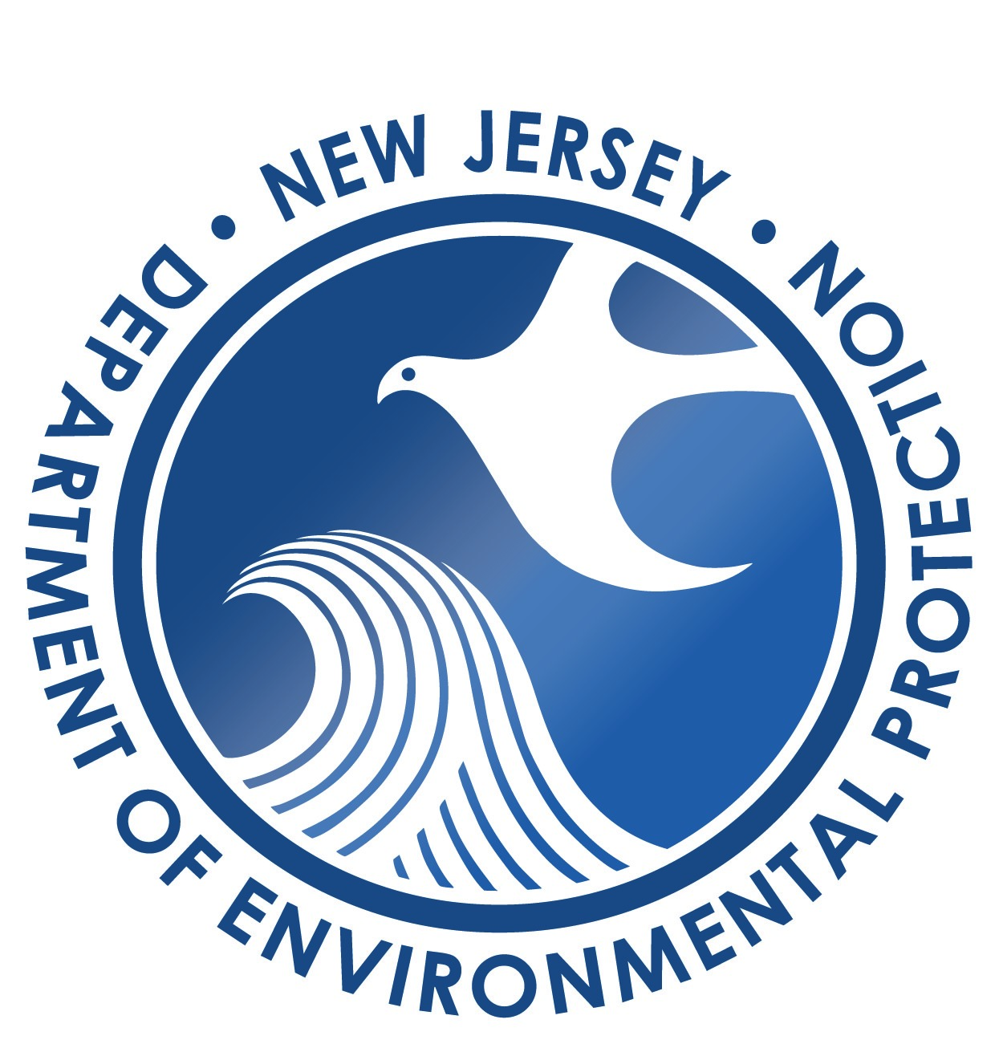

NJDEP USE ONLY
Date Received _________________

Assigned to ___________

New Jersey Department of Environmental Protection
Radon Section
Mail Code 25-01
PO Box 420
Trenton, New Jersey 08625-0420
Phone: (609) 984-5425
Fax: (609) 984-5595

Radon Professional or Business Name:
Certification #: Date:
- List the requested application amendments in the table below,
- Complete and sign this form, and
- Submit any additional documentation of the change in the order listed below.
NOTE: Documentation consists of any information needed to update the certification such as the revised form, updated plan, etc.

Statement of the Requested Amendment | Documentation Attached | NJDEP USE ONLY
 |  | Date Amendment Approved
 | ☐Yes ☐No | / /
 | ☐Yes ☐No | / /
 | ☐Yes ☐No | / /
 | ☐Yes ☐No | / /
 | ☐Yes ☐No | / /
 | ☐Yes ☐No | / /
 | ☐Yes ☐No | / /

The individual responsible for the business’s or individual’s application agrees to the following and signs the amendment below in accordance with N.J.A.C. 7:28-27.4:

I certify under penalty of law that I have personally examined and am familiar with the information submitted in this application and all attached documents. I believe that the submitted information is true, accurate and complete. I am aware that there are significant civil and criminal penalties for submitting false, inaccurate, or incomplete information, including the possibility of fine and/or imprisonment. I am aware that the certification for which this business is applying requires compliance with N.J.A.C. 7:28-27 at all times when the business and affiliates are providing radon services under that certification.

Print Name Date

Signature

