Menlo Park:

- 1x Stop Sign
- 3x Speed Limit 15MPH signs
- No Thru Traffic Sign
- No Right Turn Sign
- Do Not Enter Sign
- Wrong Way Sign
- Stop/No Left Turn Combined Sign (60”x 36”)
- Facility Guide Sign (Main Entrance, Adult Day Care Center, Maintenance Building, Receiving)
- Facility Guide Sign (Main Entrance, Maintenance Building)

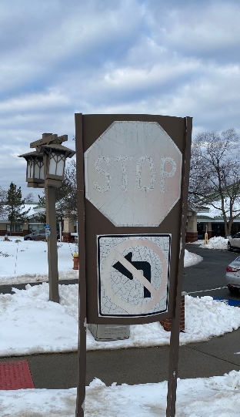
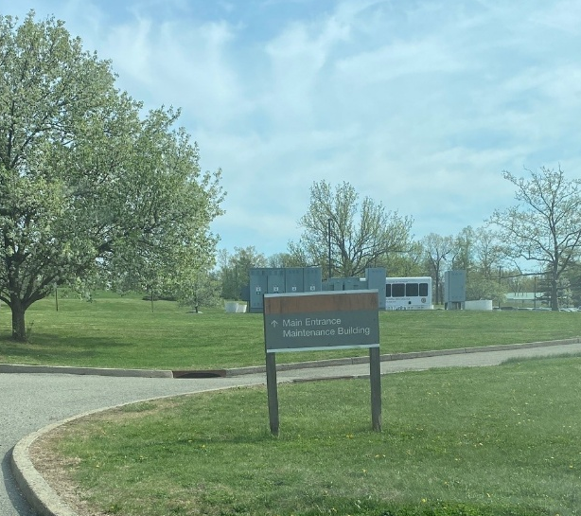
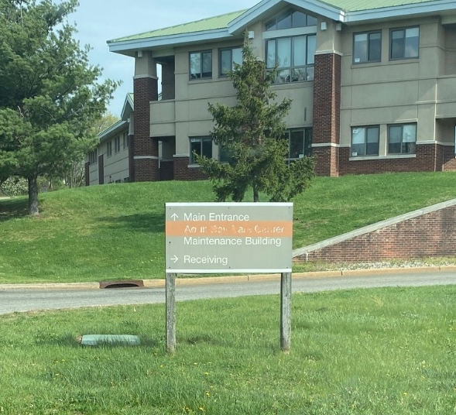
Sample Pictures:
