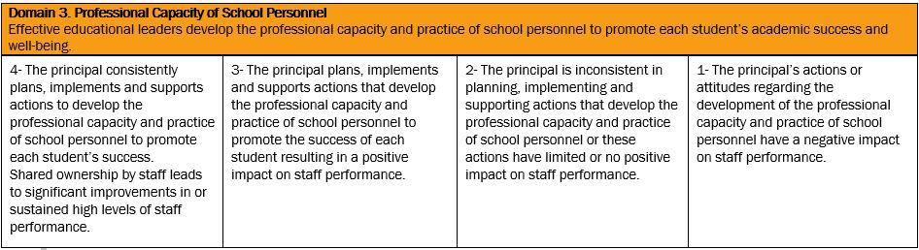
PART 1: GATHER EVIDENCE
Individually list the evidence:
- List evidence in table below in the appropriate column.
- Label whether the evidence is a principal action or an outcome of an action.
EVIDENCE
Direct | Indirect

- Review the evidence and assign a score based on this evidence according to the instrument language for Domain 3. The score must be between 1 and 4 but may contain one decimal place, e.g. 3.5.
SCORE
4 | 3.5 | 3 | 2.5 | 2 | 1.5 | 1

PART 2: AGREE ON PERFORMANCE LEVEL
In a small group (one or two others):
- Discuss your provisional score and how this was justified by the evidence.
- Identify the relative importance of difference pieces of evidence and how this impacted your evaluation.
- Agree on a final score.

In the larger group:
- Share your final score with a brief justification for the score. Include any additional information that would help support your decision on a final score for this domain.
- Note any evidence that might be used for domains other than Domain 3.

