Requirements

* Administrator goals should be accurate measures of a school leader’s effectiveness.
* Superintendent determines how many goals administrators will set each year (between one and four)
* Goals are set in consultation with a supervisor by October 31 each year.
* Goals must be specific and measurable, based on student growth and/or achievement data, and receive a final score between 1 and 4.

Recommendations

* Sustain a focus over multiple years --a multi-year goal.
* Select measures that the administrator can impact in one year such as:
* When the goal is based on a new initiative or project and the administrator’s efficacy is better demonstrated by *process measures --*outcomes other than student achievement -- such as *teacher practice, teacher understanding, success of implementation, or stakeholder satisfaction*.
* In year one (and possibly year two) of a multi-year goal, a process measure may be a better reflection of the efforts of the administrator (see examples above). Multi-year goals should evolve into goals that measure student achievement over one or more years.
* Align administrator goals with district priorities, other goals in the district, and/or teacher goals (SGOs).

Alignment Illustrated and Applied

Establishing vertical alignment among goals at different organizational levels will provide a powerful lever for student growth. Alignment can be facilitated by the thoughtful sharing of data and collaboratively establishing priorities. The following graphic organizer depicts the two-way flow of data and how priorities established at each level can influence each other.

Goal Alignment: A Graphic Organizer

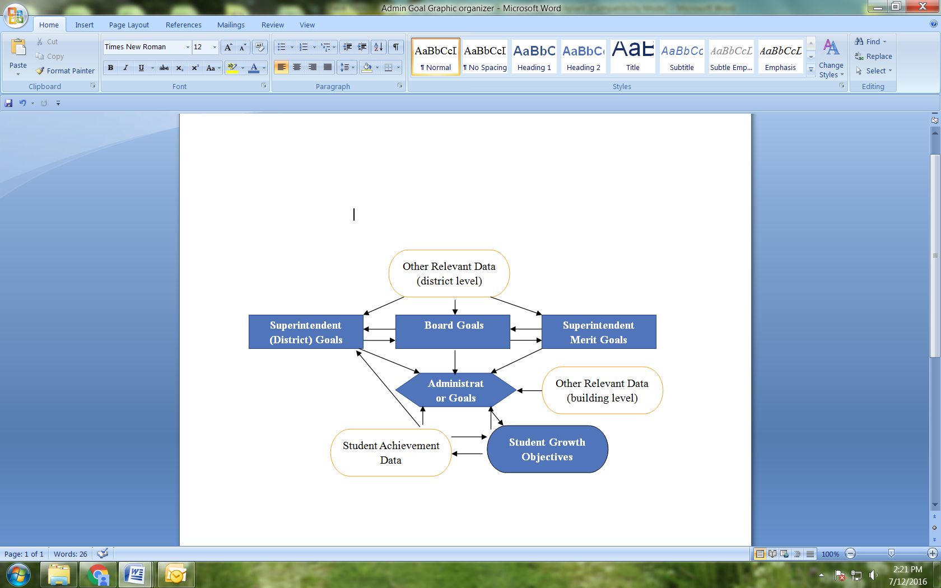

A district uses Leadership Team meetings to collect and analyze selected data. From the data analysis, the district establishes priorities. These collaboratively developed priorities inform goals at the central office, which, in turn, inform administrator goals. District priorities are widely communicated and administrator goals are communicated to the corresponding faculty and staff:

* Examples of Leadership Teams
* PLCs, DEAC, ScIP, Instructional Council, or Administrative Team
* Possible Selected Data Sets
* Student assessment results, aggregated observation data, or climate survey results
* Example of Establishing and Communicating Priorities
* The ScIP at the high school requests a component-level analysis of observation data and due to the low average score, determines that student engagement should be a building-level priority in the upcoming year which they share at the June DEAC meeting.
* Process/Exemplars: The following pages illustrate a six-step process for constructing administrator goals, followed by examples of goals from elementary, middle, and high school administrators. There is also an optional template for recording your own administrator goals.

#### Administrator Goal Form

*Principals and assistant/vice principals set 1-4 administrator goals with their superintendent by October 30, each year. The following ages provide a sample goal template that districts may use or they may develop their own forms. A copy of the completed, signed form should be given to the administrator. The central office should retain a copy for personnel purposes. For updated guidance and exemplars, please visit the principal section of our* [*website.*](http://www.state.nj.us/education/AchieveNJ/principal/)

|  |  |  |  |  |  |  |  |  |  |  |
| --- | --- | --- | --- | --- | --- | --- | --- | --- | --- | --- |
| **Name** | **District** | | | **Grade or Grades** | | **Total # of Students/ # Impacted by Goal** | | | **Target Date for Completion** | |
|  | Collingswood Public School District | | | 3, 4 | | 50 | | | 05/30/2018 | |
| Focus/Rationale   * Establish what this goal will focus on. * Describe how it is connected to student learning by providing analysis, detail or research to support the approach you plan to take. | | | | | | | | | | |
| **Focus**  In reviewing initial PARCC data, trends show that of our students who performed at the “approaching,” “meeting,” and/or “exceeding” expectation levels, most students showed higher scores in the area of reading as opposed to writing. In addressing student growth throughout the elementary years, this goal will focus on students in grades 3 and 4. | | | | | | | | | | |
| **Rationale**  We selected grades 3 and 4 in order to track data and identify patterns of growth and/or weaknesses over a number of years. | | | | | | | | | | |
| **Measure/Baseline Data**   * Identify the measure this goal will address. * Provide the corresponding baseline data. | | | | | | | | | | |
| **Measure**  The assessment tool is the Informational Writing Rubric from Writing Pathways; grades 3 and 4. | | | | | | | | | | |
| **Baseline**  The baseline data will be established after an initial pre-assessment of informational writing. | | | | | | | | | | |
| **SMART Goal**  Write a specific, measurable, achievable, realistic, and time-bound administrator goal. | | | | | | | | | | |
| Between October and May, students in grades 3 and 4 will improve their final informational writing piece rubric score by 7 points. | | | | | | | | | | |
| **Action Steps**  List the activities the administrator will engage in to drive the anticipated growth or change. | | | | | | | | | | |
| 1. We will work to achieve this goal through grade level articulation sessions central to writing workshop curriculum indicators and performance assessments. The focus on these sessions will include:  * Writing Workshop curriculum revision discussions * Pre-writing assessment administration (on-demand writing pieces) * Targeted conferring/small group work and formative assessment data planning/discussions * Student goal-setting using the Writing Pathways: Performance Assessments and Learning Progressions * Post-Writing assessment administration (on-demand writing pieces) * Peer scoring of assessments using the Writing Pathways rubrics for pre-/post-scoring * Keeping writing “joyful” for students so they see themselves as “writers” in general and not just in response to * curriculum and assessments | | | | | | | | | | |
| **Scoring Plan**  State what percentage/number will describe attainment at each level. Modify the table as needed. | | | | | | | | | | |
| Target (Effective) | | Percent/Number Range that Represents Attainment at Each Level | | | | | | | | |
| Highly Effective (4) | | | Effective (3) | | Partially Effective (2) | | | Ineffective (1) |
| 75% of students will improve by 7 points on the informational writing rubric | | 85% | | | 75% | | 65% | | | 0% |
| **Approval of Administrator Goal**  Administrator and supervisor approve the goal and the scoring plan. | | | | | | | | | | |
| Administrator ____________________________ Signature ______________________ Date _______________  Supervisor ____________________________­­­­­­­­­ Signature ______________________ Date _______________ | | | | | | | | | | |
| **Results of Administrator Goal**  Summarize results using the established scoring plan. Delete and add columns and rows as needed. | | | | | | | | | | |
| Target | | | Percent/Number Achieved | | | | | Administrator Goal Score | | |
|  | | |  | | | | |  | | |
| **Notes**:  Describe any changes made to administrator goal after initial approval because of changes in student population, or other unforeseen circumstances, etc. | | | | | | | | | | |
|  | | | | | | | | | | |
| **Review Administrator Goal at Annual Conference**  Describe successes, challenges, and lessons learned from administrator goal. Especially reflect on the impact of your planned interventions and any related P, in the outcome of your goal. | | | | | | | | | | |
|  | | | | | | | | | | |
| **Closure of Administrator Goal:**  Administrator and supervisor acknowledge completion of this goal and its associated score. | | | | | | | | | | |
| Administrator ____________________________ Signature ______________________ Date __________  Supervisor ____________________________­­­­­­­­­___ Signature ______________________ Date __________ | | | | | | | | | | |

#### Administrator Goal Form

*Principals and assistant/vice principals set 1-4 administrator goals with their superintendent by October 30, each year. The following ages provide a sample goal template that districts may use or they may develop their own forms. A copy of the completed, signed form should be given to the administrator. The central office should retain a copy for personnel purposes. For updated guidance and exemplars, please visit the principal section of our* [*website.*](http://www.state.nj.us/education/AchieveNJ/principal/)

|  |  |  |  |  |  |  |  |  |  |  |
| --- | --- | --- | --- | --- | --- | --- | --- | --- | --- | --- |
| **Name** | **District** | | | **Grade or Grades** | | **Total # of Students/ # Impacted by Goal** | | | **Target Date for Completion** | |
|  |  | | |  | |  | | |  | |
| Focus/Rationale   * Establish what this goal will focus on. * Describe how it is connected to student learning by providing analysis, detail or research to support the approach you plan to take. | | | | | | | | | | |
| **Focus** | | | | | | | | | | |
| **Rationale** | | | | | | | | | | |
| **Measure/Baseline Data**   * Identify the measure this goal will address. * Provide the corresponding baseline data. | | | | | | | | | | |
| **Measure** | | | | | | | | | | |
| **Baseline** | | | | | | | | | | |
| **SMART Goal**  Write a specific, measurable, achievable, realistic, and time-bound administrator goal. | | | | | | | | | | |
|  | | | | | | | | | | |
| **Action Steps**  List the activities the administrator will engage in to drive the anticipated growth or change. | | | | | | | | | | |
|  | | | | | | | | | | |
|  | | | | | | | | | | |
|  | | | | | | | | | | |
|  | | | | | | | | | | |
| **Scoring Plan**  State what percentage/number will describe attainment at each level. Modify the table as needed. | | | | | | | | | | |
| Target (Effective) | | Percent/Number Range that Represents Attainment at Each Level | | | | | | | | |
| Highly Effective (4) | | | Effective (3) | | Partially Effective (2) | | | Ineffective (1) |
|  | |  | | |  | |  | | |  |
| **Approval of Administrator Goal**  Administrator and supervisor approve the goal and the scoring plan. | | | | | | | | | | |
| Administrator ____________________________ Signature ______________________ Date __________  Supervisor ____________________________­­­­­­­­­_____Signature ______________________ Date __________ | | | | | | | | | | |
| **Results of Administrator Goal**  Summarize results using the established scoring plan. Delete and add columns and rows as needed. | | | | | | | | | | |
| Target | | | Percent/Number Achieved | | | | | Administrator Goal Score | | |
|  | | |  | | | | |  | | |
| **Notes**:  Describe any changes made to administrator goal after initial approval because of changes in student population, or other unforeseen circumstances, etc. | | | | | | | | | | |
|  | | | | | | | | | | |
| **Review Administrator Goal at Annual Conference**  Describe successes, challenges, and lessons learned from administrator goal. Especially reflect on the impact of your planned interventions and any related P, in the outcome of your goal. | | | | | | | | | | |
|  | | | | | | | | | | |
| **Closure of Administrator Goal:**  Administrator and supervisor acknowledge completion of this goal and its associated score. | | | | | | | | | | |
| Administrator ____________________________ Signature ______________________ Date __________  Supervisor ____________________________­­­­­­­­­___ Signature ______________________ Date __________ | | | | | | | | | | |