New Jersey Principal Evaluation for

Professional Learning Process

Background and Rationale
Principal quality is second only to teacher quality among school-related factors that drive student achievement.,
However, when compared to teacher evaluation, principal evaluation has been less commonly used as a professional learning tool to help school leaders grow. In districts where there is room to improve the effectiveness and value of principal evaluation, district and school leaders have identified a variety of challenges; structure and complexity of state evaluation requirements, complex or checklist-type observation instruments, and prioritization challenges in a crowded operational agenda.
Following a careful review of evaluation data and educator feedback, the New Jersey Department of Education (NJDOE) began to address these challenges in 2015 using a multi-pronged approach of adjusting regulations, strengthening and improving guidance, and broadly communicating and supporting best practices. For example, in order that goals better reflect the manner in which principal-driven initiatives affect student outcomes, the NJDOE recommended principals set multi-year administrator goals. Also, changes in 2016 have allowed districts to streamline principal evaluation by making the formerly required Evaluation Leadership Instrument, optional.
With the NJ Principal Evaluation for Professional Learning (NJPEPL) process and observation instrument, the NJDOE aims to further streamline and simplify AchieveNJ in order to assist district and school leaders to not only conduct accurate evaluations of their principals, but to utilize the evaluation process as a powerful professional development tool.

The NJPEPL Process and Observation Instrument were developed through broad stakeholder engagement and a two-year pilot process. Regardless of the principal observation instrument currently used by a district, the evaluation process outlined in this document can add significant value to principal evaluation. However, when used in conjunction with the NJPEPL Observation Instrument – a tool developed by New Jersey educators, for New Jersey educators – our pilot participants confirm that this integrated system offers a simpler, more powerful approach to the evaluation and professional development of school leaders. The NJPEPL Process more accurately captures the diversity and relative importance of principal roles. It can be performed more efficiently by principal evaluators, and provides a flexible approach for principals in different contexts and at different experience levels. Importantly, the NJPEPL process also strongly supports activities and conversations that lead to professional growth.

The comments of several participants in the pilot are provided below.

"The [process] allows the observer to see the true picture of what the Principal does throughout the school year. It allows the Principal to focus on individual standards that helps to guide his/her work and improve his/her craft.” ~ Samuel C. Hull, Principal, Bridgeton Public Schools
“More appropriate evaluation of what the principals are doing on a day to day basis.” ~ Chris Carrubba, Superintendent, Belvidere and Harmony Township
“This process allows for more dialogue with the superintendent and also allows you to showcase your standards with specific artifacts rather than a multitude of artifacts. It focuses on the growth model.” ~Jayme Orlando, Principal, Manalapan-Englishtown Regional School District
“The ‘window of time’ aspect is a benefit and more truly captures the role of the principal.” ~ Scott Oswald, Superintendent, Collingswood Public Schools

Process Overview
The New Jersey Principal Evaluation for Professional Learning Process seeks to integrate existing evaluation and professional development requirements, establish a calendar for regular collaborative conversations, and transform observations and goal-setting into processes that are more accurate and have more value for principal growth. The following table summarizes the key components of the process and their benefits and is arranged into three major areas; Planning and Goal Setting Conference, Observations and Post-observation Conferences, and Annual Summary Conference. Further details for each of these areas follow the table.

Annual Planning/Goal-setting Conference
Component | Benefits
- Plan - Hold an annual evaluation and development planning conference at the beginning of the evaluation cycle. | Provides a foundation for success and growth for the principal, clarifying timelines, evaluation expectations, and evidence collection processes for observations. Opportunity to collaboratively set administrator goals and determine PD needs.
- Prioritize – For observations, collect evidence for all domains prioritizing those that are closely connected to administrator goals. | Streamlines evaluation process by unifying observations and administrator goals. Creates targeted opportunity for principal growth and success in school improvement areas.
- PDP - Align principal PD plan with Administrator Goals and prioritized practice standards. | Provides aligned focus point for personal professional development and helps principal attain goals and highest levels of effectiveness.

Observations/Post-observation Conference
- Component | Benefits
- Portfolio - Base observations on a portfolio of evidence collected over 2-3 months by practitioner and supervisor. | Evidence collected from a variety of sources over an extended period of time more accurately and fairly reflects the complexity of the principal’s work.
- Process- Discuss observation portfolios, and progress on Administrator Goals and PDP goals during in-person, post-observation conferences. | Dedicated coaching time to provide feedback and discuss progress maximizes principal growth and development. Discussion allows for course corrections and adjustments in the focus of the evaluation process as needed

Annual Summary Conference
Component | Benefits
- Plan - Use the annual summary conference to discuss performance, determine scores and begin planning for the next cycle. | Formal review of successes and areas of growth establishes foundation for next evaluation cycle and steps for principal growth.

Process Details
The following section provides information to help a principal and his or her supervisor navigate each of the key areas of the NJPEPL Process, particularly how to frame the conferences that are crucial to the overall process.

Annual Planning/Goal-setting Conference

In Advance
- Principal reviews relevant student performance data, survey results and prior evaluation feedback
- Principal develops first draft of Administrator Goals and updates Professional Development Plan (PDP)

During the Conference
  - Establish a Foundation for Success
    - Reflect on the successes and challenges of the prior year
    - Establish expectations for evaluation and development process
  - Align and Set Administrator Goals
    - Develop a shared understanding of district/school goals
    - Discuss student and school data including available mSGP scores
    - Agree to administrator goals that align to school and district priorities
  - Determine Observation Protocol
    - Identify domains aligned to Administrator Goals
    - Identify other priority domains
- Agree on potential sources of direct and indirect evidence for each domain – determine evidence the principal will provide and what the evaluator will collect
    - Identify potential opportunities of direct observation of the principal
    - Discuss start and end dates of observation windows to capture full scope of principal’s work (2-3 months per window)
  - Identify and Align Principal’s Professional Development Needs
    - Determine PD needs related to most recent performance evaluation, administrator goals and prioritized practice standards
    - Agree to appropriate PD plan and goals

A. Observations

During the Observation Windows (two for tenured and three for non-tenured principals)
- Collect a portfolio of evidence portraying principal’s effectiveness in each practice domain

Type of Observation Evidence | Examples (may include, but are not limited to)
Direct  The principal is present and leading | - teacher post-observation conference  - instructional rounds  - hiring interview  - faculty meeting
Indirect  The principal’s effect is observed indirectly, through the actions of others and artifacts | - a data meeting led by a teacher leader  - stakeholder feedback on a survey  - testimony of staff and students  - state test and benchmark testing results  - meeting agendas  - social media posts

B. Post-observation Conferences

In Advance
- Principal and supervisor review Administrator Goals and PDP
- Principal submits additional relevant evidence voluntarily and/or at the supervisor’s request
- Supervisor prepares observation report

During the Conference
- Discuss evidence collected/submitted during the observation window
- Discuss progress toward Administrator Goals and PDP
- Review school and student data (including mSGP scores if available) to inform any course corrections in established priorities
- Provide actionable feedback verbally and through the completed observation report
- Provide an interim observation score
- Final Post-observation conference may be combined with the Annual Summary Conference

Annual Summary Conference

In Advance
- Supervisor provides Principal with an observation report from the final Observation Window
- Principal submits completed Administrator Goals and PDP
- Supervisor completes a preliminary annual performance report with rating

During the Conference
- Discuss evidence collected/submitted regarding practice and provide a final observation score
- Discuss attainment of Administrator Goals and scores
Discuss SGO average score, provide a summative score (non-mSGP principals), and review the preliminary annual performance report
- Discuss progress on PDP
- Discuss strengths and potential areas for growth and development

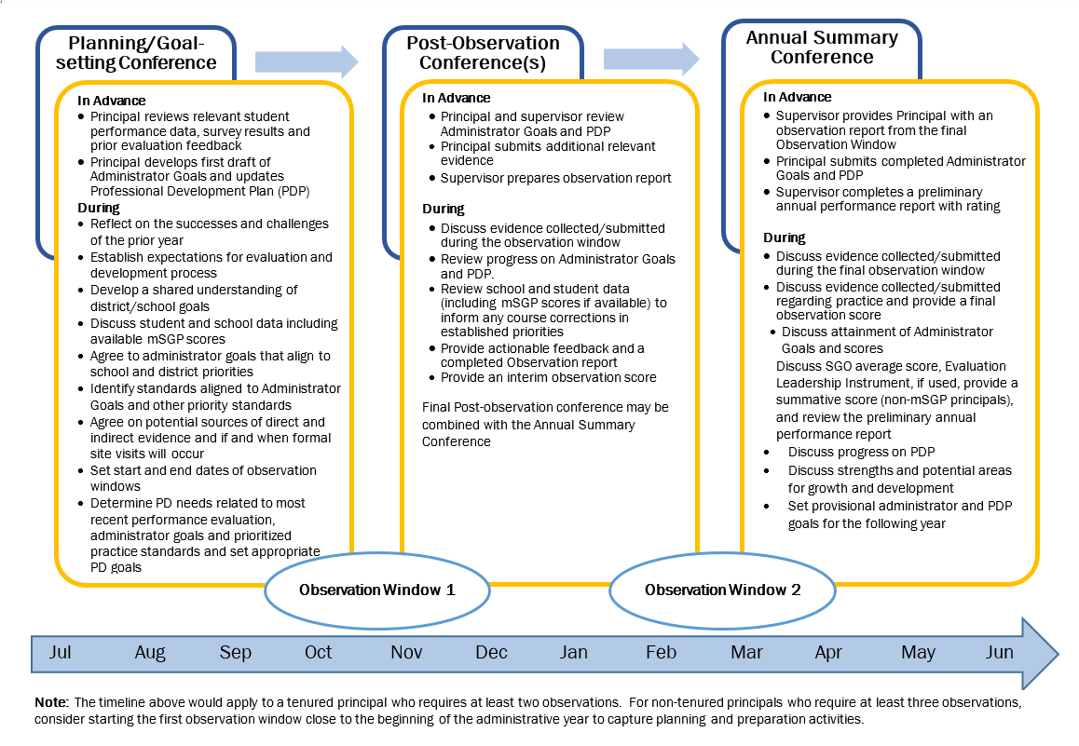

Leithwood, Kenneth; Louis, Karen Seashore; Anderson, Stephen; Wahlstrom, Kyla. How Leadership Influences Student Learning, 2004. The Wallace Foundation, New York.
P. Goff; E. Goldring; J. Guthrie; L. Bickman. Changing principals’ leadership through feedback and coaching, 2014. Journal of Educational Administration, 52(5), 682-704.
AchieveNJ requirements, components and associated weights can be found in Principal Evaluation Overview.

