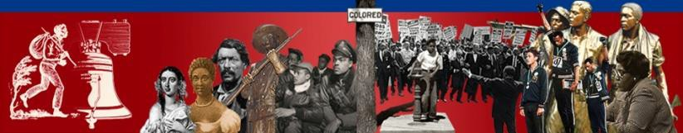

THE AMISTAD COMMISSION
100 Riverview Plaza
PO Box 500
Trenton, NJ 08625-0500

June 11, 2024
To: The Honorable Phil Murphy, Governor
The Honorable Tahesha Way, Lt Governor & Secretary of State State House Press Corps

From: Patrick Lamy, Ed.D., Executive Director The Amistad Commission

Subject: Meeting of The Amistad Commission,

Please be advised that due to ongoing public health concerns, the June 14, 2024, public meeting of the Amistad Commission will be held via Microsoft TEAMS. The meeting is Friday,
June 14, 2024, scheduled to begin at 1:00 p.m. and end at 3:00 p.m.

To listen to the meeting, please click to join the Live Event (via the web) at 1:00 p.m. to hear the meeting.

If you have any questions concerning this matter, please email the Amistad Commission.

This notice is made pursuant to the Open Public Meetings Act (Chapter 231, P.L.1975).

