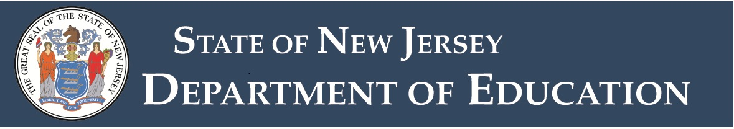

Budget Guidelines - Appendix D-3
2026-27 Budget Review Checklist
Additional Spending Proposals Pursuant to N.J.S.A. 18A:7F-5 and-39 - For Current Budget Year
District Name:
Completed by:
Area of Review | County Office Review/Comments
Proposals, pursuant to N.J.A.C. 6A:23A-12.1:
- Do Not include programs and services required to meet NJSLS (“T&E”);
- Do Not include Capital Outlay projects necessary for health and safety;
- Do Not include programs and services included in the pre-budget year;
- If they are included: District can demonstrate that maintaining such costs in the Base budget would (a) force reductions of other T&E programs/services, or (b) such other T&E programs/services are not necessary for T&E;
- Do Not appear to be contingent on other factors (i.e. passage of the Base budget; matching funds; etc.).
- For questions at November elections, are for the budget year. (See Budget Q&A item D9.)
Requested funds:
- Are detailed by GAAP codes. The accounts used agree to the wording in the question to be presented to the voters.
- Appear sufficient to carry out the contemplated purposes.
N.J.S.A. 18A:7-8 The district must certify and provide written documentation that the school district has made efforts to enter into shared arrangements with other districts or local governmental units for the provision of administrative, business, purchasing, transportation, and other required school district services and participates in such arrangements unless such shared arrangements would not result in cost savings or would result in additional expenses for the district.
No indication that the district has not implemented all potential efficiencies in administrative operations which could eliminate the need for raising additional General Fund tax levies.
Board resolution submitted that:
- States dollar amounts and specific purposes;
- Includes a clear statement on whether approval will affect only the current year or result in a permanent increase in tax levy and such designation appears reasonable;
- States these expenditures are in addition to those required to achieve NJSLS; and
- Was adopted by a roll call majority of the full Board.
If the district obtains voter approval for additional spending via separate proposals, the base budget and approved additional appropriation amounts have been merged and included in the final budget, and the tax levy has been reported on the revenue line for separate proposals at the school election.
Name of Reviewing ECS or ECBO:
Approved by:
Date:

