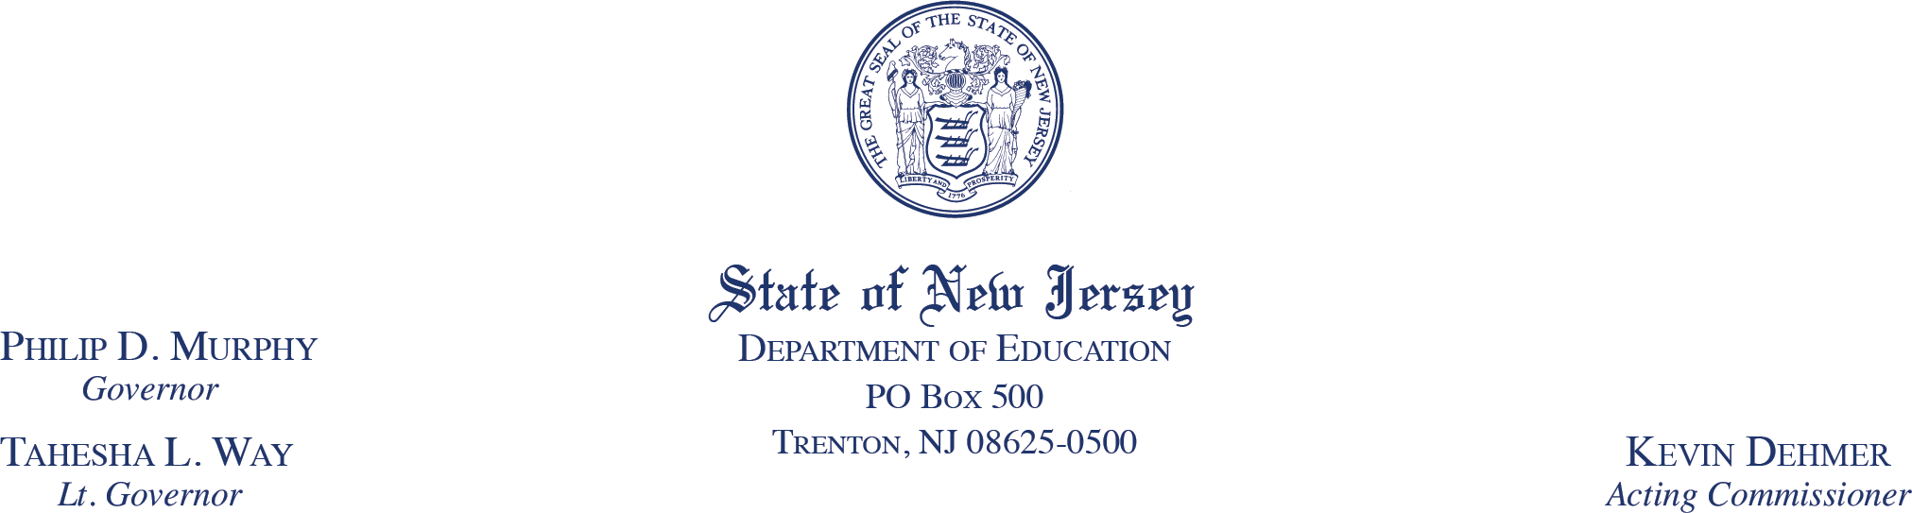

June [TBD}, 2024

Mr. Adam Schott

Principal Deputy Assistant Secretary

Office of Elementary and Secondary Education

U.S. Department of Education

400 Maryland Avenue, SW

Washington, DC 20202

Dear Principal Deputy Assistant Secretary Schott:

The New Jersey Department of Education (NJDOE) requests approval for a Tydings Amendment waiver to extend the period of availability for the American Rescue Plan Elementary and Secondary School Emergency Relief (ARP ESSER) and Homeless Children and Youth (HCY) administrative funds and fiscal year (FY) 2022 Elementary and Secondary Education Act (ESEA) program administrative funds that are consolidated under ESEA section 8201 to March 31, 2026.

The waiver would allow the NJDOE to use funds reserved for administration under ESEA section 8201 to address ongoing administrative costs, including reporting on the use of funds, conducting ongoing monitoring of subgrantees, managing close-out activities, and avoiding diverting funds away from critical services for local educational agencies (LEAs), schools, students, teachers, and other educational staff. Additionally, the waiver would allow the NJDOE to continue to focus its resources on meeting students’ academic and other needs, including groups of students most impacted by the pandemic.

The NJDOE seeks approval to consolidate the following programs pursuant to ESEA section 8401(b)(1):

| ARP Programs | ESSA Programs |
| --- | --- |
| ARP ESSER  ARP HCY | 1.Title I, Part A of the ESEA (Improving Basic Programs Operated by LEAs)  2. Title I, Part C of the ESEA (Education of Migratory Children)  3. Title I, Part D, Subpart 1 of the ESEA (Prevention and Intervention Programs for Children and Youth Who Are Neglected, Delinquent, or At Risk)  4. Title II, Part A of the ESEA (Supporting Effective Instruction)  5. Title III, Part A of the ESEA (English Language Acquisition, Language Enhancement, and Academic Achievement)  6. Title IV, Part A of the ESEA (Student Support and Academic Enrichment Grants)  7. Title IV, Part B of the ESEA (21st Century Community Learning Centers)  8. Title V, Part B, Subpart 2 of the ESEA (Rural and Low-Income School Program) |

The NJDOE will use the consolidated administrative funds under the respective programs in accordance with the provisions of all applicable statutes, regulations, program plans, and applications.

Per usual practice for collecting public comment, the NJDOE has provided the public and all LEAs in the State with notice of and the opportunity to comment on this request by posting information regarding the waiver request and the commenting process on the NJDOE's [ARP ESSER website](https://www.nj.gov/education/esser/arp/). Below is a summary of the comments received and how the State addressed them. *[Note: this summary will be provided after the close of the public comment period.]*

Thank you for considering this request. If you have any questions or require additional information, please call Assistant Commissioner Kathy Ehling at (609) 376-9100.

Sincerely,

Kevin Dehmer

Acting Commissioner

c: Robert Amon

Laura Console

Kathy Ehling

Secil Onat

Amanda Schultz

Jesse Young