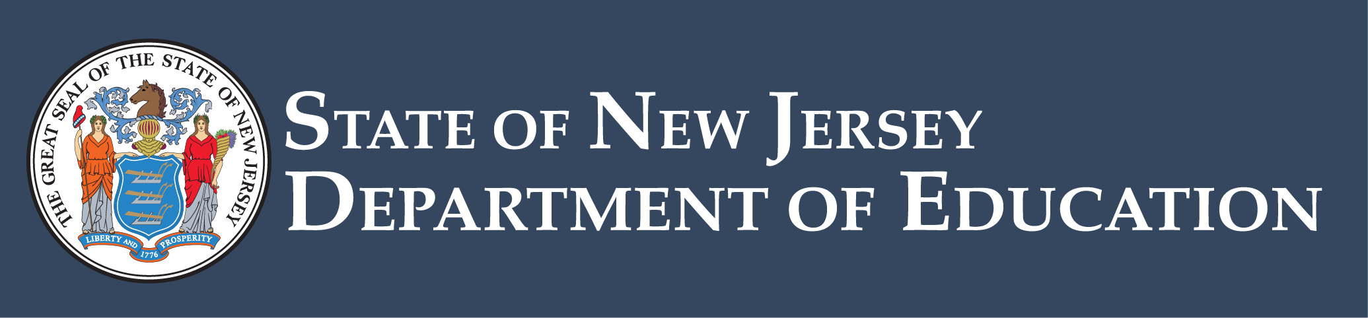

BRIDGE Cohort 2 Grant FAQs

Resources
- NGO Webpage: nj.gov/education/grants/opportunities/2026/26-TL04-G03_NGO.shtml
- NGO Document: nj.gov/education/grants/opportunities/2026/docs/26-TL04-G03_NGO.docx

General Questions

Board Resolution
Q1: Can we submit our board resolution after our April 27th board meeting and still be eligible?
A: In the application, if the district board has not yet approved the application, please include the anticipated date of board approval at a future date. After an application has been selected for funding, as a result of the competitive process, either upload the meeting minutes or maintain the records locally for monitoring purposes.

Eligible Costs
Q2: Can we use funds to purchase ELA HQIM in grades K–3 as justified by our Universal Screener data?
A: LEAs can use funds to purchase instructional materials that support implementation of evidence-based literacy practices in Tier 1 instruction.
Page 12 of the NGO outlines allowable uses and eligible activities as:
- Materials — supporting implementation of evidence-based literacy practices in Tier 1 instruction
The NGO further defines eligible costs on page 13:
Costs for materials and resources include:
- Purchase of literacy leadership books, instructional guides and research-based professional learning materials.
- Purchase of instructional materials to support implementation of evidence-based literacy practices
- Subscription to online literacy professional development platforms.

Focus Grant
Q3: Is this a new grant replacing the Focus?
A: No. FOCUS is a separate grant opportunity that supports LEAs in purchasing, adopting, and implementing high-quality universal literacy screeners that align with the Universal Literacy Screening Criteria, as outlined in the Department's guidance, to meet the screening requirements in kindergarten through grade 3 (K –3) according to State law. For more information about FOCUS, please visit the Funding for Optimal Comprehensive Universal Screeners (FOCUS 1) Continuation Year 2 webpage.
Q4: If the FOCUS grant continuation is not enough to cover our universal screener for next year, would we be able to pay for the rest of it with this BRIDGE grant?
A: Applicants are encouraged to tie any proposed activities and associated costs to the LEA’s identified needs and project goals and objectives. Page 12 of the NGO outlines allowable uses and eligible activities as:
- Leadership Team — supporting the team’s work through materials and/or resources, stipends for team members, and meeting facilitation
- Materials — supporting implementation of evidence-based literacy practices in Tier 1 instruction
- Professional development — providing team members and teachers with training related to the work
The NGO further defines eligible costs on page 13:
Costs for materials and resources include:
- Purchase of literacy leadership books, instructional guides and research-based professional learning materials.
- Purchase of instructional materials to support implementation of evidence-based literacy practices
- Subscription to online literacy professional development platforms.
Technology and data tool costs include:
- Purchase of data analysis software or dashboards to support data-driven decision-making.
- Subscription to platforms that facilitate data collection, analysis and visualization.
- Development or purchase of a monitoring framework and tracking system for literacy progress.
- Investment in universal screening tools and additional formative assessment resources.

Link to Apply
Q5: Where is the link to begin the application?
A: The BRIDGE Cohort 2 opportunity is active in EWEG, and LEAs can begin creating their application at any time. Follow the instructions on page 1, paragraph 2 of the NGO to locate the application. Applications are due by 4:00 p.m. on April 23, 2026.

Slides
Q6: Will you share the slides with us?
A: We will not be posting the slides from this technical assistance session, but we invite you to reference the NGO webpage and document from which all of the content was extracted.

