

LEARning about Literacy:
Professional Learning Community (PLC) Series
Session 3 Fluency as the Bridge to Comprehension Facilitator Guide
This facilitation guide provides a structured approach to lead Session 3 Fluency as the Bridge to Comprehension. The session aims to help educators understand sight recognition and word recognition automaticity as the bridge to comprehension. The facilitator is tasked with preparing materials, engaging participants, and ensuring active participation throughout the session.

Step-by-Step Facilitation Process
- Send Pre-Work Email to Community Members: Send the pre-drafted email with the pre-work assignment attached (e.g., reading or video) and session details (date, time, location/platform).
- Review Pre-Work and Session Presentation Materials: Review the pre-work assignment, session slides, and facilitator notes to ensure familiarity with content.
- Prepare and Update Session Presentation Materials: Update slides with relevant contextual information for the group, prepare all handouts and supplementary resources needed, and check on the room set up, materials needed for activities, and technology to ensure a smooth session. Test any video links in the presentation to confirm they are working properly.
- Deliver the Session: Present the pre-drafted session presentation, engage participants with discussions and activities, and answer questions to ensure understanding.
- Invite Community Members to Next Session: Thank participants, share details of the next session, and encourage ongoing engagement with additional resources.

Draft Email
Subject Line: Join us for Session 3! Evidence-Based Literacy Instruction PLC Series
Dear [Staff Member],
This is a friendly reminder that the second session of the Learning Equity & Academic Recovery’s Evidence-Based Literacy Instruction Professional Learning Community (PLC) Series is coming soon!

PLC Session 3: Fluency as the Bridge to Comprehension
Date: [Insert Date]
Time: [Insert Time]
Location: [Insert Location/Platform Link]
In this session, we will focus on the role of fluency as a bridge to comprehension, the components of reading fluency, and the development of sub-skill automaticity as it relates to assessment, effective instructional practices, and the benefits of wide reading. The session is designed to be interactive and collaborative, allowing you to engage with your colleagues and share ideas and best practices for supporting students’ literacy development.
Prior to our session together, please be sure to watch the brief video The Simple View of Reading to be prepared for our discussion and activities.
We look forward to seeing you there and working together to enhance our literacy instruction!
Best regards,
[Your Name]
[Your Title]
[School District Name]
[Your Contact Information]
Video Link: https://rutgers.mediaspace.kaltura.com/media/3.1+The+Simple+View+of+Reading/1_loai32g5

Session Presentation Facilitation Notes

Slide 1: Title Slide
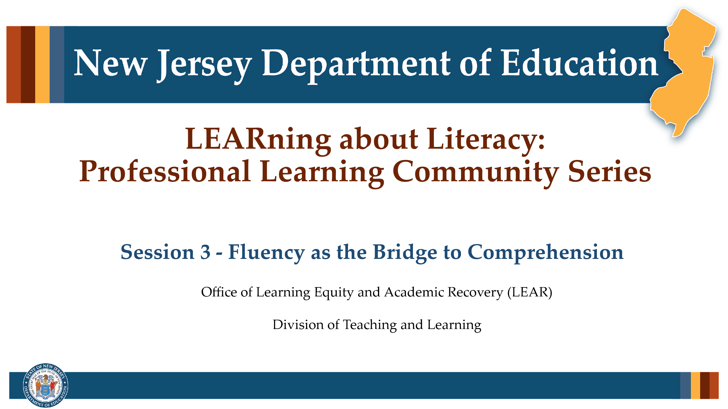

Facilitator Narration
Welcome! We’re excited to have you join us for this third session in our Professional Learning Community Series. Today, we’ll be looking to strengthen our instructional practices based on the latest research in reading fluency.

Slide 2: Phonological Awareness
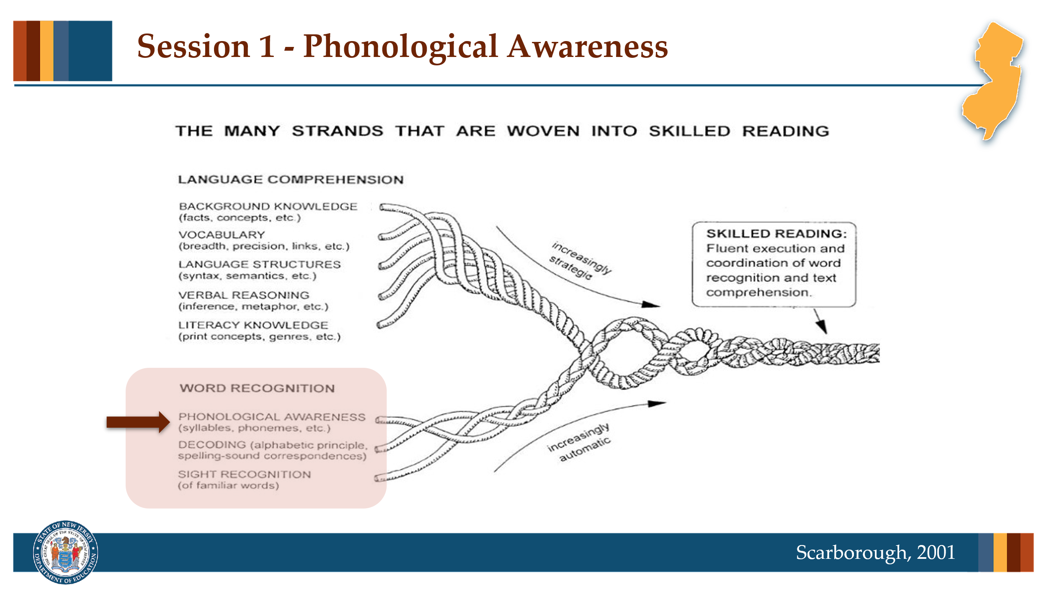

Facilitator Narration
Grounding our session once again in Scarborough’s Reading Rope, today we will get started with a short discussion of sight recognition.

Slide 3: Text Version of Scarborough’s Rope
The text version is provided for people who cannot access the content in the image (e.g., someone who is blind or has low vision).

Slide 4: Sight Recognition & Orthographic Mapping
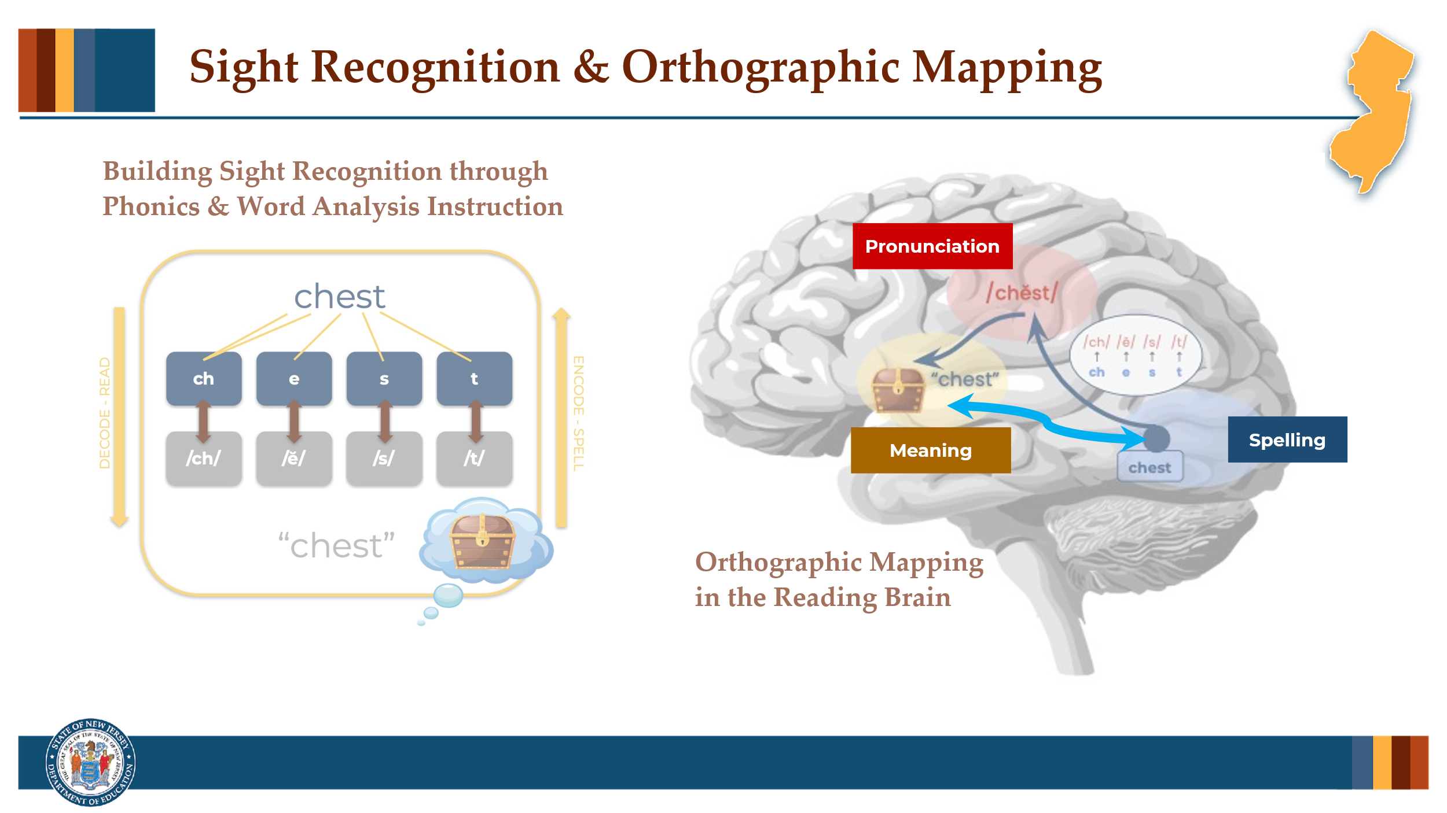

Facilitator Narration
Over time, as students receive explicit phonics instruction and lots of guided and independent practice in decoding and spelling words they begin to recognize words in print without having to consciously sound them out or think about their structure. This ability to instantly recognize familiar words is referred to as sight recognition.
Orthographic mapping is the mental process in the brain through which a word’s orthographic or written form is linked to its phonological or spoken form and its meaning.
As students’ decoding and encoding skills become more automatic, reading networks have formed that are more direct routes (note the turquoise arrow representing the neuronal network in the reading brain) that allow the reader to instantly recognize (on sight) the meaning of the words they read because the word’s pronunciation, spelling and meaning have been bound together and stored in long term memory for efficient retrieval when reading and spelling.
Phonics and word analysis instruction focus on teaching students about the correspondences and spelling patterns through a cumulative scope and sequence beginning with the most common correspondences and patterns and moving toward those that are less common and more complex.

Slide 5: Text Version: Building Sight Recognition through Phonics and Word Analysis Instruction
The text version is provided for people who cannot access the content in the image (e.g., someone who is blind or has low vision).

Slide 6: Text Version: Orthographic Mapping in the Reading Brain
The text version is provided for people who cannot access the content in the image (e.g., someone who is blind or has low vision).

Slide 7: Mapping Irregular Words
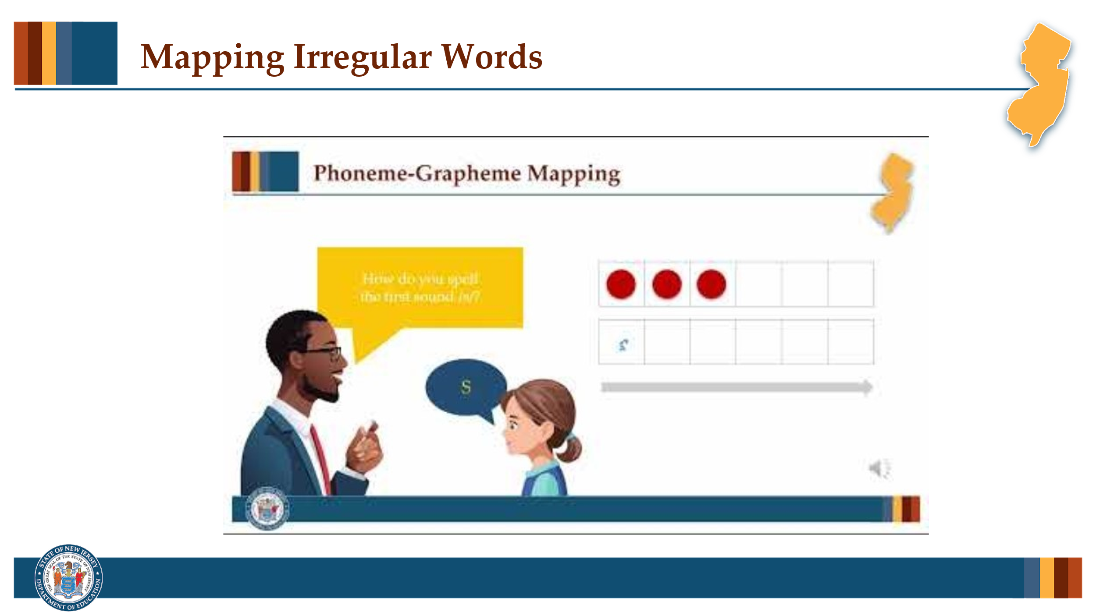

Facilitator Narration
It is important to understand, however, that ALL words including those that may contain irregular or unusual correspondences or patterns must be analyzed so that they can be similarly orthographically mapped into memory. Let’s watch this brief video demonstrating a phoneme-grapheme mapping routine for irregular words.

Slide 8: Reading Fluency (1 of 4)
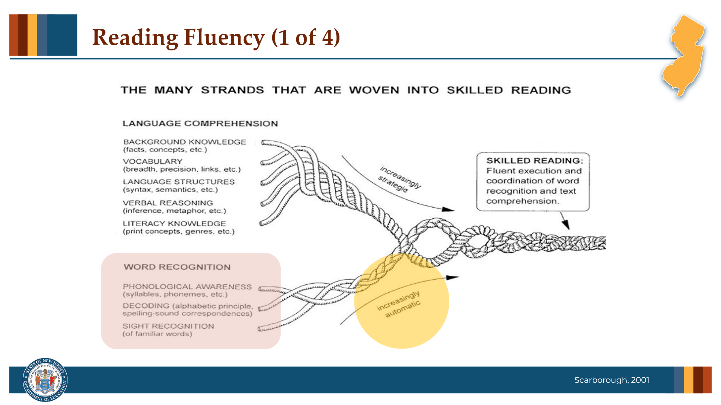

Facilitator Narration
As students’ word recognition skills (phonemic awareness, decoding, and sight recognition) become more and more automatic over time, they are building oral reading accuracy and automaticity at the word level.

Slide 9: Reading Fluency (2 of 4)
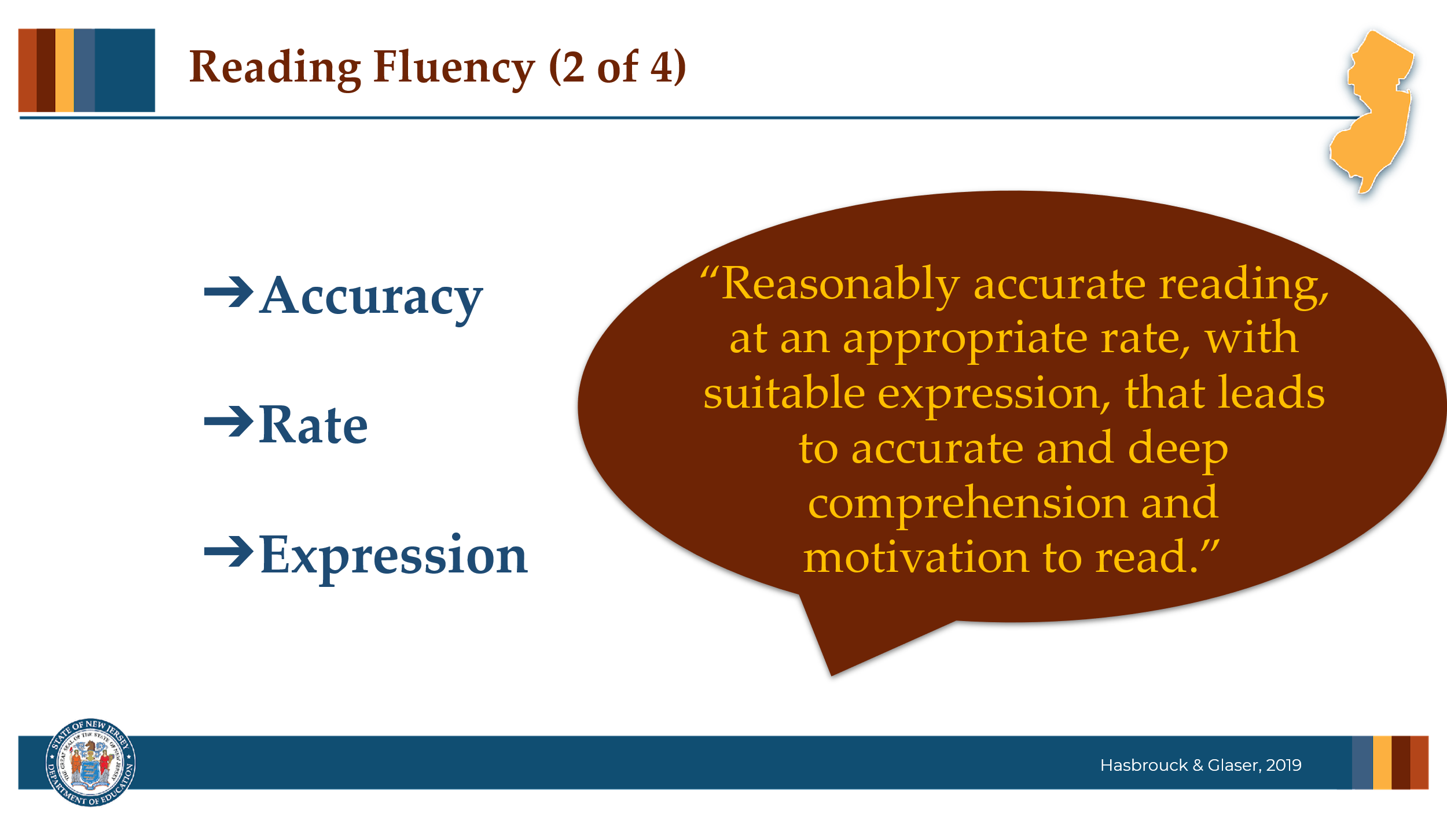

Facilitator Narration
Researchers Hasbrouck and Glaser define fluency as reasonably accurate reading, at an appropriate rate, with suitable expression, that leads to accurate and deep comprehension and motivation to read.

Slide 10: Reading Fluency (3 of 4)
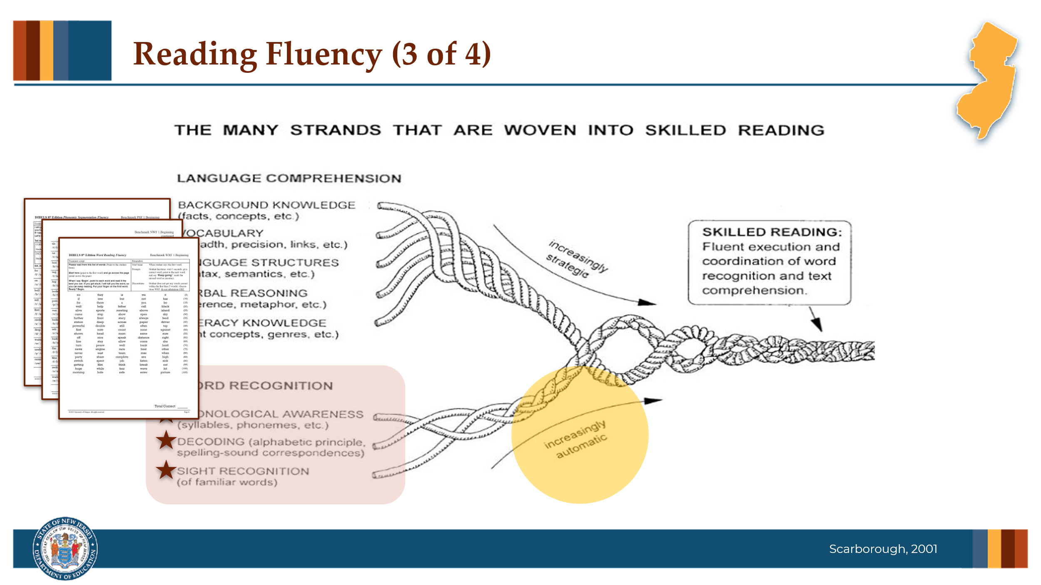

Facilitator Narration
These discrete word recognition skills can be measured and students’ accuracy and automaticity growth monitored using a universal screening assessment.
Phonological awareness is typically assessed through a measure of phoneme segmentation fluency, which determines the student’s ability to accurately and automatically segment the sound in words.
Decoding is typically assessed through a measure of nonsense word fluency, which determines the student’s ability to accurately apply phoneme-grapheme correspondence, or correct letter sounds, when reading made-up words as well as their ability to automatically blend those sounds together to read the whole word.
And sight recognition is typically assessed through a measure of word reading fluency, which determines the student’s ability to accurately and automatically read a list of real words.

Slide 11: Reading Fluency (4 of 4)
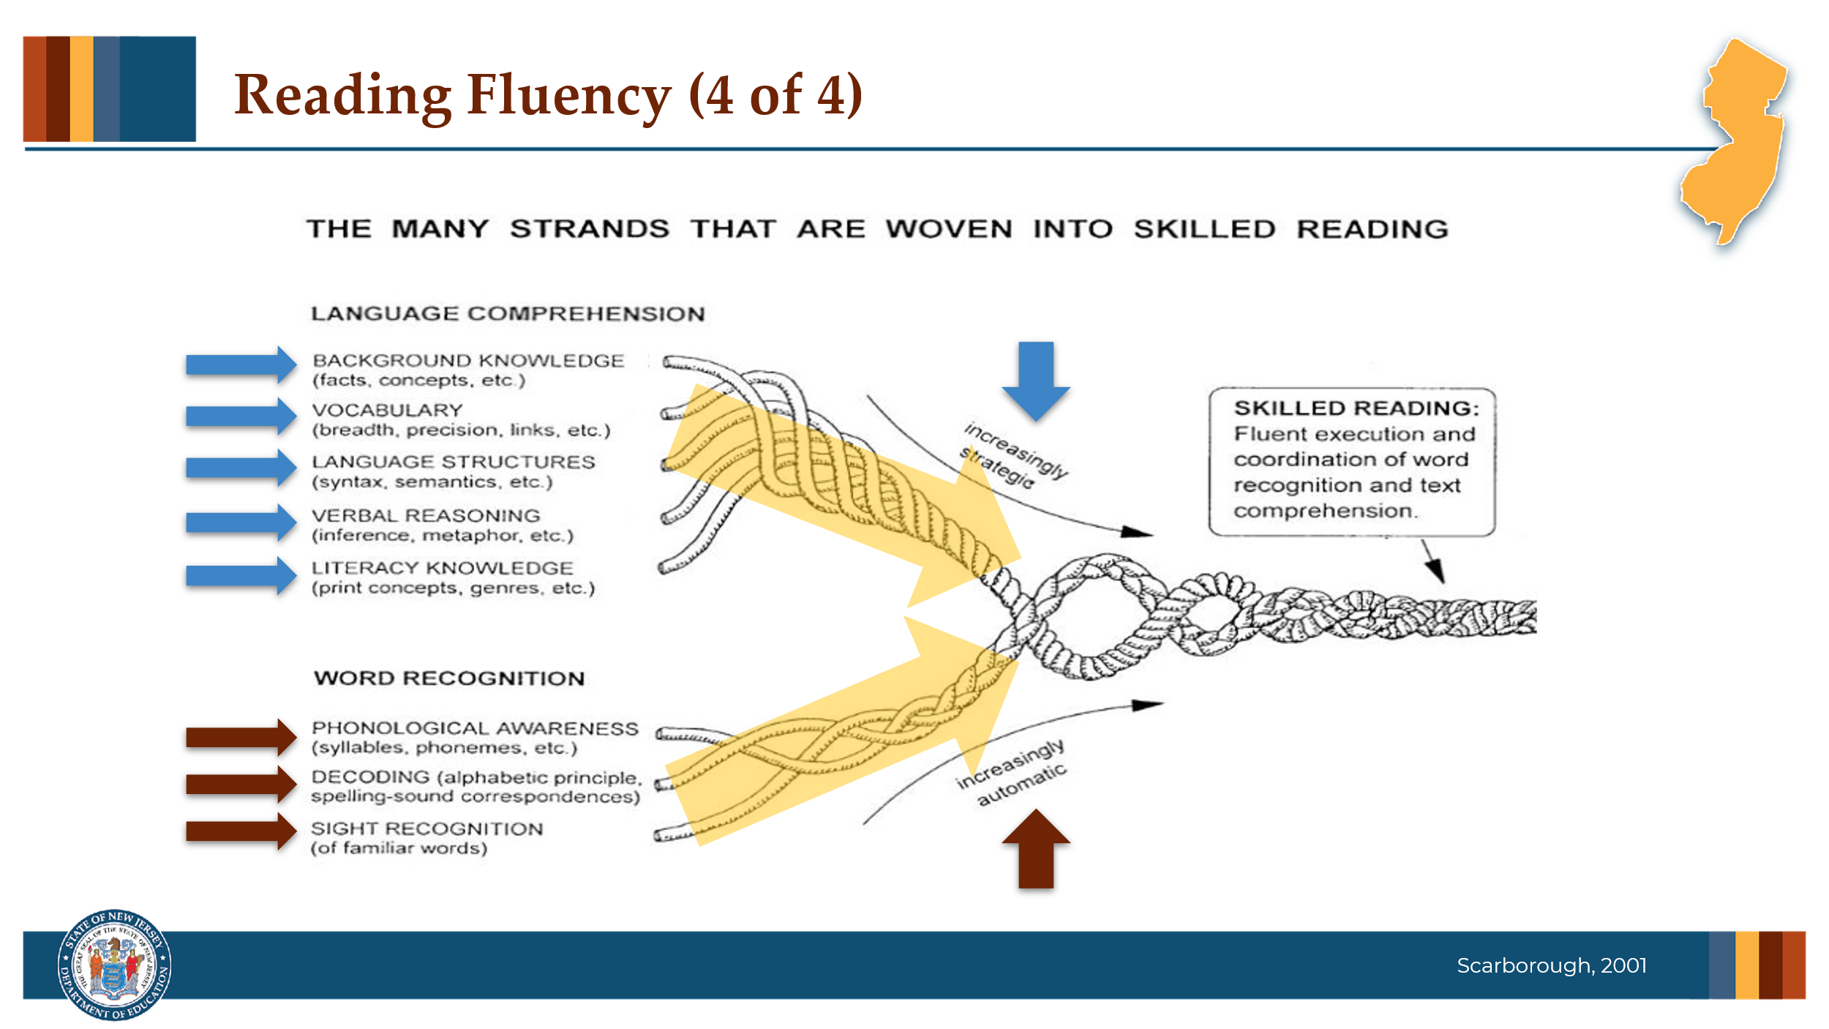

Facilitator Narration
As instruction supports the growth of increasingly accurate and automatic word recognition skills, it should simultaneously be supporting the growth of strategic language comprehension skills in order to support students in their ability to read connected text with proper expression to support their reading comprehension.

Slide 12: Simple View of Reading
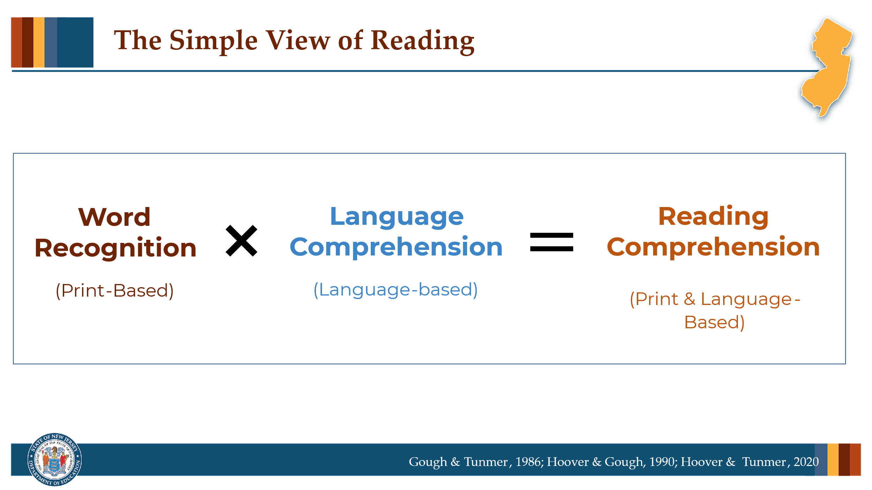

Facilitator Narration
This is the perfect time to pause and discuss The Simple View of Reading that was explained in the brief video included in the reminder email. In what ways do the Reading Rope and the equation in the Simple View of Reading represent reading fluency?

Slide 13: Reading Fluency
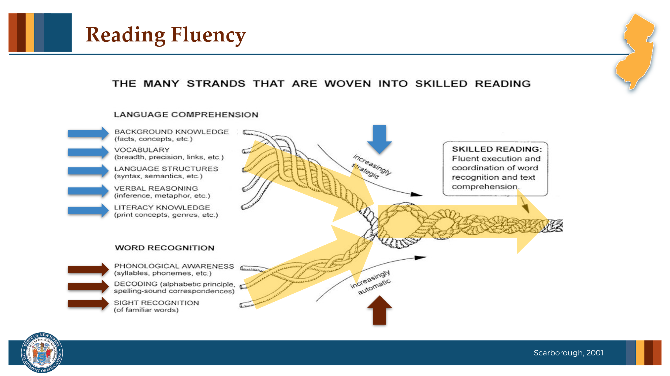

Facilitator Narration
The multiplying effect of these factors (automatic word recognition and strategic language comprehension) described in the Simple View’s equation is equivalent to the braiding and twisting shown in Scarborough’s Reading Rope. Skilled reading is the result of fluent execution and coordination of word recognition and text comprehension. Let’s now discuss some instructional strategies that support fluent reading.

Slide 14: Instruction to Support Reading Fluency
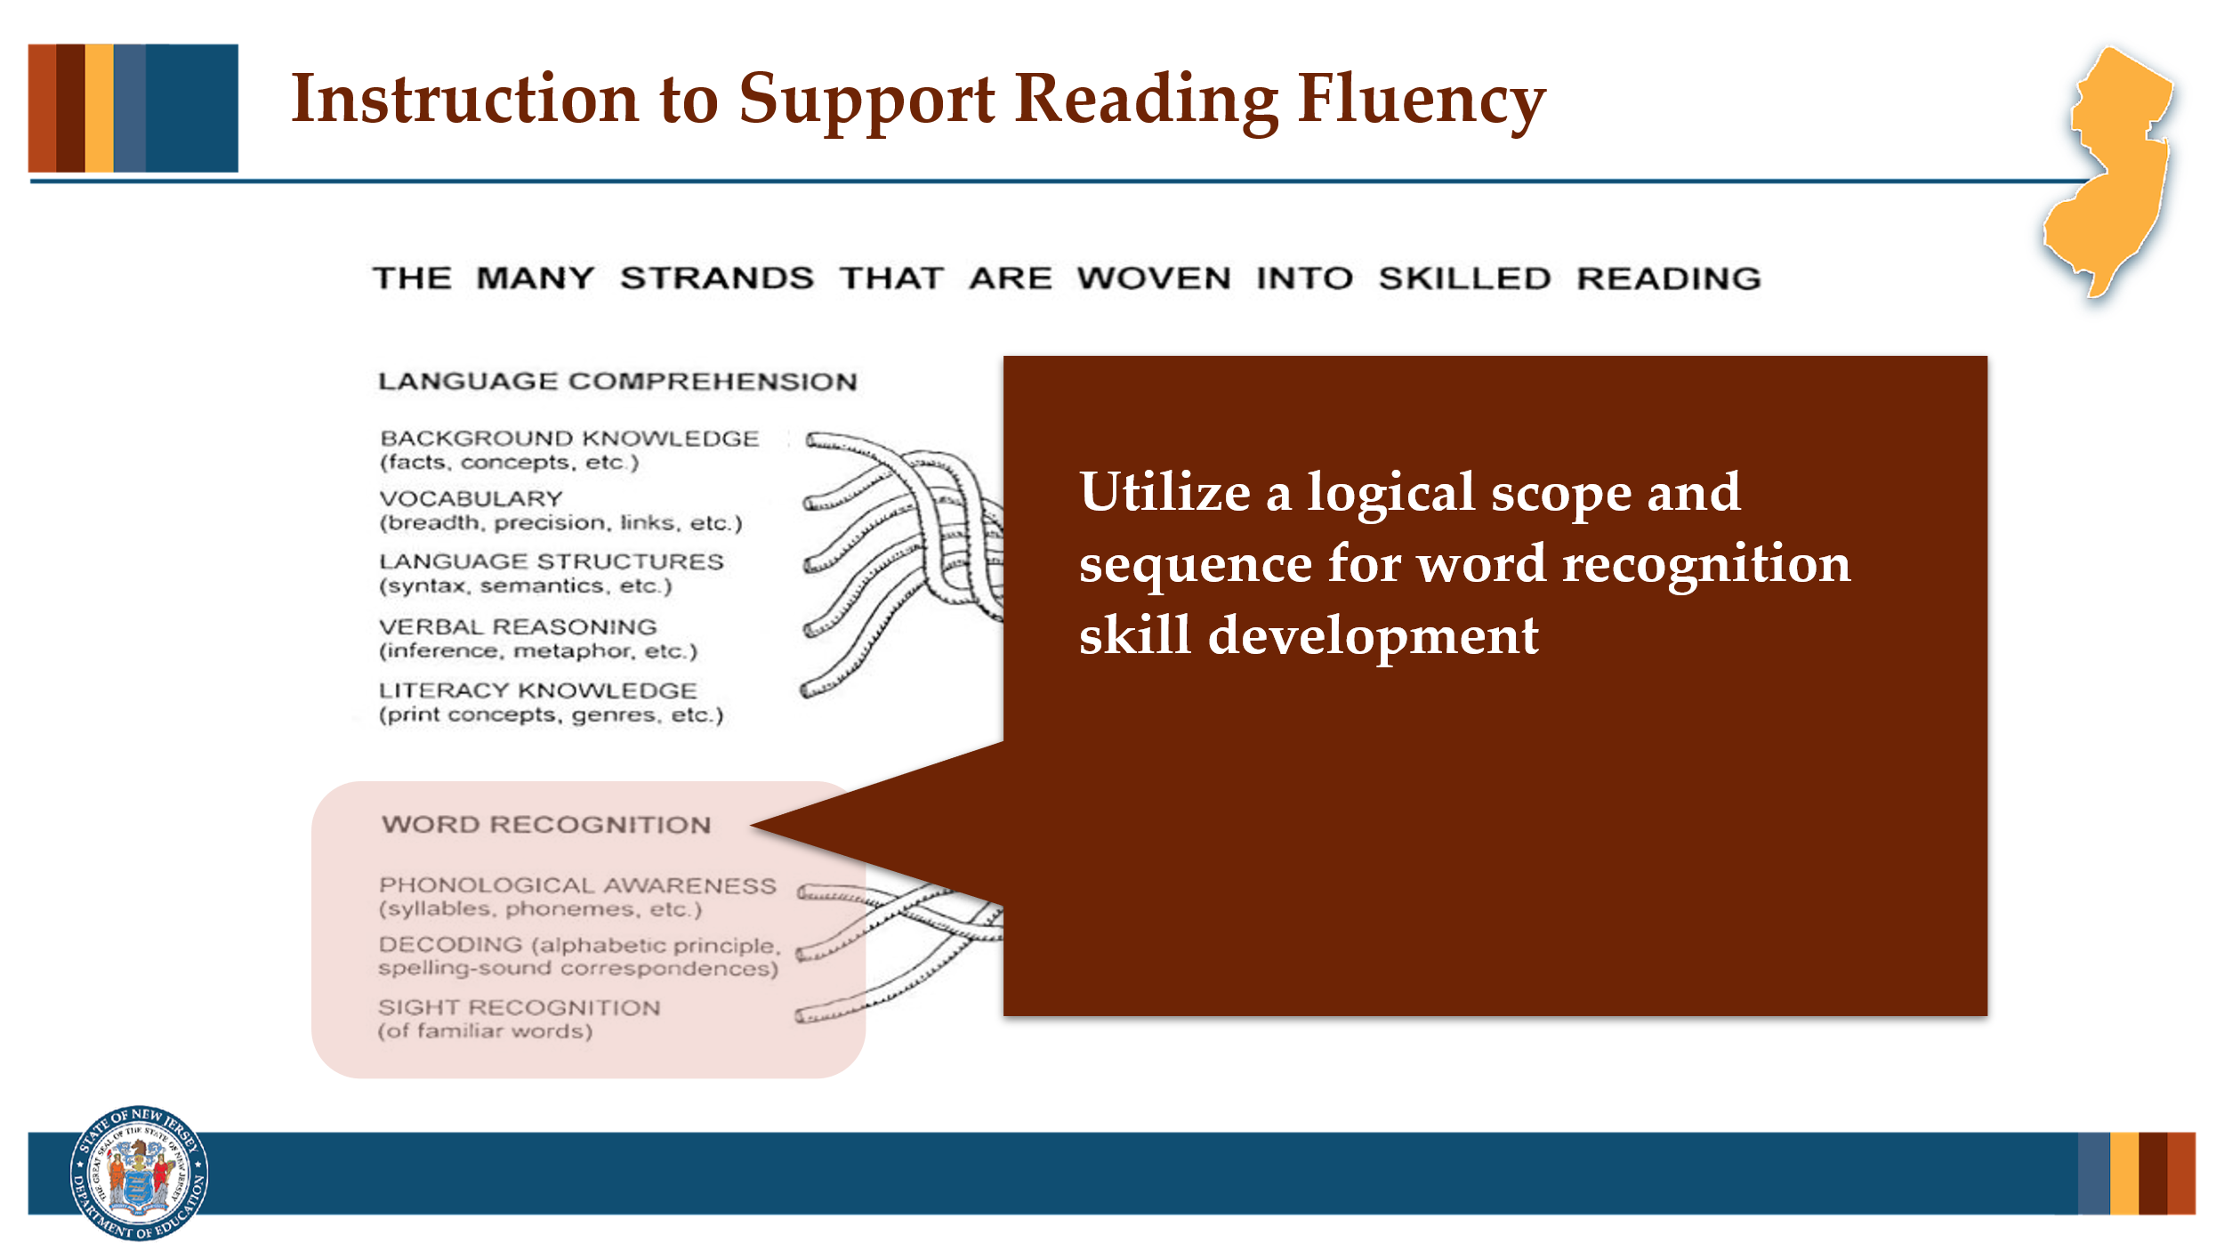

Facilitator Narration
Structured Literacy programs introduce and reinforce the essential building blocks of word recognition in a carefully ordered scope and sequence that integrates the sounds (phonemes), letters (graphemes), and the phoneme-grapheme correspondences used for decoding and encoding words, as well as the introduction of frequently used irregular words. This scope and sequence ensures that students are cumulatively building their knowledge of these important skills.

Slide 15: Instruction to Support Reading Fluency (1 of 3)
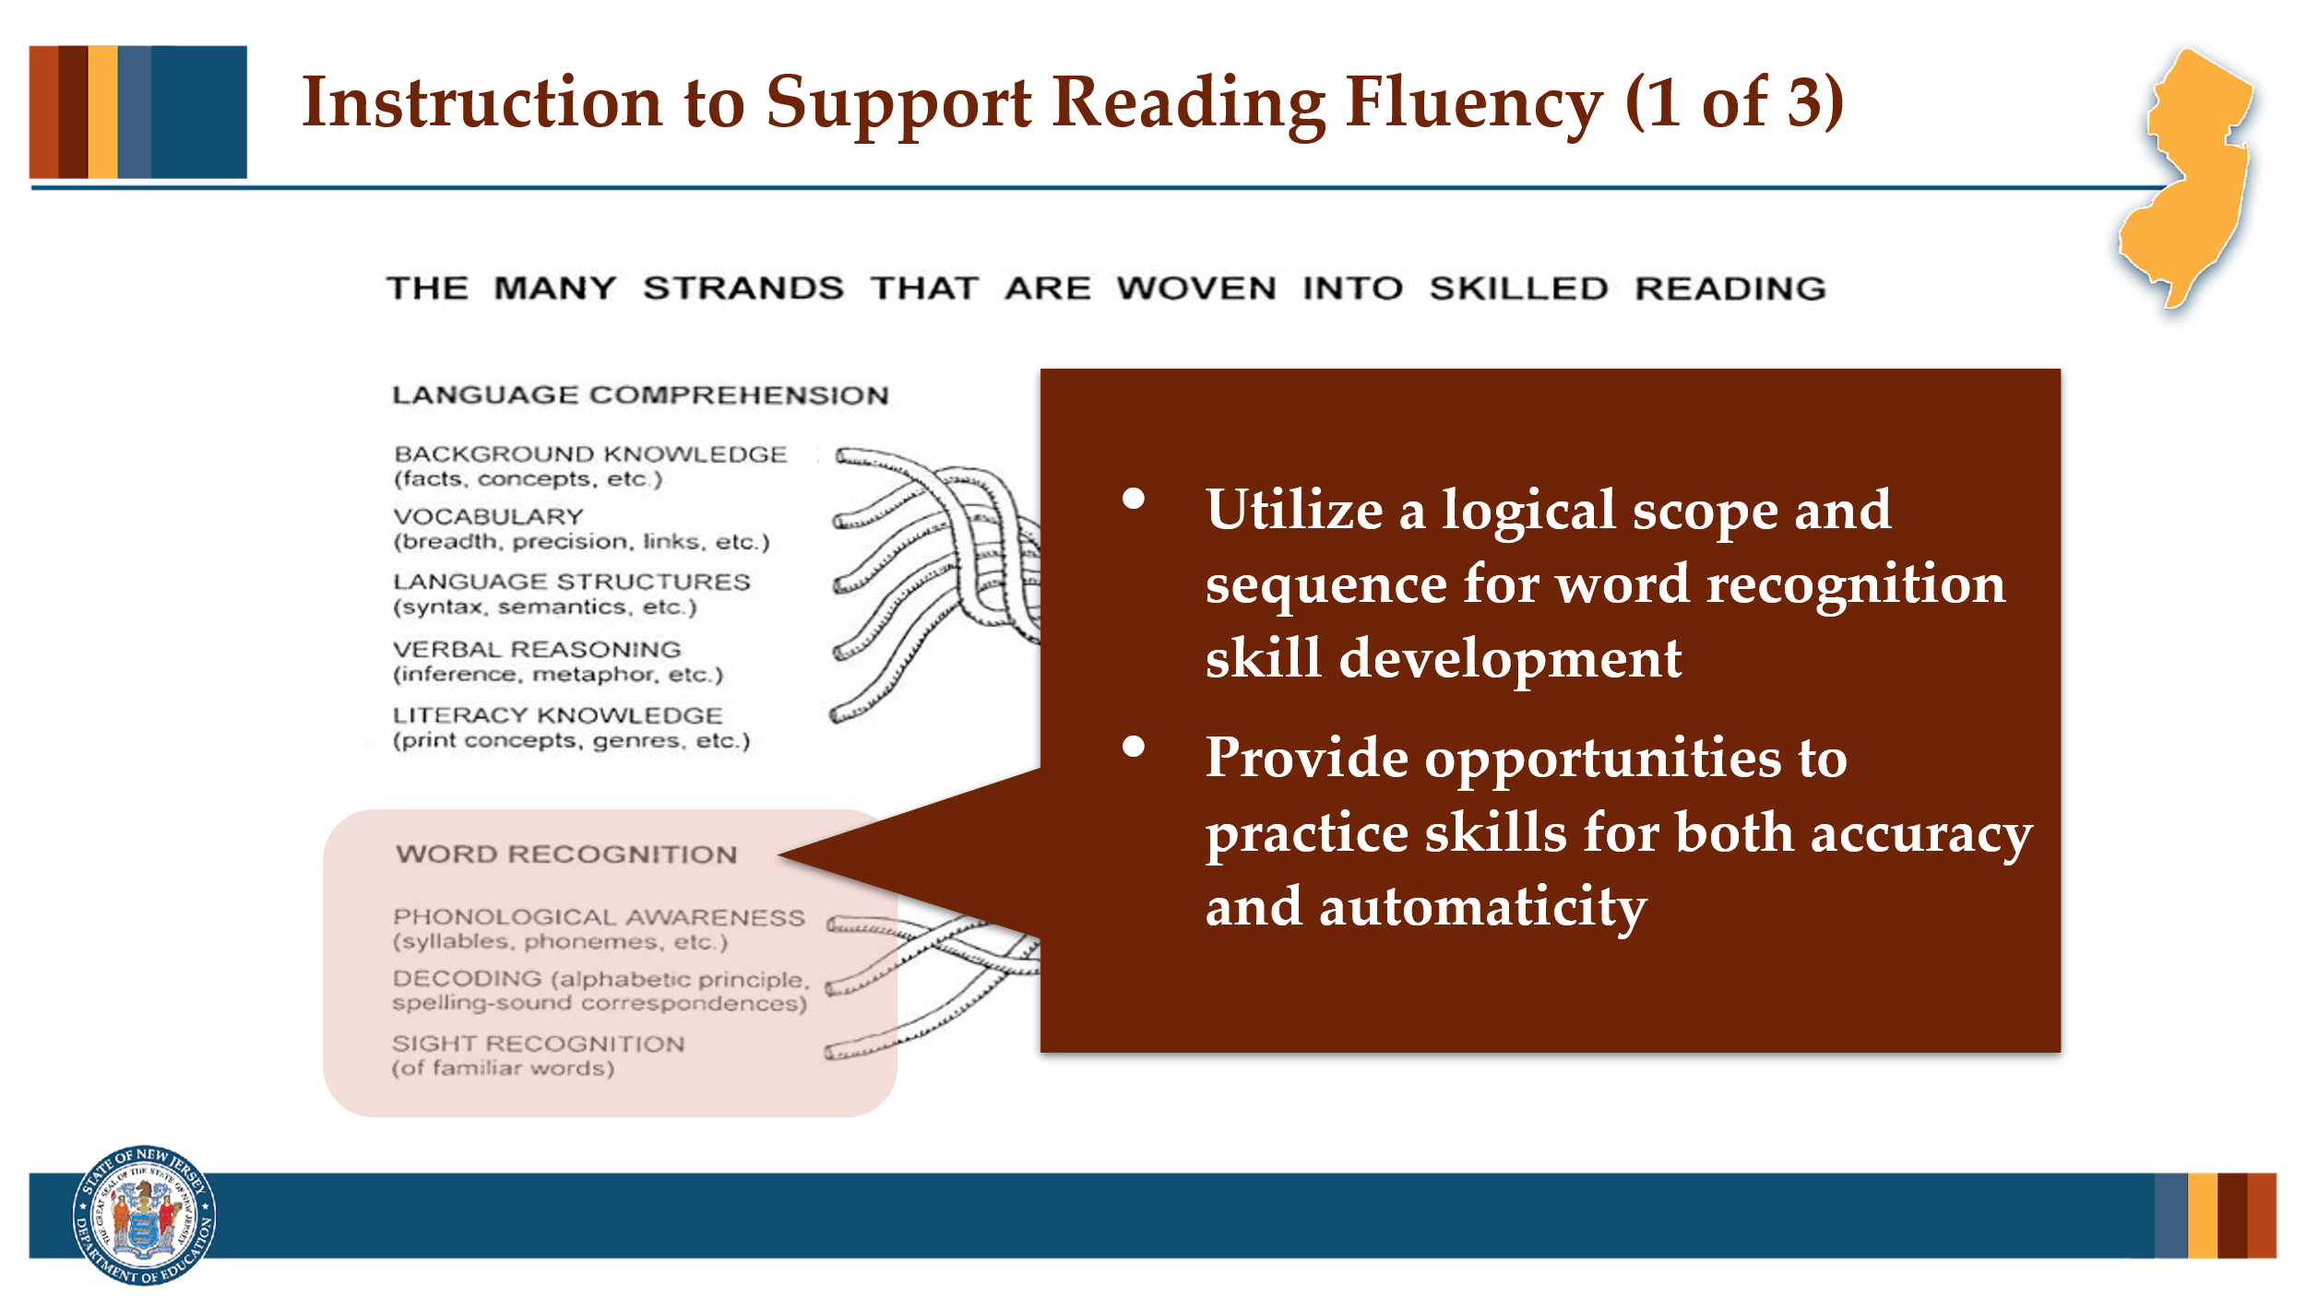

Facilitator Narration
Word recognition automaticity also requires lots of distributed, repeated practice opportunities so that students can build skill accuracy and automaticity. For example, activities such as using grapheme cards for lesson reviews that require students to recall phoneme-grapheme correspondences. The teacher would show the grapheme cards and students would provide the names and sounds for the graphemes shown. At the word level, explicit blending instruction and lesson activities that involve students reading lists of words with newly taught correspondences and patterns are helpful for building accuracy, and once reasonable accuracy is reached a timed element can be added to help students build automaticity or a reasonable word reading rate.

Slide 16: Instruction to Support Reading Fluency (2of 3)
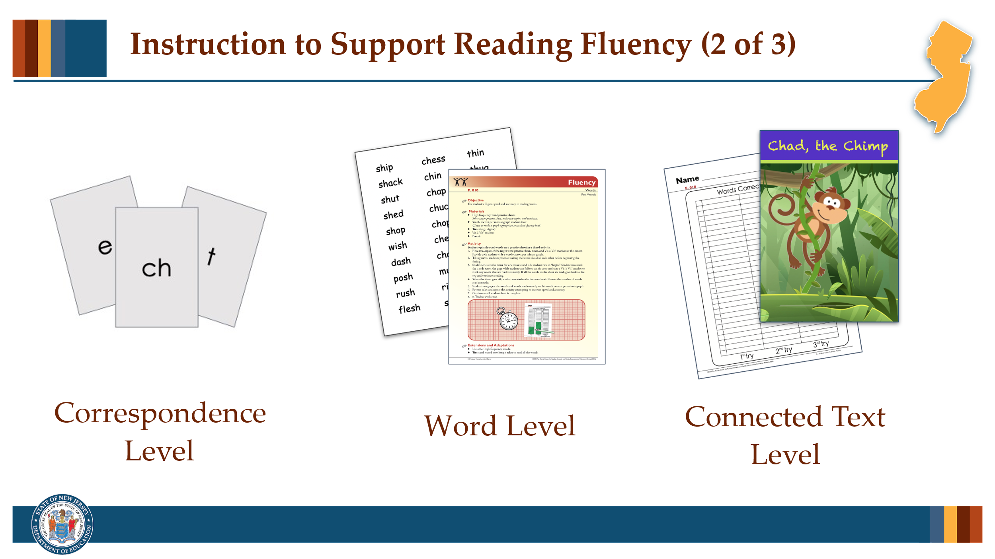

Facilitator Narration
For example, activities such as using grapheme cards for lesson reviews that require students to recall phoneme-grapheme correspondences. The teacher would show the grapheme cards and students would provide the names and sounds for the graphemes shown. At the word level, explicit blending instruction and lesson activities that involve students reading lists of words with newly taught correspondences and patterns are helpful for building accuracy, and once reasonable accuracy is reached a timed element can be added to help students build automaticity or a reasonable word reading rate.
Once students are reading connected text with reasonable word recognition accuracy, they can be provided repeated reading practice, graphing their reading rate progress from the first cold read to the next warn read to a final hot read. It is important to introduce students to appropriate texts for building fluent reading in connected text. An appropriate text for fluency practice is one which is relatively easy for a student, meaning no more than 1 in 20 words would be difficult, meaning an established reader can read with 95% accuracy. For emerging or beginning readers, they should be able to read the text with closer to 97 or 98% accuracy.

Slide 17: Instruction to Support Reading Fluency (3 of 3)
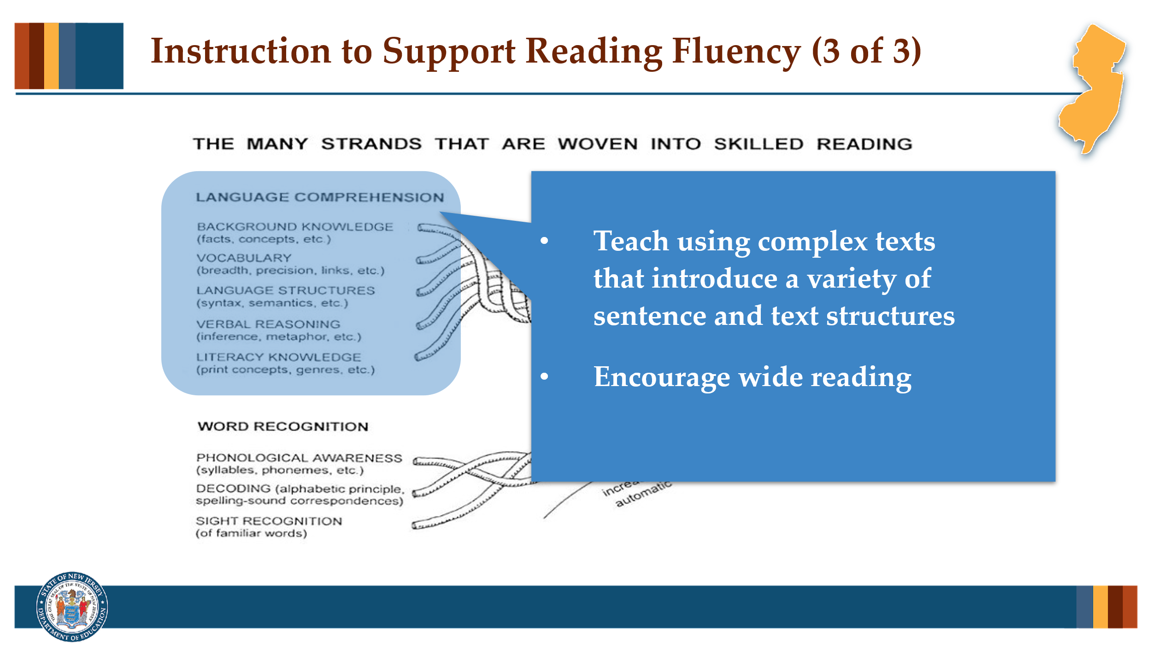

Facilitator Narration
In support of simultaneous language comprehension development, students should also be introduced to more complex connected texts with teacher support. As students listen to read alouds and learn about various sentence structures, they build their ability to group words into grammatical phrases to promote proper intonation and prosody. Reading with expression is another important part of reading fluency. At the sentence level, teachers can show students how to practice scooping words into phrases as needed to support mean-making.
And finally that bridge into reading comprehension requires that students read widely! Teachers can support and encourage wide reading using a variety of texts using both structured reading experiences and independent reading experiences. Teachers can even encourage students to read texts on similar topics, to capitalize on shared vocabulary words and themes.

Activity
(5 –10 minutes)
Distribute copies of the supplemental resource from Student Achievement Partners titled Weekly 5 Day Reading Practice Routine for Fluency to all community members. Ask community members to pair off and review the routine.
Prompt with questions as needed:
- What did you notice about the instructional routine?
- Does our current reading program have a similar routine for integrating repeated oral readings?
- How can this new routine be implemented to improve our current reading program or to help better coordinate existing programs already in use?
- For younger students, does our current program offer enough fluency practice at the word level to support students word recognition skill development?

Slide 18: Adapting to Student Needs
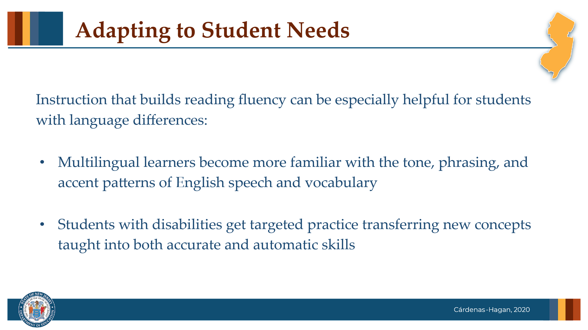

Facilitator Narration
These strategies used to build reading fluency also support the development of spoken English for multilingual learners. As students work on reading texts with accuracy, speed, and expression, they become more familiar with the tone, phrasing, and accent patterns of English speech. This practice also helps them build vocabulary, which strengthens their oral fluency and improves both their reading and listening comprehension. Students with disabilities benefit from the distributed skill practice targeting both skill accuracy and automaticity.

Optional Question
Describe how instruction designed to build fluency supports all students - those with language differences as well as those with disabilities?

Slide 19: Thanks for Participating!
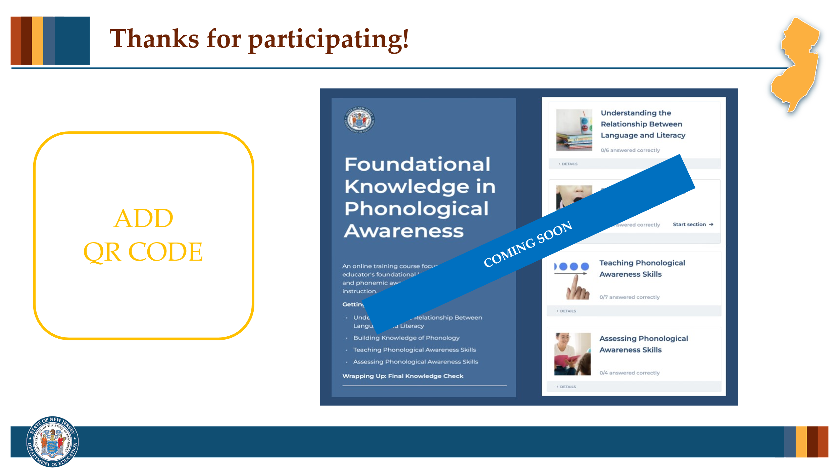

Facilitator Narration
This brings us to the end of our session today! If you are interested to learn more about reading fluency, keep an eye out for the NJ Department of Education’s upcoming free SISEP online learning modules.

Slide 20: Next Session in the PLC Series
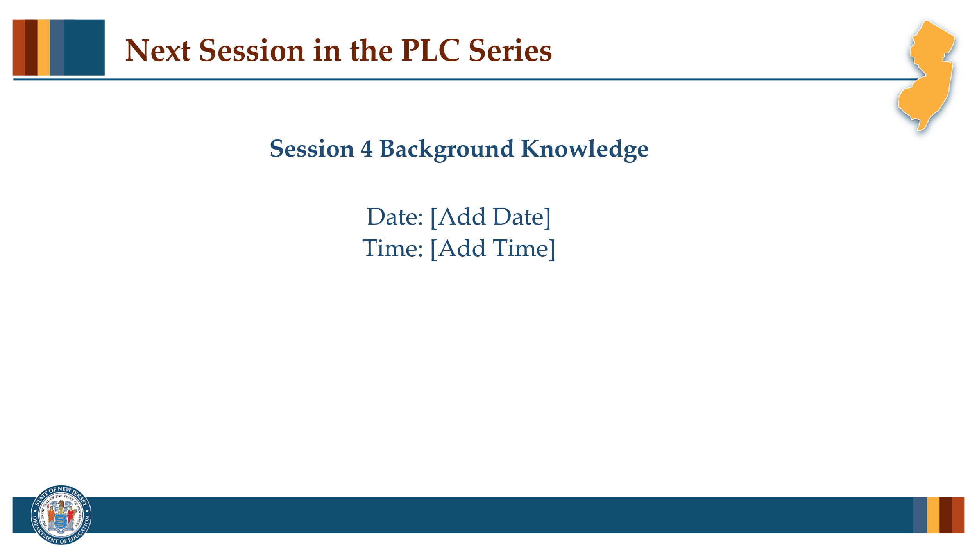

Facilitator Narration
Up next is Session 4 Background Knowledge. This PLC session will focus on best practices in building, activating, and connecting to student’s prior knowledge before and during reading to enhance comprehension. We will meet on [add date and time]. See you then!

Slide 12: References
This slide lists references from the presentation.

Session Materials Needed
- PLC Series Session 3 - Slide Presentation
- Copies of Supplementary Resources for Community Members:
  - Weekly 5 Day Reading Practice Routine for Fluency
If the session is being delivered virtually, use a virtual meeting space that allows for meeting participants to engage via both audio and video.

