

# LEARning about Literacy: Professional Learning Community (PLC) Series Session 4 Background Knowledge Facilitator Guide

This facilitation guide provides a structured approach to lead Session 4 Background Knowledge. This session focuses on how students’ prior knowledge and content knowledge supports their understanding of a text. The facilitator is tasked with preparing materials, engaging participants, and ensuring active participation throughout the session.

## Step-by-Step Facilitation Process

1. **Send Pre-Work Email to Community Members:** Send the pre-drafted email with the pre-work assignment attached (e.g., reading or video) and session details (date, time, location/platform).
2. **Review Pre-Work and Session Presentation Materials:** Review the pre-work assignment, session slides, and facilitator notes to ensure familiarity with content.
3. **Prepare and Update Session Presentation Materials:** Update slides with relevant contextual information for the group, prepare all handouts and supplementary resources needed, and check on the room set up, materials needed for activities, and technology to ensure a smooth session. Test any video links in the presentation to confirm they are working properly.
4. **Deliver the Session:** Present the pre-drafted session presentation, engage participants with discussions and activities, and answer questions to ensure understanding.
5. **Invite Community Members to Next Session:** Thank participants, share details of the next session, and encourage ongoing engagement with additional resources.

## Draft Email

**Subject Line:** Join us for Session 4! Evidence-Based Literacy Instruction PLC Series

Dear [Staff Member],

This is a friendly reminder that the second session of the Learning Equity & Academic Recovery’s Evidence-Based Literacy Instruction Professional Learning Community (PLC) Series is coming soon!

### PLC Session 4: Background Knowledge

Date: [Insert Date]  
Time: [Insert Time]  
Location: [Insert Location/Platform Link]

In this session, we will focus on background knowledge, with an emphasis on strategies for activating, building, and connecting to students’ prior knowledge and content knowledge to enhance their reading comprehension. The session is designed to be interactive and collaborative, allowing you to engage with your colleagues and share ideas and best practices for supporting students’ literacy development.

Prior to our session together, please be sure to watch the brief video [**Teaching Content is Teaching Reading**](https://youtu.be/RiP-ijdxqEc?feature=shared) to be prepared for our discussion and activities.

We look forward to seeing you there and working together to enhance our literacy instruction!

Best regards,

[Your Name]  
[Your Title]  
[School District Name]  
[Your Contact Information]

## Session Presentation Facilitation Notes

### Slide 1: Title Slide

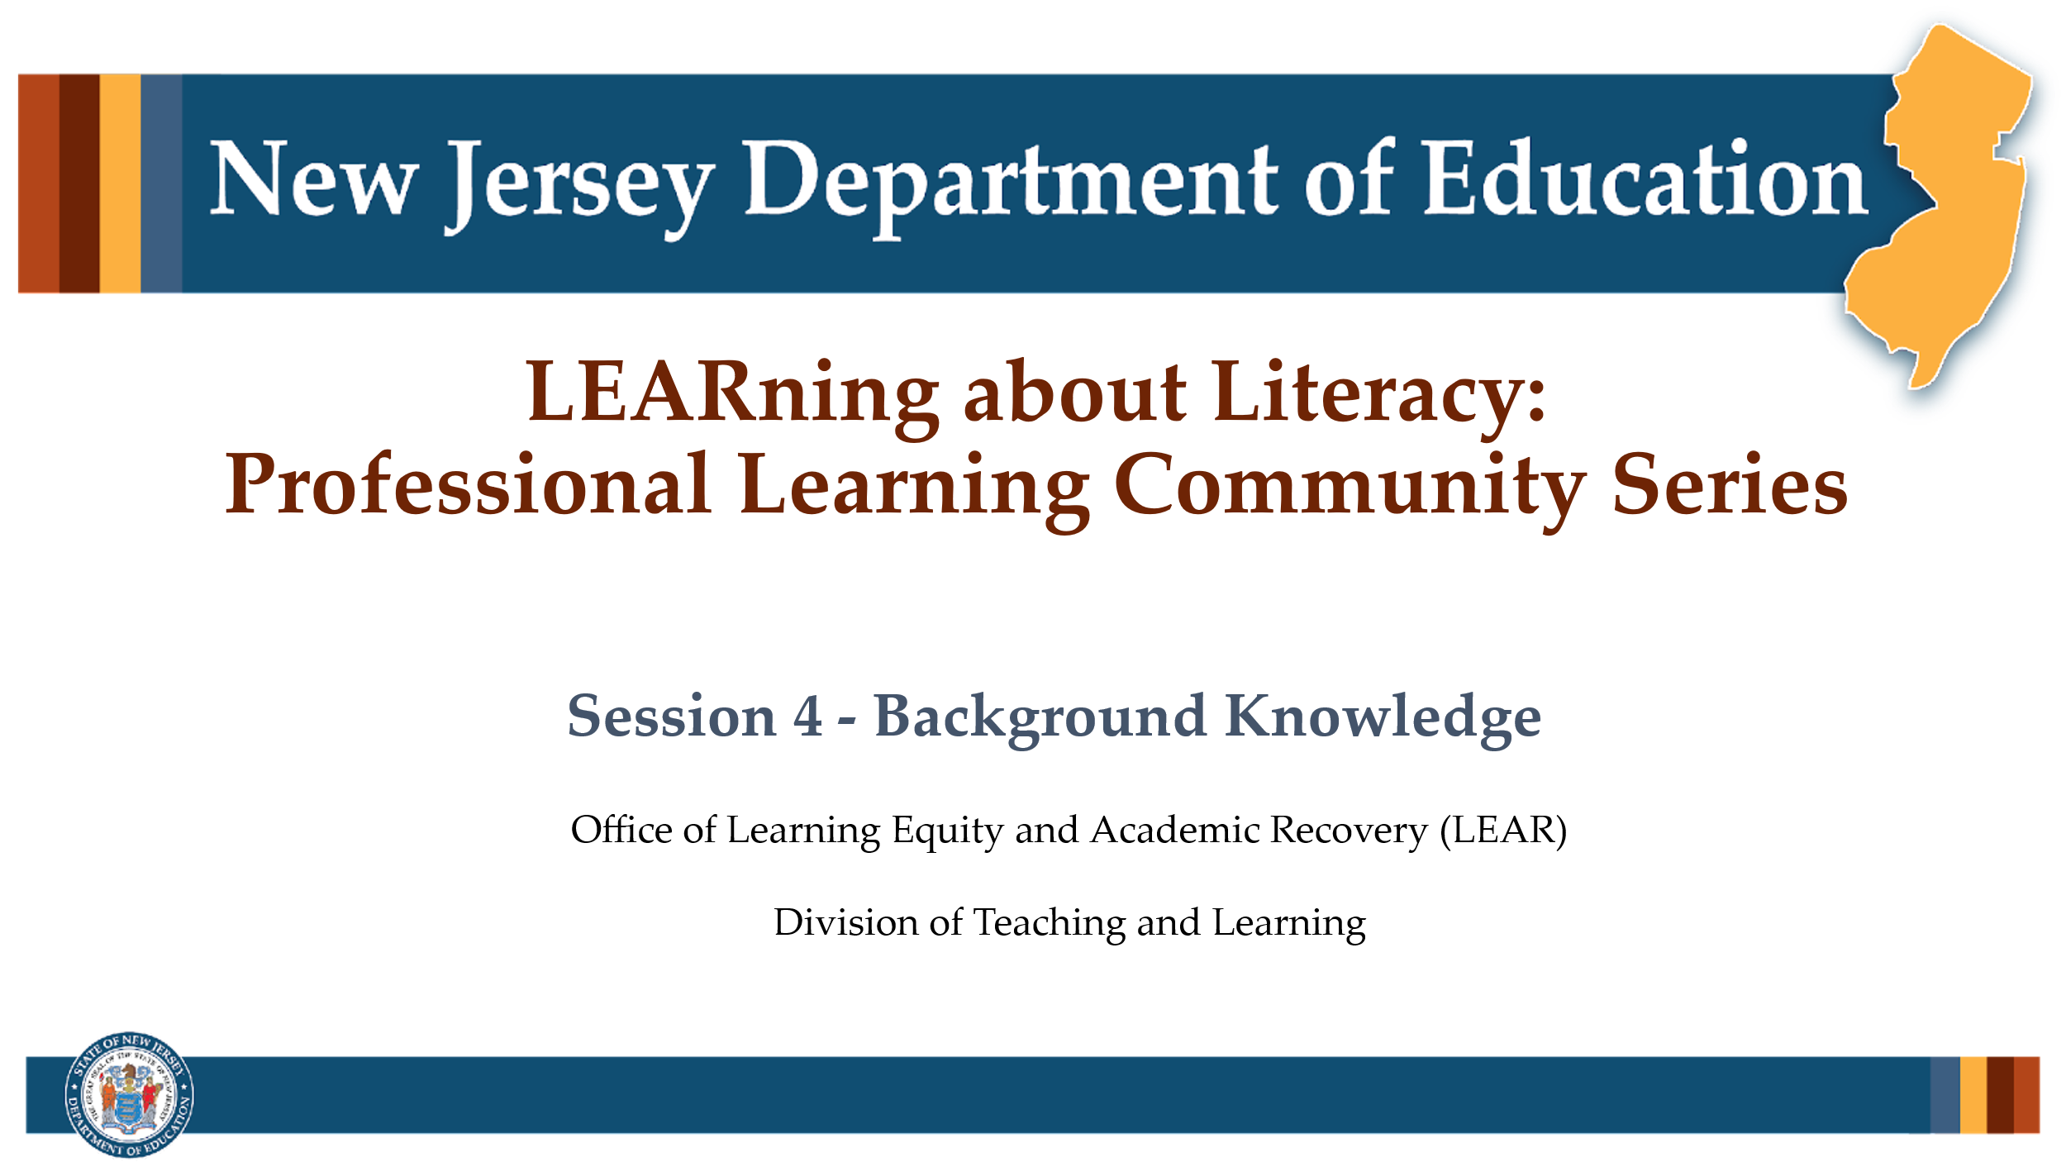

#### Facilitator Narration

Welcome! We’re excited to have you join us for this third session in our Professional Learning Community Series. Today, we’ll be looking to strengthen our instructional practices based on the latest research in background knowledge.

### Slide 2: Background Knowledge

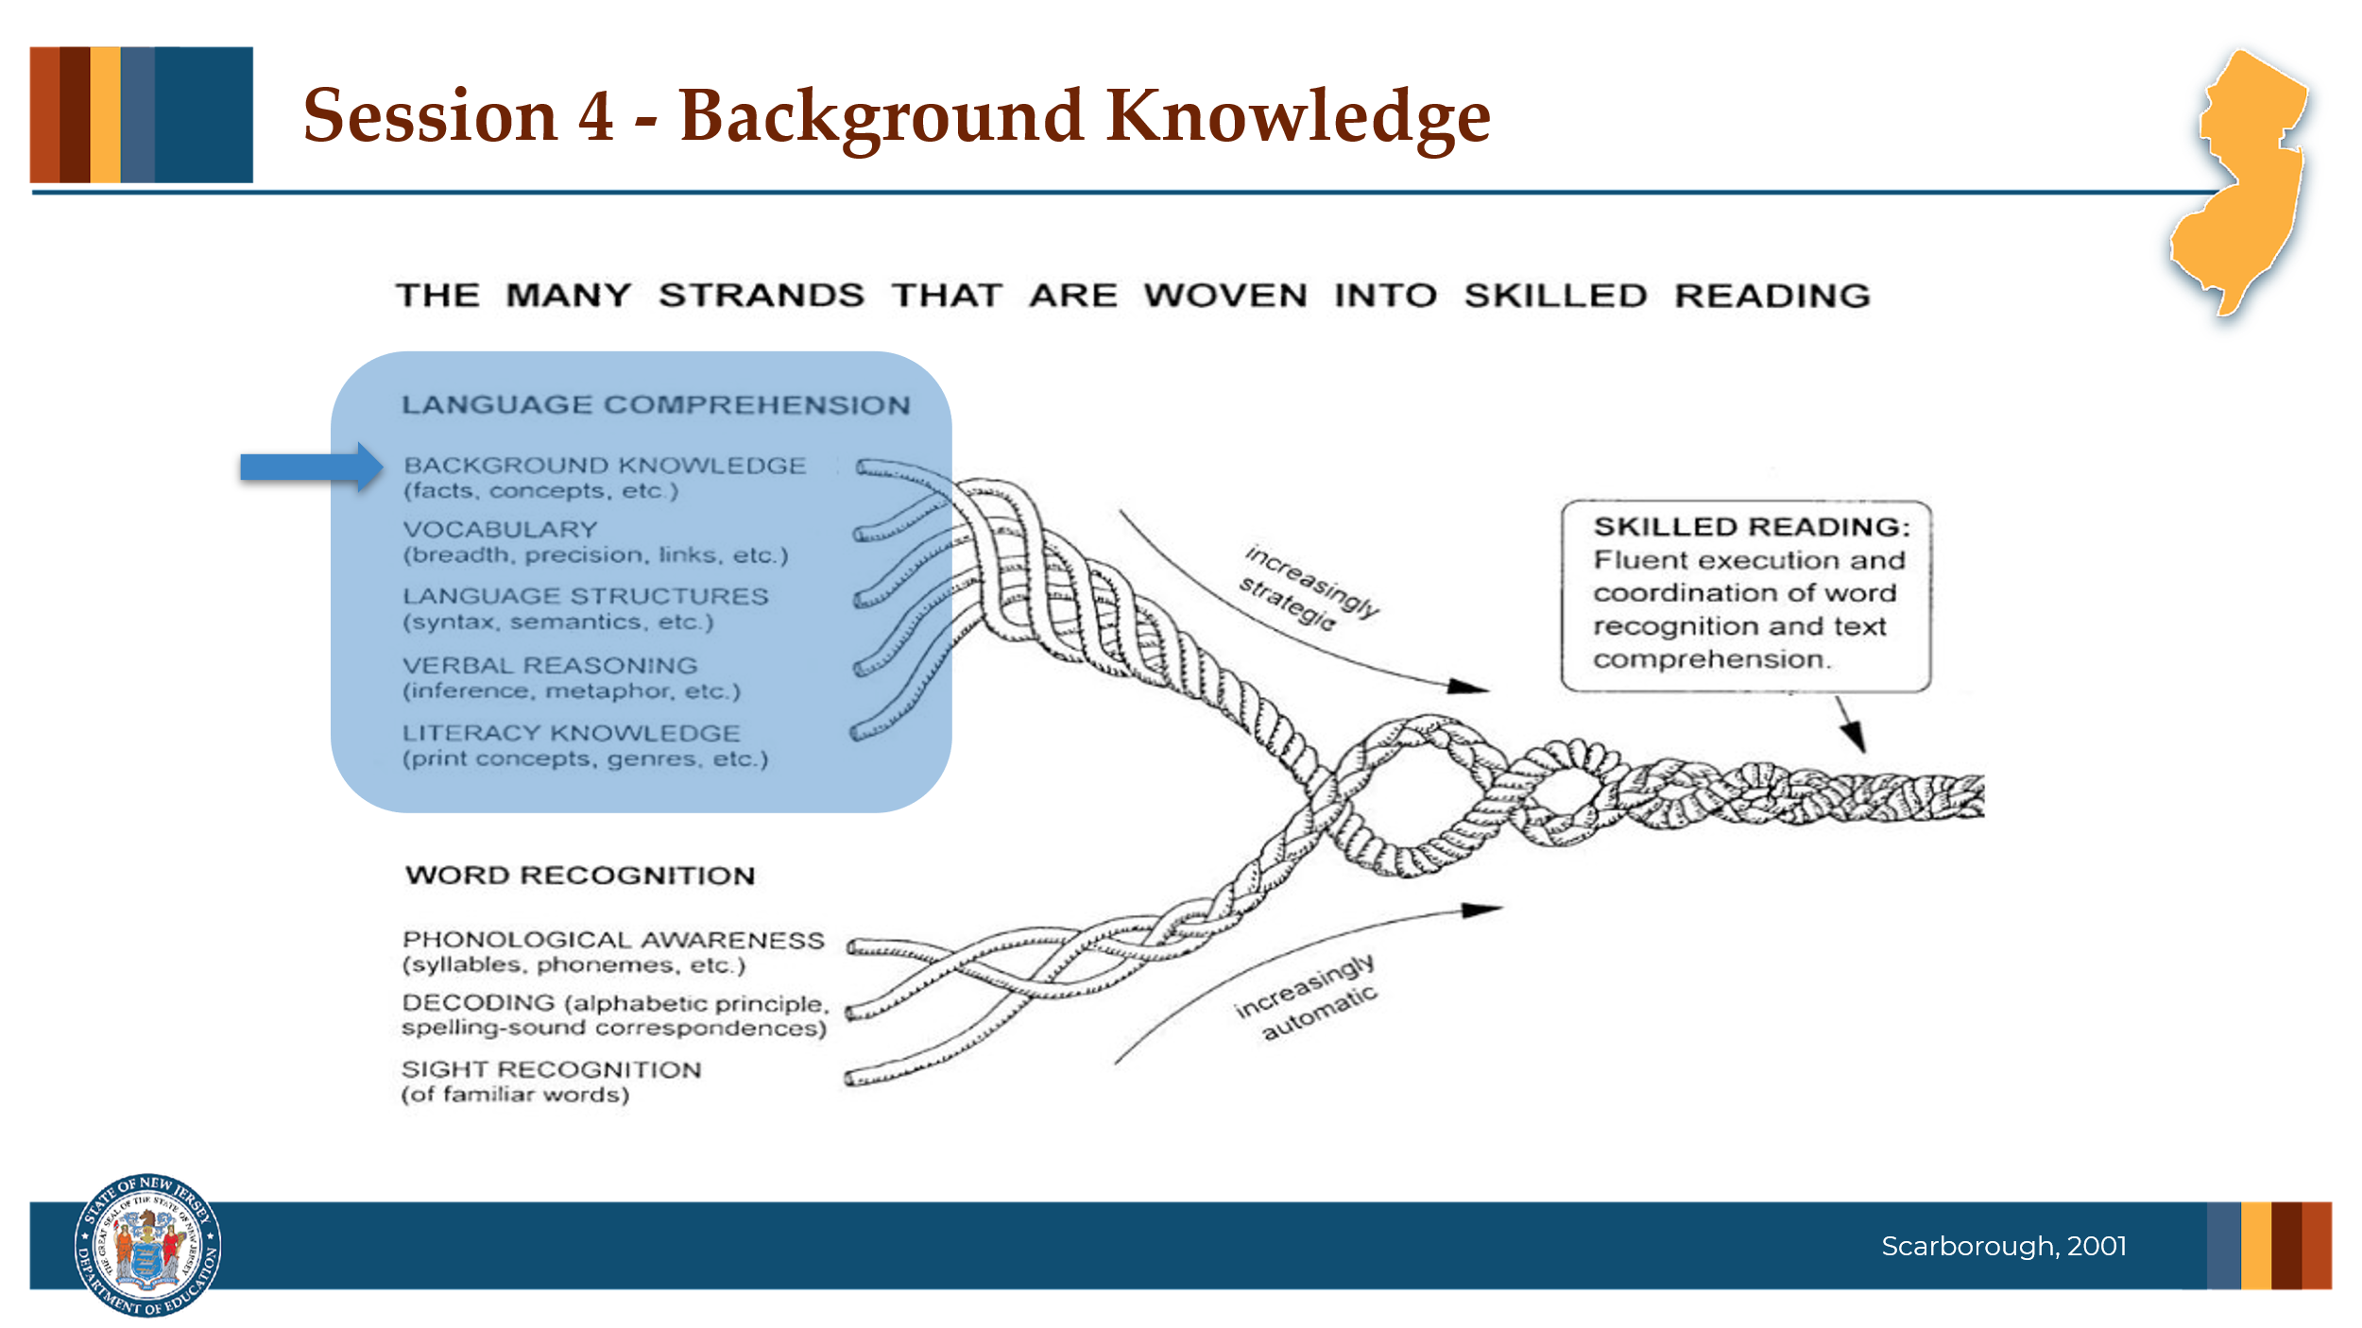

#### Facilitator Narration

Beginning with our conceptual framework for skilled reading, Scarborough’s Reading Rope, let’s spend some time together exploring the role **Background Knowledge** plays in reading comprehension.

### Slide 3: Text Version of Scarborough’s Rope

The text version is provided for people who cannot access the content in the image (e.g., someone who is blind or has low vision).

### Slide 4: Teaching Content is Teaching Reading

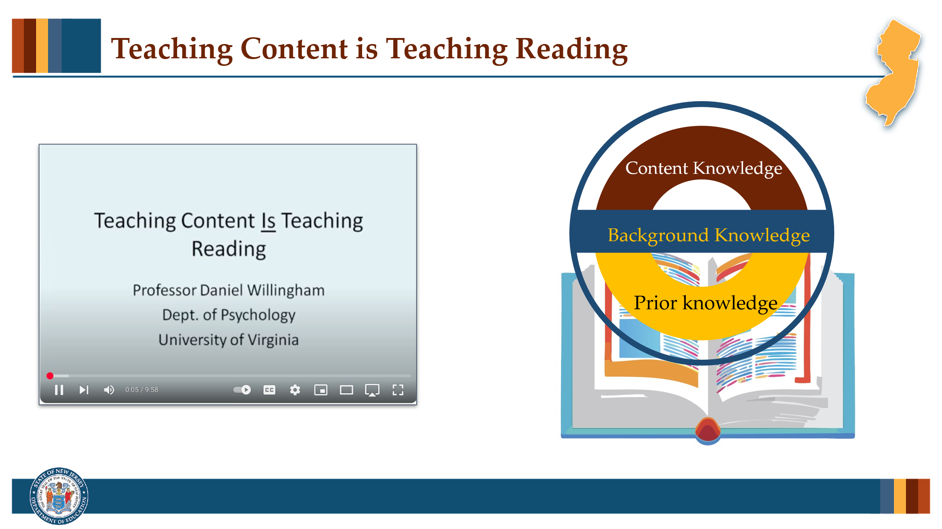

#### Facilitator Narration

As a pre-work activity for this session, we watched a video by Professor Daniel Willingham, Teaching Content is Teaching Reading. To get started with today’s session, we are going to discuss the video but first let’s think about what the terms content knowledge, prior knowledge, and background knowledge mean in relation to one another in the context of reading comprehension.

* Content knowledge is the specific and structured body of information, facts, concepts, and principles that are associated with a particular subject or academic discipline. It represents the "what" of learning—what learners are expected to know and master.
* Prior knowledge refers to the information, skills, experiences, and understandings that a learner brings to a new learning situation. It encompasses any pre-existing mental frameworks or conceptual understandings—whether accurate or flawed—that a learner activates when encountering new content.

With these definitions in mind, let’s imagine background knowledge functioning as the overarching framework that supports meaning-making of a particular, specific text. When we talk about background knowledge in relation to reading comprehension, we must account for our students’ pre-existing prior knowledge and acknowledge the discipline-specific content knowledge that is needed for a reader to fully understand the specific text.

#### Activity

10–15 minutes

Now that we’ve clarified the definitions of content knowledge, prior knowledge, and background knowledge, let’s take a few minutes to reflect on the video content together. Turn and Talk with a partner and discuss the following prompts. After your discussion, we’ll come back together and share a few insights with the whole group.

* How do you see the relationship between content knowledge, prior knowledge, and background knowledge playing out in your classroom during reading instruction?
* Can you think of a moment when a student struggled with comprehension not because they lacked strategy, but because they lacked key knowledge?

### Slide 5: The ABCs of Background Knowledge (1 of 4)

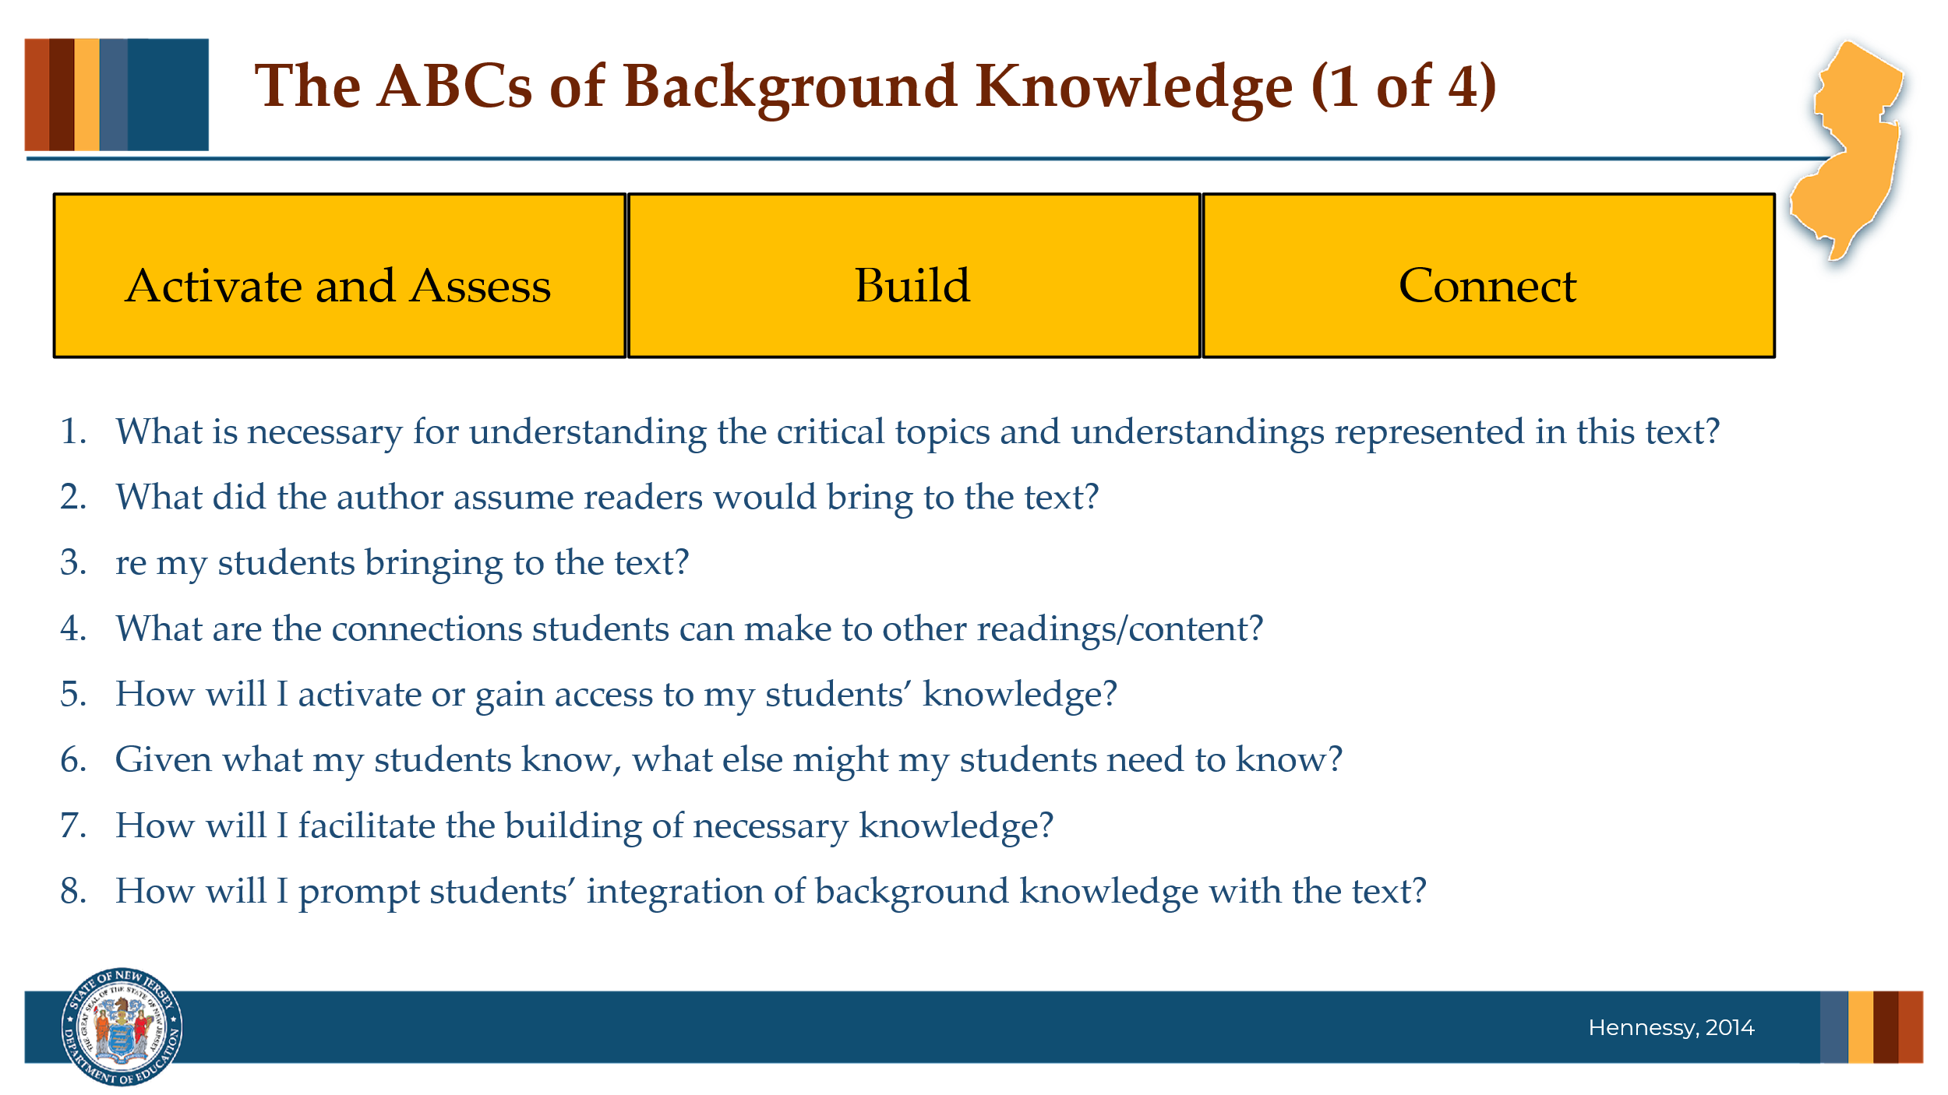

#### Facilitator Narration

Given the direct effect that background knowledge has on comprehension, let’s focus on the teacher’s role. Expert practitioner Nancy Hennessy has conceptualized The ABCs of Background Knowledge, a framework we can use to plan intentional instruction that Activates and Assesses, Builds, and Connects to the Background Knowledge student need for a text we are teaching in our classroom. Ms. Hennessy suggests we ask ourselves some important questions when planning instruction. Can I get some volunteers to read these suggested questions?

#### Volunteer Reads

* What is necessary for understanding the critical topics and understandings represented in this text?
* What did the author assume readers would bring to the text?
* What are my students bringing to the text?
* What are the connections students can make to other readings/content?
* How will I activate or gain access to my students’ knowledge?
* Given what my students know, what else might my students need to know?
* How will I facilitate the building of necessary knowledge?
* How will I prompt students’ integration or connection of relevant background knowledge with the text?

#### Question

Reflect on this ABC framework and the guiding questions we just read aloud. How do you currently approach activating, building, and connecting background knowledge in your reading instruction? Which part of the ABCs feels most familiar or natural to you, and which part might require more intentional planning in your practice?

### Slide 6: The ABCs of Background Knowledge

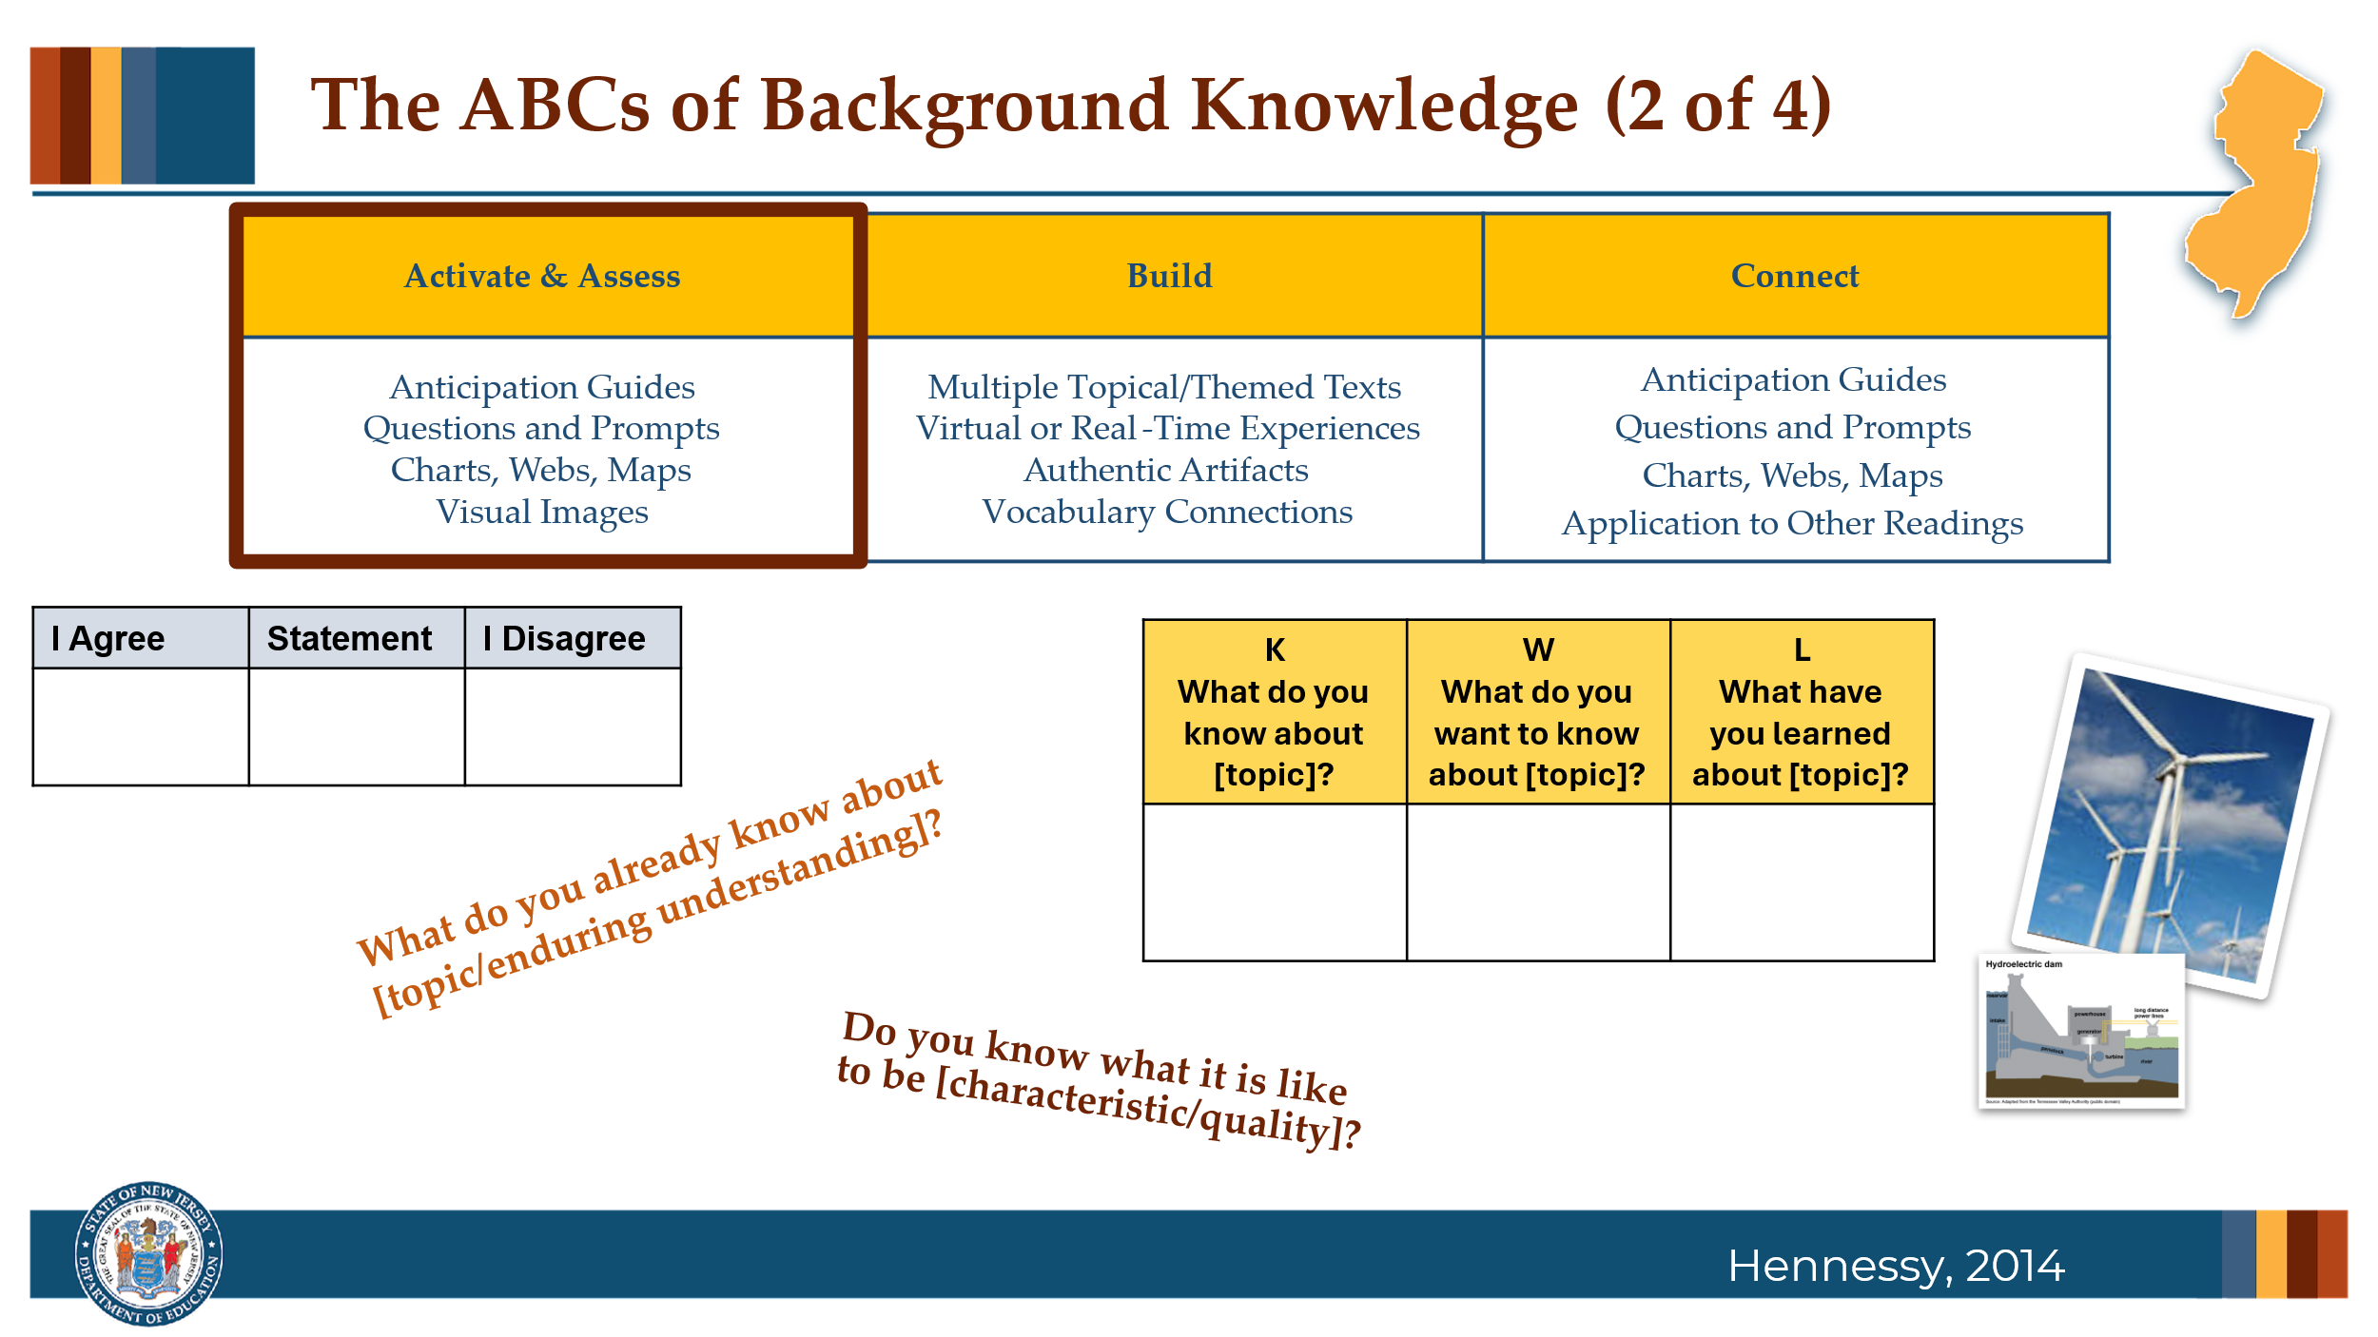

#### Facilitator Narration

Now let’s explore some instructional activities aligned with each component of the ABCs of Background Knowledge framework. To Activate and Assess Students’ Background Knowledge:

* Anticipation Guides can be used before reading to spark interest and activate prior knowledge. Students respond to a series of statements related to key ideas in the text—agreeing or disagreeing based on what they already know. These guides help surface students’ preconceptions and set a purpose for reading.
* Open-ended Questions and Prompts can be posed that tap into relevant background knowledge before or during reading. These can help students make connections between what they already know and the new content in the text.
* Visual Organizers such as concept maps, webs, or KWL charts can support students in organizing their existing knowledge, identifying gaps, and connecting ideas as they engage with a text.
* And visual Images, such as photographs, illustrations, artwork, and other images—from picture books, media, or online sources—can be powerful tools to activate background knowledge. Pair them with guiding questions to prompt observation, discussion, and connections to the text’s content

#### Questions

* Which of these strategies for activating and assessing background knowledge have you used before?
* What worked well, and what challenges did you encounter?

#### Optional Follow-up Prompts for Deeper Conversation

* Are there particular texts or topics where these strategies have been especially helpful?
* How do your students respond to these approaches?
* Is there a strategy you’ve heard today that you haven’t used yet but would like to try? What might that look like in your context?

### Slide 7: The ABCs of Background Knowledge

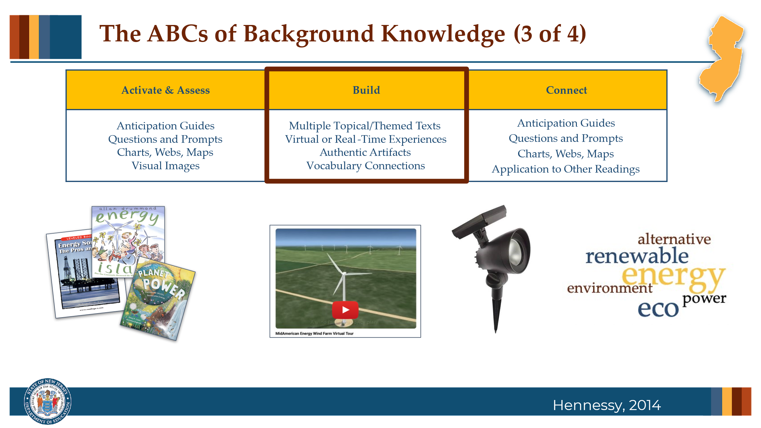

#### Facilitator Narration

Let’s now turn to strategies that help build the background knowledge students need to engage deeply with a text:

* Organizing instruction around **Multiple Topical or Themed Texts** allows students to explore content from different angles. This approach strengthens their understanding of language, vocabulary, and domain-specific concepts across genres and content areas.
* **Virtual or Real-Time experiences** such as field trips, virtual museum tours, or guest speakers, bring abstract topics to life. Immersing students in real-world contexts can spark interest and provide concrete references for new learning.
* With thoughtful guiding questions, **Authentic Artifacts** and real-world items like maps, objects, or primary documents can introduce key concepts in tangible ways and prepare students to engage with new information in texts.
* Teaching **Vocabulary Connections** before and during reading helps students access and retain new information. Explicit instruction of key terms and the use of context clues to derive meaning of new words while reading builds the linguistic foundation students need to make meaning from text and repair comprehension when it breaks down.

#### Questions

* Which of these strategies for building background knowledge have you used in your instruction?
* What impact did they have on student engagement or comprehension?

#### Optional Follow-up Prompts for Deeper Conversation

* Can you recall a time when one of these strategies helped a student make a breakthrough in understanding?
* What challenges have you faced when trying to incorporate these approaches?
* Which of these strategies would you like to try or expand on in your current instruction, and why?

### Slide 8: The ABCs of Background Knowledge

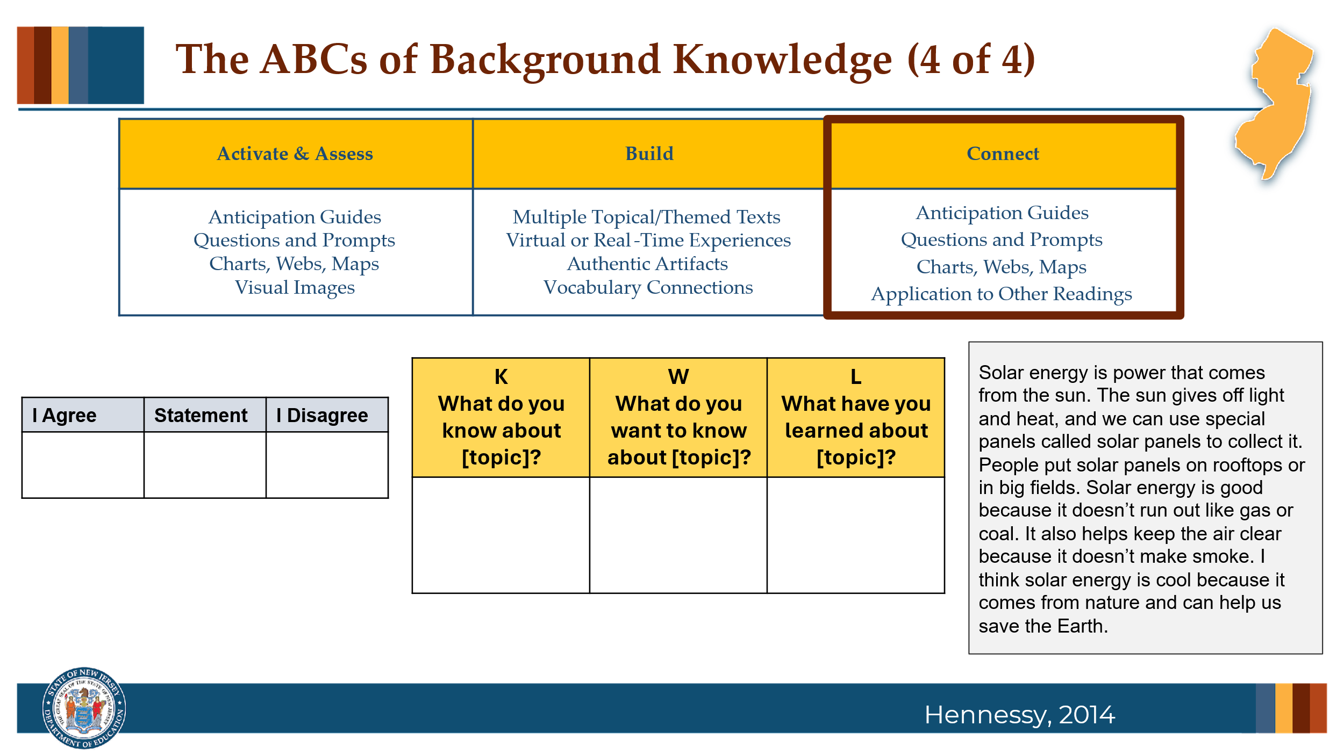

#### Facilitator Narration

Activating, assessing, and often building background knowledge are essential steps that pave the way for students to make meaningful connections with a text. Skilled readers consistently draw upon and integrate their knowledge before, during, and after reading. This ability is deeply supported by intentional instruction that ensures students have access to the knowledge they need in order to understand and engage with what they read. After reading, students can:

* Revisit their **anticipation guides** to revise or expand on their initial responses in light of new information.
* Complete the “Learned” sections of **visual organizers** (e.g., KWL charts or concept webs), helping them consolidate their understanding.
* Respond to **reflection prompts**, either orally or in writing, that encourage them to connect what they’ve read to their own experiences, to other texts they’ve read, or to broader themes within the unit.

These post-reading activities not only deepen comprehension but also promote metacognitive habits—helping students become more thoughtful, reflective readers who see learning as a process of continuous connection-making.

### Slide 9: Adapting to Student Needs

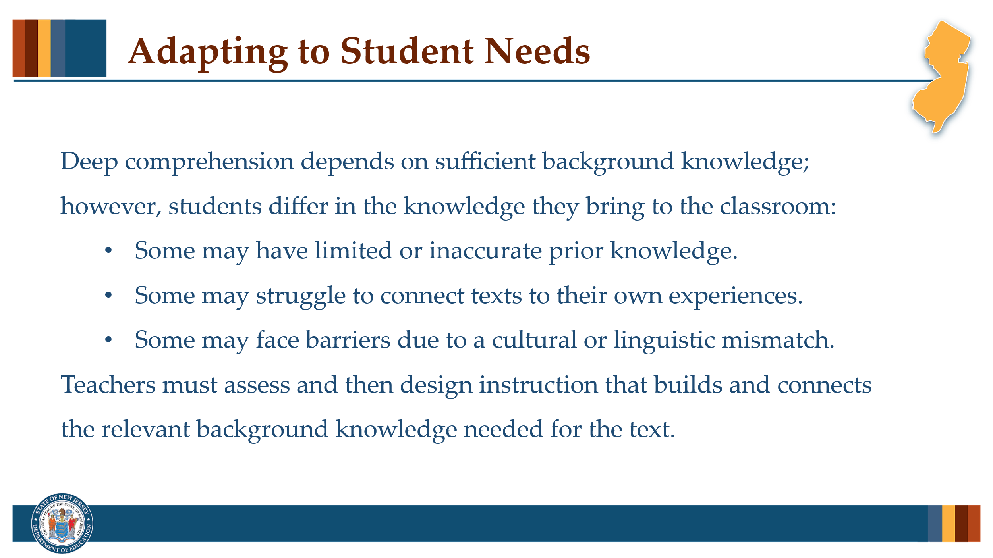

#### Facilitator Narration

Students cannot be expected to comprehend deeply or excel academically if they lack the necessary background knowledge to engage with texts they are asked to read in the classroom. Research shows that struggling readers often have difficulty making connections between the texts they read and what they already know. These students may have limited world knowledge, hold incomplete or inaccurate understandings of certain topics, or experience challenges accessing or applying their prior knowledge—especially when their cultural or linguistic background differs from the dominant classroom expectations. As a result, it is critical that teachers differentiate their instruction to ensure all students have equitable access to the background knowledge required for comprehension.

### Slide 10: Thanks for Participating!

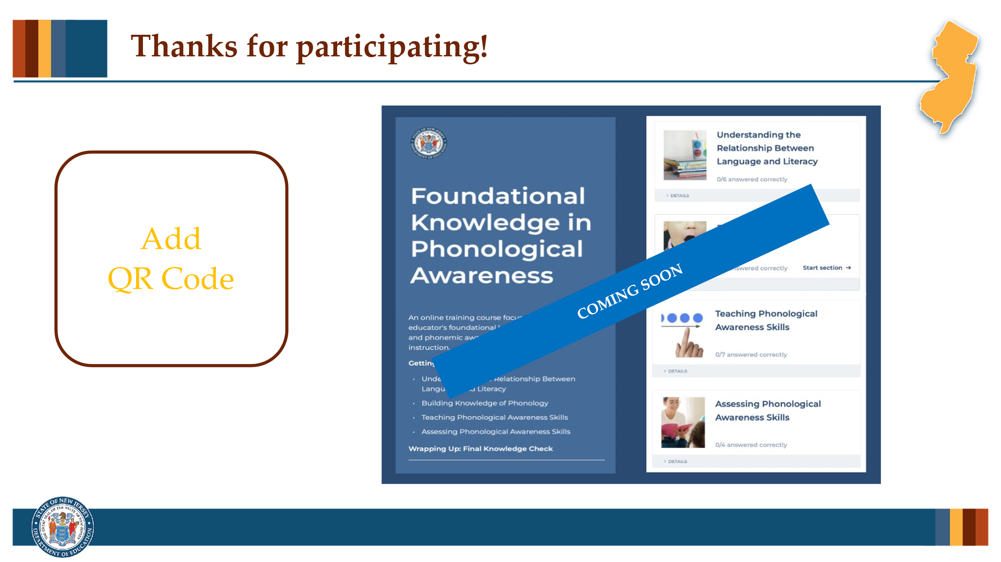

#### Facilitator Narration

This brings us to the end of our session today! If you are interested to learn more about reading fluency, keep an eye out for the NJ Department of Education’s upcoming free SISEP online learning modules.

### Slide 11: Next Session in the PLC Series

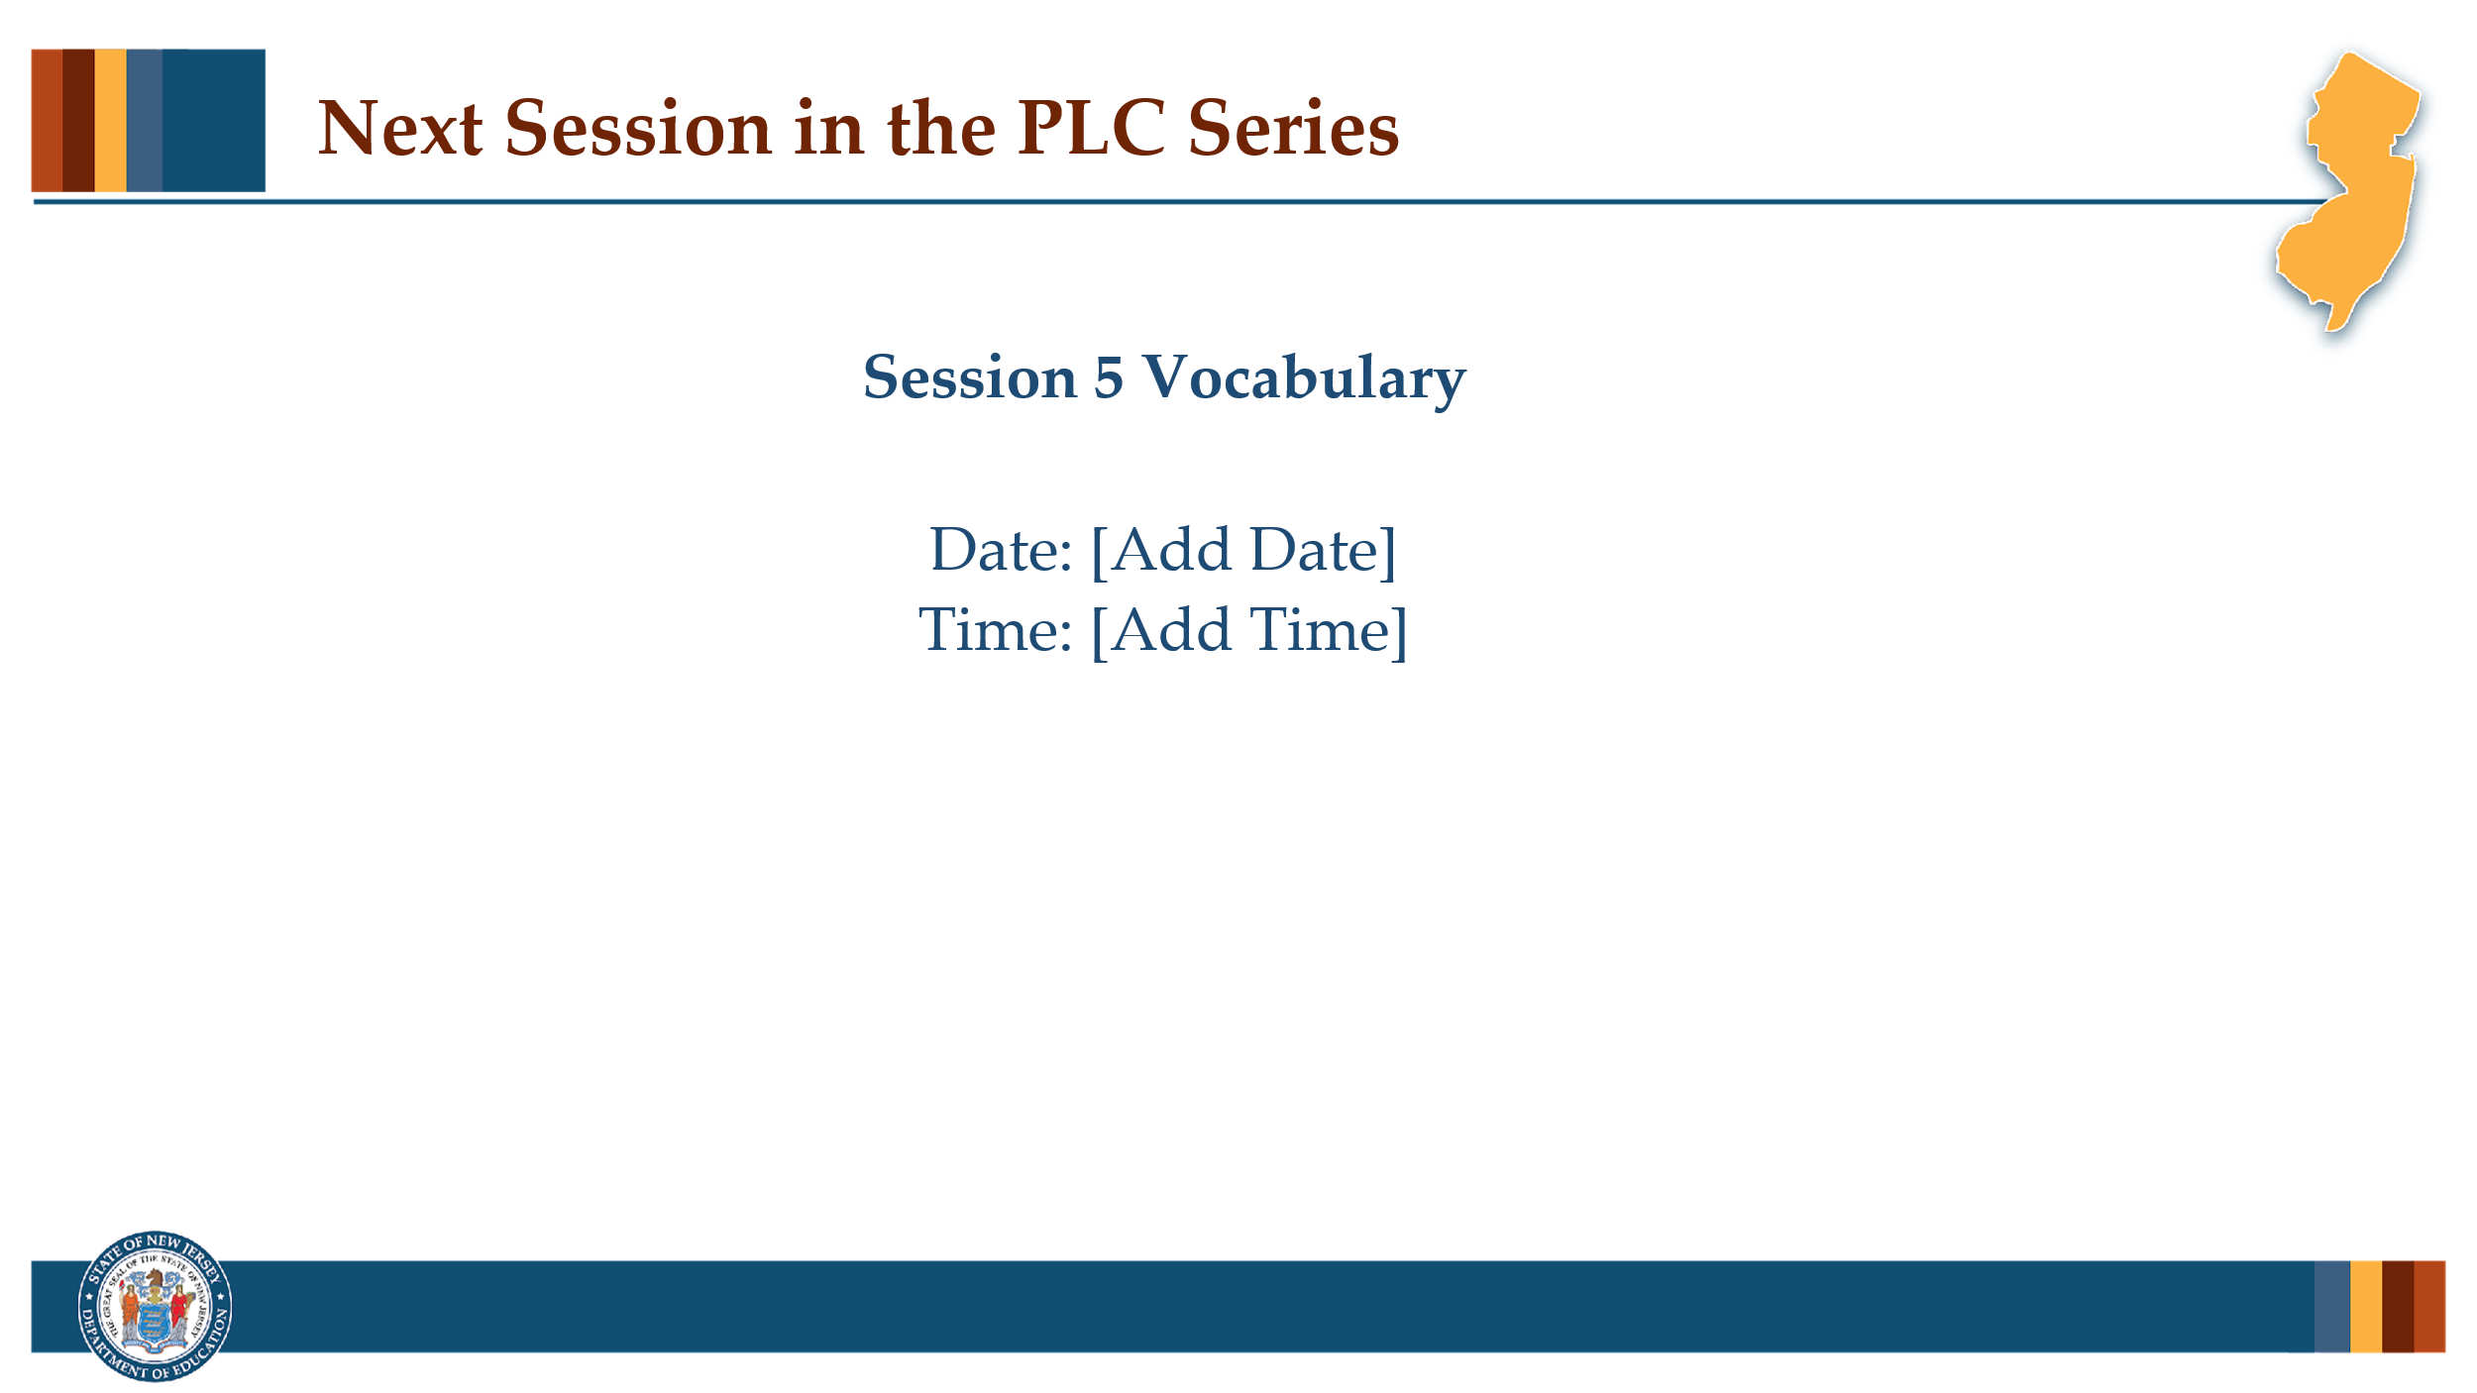

#### Facilitator Narration

Up next is Session 5 Background Knowledge. This PLC session will focus on best practices in vocabulary. We will meet on [add date and time]. See you then!

### Slide 12: References

This slide lists references from the presentation.

### Session Materials Needed

PLC Series Session 4 - Slide Presentation

If the session is being delivered virtually, use a virtual meeting space that allows for meeting participants to engage via both audio and video.