

LEARning about Literacy:
Professional Learning Community (PLC) Series
Session 5 Vocabulary Facilitator Guide
This facilitation guide provides a structured approach to lead Session 5 Vocabulary. The session aims to help educators understand vocabulary acquisition and instruction and its connection to the development of language comprehension skills. The facilitator is tasked with preparing materials, engaging participants, and ensuring active participation throughout the session.

Step-by-Step Facilitation Process
- Send Pre-Work Email to Community Members: Send the pre-drafted email with the pre-work assignment attached (e.g., reading or video) and session details (date, time, location/platform).
- Review Pre-Work and Session Presentation Materials: Review the pre-work assignment, session slides, and facilitator notes to ensure familiarity with content.
- Prepare and Update Session Presentation Materials: Update slides with relevant contextual information for the group, prepare all handouts and supplementary resources needed, and check on the room set up, materials needed for activities, and technology to ensure a smooth session. Test any video links in the presentation to confirm they are working properly.
- Deliver the Session: Present the pre-drafted session presentation, engage participants with discussions and activities, and answer questions to ensure understanding.
- Invite Community Members to Next Session: Thank participants, share details of the next session, and encourage ongoing engagement with additional resources.

Draft Email
Subject Line: Join us for Session 5! Evidence-Based Literacy Instruction PLC Series
Dear [Staff Member],
This is a friendly reminder that the fifth session of the Learning Equity & Academic Recovery’s Evidence-Based Literacy Instruction Professional Learning Community (PLC) Series is coming soon!

PLC Session 5: Vocabulary
Date: [Insert Date]
Time: [Insert Time]
Location: [Insert Location/Platform Link]
In this session, we will focus on vocabulary acquisition and instruction, with an emphasis on effective classroom instructional approaches and routines. The session is designed to be interactive and collaborative, allowing you to engage with your colleagues and share ideas and best practices for supporting students’ literacy development.
Prior to our session together, please be sure to visit Reading Universe to learn about the “7 Features of a Word” in their Vocabulary Skill Explainer. To be prepared for our discussion and activities, choose a vocabulary word that you will be teaching this week and make note of these 7 features.
We look forward to seeing you there and working together to enhance our literacy instruction!
Best regards,
[Your Name]
[Your Title]
[School District Name]
[Your Contact Information]

Session Presentation Facilitation Notes

Slide 1: Title Slide
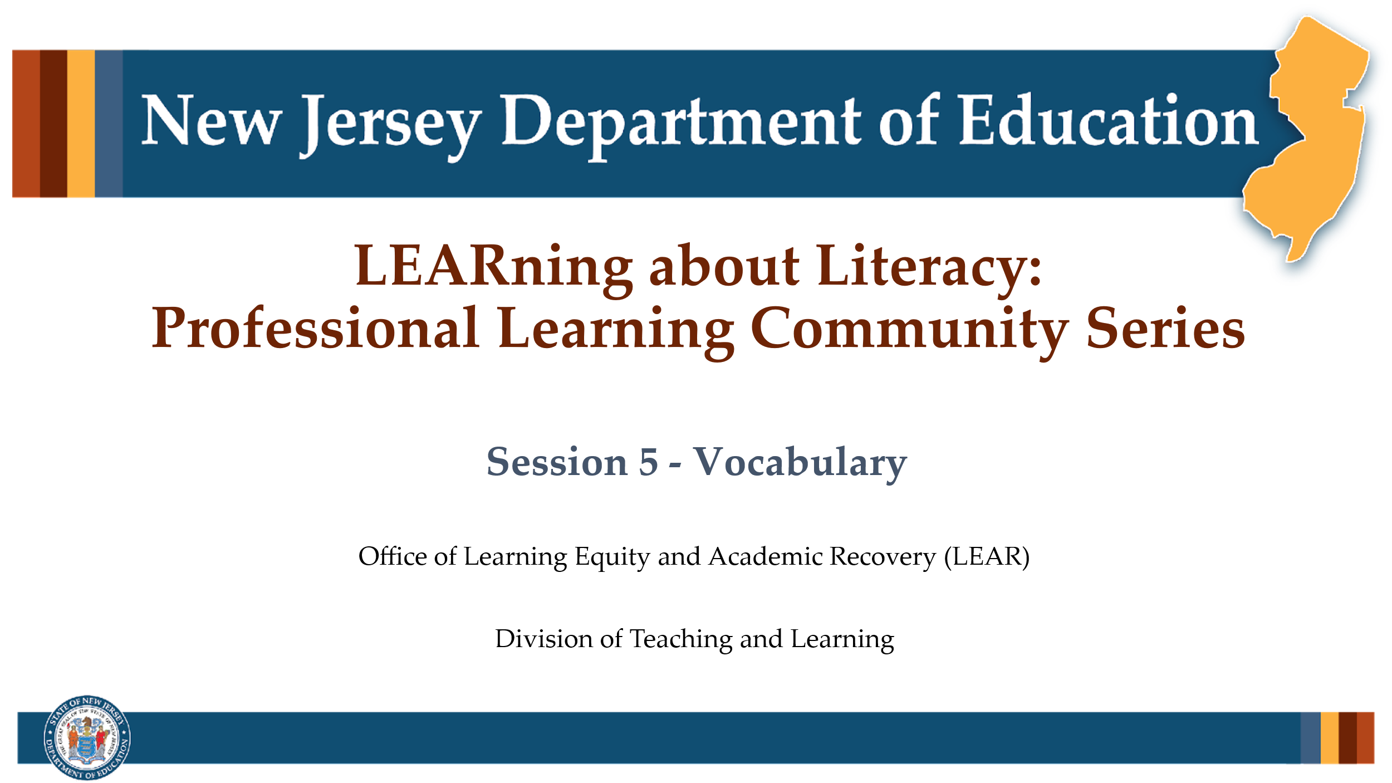

Facilitator Narration
Welcome! We’re excited to have you join us for this fifth session in our Professional Learning Community Series.

Slide 2: Vocabulary
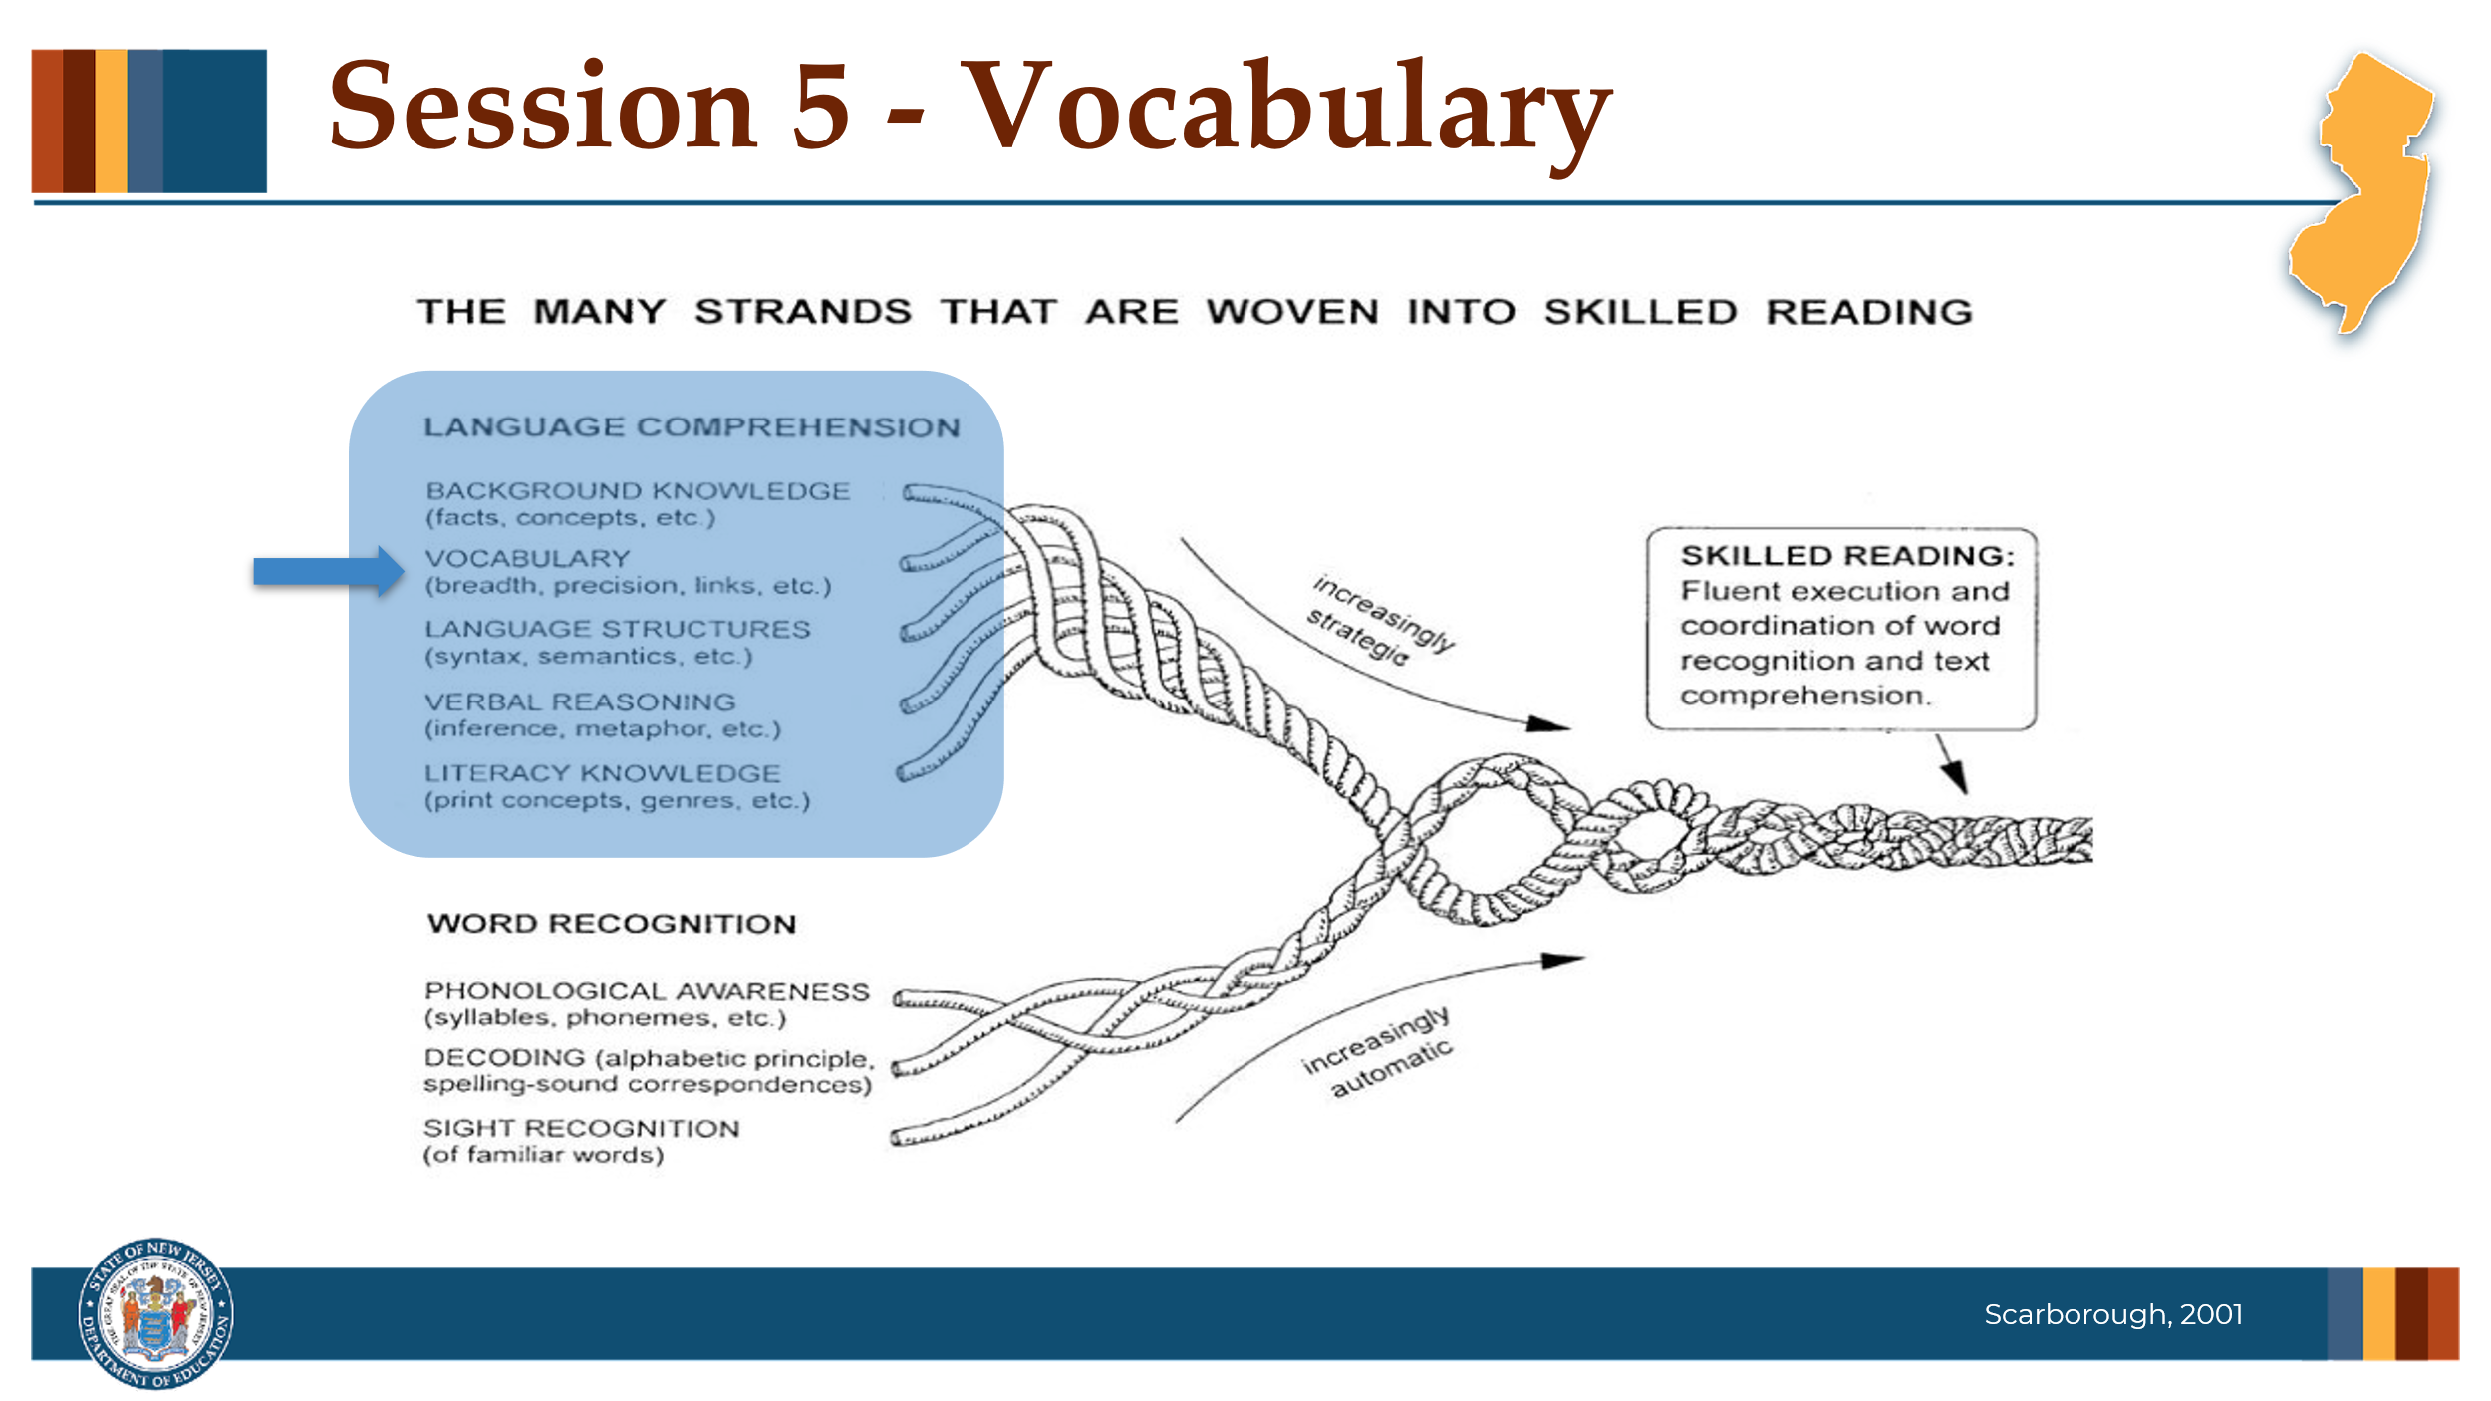

Facilitator Narration
Always starting with our conceptual framework for skilled reading, Scarborough’s Reading Rope, today’s session will explore the role of Vocabulary in reading comprehension.

Slide 3: Text Version of Scarborough’s Rope
The text version is provided for people who cannot access the content in the image (e.g., someone who is blind or has low vision).

Slide 4: The Importance of Vocabulary
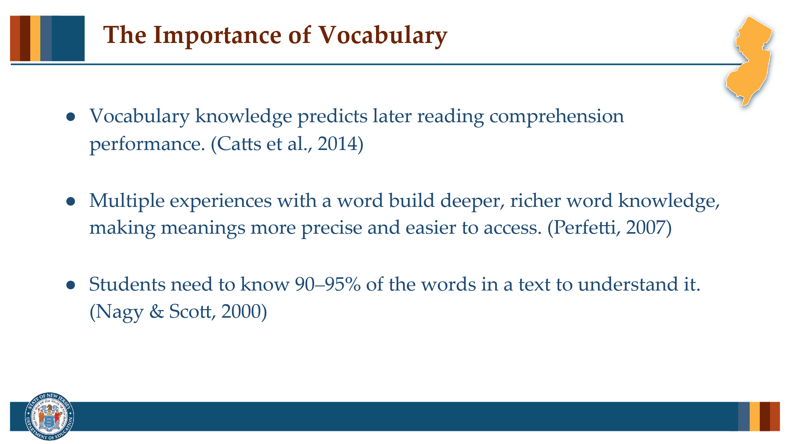

Facilitator Narration
Vocabulary plays a crucial role in reading development.
- Research shows that vocabulary knowledge is highly predictive of later reading comprehension — in fact, students with stronger vocabularies tend to score higher on comprehension assessments.
- Knowledge of individual word meanings is essential for building understanding of larger texts, but it’s not enough to simply memorize definitions. To truly grasp texts, students need to deeply understand the words they encounter. This deep knowledge helps them navigate increasingly complex material throughout their academic and life journeys.
- To truly understand what they read, students need to know 90 to 95 percent of the words in a text. Without that foundational word knowledge, making sense of connected ideas becomes much harder.

Slide 5: Vocabulary Instruction
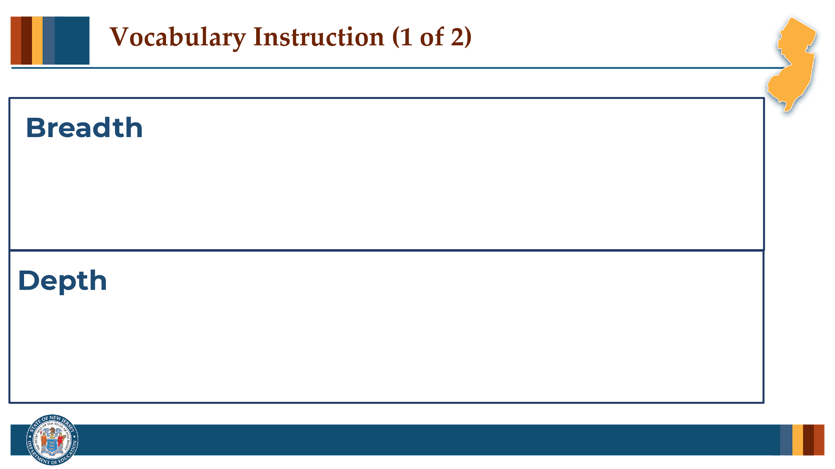

Facilitator Narration
Teachers should not assume and depth in relation to our vocabulary instruction? that all students come to class with the same level of word knowledge. Students will bring varying levels of understanding based on their personal experiences. The goal of vocabulary instruction is to build breadth and depth. As a pre-work activity for this session, we read the Reading Universe’s Vocabulary Skill Explainer. Can I get some volunteers to describe what we mean by breadth

Activity
(5 minutes)
Create a space to capture notes on the two terms. Facilitate the discussion to prompt community members for the following points:
- Breadth refers to the number of words a student recognizes or knows at a certain level, which contributes to the overall size of their vocabulary. However, breadth alone doesn’t measure how well students understand each word.
- Depth describes the richness of a student’s knowledge about a word. It’s not just about recognizing a word (breadth), but understanding its definition, context, and connections to other words. As depth increases, students can define words more thoroughly, grasp multiple meanings, and use the words more flexibly across contexts.

Slide 6: Vocabulary Instruction
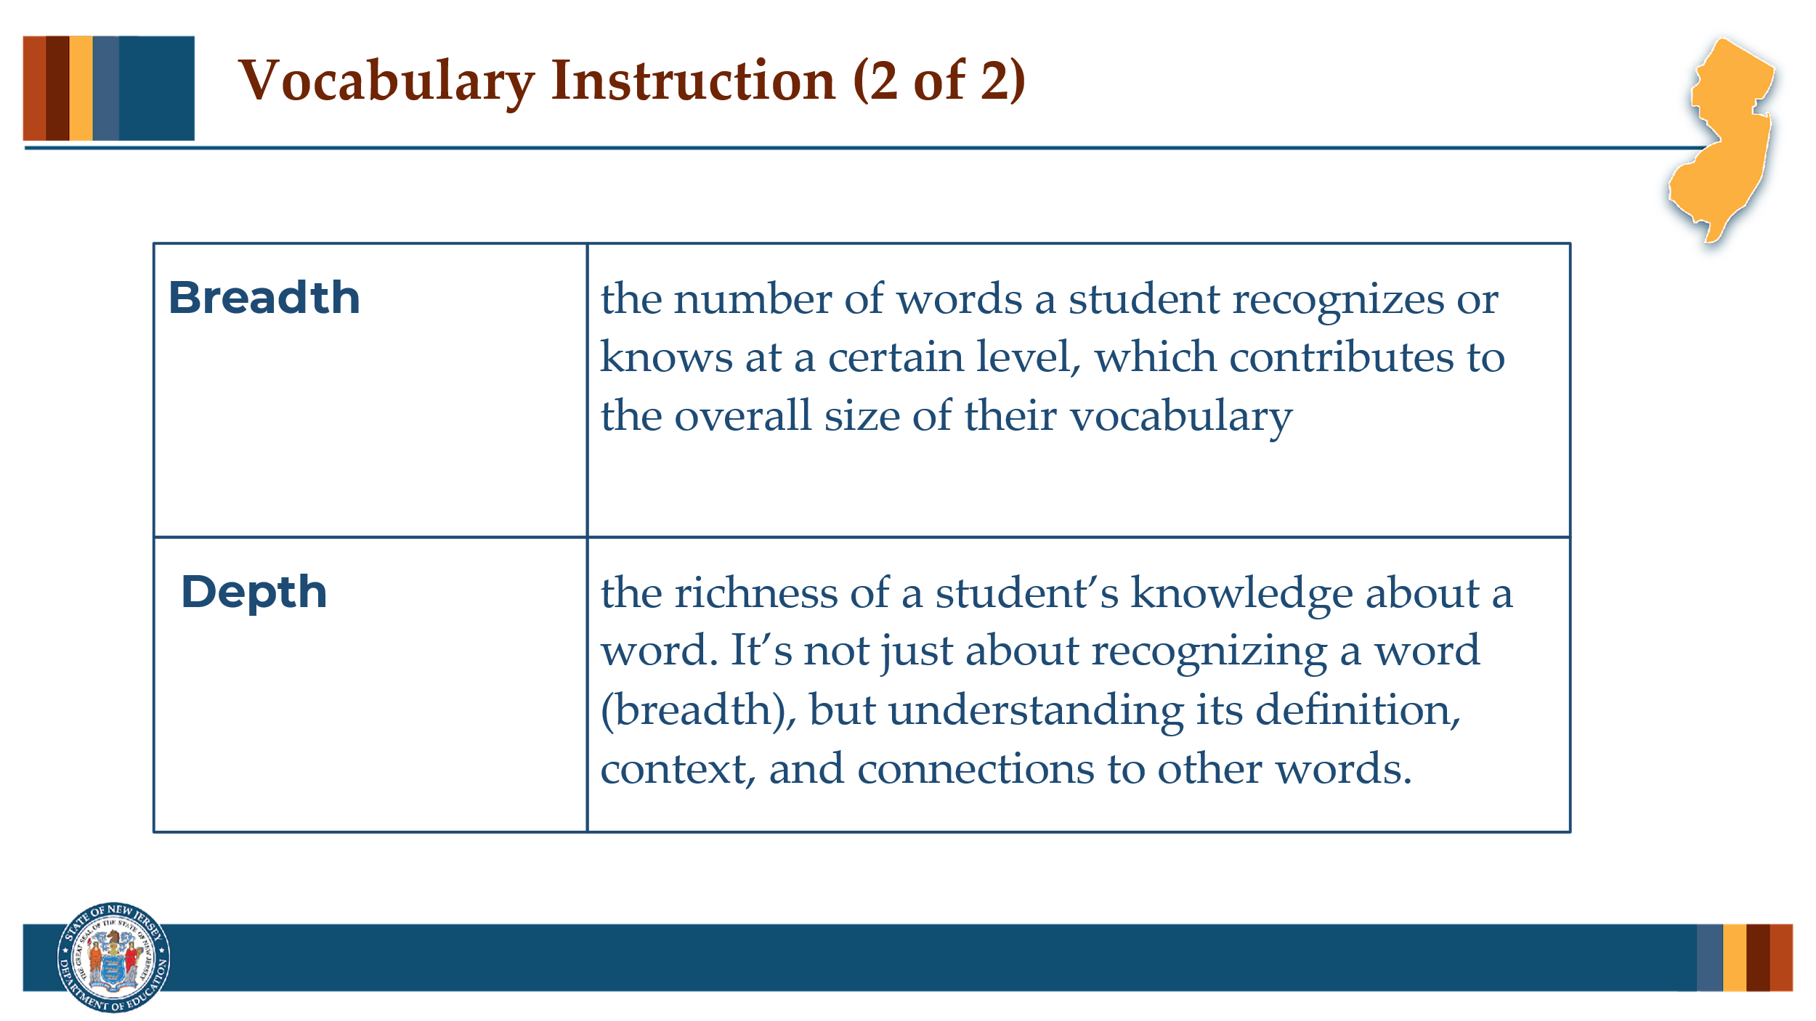

Facilitator Narration
Great discussion! It is also important to note that as students’ vocabularies deepen and they encounter words in various contexts, they will become faster at recognizing and understanding word meanings, which directly enhances reading fluency and comprehension.

Slide 7: 7 Feature of Words
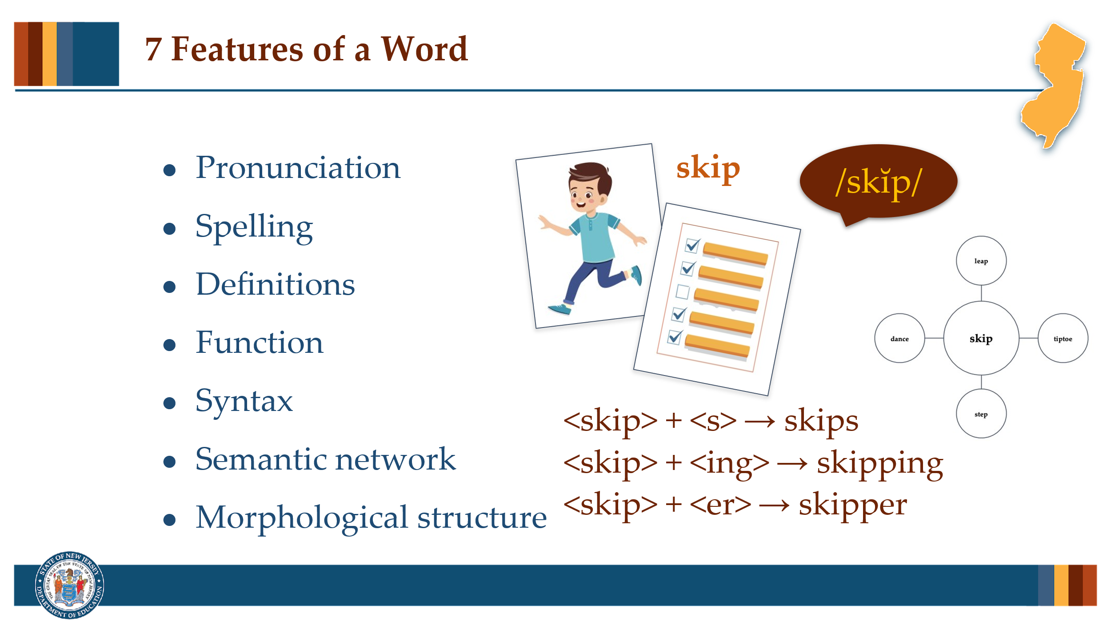

Facilitator Narration
This brings us to the “7 Features of a Word” described in our pre-work activity - pronunciation, spelling, definitions, function, syntax, semantic network, and morphological structure. The example vocabulary word used in the skill explainer was skip. We were asked to choose a vocabulary word that we would be teaching this week and make note of these 7 features. Can I get 1-2 volunteers to share the word they choose and its 7 features?

Activity
(5 minutes)
Create a space for volunteers to share their words and features. This can be shared orally or displayed visually. Facilitate a discussion around the words and let the community members know that the rest of the session will focus on ways to explicitly think about teaching vocabulary that capitalizes on these features.

Slide 8: Vocabulary Instruction
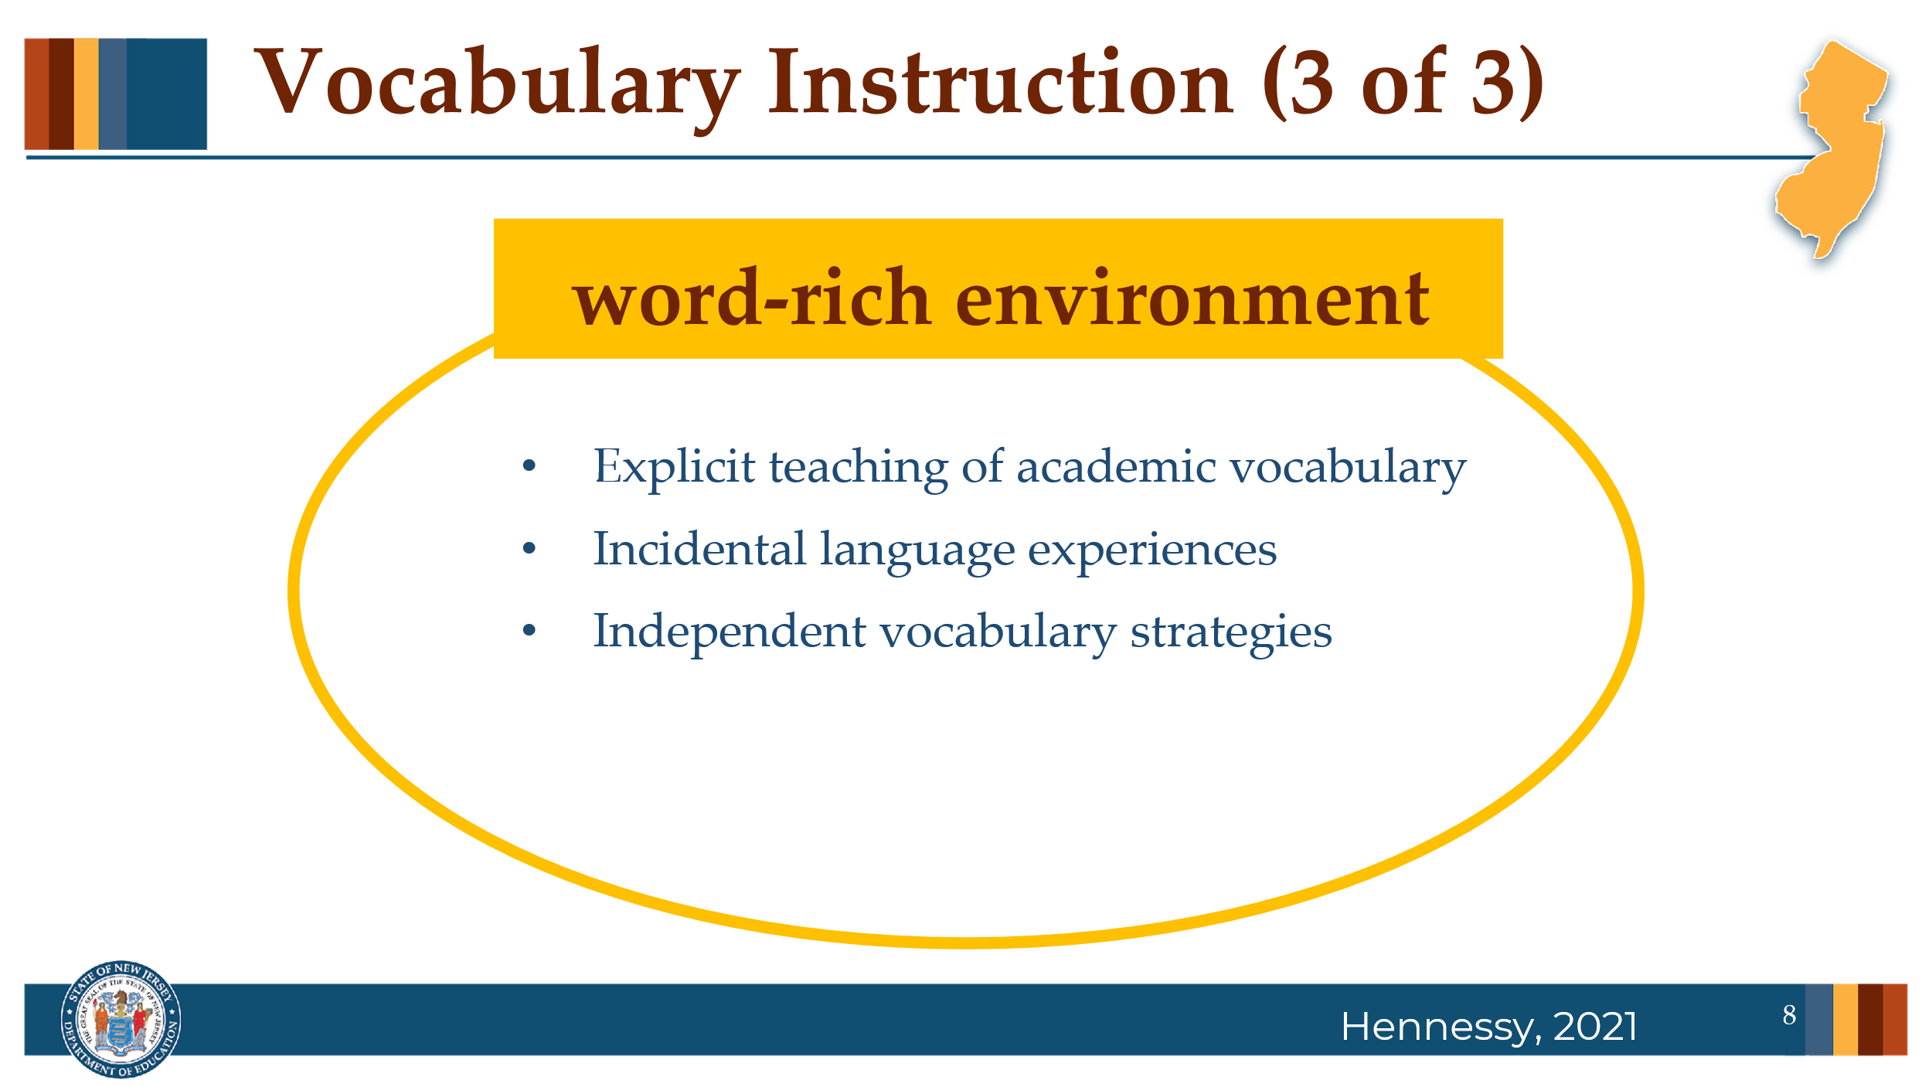

Facilitator Narration
Great work - you can see how our own understanding of word features can make vocabulary instruction richer and more explicit for our students! Now, let’s discuss instruction. When it comes to building vocabulary, children learn words in many ways, both inside and outside the classroom. As teachers, it’s important that we recognize there will be differences in our students’ vocabulary acquisition and intentionally design our instruction to support every student right from the start.
Effective classrooms foster a strong curiosity about language and actively create a word-rich environment, where students are regularly exposed to engaging discussions, playful interactions with language, and opportunities to notice, use, and enjoy words.
Within consciously word-rich classrooms, three key types of instruction work together:
- Explicit teaching of academic vocabulary, where students learn meanings through direct explanations and examples;
- Incidental language experiences, where students naturally pick up new words through conversations, read-alouds, and storytelling; and
- Independent vocabulary strategies, where students are directly taught how to figure out unfamiliar words on their own when reading, such using context clues within the text, using the morphemes that make up the word, and/or using reference tools like glossaries or dictionaries, when needed.
It's important to remember that while we can explicitly teach a few hundred words a year, students on track for proficient reading are expected to learn thousands. To meet this challenge, we must balance deep, targeted instruction with rich exposure and equip students with the tools to independently grow their vocabulary for life. Let’s look more closely at some instructional strategies for our explicit teaching.

Slide 9: Explicit Teaching of Academic Vocabulary
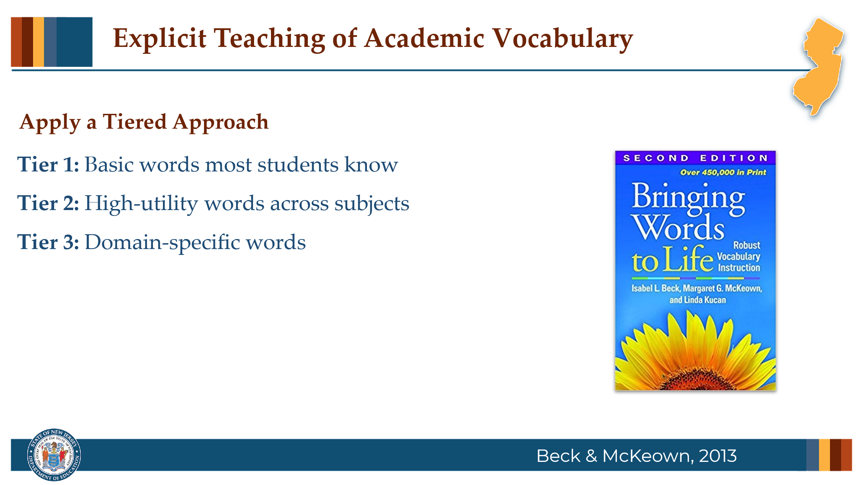

Facilitator Narration
Academic language is more complex than everyday speech and students must be prepared to handle this complexity. In vocabulary instruction, word choice is critical and you may ask: Which words should I teach? In their book Bringing Words to Life researchers Beck and McKeown explain the benefits of applying a tiered approach.
Tier 1 includes basic, everyday words — words like house, run, or baby — that most students will already know when they enter school. These words usually don't require explicit instruction unless a student needs additional support.
Tier 2 words are high-utility words that appear across many subjects and contexts. These are words like analyze, establish, or contrast. Because they are common in academic texts and important for comprehension, Tier 2 words are prime targets for explicit instruction.
Tier 3 words are domain-specific — words tied to a particular subject area, like photosynthesis in science or legislature in social studies. These words are usually taught as needed, when students encounter them in specific lessons or units.
By understanding and applying this tiered approach, we can prioritize the words that will have the biggest impact on students’ academic success, making our vocabulary instruction more focused and effective. As you choose which words to teach, it can be helpful to ask yourself a few guiding questions:
- Is this word useful beyond this one lesson or subject area?
- Does it offer opportunities for rich discussion, deeper exploration, or connection to other words and ideas?
- Can this word help students grow their vocabulary through patterns, roots, or related words?
- And, is this word essential for understanding the key ideas of the text?

Slide 10: An Explicit Vocabulary Routine
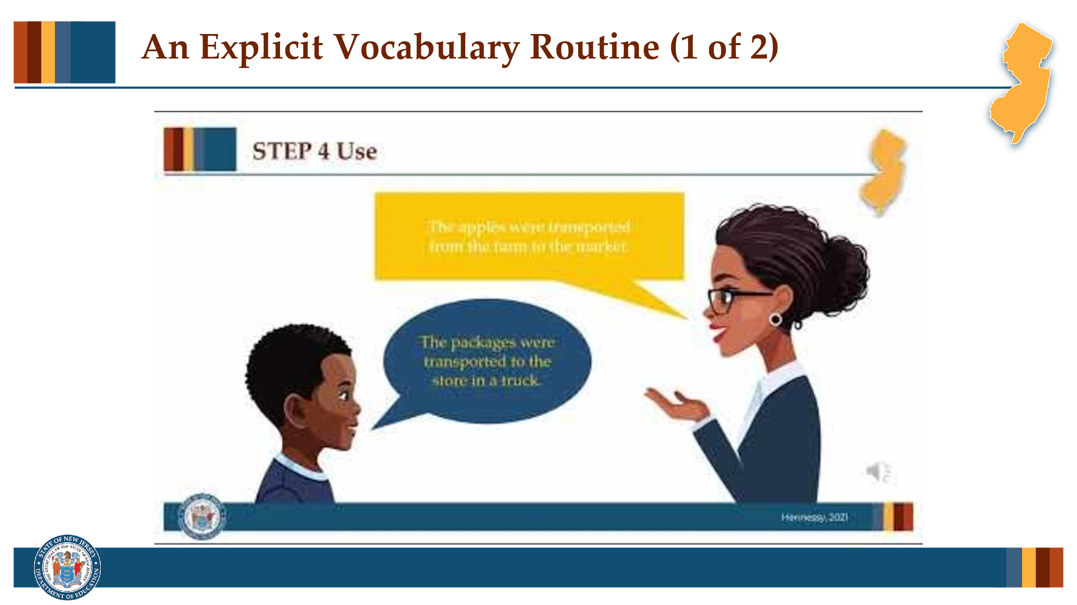

Facilitator Narration
Once we know what words we want to teach, explicit instructional routines give students both definitional and contextual exposure to the features of new words. Let’s watch this short video.

Slide 11: An Explicit Vocabulary Routine
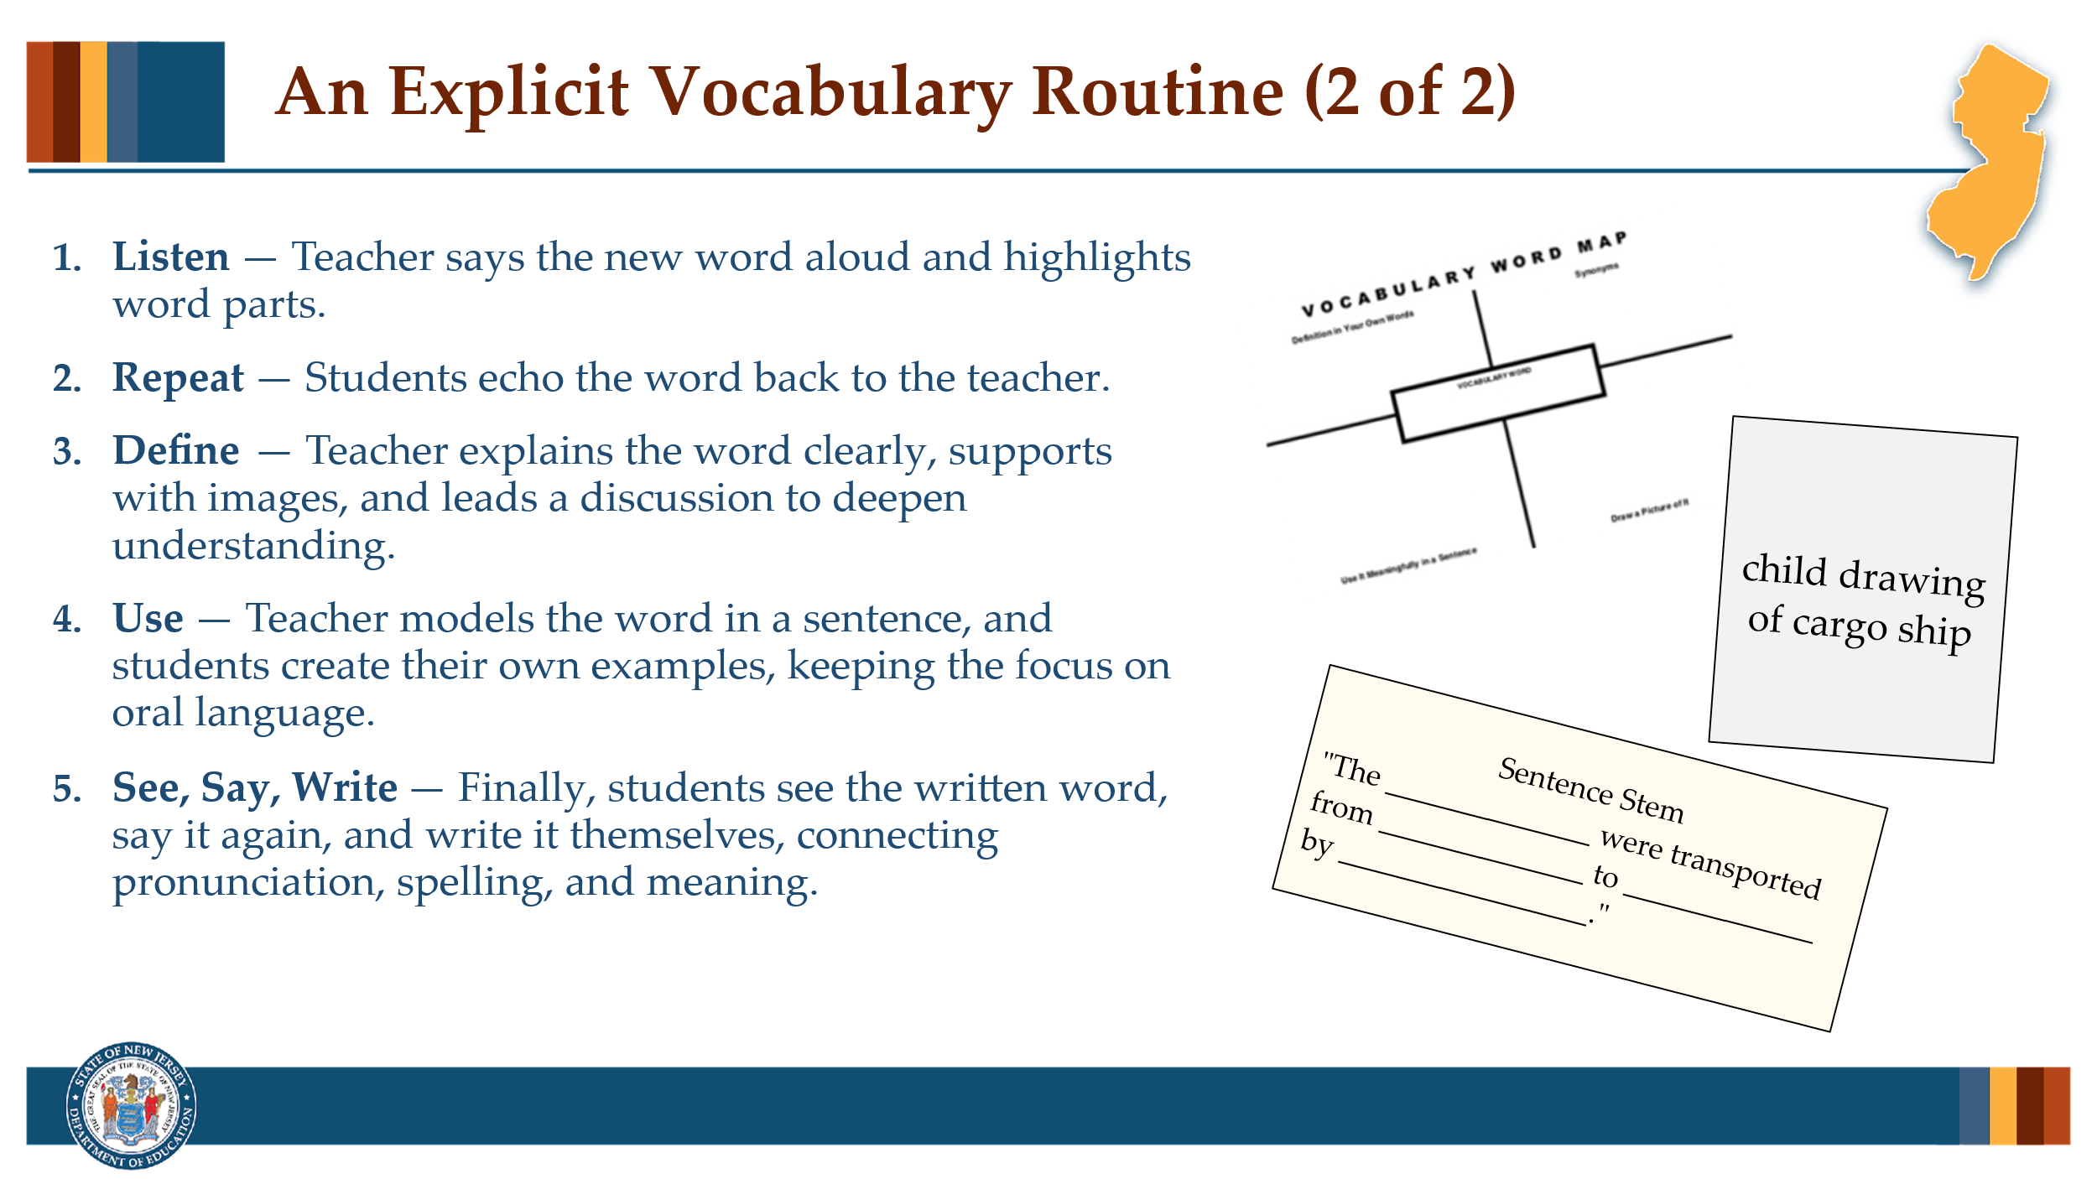

Facilitator Narration
Given that vocabulary knowledge is a key predictor of reading comprehension, it’s essential that we implement effective vocabulary instruction to help students build a broad and deep vocabulary, enabling them to understand and engage with the complex texts they will encounter throughout their lives.

Optional Activity
Have community members work in pairs to discuss how they might introduce the vocabulary word they identified in the pre-work to students using this simple vocabulary routine and what extension activities they can plan to include to provide students practice and opportunities for deep processing.

Slide 12: Text Version: Vocabulary Word Map
The text version is provided for people who cannot access the content in the image (e.g., someone who is blind or has low vision).

Slide 13: Adapting to Student Needs
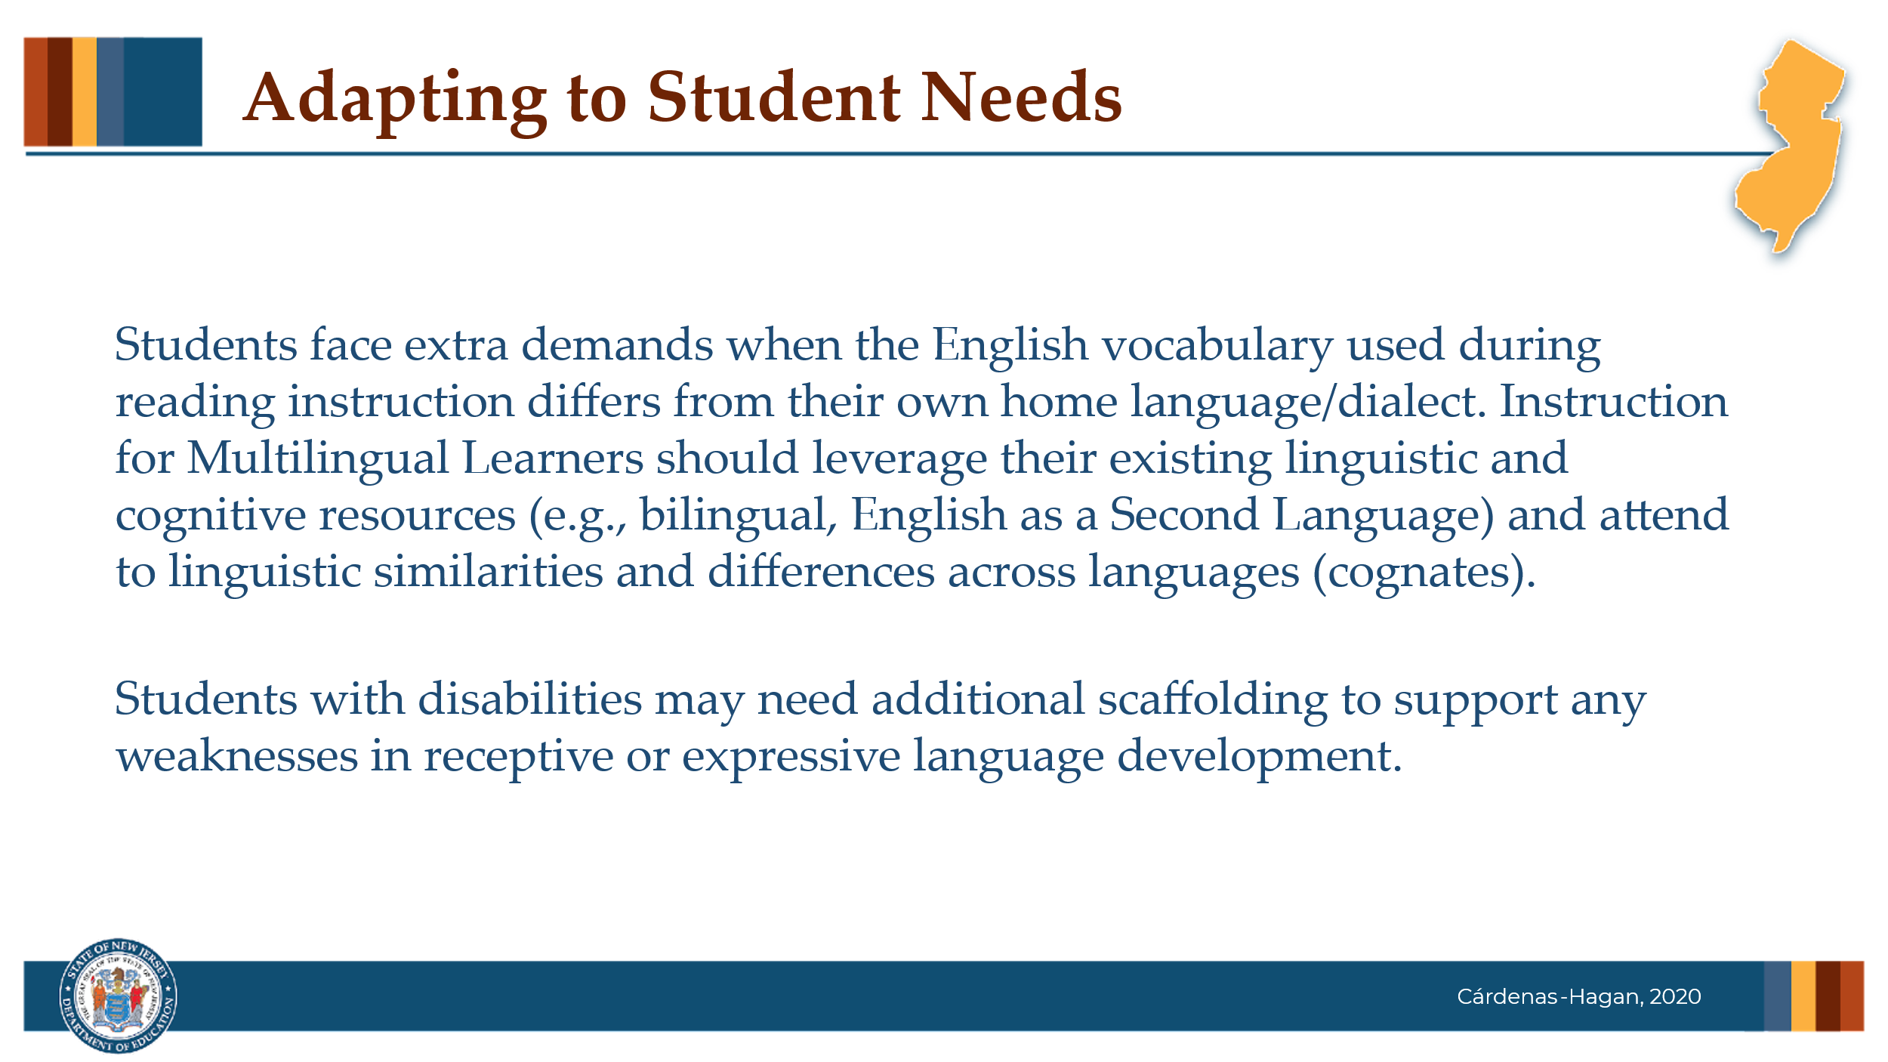

Facilitator Narration
Students face extra demands when the English vocabulary used during reading instruction differs from their own home language/dialect. Instruction for Multilingual Learners should leverage their existing linguistic and cognitive resources (e.g., bilingual, English as a Second Language) and attend to linguistic similarities and differences across languages (cognates).
Students with disabilities may need additional scaffolding to support any weaknesses in receptive or expressive language development.

Slide 14: Thanks for participating!
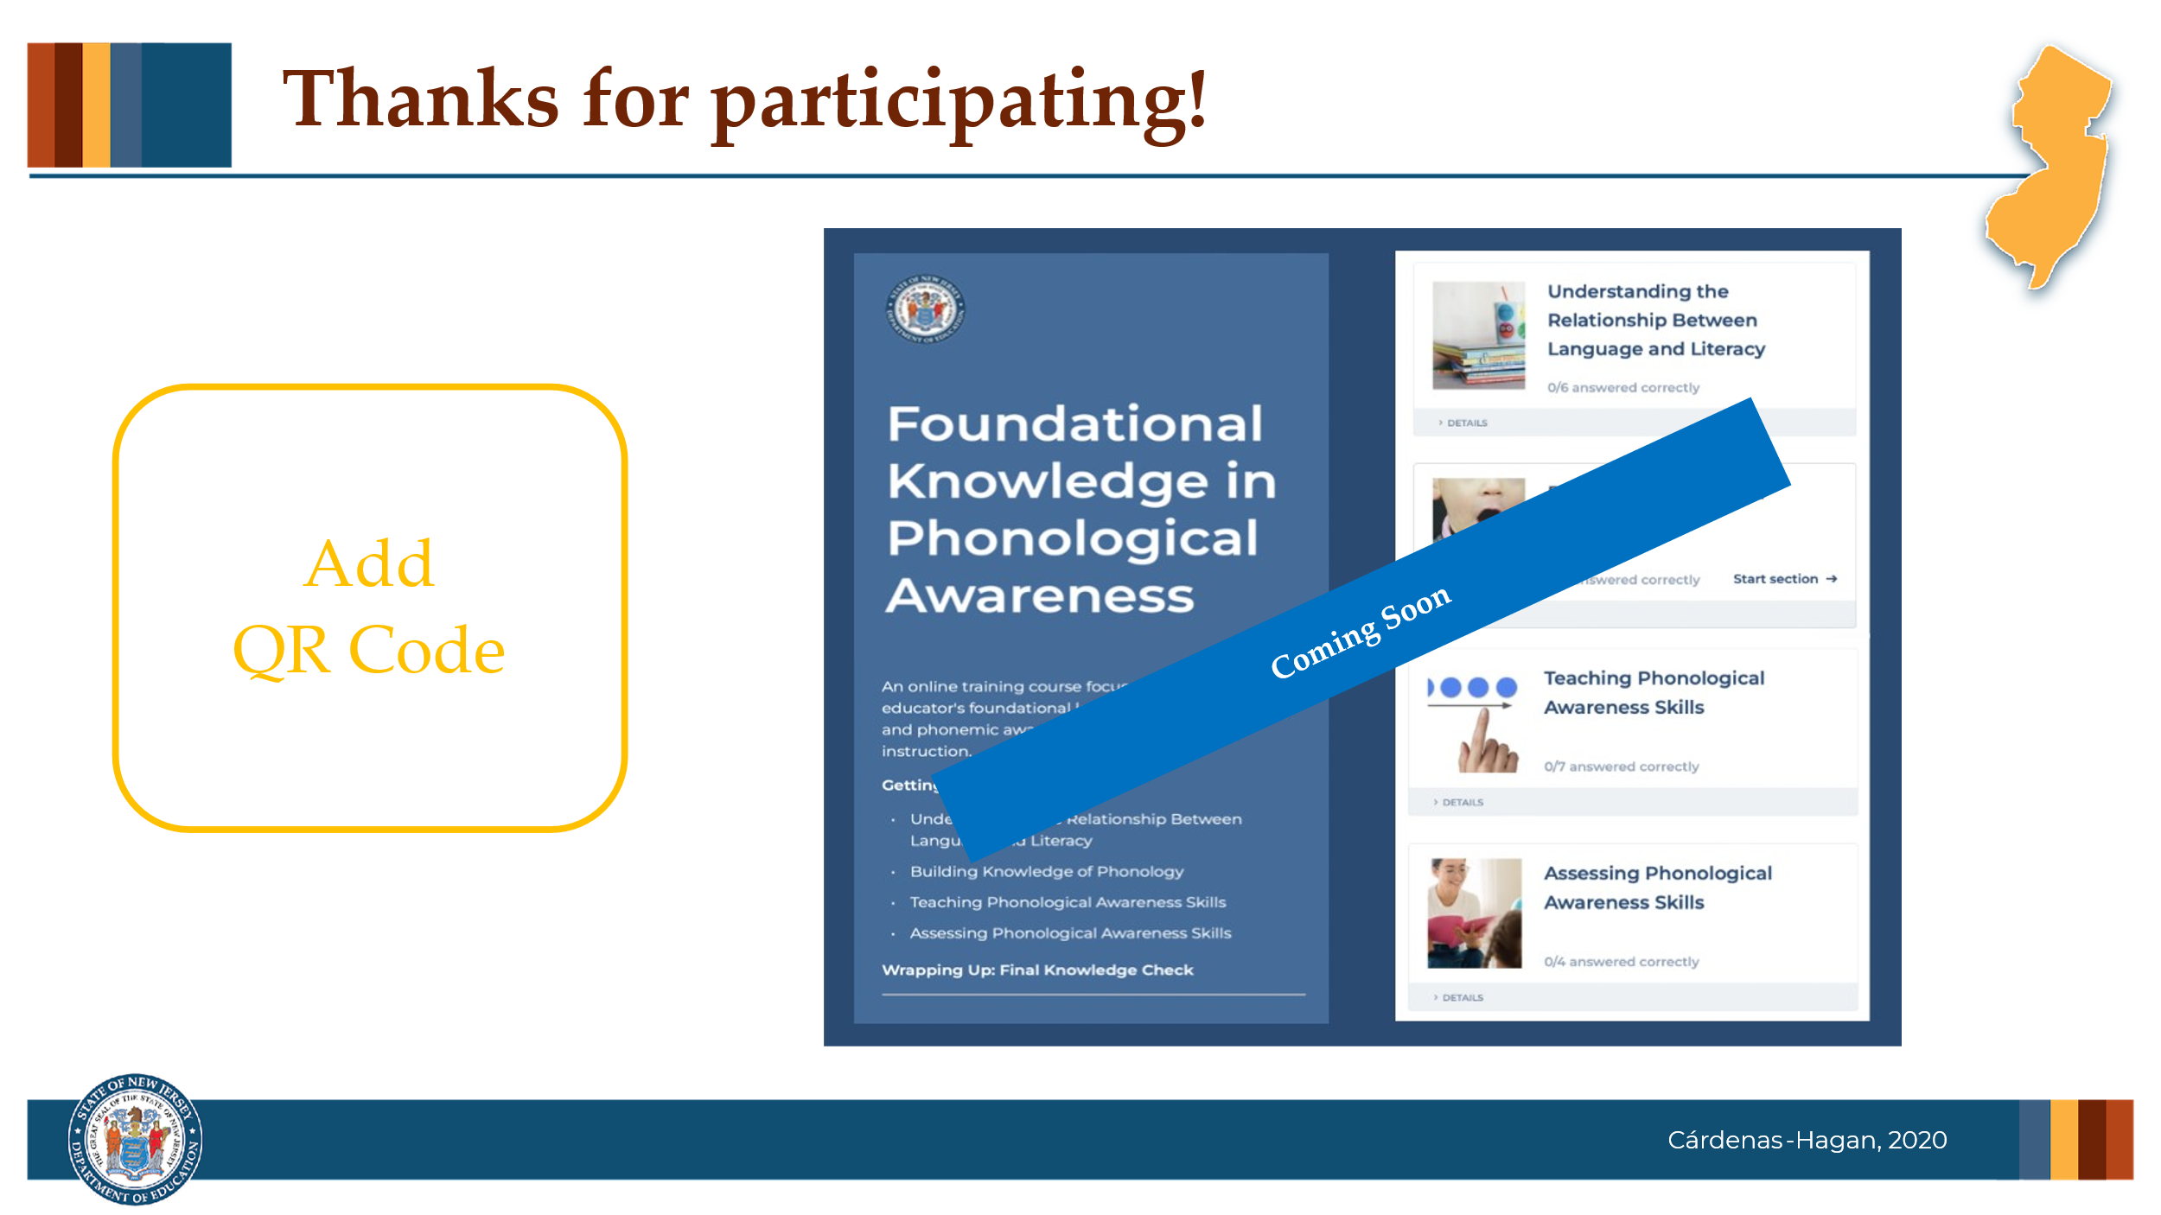

Facilitator Narration
This brings us to the end of our session today! If you are interested to learn more about vocabulary, keep an eye out for the NJ Department of Education’s upcoming free SISEP online learning modules.

Slide 15: Next Session in the PLC Series
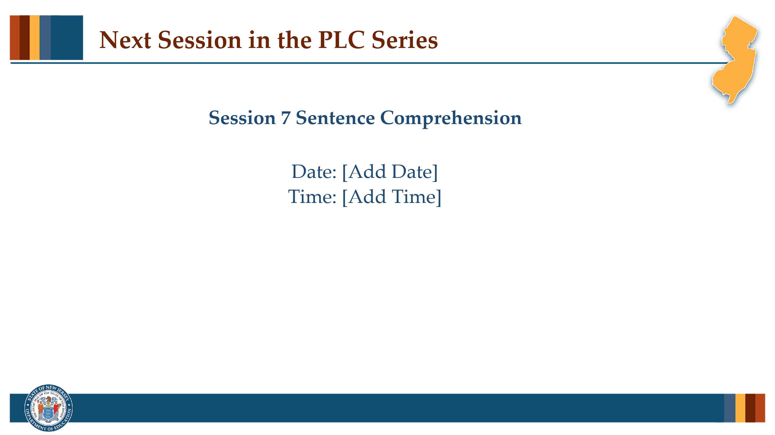

Facilitator Narration
Up next is Session 7 Sentence Comprehension. This PLC session will focus on syntax and semantics at the sentence level. We will meet on [add date and time]. See you then!

Slide 12: References
This slide lists references from the presentation.

Session Materials Needed
- PLC Series Session 5 - Slide Presentation
- Copy of book, Bringing Words to Life by Isabel Beck and Maragaret McKeown (optional)
If the session is being delivered virtually, use a virtual meeting space that allows for meeting participants to engage via both audio and video.

