

# LEARning about Literacy: Professional Learning Community (PLC) Series Session 6 Sentence Comprehension Facilitator Guide

This facilitation guide provides a structured approach to lead Session 6 Sentence Comprehension. The session aims to help educators understand how language structures including syntax (sentence structure) and semantics (meaning) contribute to reading comprehension. The facilitator is tasked with preparing materials, engaging participants, and ensuring active participation throughout the session.

## Step-by-Step Facilitation Process

1. **Send Pre-Work Email to Community Members:** Send the pre-drafted email with the pre-work assignment attached (e.g., reading or video) and session details (date, time, location/platform).
2. **Review Pre-Work and Session Presentation Materials:** Review the pre-work assignment, session slides, and facilitator notes to ensure familiarity with content.
3. **Prepare and Update Session Presentation Materials:** Update slides with relevant contextual information for the group, prepare all handouts and supplementary resources needed, and check on the room set up, materials needed for activities, and technology to ensure a smooth session. Test any video links in the presentation to confirm they are working properly.
4. **Deliver the Session:** Present the pre-drafted session presentation, engage participants with discussions and activities, and answer questions to ensure understanding.
5. **Invite Community Members to Next Session:** Thank participants, share details of the next session, and encourage ongoing engagement with additional resources.

## Draft Email

**Subject Line:** Join us for Session 6! Evidence-Based Literacy Instruction PLC Series

Dear [Staff Member],

This is a friendly reminder that the sixth session of the Learning Equity & Academic Recovery’s Evidence-Based Literacy Instruction Professional Learning Community (PLC) Series is coming soon!

### PLC Session 6: Sentence Comprehension

Date: [Insert Date]  
Time: [Insert Time]  
Location: [Insert Location/Platform Link]

In this session, we will focus on language structures including syntax (sentence structure) and semantics (meaning) and their contribution to reading comprehension, including instructional strategies to support sentence comprehension. The session is designed to be interactive and collaborative, allowing you to engage with your colleagues and share ideas and best practices for supporting students’ literacy development.

Prior to our session together, please be sure to visit *Reading Rockets* to watch the video demonstration “3 Different Ways to Combine Sentences” in their [Classroom Strategies for Sentence Combining](https://www.readingrockets.org/classroom/classroom-strategies/sentence-combining) to be prepared for our discussion and activities.

We look forward to seeing you there and working together to enhance our literacy instruction!

Best regards,

[Your Name]  
[Your Title]  
[School District Name]  
[Your Contact Information]

## Session Presentation Facilitation Notes

### Slide 1: Title Slide

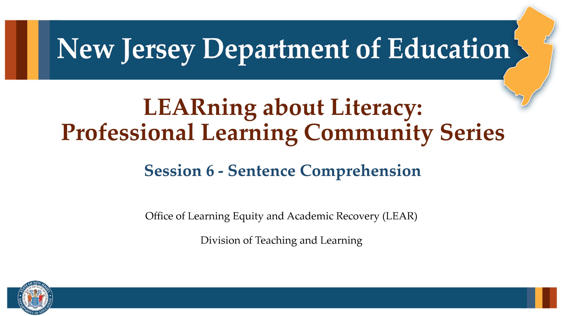

#### Facilitator Narration

Welcome! We’re excited to have you join us for this sixth session in our Professional Learning Community Series. Today, we’ll be looking to strengthen our instructional practices based on the latest research in sentence comprehension.

### Slide 2: Session 6 — Language Structures

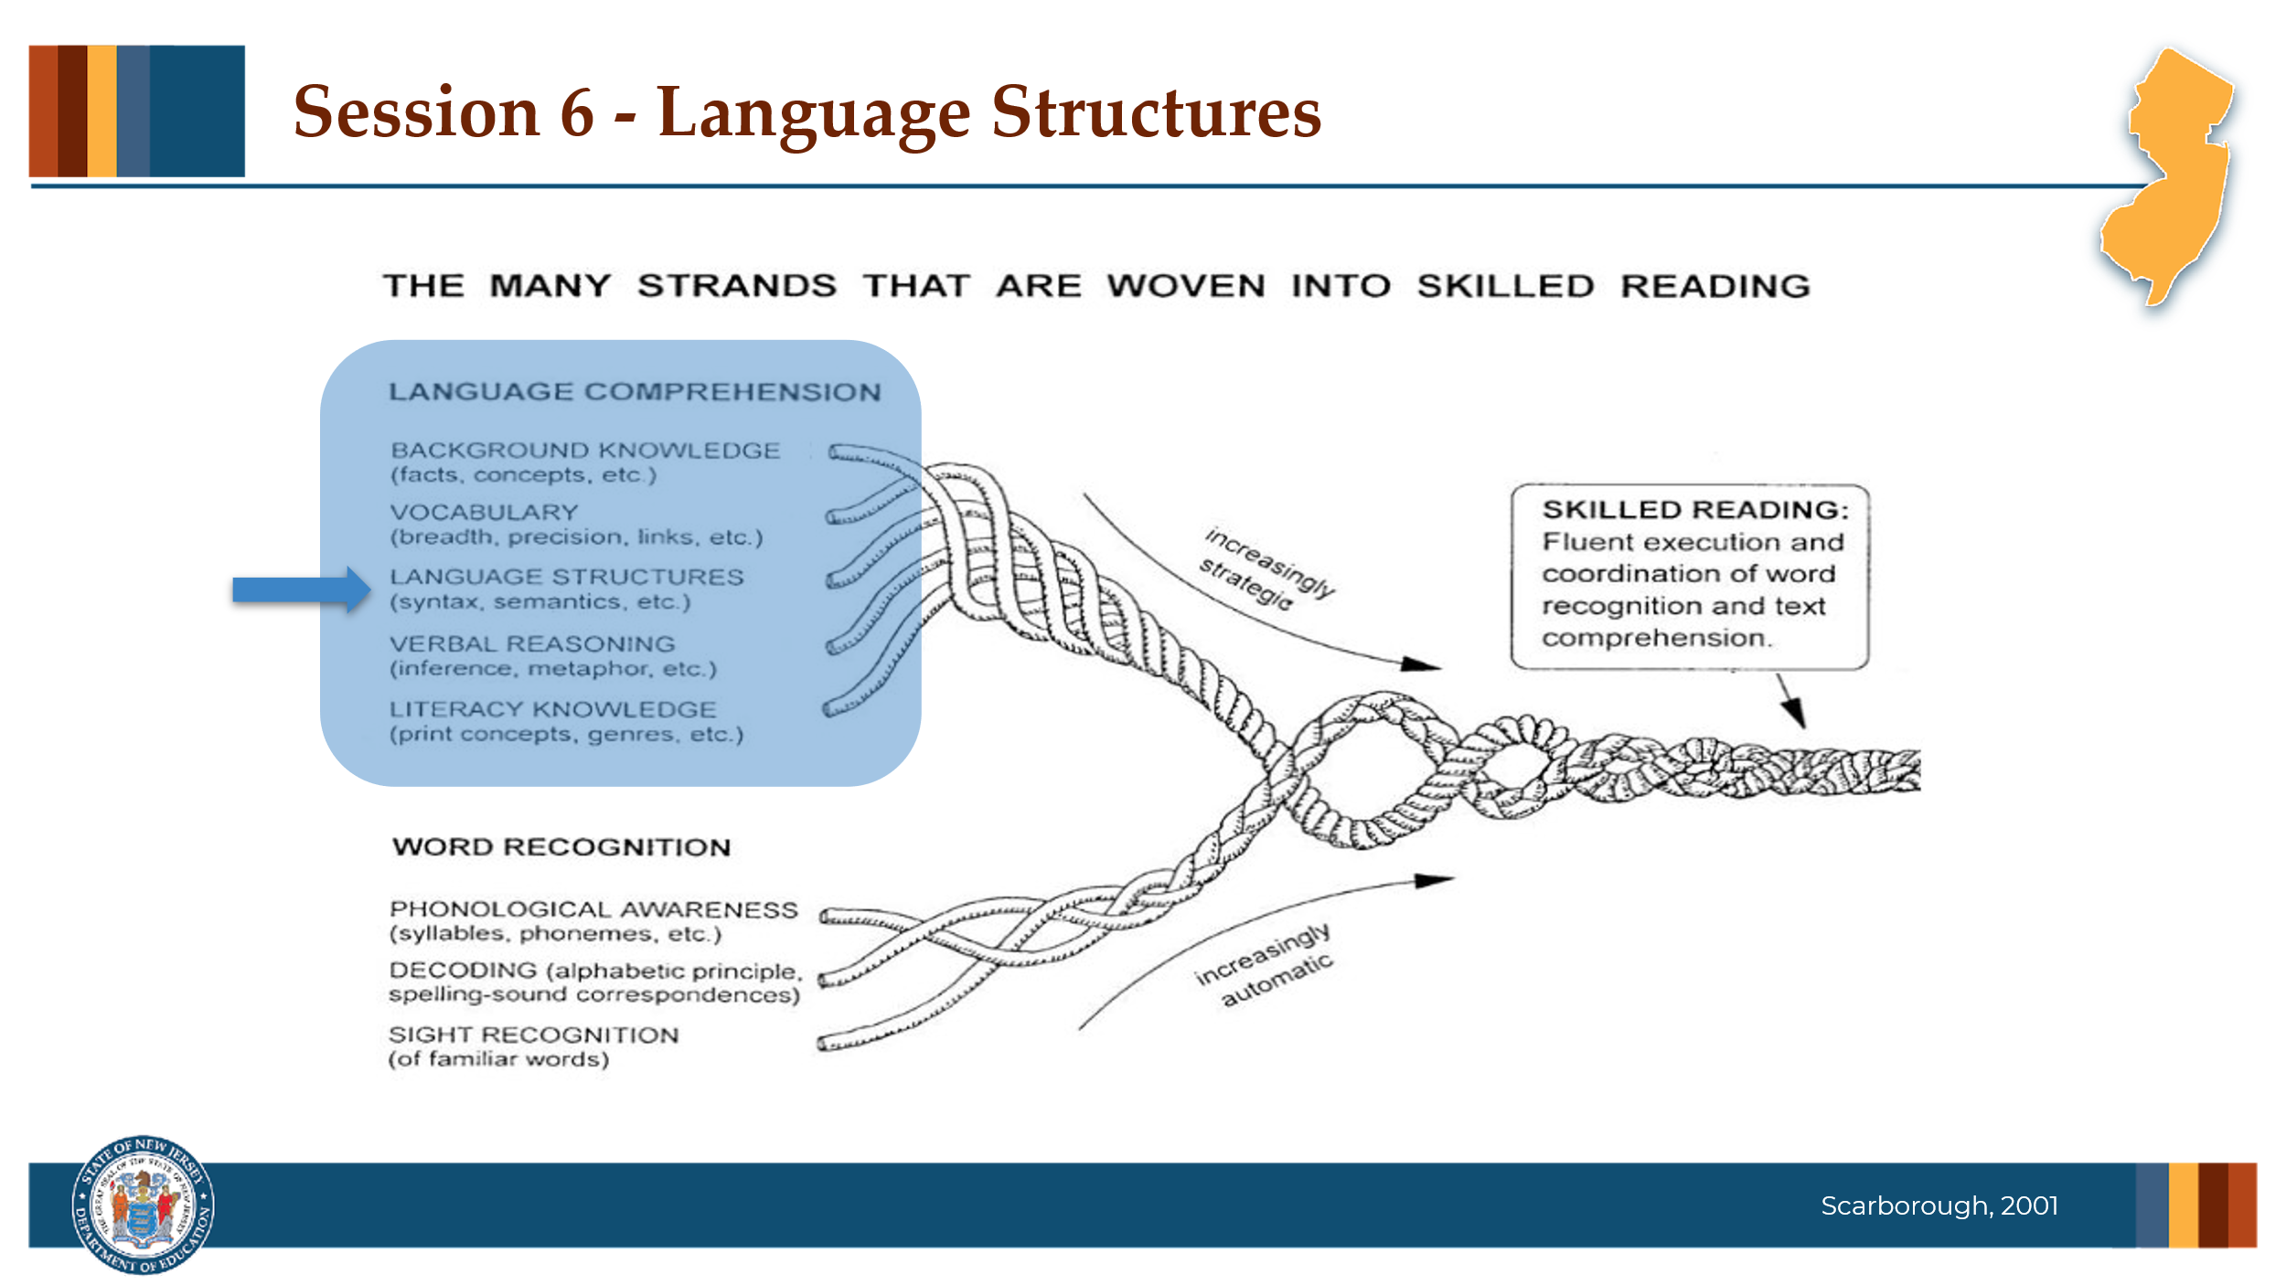

#### Facilitator Narration

Always starting with our conceptual framework for skilled reading, Scarborough’s Reading Rope, in today’s session we will discuss language structures, the semantic and syntactic knowledge needed for sentence-level comprehension.

### Slide 3: Text Version of Scarborough’s Rope

The text version is provided for people who cannot access the content in the image (e.g., someone who is blind or has low vision).

### Slide 4: The Importance of Syntax

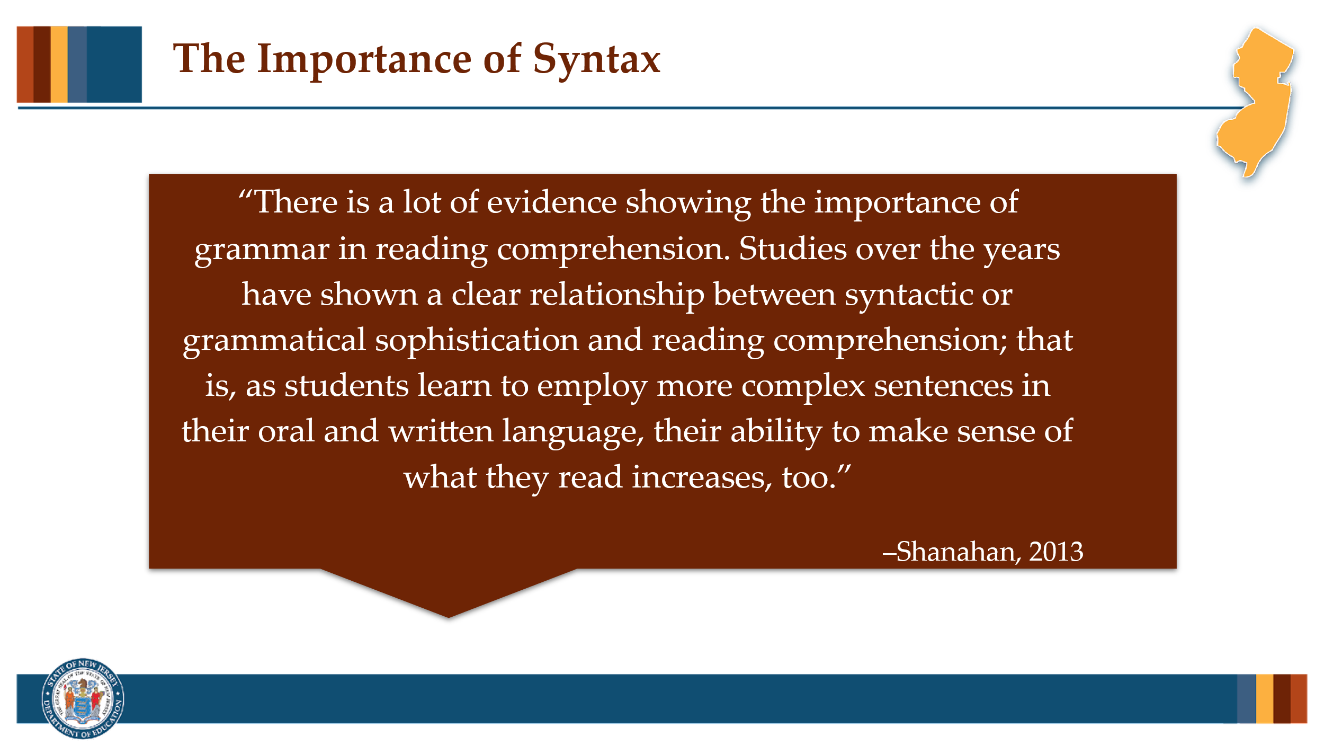

#### Facilitator Narration

Sentence comprehension requires an important foundation in grammar and syntax. Traditionally, grammar has been the larger term, made up of both syntax and morphology. Syntax is the study of how words and phrases are arranged to form sentences in a language, while grammar provides the rules for how sentences, clauses, and words are constructed. Both grammar and syntax are critical because they are the vehicle for conveying meaning. Research shows a strong link between grammatical knowledge and reading comprehension—students who can write and understand more complex sentences are better able to make sense of what they read.

### Slide 5: Reflection Activity

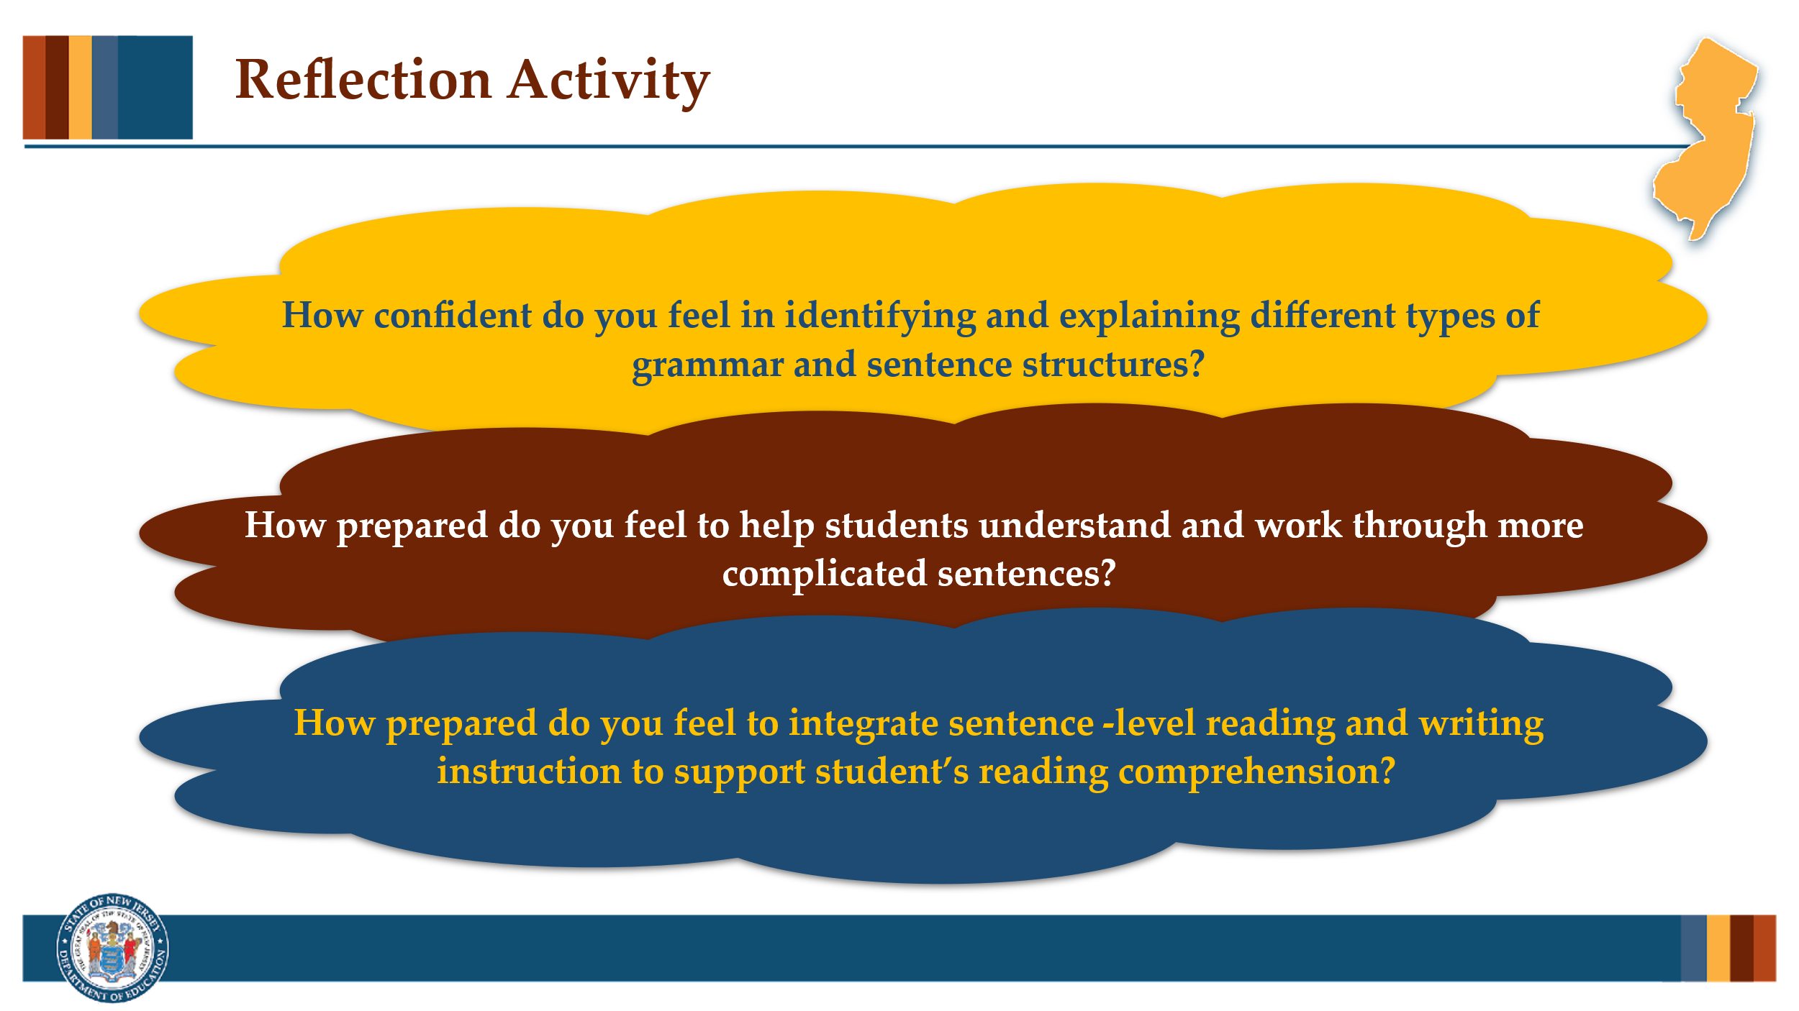

#### Facilitator Narration

Strong readers need to understand how sentences are built, especially when they encounter the more complex sentence structures that link multiple ideas together in academic text. Knowing how conjunctions connect ideas and how certain sentence features—like independent and dependent clauses, long noun phrases, and confusing pronoun references—can make comprehension harder for students can help us plan more effective instruction. When we understand what makes a sentence challenging, we can better anticipate where students might struggle and adjust our teaching to meet their needs.

As a pre-work activity for this session, we watched the video on [Classroom Strategies for Sentence Combining](https://www.readingrockets.org/classroom/classroom-strategies/sentence-combining) which delved into independent and dependent clauses and activities for sentence combining, let's take a moment to reflect on our own knowledge of syntax and our ability to teach it to students.

#### Activity

(5 minutes)

Facilitate the discussion to prompt community members to reflect on the following questions before sharing their thoughts with the group:

* How confident do you feel in identifying and explaining different types of grammar sentence structures?
* How prepared do you feel to help students understand and work through more complicated sentences?
* How prepared do you feel to integrate sentence-level reading and writing instruction to support student’s reading comprehension?

### Slide 6: Effective Instructional Practices

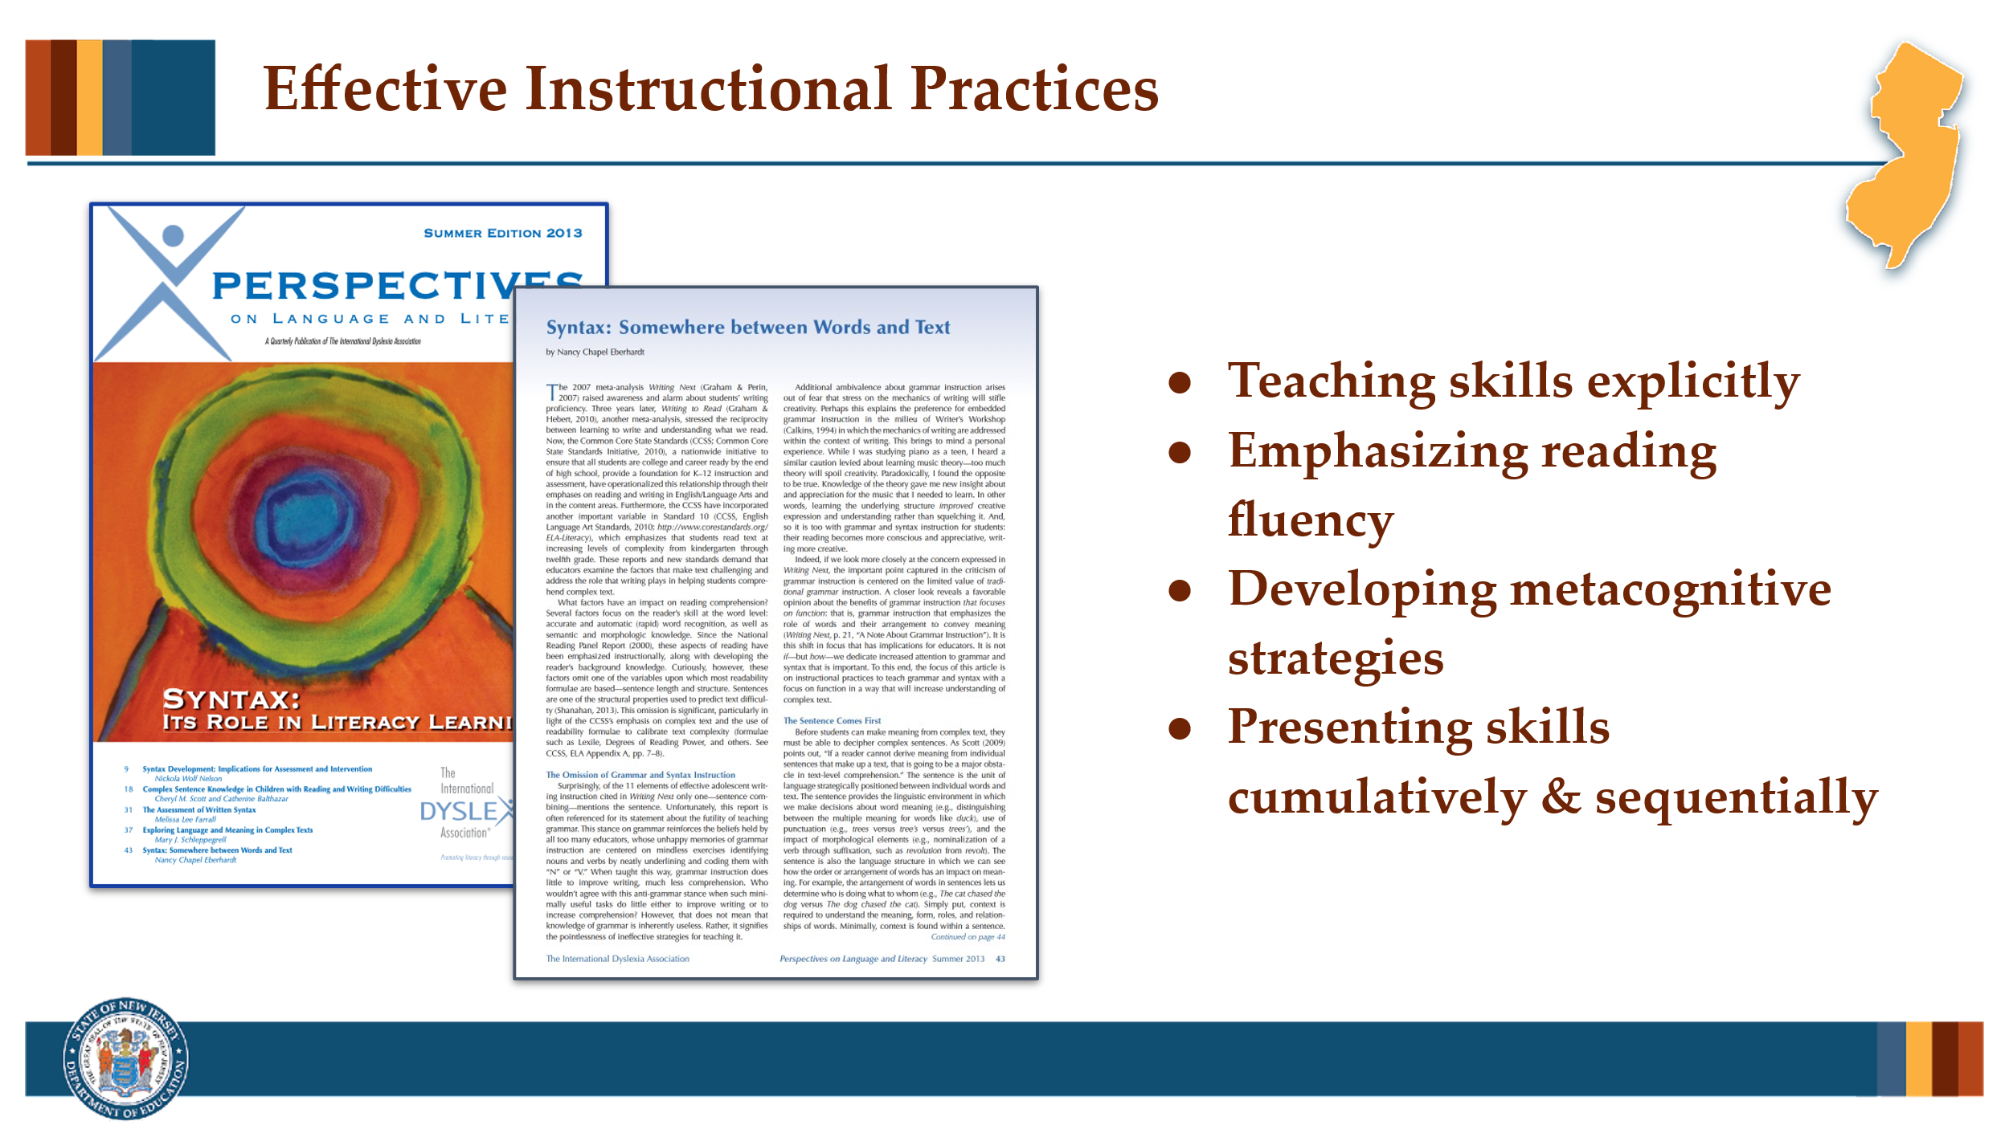

#### Facilitator Narration

To build strong readers, we need a solid foundation in how we teach sentence comprehension (and sentence composition). In her article, *Syntax: Somewhere between Words and Text*, Nancy Chapel Eberhardt identifies a few key instructional practices:

* Teaching skills explicitly - making abstract concepts concrete and visual for students
* Emphasizing reading fluency - supporting oral reading with meaningful phrasing and attention to punctuation
* Developing metacognitive strategies - helping students think about how sentences work and apply strategies to new texts
* Presenting skills cumulatively and sequentially - laying foundations early and building step-by-step

Let’s now dive into some instructional practices that help students unlock the meaning behind sentences — especially those that are more complex.

#### Activity

(20 minutes)

Provide copies of the article, Syntax: Somewhere between Words and Text by Nancy Chapel Eberhardt. Divide community members into small groups and have each read a short segment of the article that focuses on effective instructional practices. First, ask community members to read their assigned section independently. Then, each group will discuss and summarize the big takeaways of their assigned section. Finally, the groups will share what was learned with the full group, teaching all community members about instructional practices introduced. Be sure to end the discussion by asking participants why this is important for students with dyslexia.

Group 1 will read section “A Function-Based Instructional Approach” on pages 45–46. Group 2 will read sections “A Reciprocal Process: Writing Based on Reading” and “Instruction to Increase Syntactic Complexity” on pages 46–47. Group 3 will read sections “Sentence Combining—When, Why, How” and “I Don’t Understand This” on pages 47–48.

### Slide 7: Lesson on Sentence Parsing

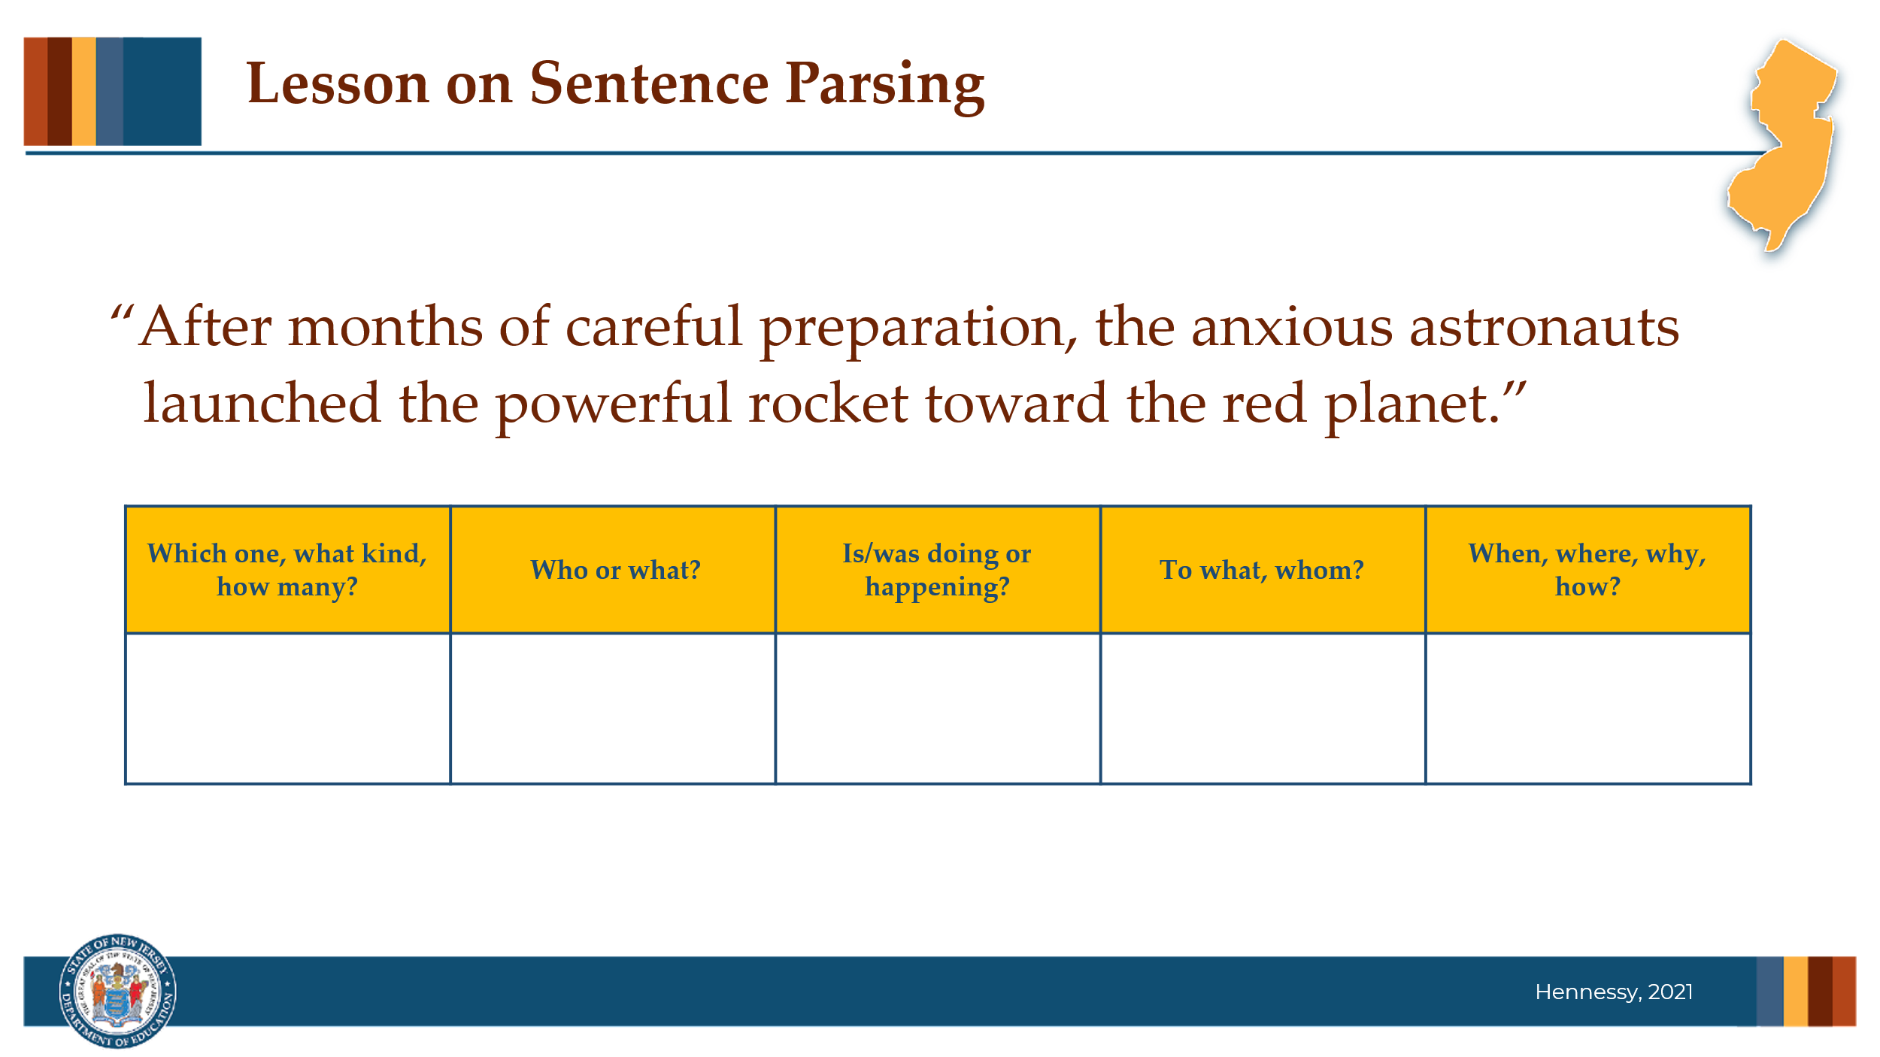

#### Facilitator Narration

Now let’s look more closely at a lesson connected to a text students have been reading, *Mission to Mars*, from a themed unit on exploration. This lesson focuses on building their understanding of parts of speech and sentence structure by using a questioning technique with a sentence frame. Sentence frames organize question words that correspond to different parts of speech — such as "who," "what," "where," and "when" — and help students map out the roles or functions of words, phrases, and clauses in a sentence.

Teachers should purposely select sentences either from the text itself or create new sentences that connect to the unit’s themes. Here we see the sentence: *After months of careful preparation, the anxious astronauts launched the powerful rocket toward the red planet.*

The teacher then models through think aloud, the following questions to parse and deconstruct the sentence into the frame:

* Who is the sentence about? *astronauts* → This is the subject (noun).
* Which words describe the astronauts? *the anxious* - (adjective)
* What did the astronauts do? *launched* → This is the action (verb).
* What did they launch? *the powerful rocket* → This is the object of the action.
* When did this happen? *after months of preparation* → This prepositional phrase tells when.
* Where was the rocket launched toward? *toward the red planet* → This prepositional phrase tells where.

After modeling the teacher will then provide another sentence for students to parse into a sentence frame as they are prompted with the same questions. As a close to the lesson, students will parse additional sentences on their own. The teacher will circulate and provide feedback on students responses to the questions they are asking themselves.

This lesson focuses on student’s identifying and understanding the **function** of the words, phrases, and clauses and how they work together to create sentences.

### Slide 8: Lesson on Sentence Combing

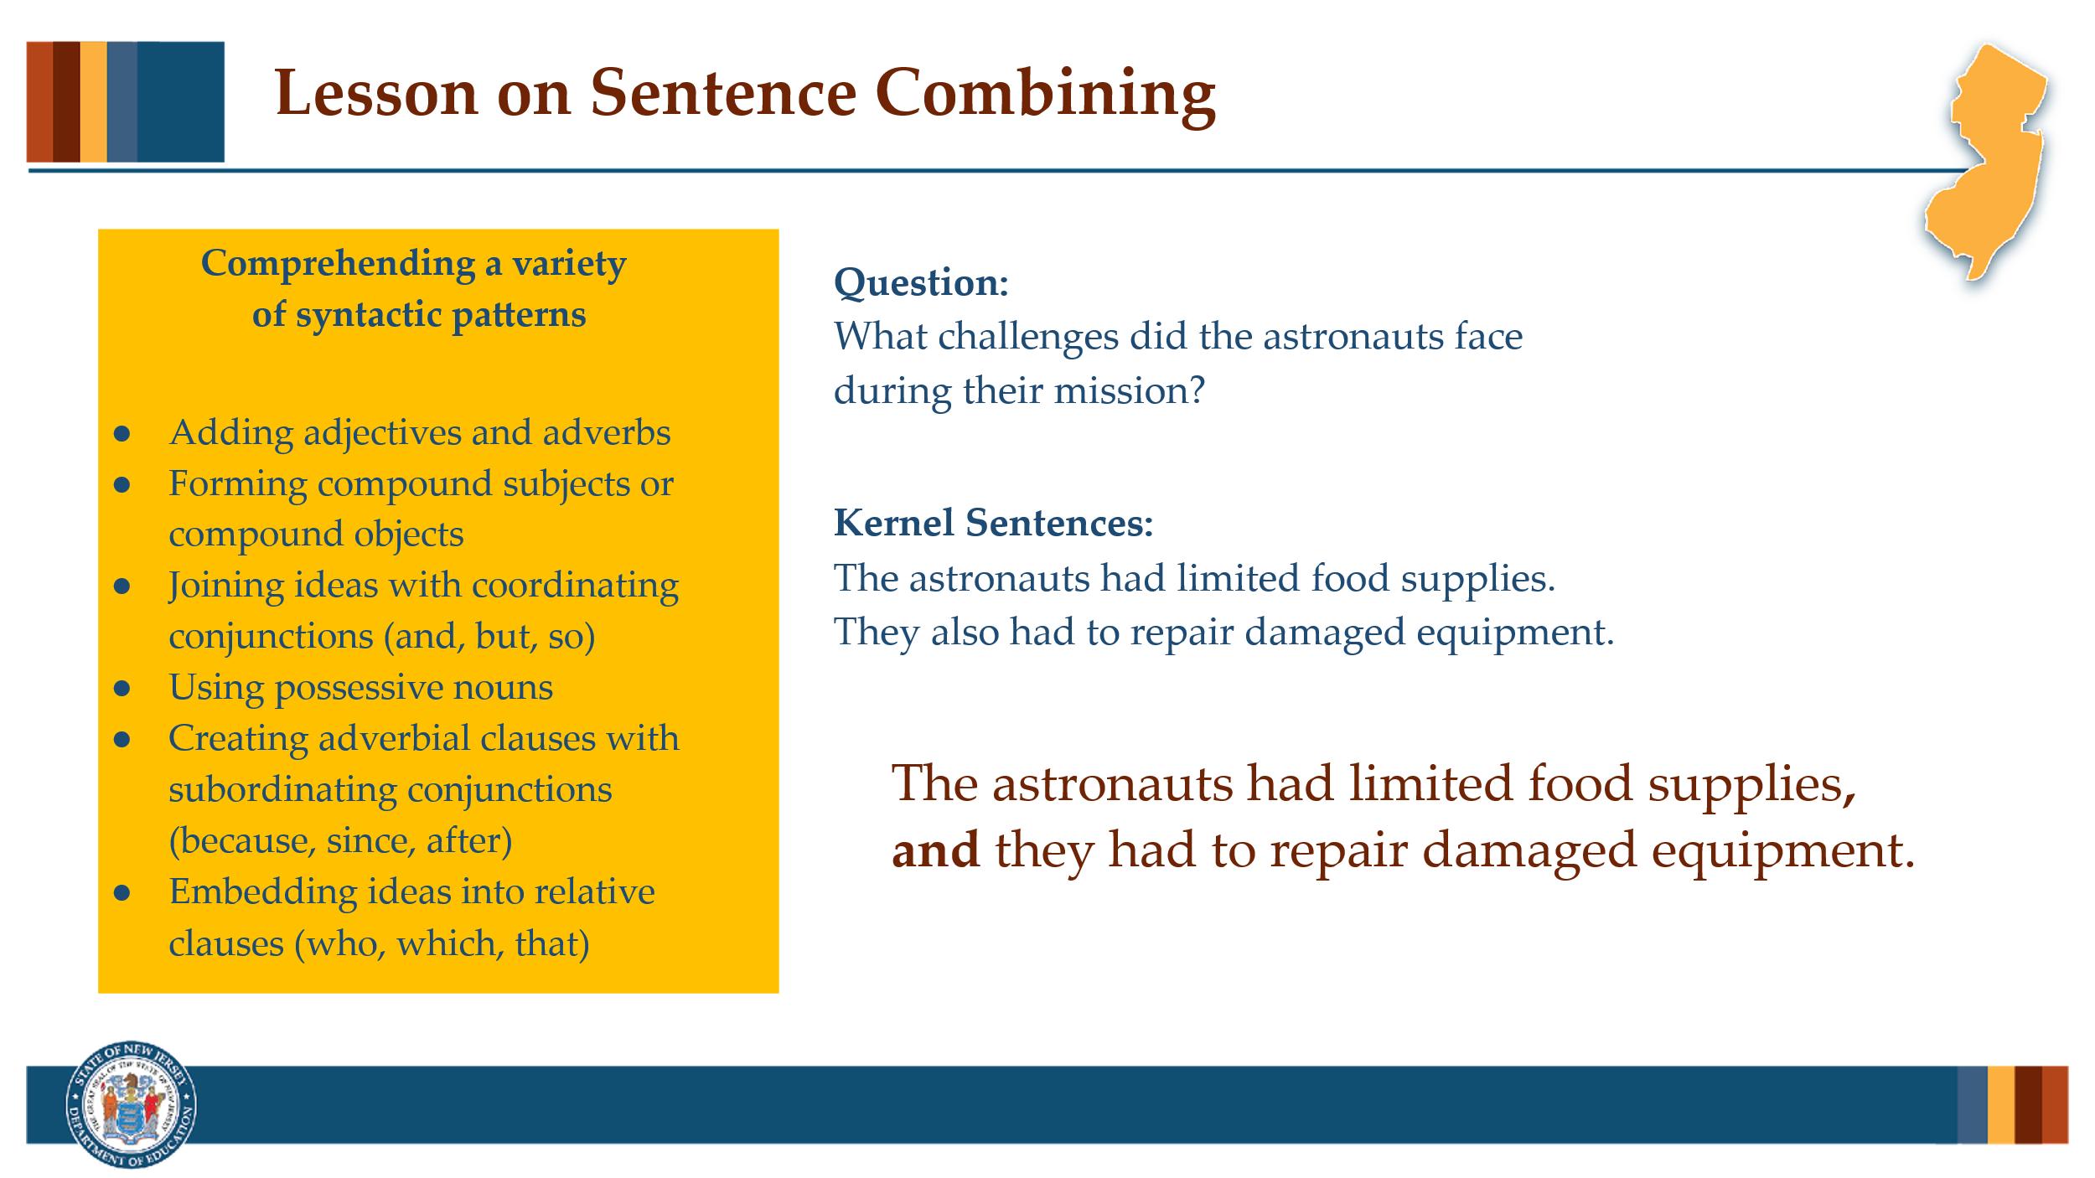

#### Facilitator Narration

Sentence combining is another powerful instructional tool traditionally discussed in the context of writing, but it also plays an important role in supporting reading comprehension. In sentence combining activities, students are given two or more kernel sentences — short, simple sentences — and asked to combine them into one well-formed, syntactically rich sentence. With a well-designed scope and sequence, students can learn to use a variety of syntactic patterns, such as:

* Adding adjectives and adverbs
* Forming compound subjects or compound objects
* Joining ideas with coordinating conjunctions (and, but, so)
* Using possessive nouns
* Creating adverbial clauses with subordinating conjunctions (because, since, after)
* Embedding ideas into relative clauses (who, which, that)

For this lesson, again teachers select or create kernel sentences and focused questions tied to the texts students are currently reading. The first step is to model through thinking aloud, using the question *What challenges did the astronauts face during their mission?* Showing these sentences to the student, the teacher will explain that in the passage the *The astronauts had limited food supplies.* and *They also had to repair damaged equipment.* The teacher will then ask the students to watch as she combines the two sentences into one, using a coordinating conjunction. ***The astronauts had limited food supplies, and they had to repair damaged equipment.*** While demonstrating the combination, the teacher can discuss punctuation and other options for coordinating conjunctions (like the FANBOYS discussion from the pre-work video). Different guiding questions and kernel sentences will require different coordinating conjunctions.

Once again after modeling, to ensure instruction is explicit and clearly integrating reading and writing instruction, the teacher will follow with guided and independent practice opportunities for students.

### Slide 9: Adapting to Student Needs

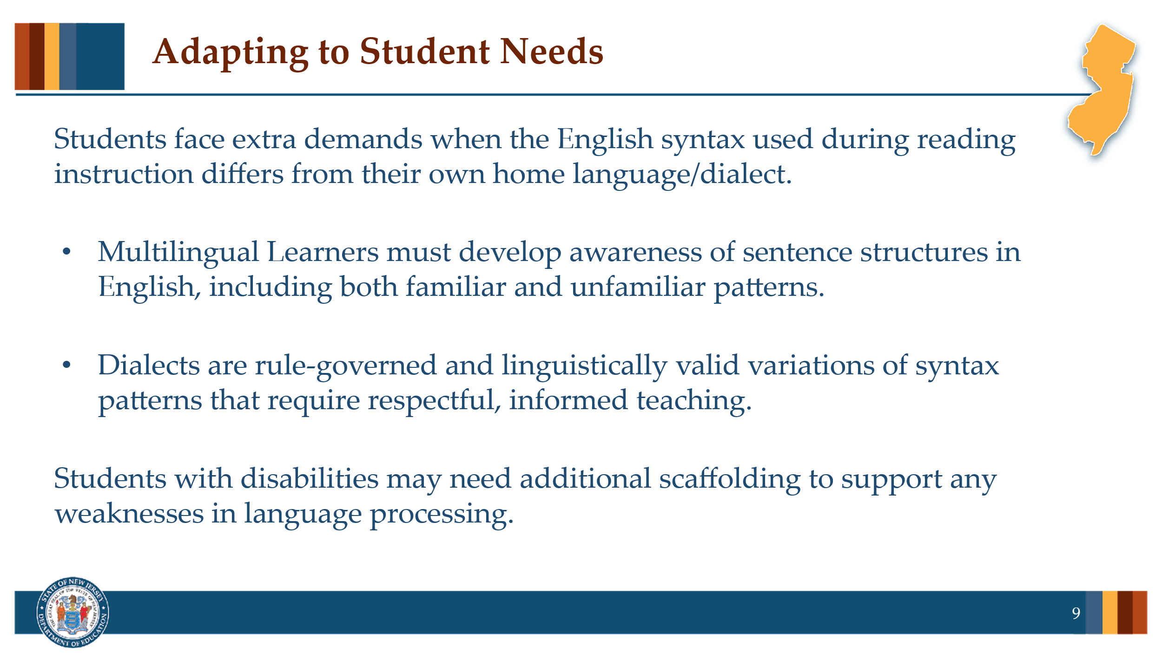

#### Facilitator Narration

Students face extra demands when the English syntax used during reading instruction differs from their own home language/dialect

### Slide 10: Thanks for Participating

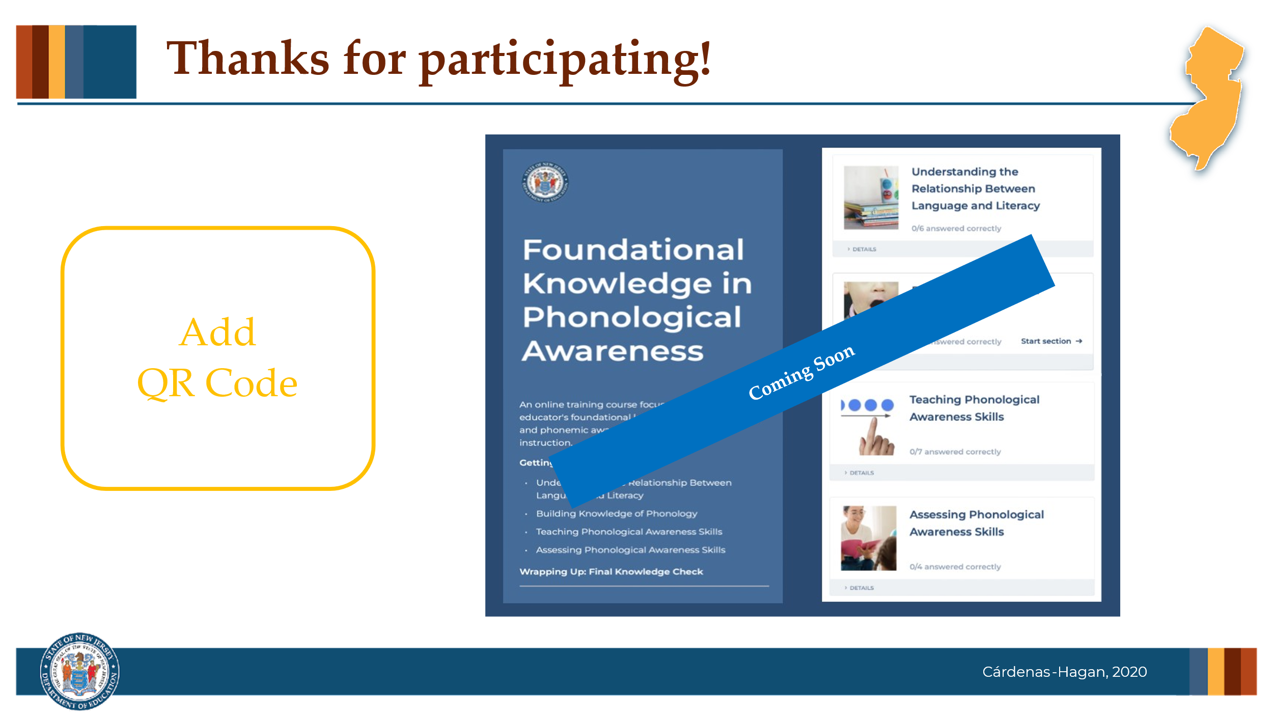

#### Facilitator Narration

This brings us to the end of our session today! If you are interested to learn more about sentence comprehension, keep an eye out for the NJ Department of Education’s upcoming free SISEP online learning modules.

### Slide 11: Next Session in the PLC Series

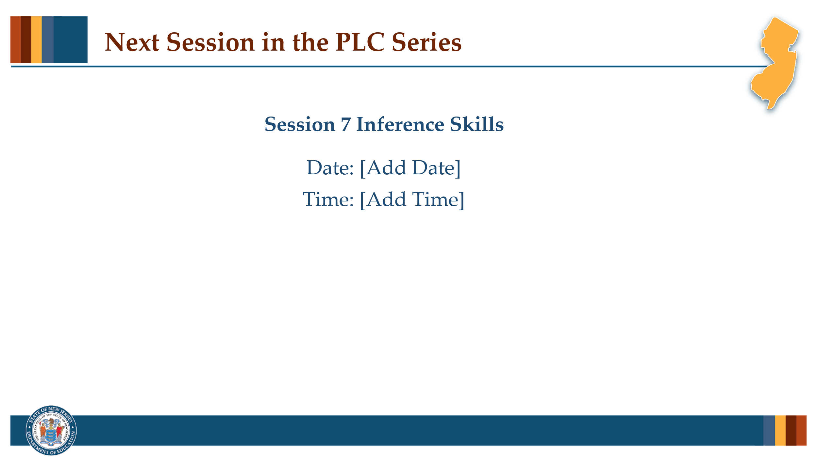

#### Facilitator Narration

Up next is Session 7 Inference Skills. This PLC session will focus on verbal reasoning and instructional practices for teaching inference skills. We will meet on [add date and time]. See you then!

### Slide 12: References

This slide lists references from the presentation.

### Session Materials Needed

* PLC Series Session 6 - Slide Presentation
* Copies of Supplementary Resources for Community Members:
  + Article, *Syntax: Somewhere between Words and Text*

If the session is being delivered virtually, use a virtual meeting space that allows for meeting participants to engage via both audio and video.