

LEARning about Literacy:
Professional Learning Community (PLC) Series
Session 7 Inference Skills Facilitator Guide
This facilitation guide provides a structured approach to lead Session 7 Inference Skills. The session aims to help educators teach inferencing skills to enhance students’ comprehension while reading. The facilitator is tasked with preparing materials, engaging participants, and ensuring active participation throughout the session.

Step-by-Step Facilitation Process
- Send Pre-Work Email to Community Members: Send the pre-drafted email with the pre-work assignment attached (e.g., reading or video) and session details (date, time, location/platform).
- Review Pre-Work and Session Presentation Materials: Review the pre-work assignment, session slides, and facilitator notes to ensure familiarity with content.
- Prepare and Update Session Presentation Materials: Update slides with relevant contextual information for the group, prepare all handouts and supplementary resources needed, and check on the room set up, materials needed for activities, and technology to ensure a smooth session. Test any video links in the presentation to confirm they are working properly.
- Deliver the Session: Present the pre-drafted session presentation, engage participants with discussions and activities, and answer questions to ensure understanding.
- Invite Community Members to Next Session: Thank participants, share details of the next session, and encourage ongoing engagement with additional resources.

Draft Email
Subject Line: Join us for Session 7! Evidence-Based Literacy Instruction PLC Series
Dear [Staff Member],
This is a friendly reminder that the seventh session of the Learning Equity & Academic Recovery’s Evidence-Based Literacy Instruction Professional Learning Community (PLC) Series is coming soon!

PLC Session 7: Inference Skills
Date: [Insert Date]
Time: [Insert Time]
Location: [Insert Location/Platform Link]
In this session, we will focus on verbal reasoning skills, with an emphasis on inference-making to help students’ connect text to prior knowledge. The session is designed to be interactive and collaborative, allowing you to engage with your colleagues and share ideas and best practices for supporting students’ literacy development.
Prior to our session together, please be sure to visit Shanahan on Literacy to read the blog post What Does It Take to Teach Inferencing? to be prepared for our discussion and activities.
We look forward to seeing you there and working together to enhance our literacy instruction!
Best regards,
[Your Name]
[Your Title]
[School District Name]
[Your Contact Information]

Session Presentation Facilitation Notes

Slide 1: Title Slide
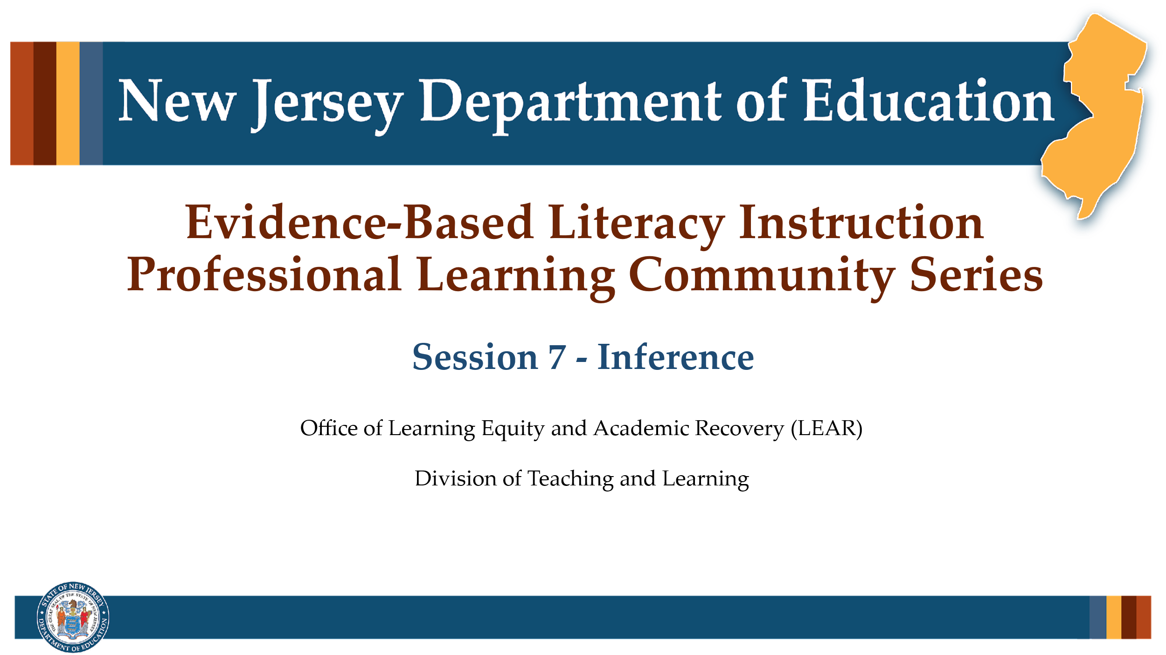

Facilitator Narration
Welcome! We’re excited to have you join us for this seventh session in our Professional Learning Community Series. Today, we’ll be looking to strengthen our instructional practices based on the latest research on inferencing as a strategy for intentionally making sense of text.

Slide 2: Session 7 – Verbal Reasoning
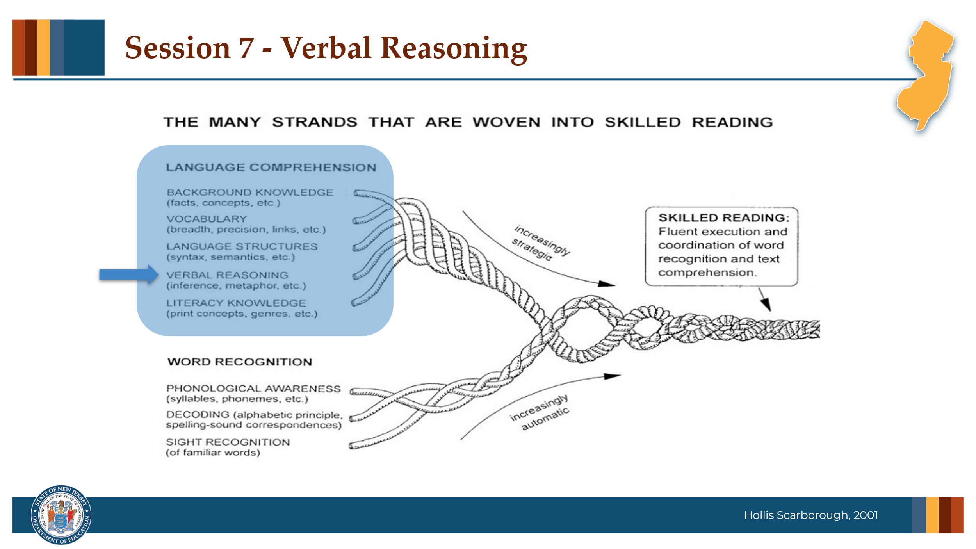

Facilitator Narration
Always starting with our conceptual framework for skilled reading, Scarborough’s Reading Rope, in today’s session we will discuss verbal reasoning, specifically the tole inferencing plays in comprehending text. It is important to note that the ability to make inferences when reading requires the strategic integration of all the language comprehension skills.

Slide 3: Text Version of Scarborough’s Rope
The text version is provided for people who cannot access the content in the image (e.g., someone who is blind or has low vision).

Slide 4: Reflection Activity
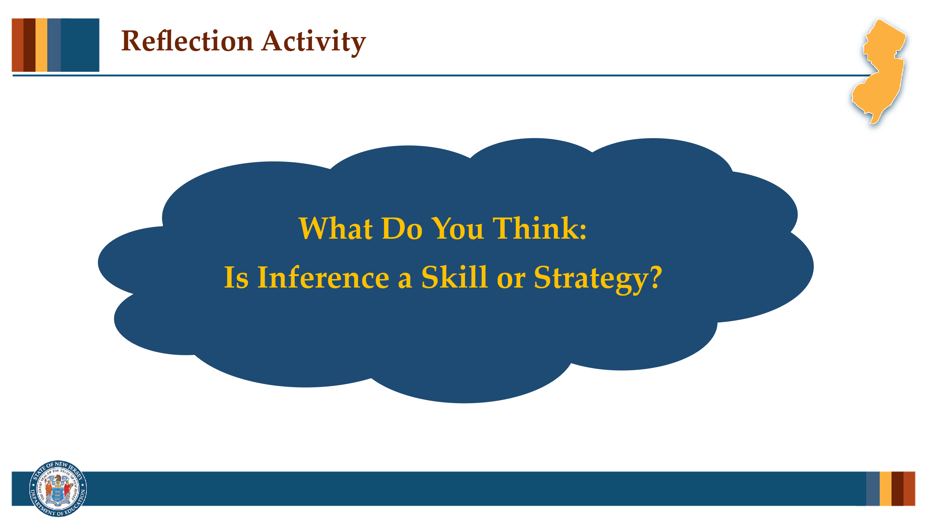

Facilitator Narration
As a pre-work activity for this session, we read the blog post What Does It Take to Teach Inferencing? by Timothy Shanahan. In it, Shanahan suggests that inferencing should be viewed not as a discrete skill, but as a strategy readers use intentionally to make meaning from a text.

Activity
(5 –10 minutes)
Facilitate the discussion to prompt community members to reflect on the following points made by Timothy Shanahan.
- Inferencing is not an isolated skill—it’s a complex process that depends on the reader’s ability to connect information within and between sentences in the text itself and to supplement information from the text with their own background knowledge.
- Teaching students to “infer” through generic inferential questions or skill labels (like predicting or drawing conclusions) is ineffective, because these approaches don’t guide students toward concrete reading actions.
- Effective instruction treats inferencing as a strategy—students should be taught to look for specific patterns in texts, such as character motivation, text structures, or cohesive devices like pronoun referents and synonyms.
- Comprehension improves when students are shown how to think actively about the ideas, themes, or logic in a specific text.

Slide 5: The Importance of Local & Global Coherence
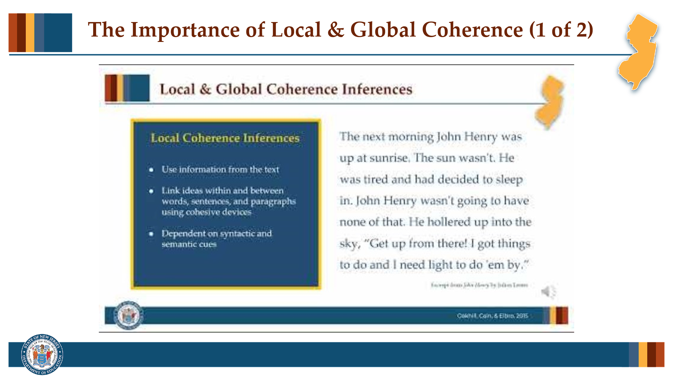

Facilitator Narration
Effective reading comprehension relies on two essential types of inferences: local coherence inferences and global coherence inferences. Let’s watch this short video.

Slide 6: The Importance of Local & Global Coherence
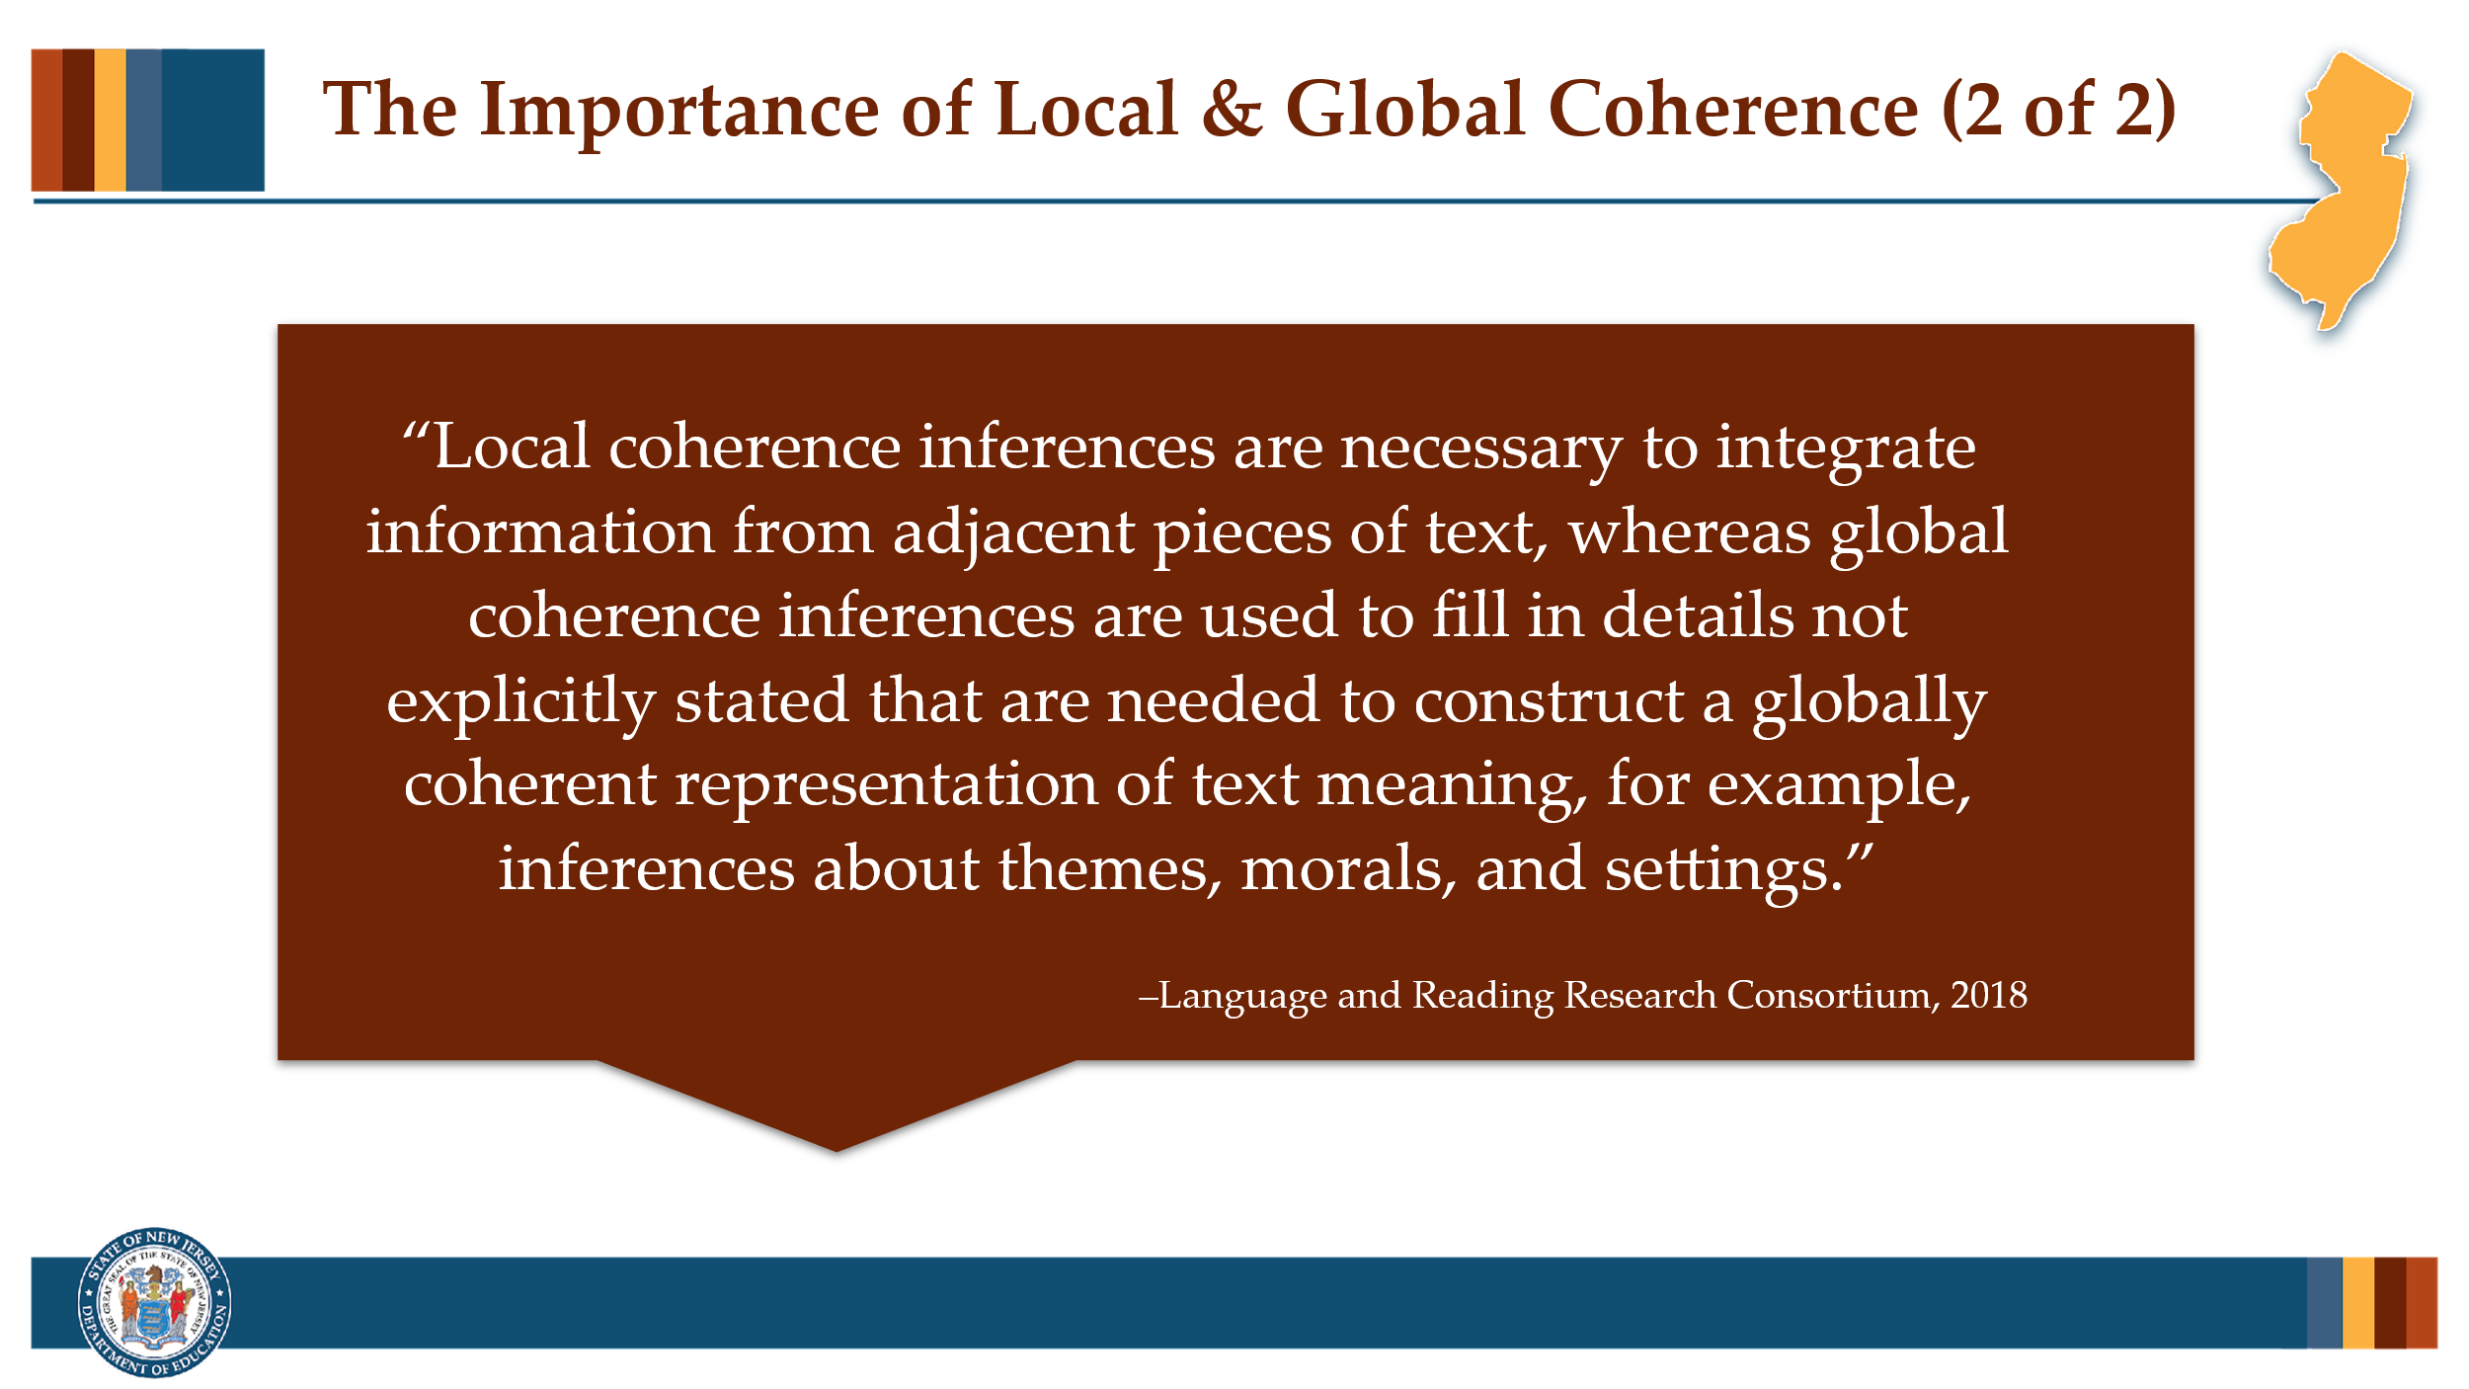

Facilitator Narration
So, we’ve just seen how local coherence inferences help readers connect and make sense of information from nearby parts of a text, while global coherence inferences help readers fill in missing details that aren’t directly stated, such as understanding the overall theme, moral, or setting of the text.
Let’s now turn to a discussion of the instructional practices that will support students in drawing both types of inferences while reading.

Slide 7: Global Coherence & the Role of Knowledge
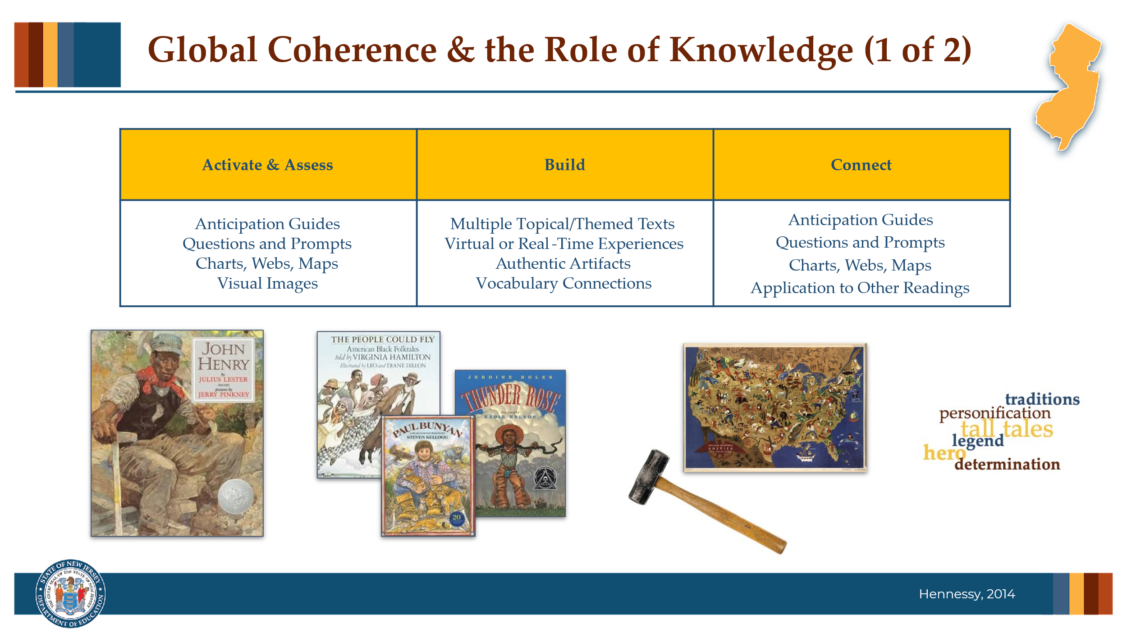

Facilitator Narration
In our PLC session on background knowledge, we already discussed some of the instructional strategies for activating, building, and connecting to student’s background knowledge in support of reading comprehension. After learning about the role knowledge plays in readers’ abilities to draw strong and accurate global coherence inferences, we can see how this attention to the background knowledge required to make-meaning of a text is key to supporting student’s inference making.
The video we just watched included an excerpt from the children’s picture book John Henry by Julius Lester. Think about the inference making potential that could be fostered in our students when a text selection like this is:
- included in a themed unit on “Folk Storytelling & Oral Traditions” in which our lesson planning
- introduced along with authentic artifacts, such as artist William Gropper’s map of America folklore (from 1946) or provides students the opportunity to experience the weight of a sledge-hammer;
- and vocabulary is intentionally chosen to build meaningfully broad and deep connections that can be called upon time and time again to support mental models.

Slide 8: Global Coherence & the Role of Knowledge
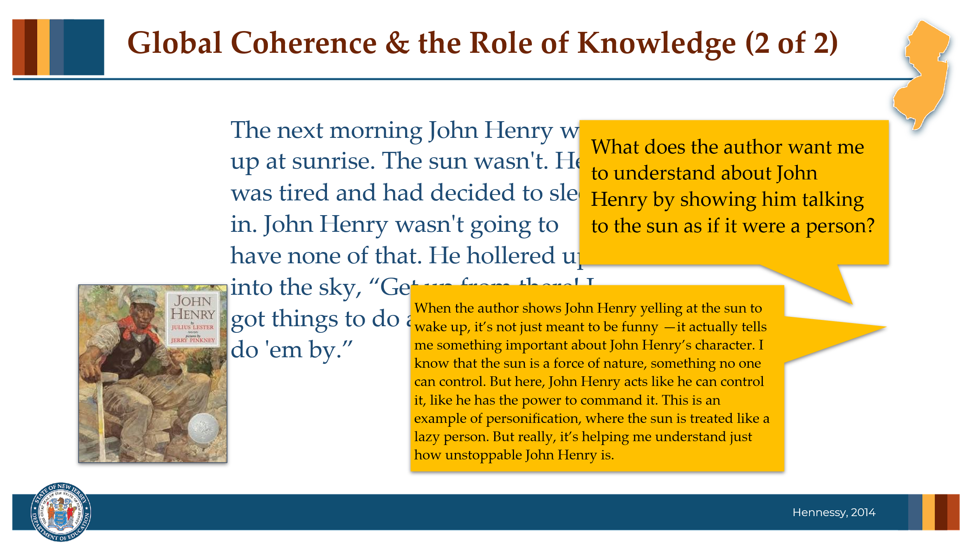

Facilitator Narration
Effective instruction focuses on helping students build and then integrate the background knowledge needed for a given text. When preparing a text or a visual image to accompany a text, teachers can frame inferential questions and prompts, such as “What does the author want me to understand about John Henry by showing him talking to the sun as if it were a person?”
The teacher can then model the identification of clues and the integration of knowledge, by thinking out loud how she infers that the personification of the sun emphasizes John Henry’s determination, power, or larger-than-life character traits, even before the main action of the tall tale begins.
Then the teacher can provide opportunities for students to practice themselves by identifying other places in the story that help the reader understand just how unstoppable John Henry is based on their knowledge of tone and exaggeration in folk storytelling.

Slide 9: Global Coherence & the Role of Knowledge
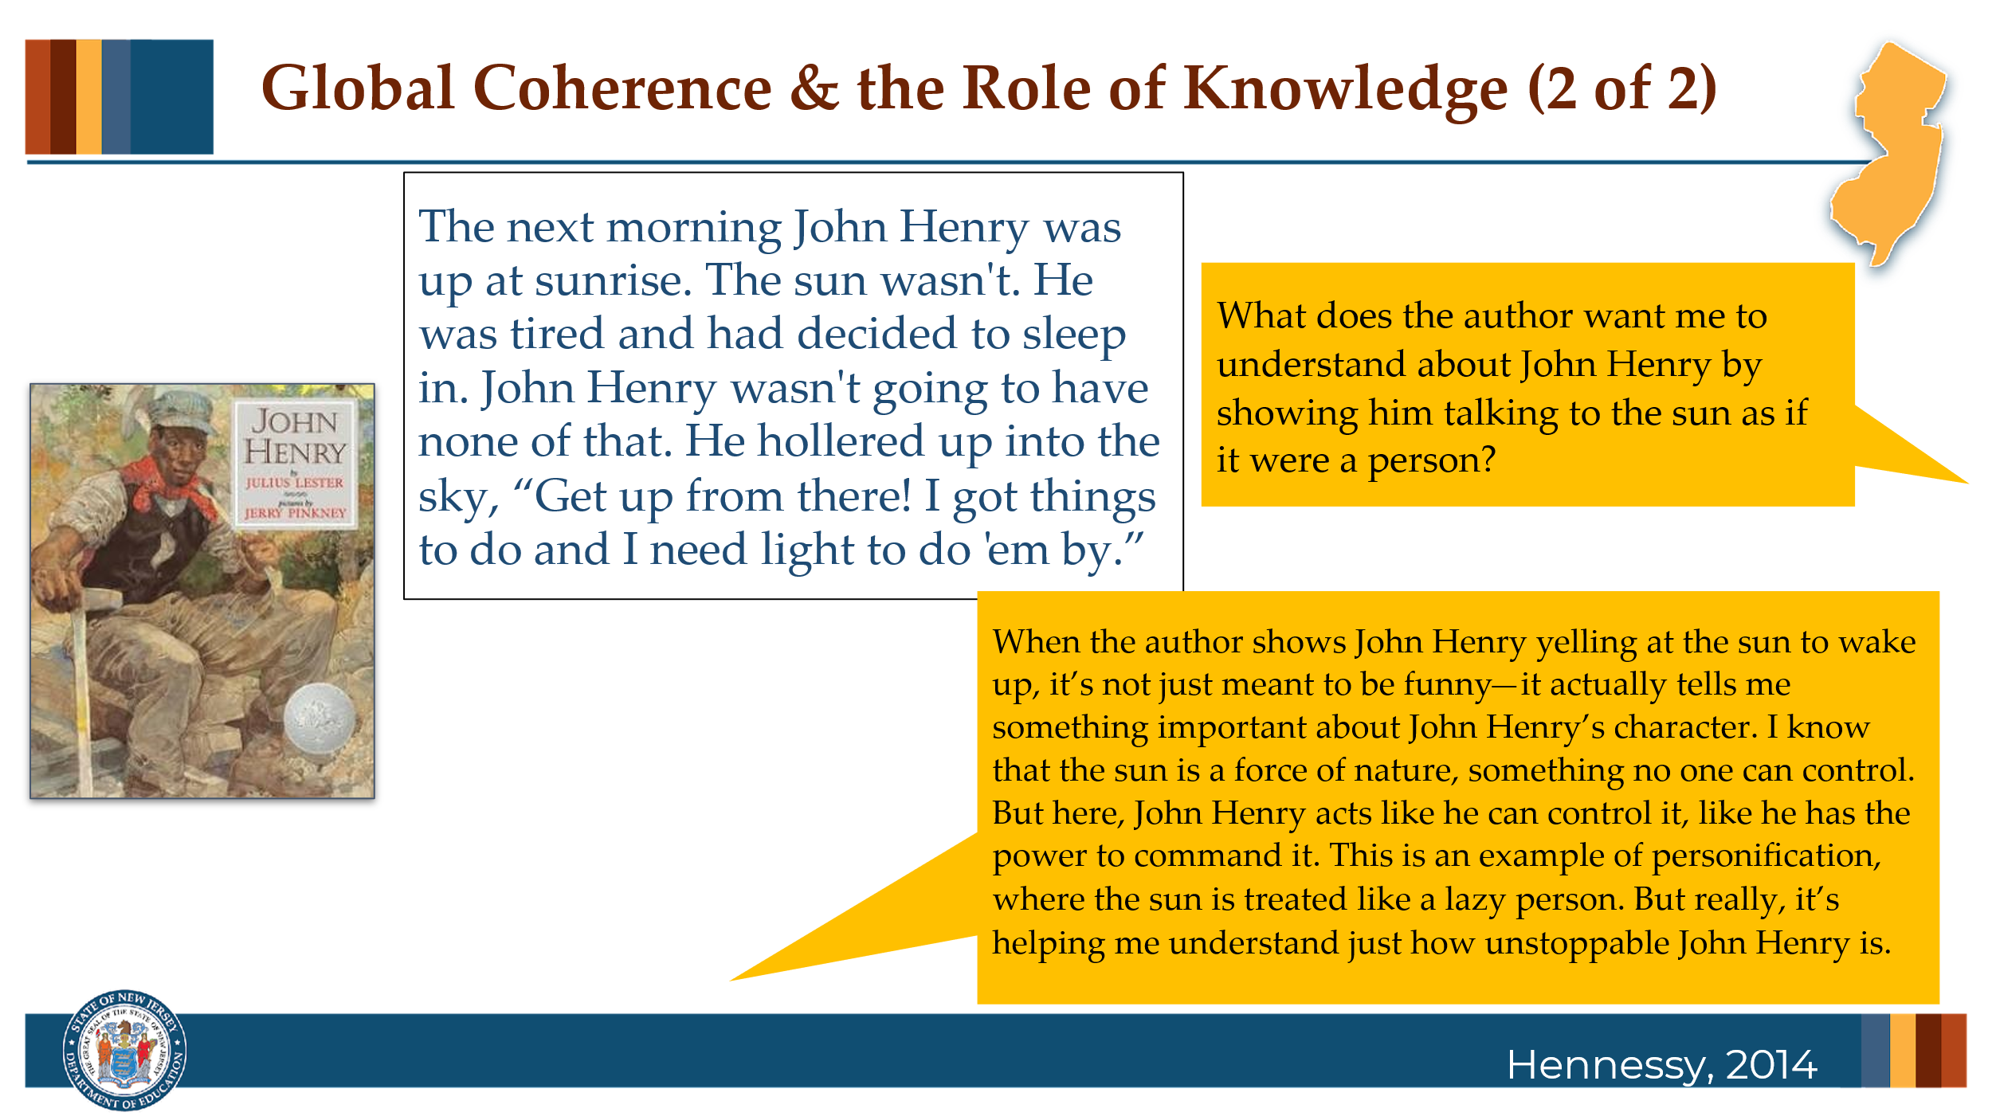

Facilitator Narration
Effective instruction focuses on helping students build and then integrate the background knowledge needed for a given text. When preparing a text or a visual image to accompany a text, teachers can frame inferential questions and prompts, such as “What does the author want me to understand about John Henry by showing him talking to the sun as if it were a person?”
The teacher can then model the identification of clues and the integration of knowledge, by thinking out loud how she infers that the personification of the sun emphasizes John Henry’s determination, power, or larger-than-life character traits, even before the main action of the tall tale begins.
Then the teacher can provide opportunities for students to practice themselves by identifying other places in the story that help the reader understand just how unstoppable John Henry is based on their knowledge of tone and exaggeration in folk storytelling.

Slide 10: Local Coherence & Cohesive Devices
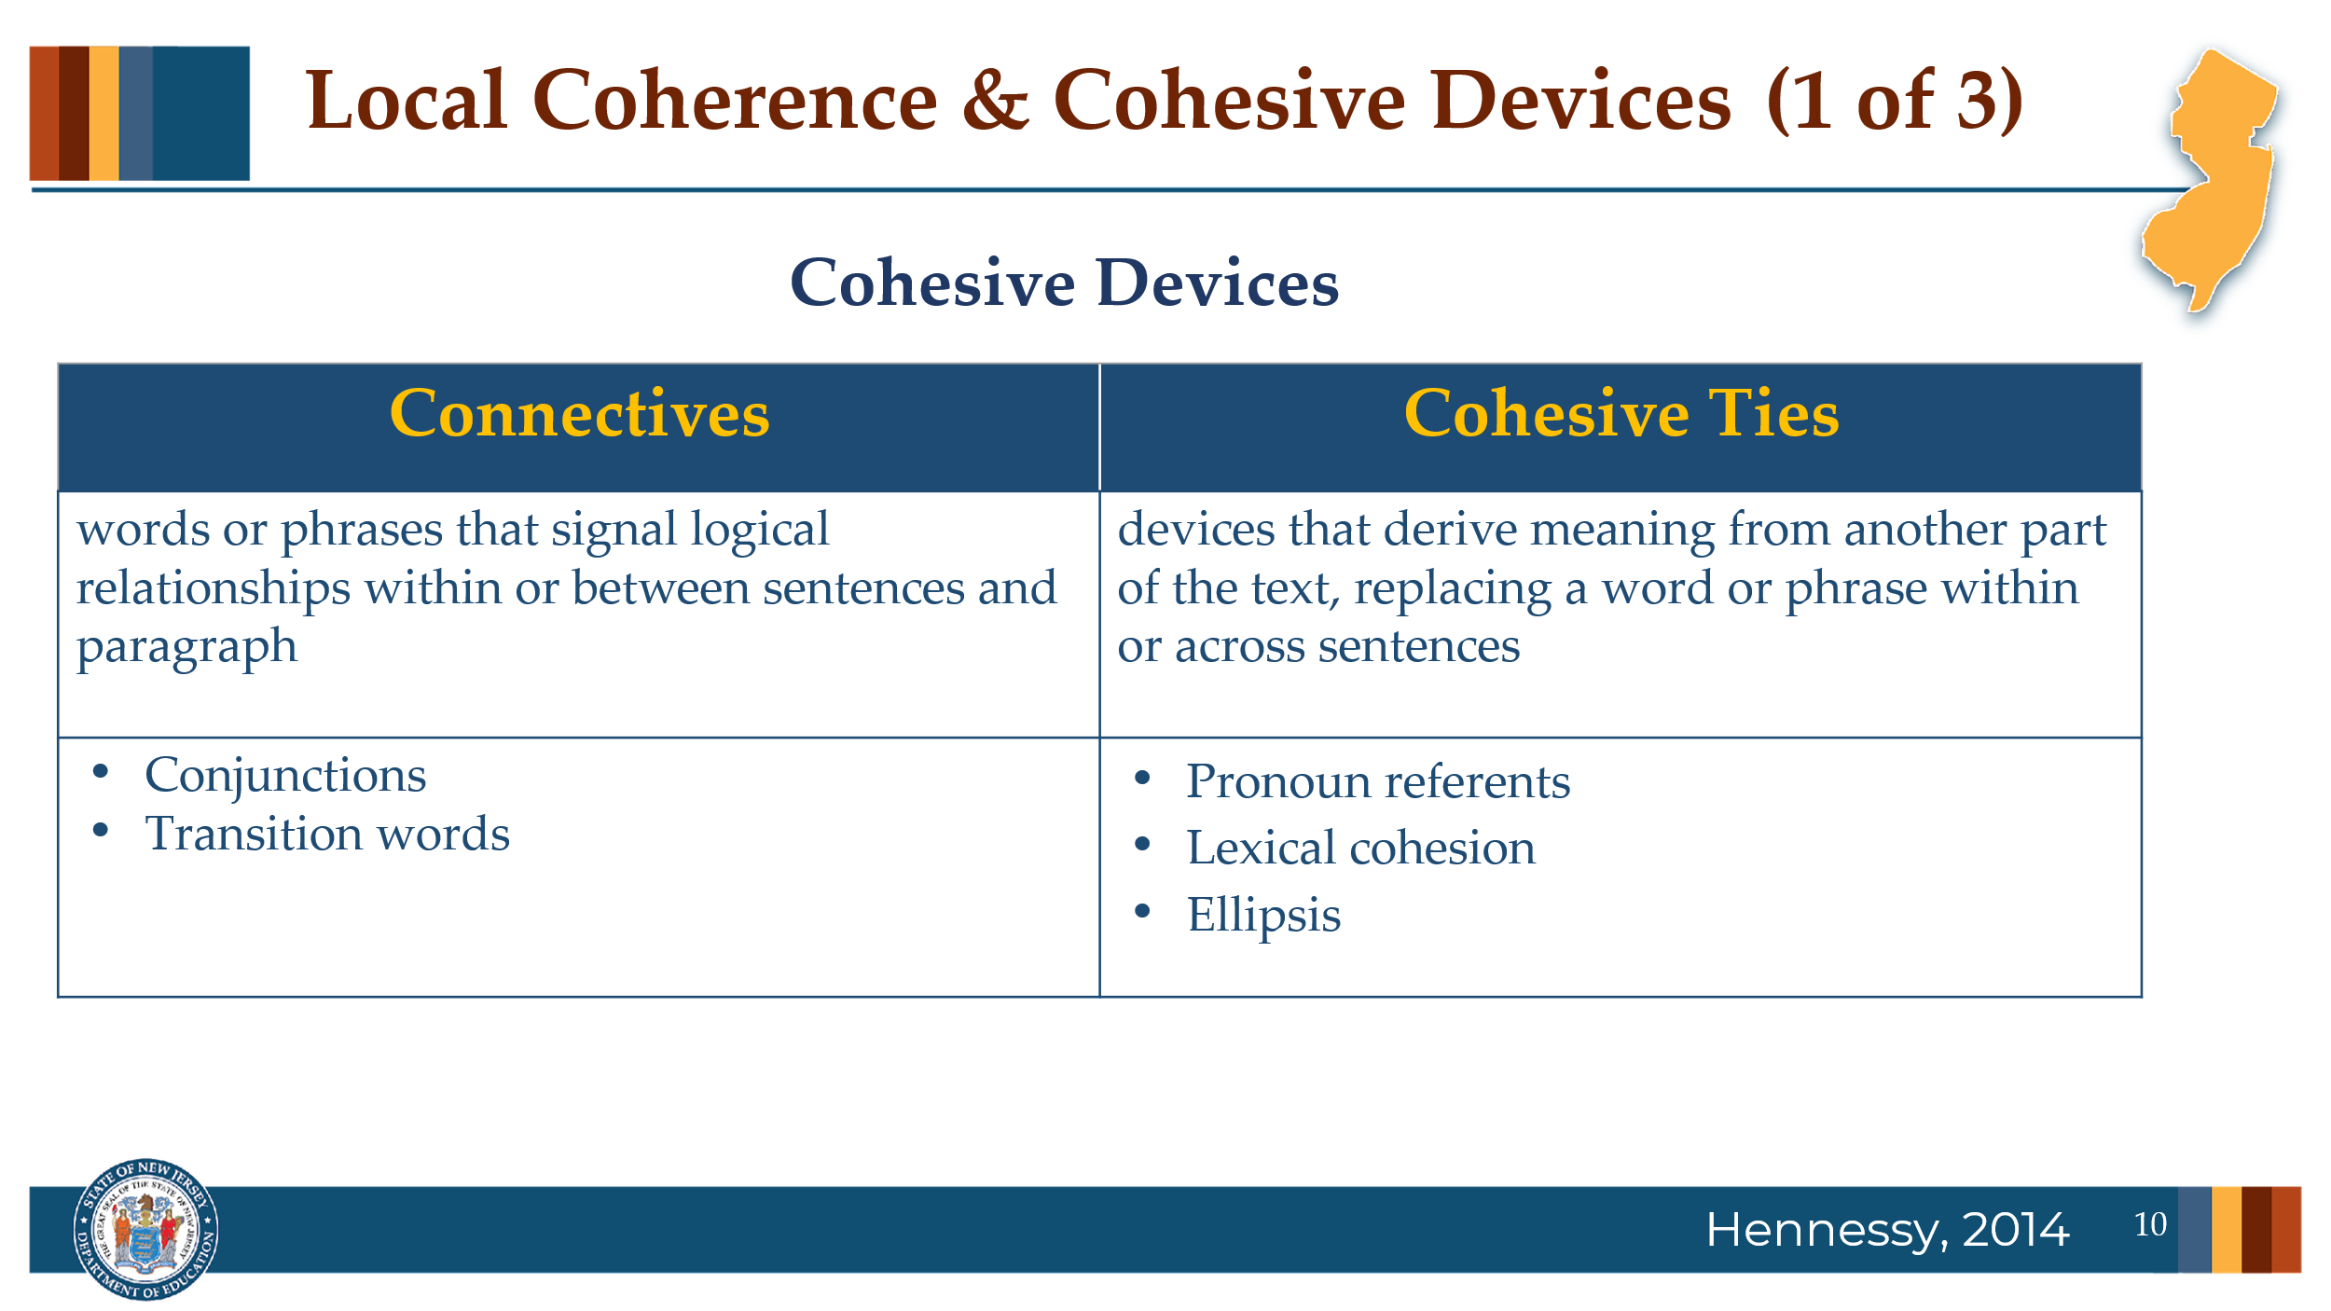

Facilitator Narration
Cohesive devices are the semantic and syntactic cues that help readers bridge and integrate information within and between sentences and paragraphs in a text. These include connectives and cohesive ties.
Connectives are words or phrases that signal logical relationships within or between sentences and paragraphs. These include conjunctions like we discussed in the sentence comprehension session which function to join words, phrases, or clauses within a sentence and transition words like "therefore" or "for example" which link ideas across sentences or paragraphs.
Cohesive ties derive their meaning from another part of the text, replacing a word or phrase within or across sentences. These include:
- pronoun referents which refer back to or take the place of a specific noun already introduced;
- lexical cohesion that is achieved through the repetition of words or phrases in a passage or the use of synonyms and substitutions which reduce repetition and introduce more precise or descriptive vocabulary; and
- ellipsis, when words are deliberately left out because they are understood from earlier in the sentence or context, reducing repetition while maintaining meaning.
In our PLC session on sentence comprehension, we already discussed some of the instructional strategies for teaching students about parts of speech and sentence structure in support of sentence comprehension and construction, which addresses some of the use of connectives so let’s now show how our instruction can address cohesive ties.

Slide 11: Local Coherence & Cohesive Devices
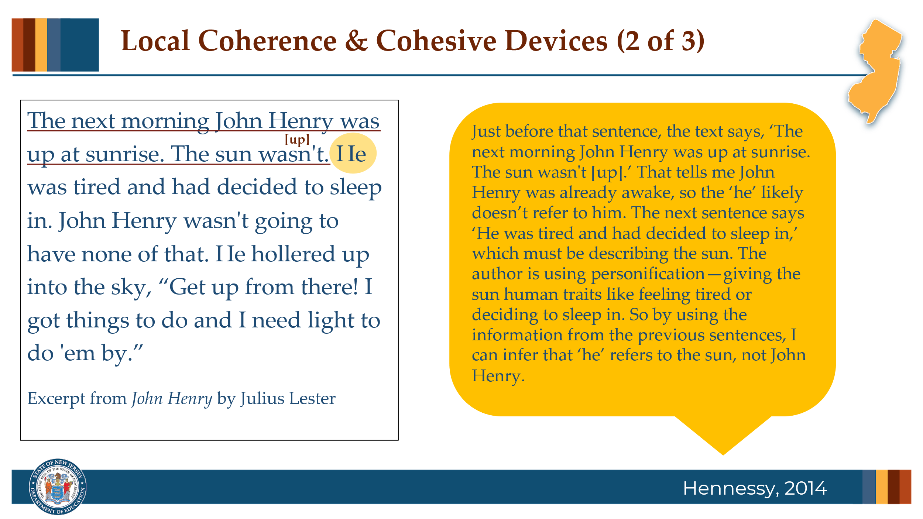

Facilitator Narration
Again when preparing a text, teachers can frame inferential questions and prompts to teach students about pronoun referents, such as “When I read the sentence, ‘He was tired and had decided to sleep in,’ I ask myself, ‘Who does “he” refer to?’ and “How do I know?”
The teacher can then model the identification of clues and the integration of knowledge, by marking up the text passage and thinking out loud about how she infers connections based on the pronoun referent. Listen to the teacher’s modeled response:
“When I read the sentence, I ask myself, ‘Who does “he” refer to?’ Just before that, the text says, ‘The next morning John Henry was up at sunrise. The sun wasn't.’ That tells me John Henry was already awake, so ‘he’ likely doesn’t refer to him. The next sentence says ‘He was tired and had decided to sleep in,’ which must be describing the sun. The author is using personification—giving the sun human traits like feeling tired or deciding to sleep in. So by using the information from the previous sentences, I can infer that ‘he’ refers to the sun, not John Henry.”

Slide 12: Local Coherence & Cohesive Devices
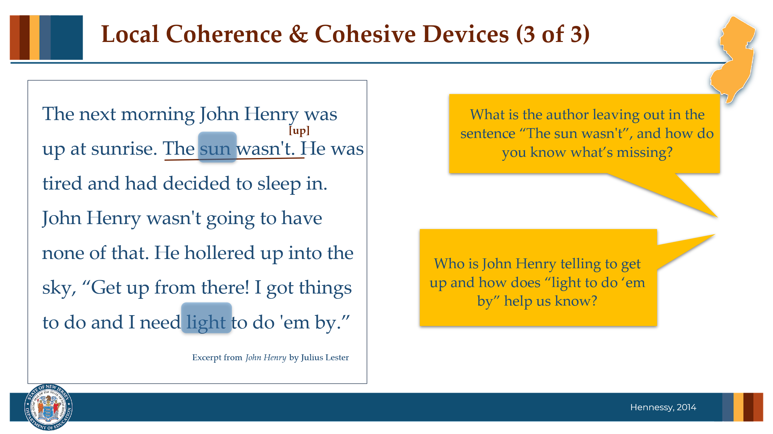

Facilitator Narration

This same passage could be prepared to teach ellipsis → The sun wasn’t… what? up… or to discuss how the author is using substitutions, that let us know that John is yelling up at the sun because needs the sunlight to get started on his work.

After modeling and providing clear explanations for inferences drawn using the cohesive ties, the teacher can provide opportunities for students to practice themselves by identifying other places where those types of cohesive ties are working to connect meaning.

Slide 13: Local Coherence & Cohesive Devices
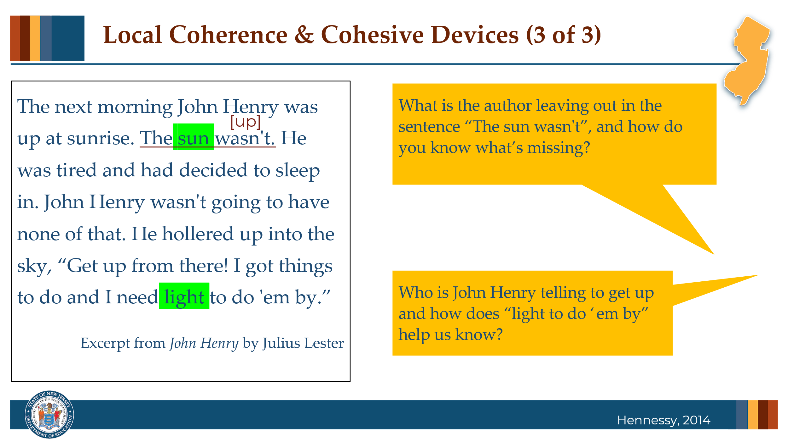

Facilitator Narration
This same passage could be prepared to teach ellipsis → The sun wasn’t… what? up… or to discuss how the author is using substitutions, that let us know that John is yelling up at the sun because needs the sunlight to get started on his work.
After modeling and providing clear explanations for inferences drawn using the cohesive ties, the teacher can provide opportunities for students to practice themselves by identifying other places where those types of cohesive ties are working to connect meaning.

Slide 14: Apply Your Knowledge
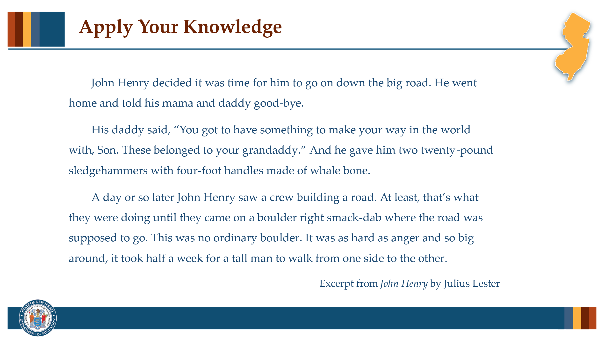

Facilitator Narration
Now let’s apply our own knowledge of cohesive ties in this next activity.

Activity
(5 –10 minutes)
Distribute copies of the excerpt and ask participants to prepare the passage for a lesson on one type of cohesive ties: pronoun referents, lexical cohesion (repetitions or synonyms/substitutes), or ellipsis. Then facilitate a discussion about the examples identified in the excerpt. Suggested examples are listed below:

Pronoun Referents:
…for “him,” “he” went home…, → refers to John Henry
“his” mama and daddy…, “his” daddy said… → refers to John Henry
“You” got to…, make “your” way → refers to John Henry
“these” belonged to your granddaddy… → refers to the sledgehammers
“he” gave “him” → both refer to John Henry’s father and John Henry, respectively
“they” were doing…, “they” came on a boulder → refers to the crew
“that’s what they were doing” → refers to building a road
“this” was no ordinary boulder → refers back to the boulder
“it” was as hard as anger… → refers to the boulder

Lexical Cohesion:
“John Henry” is repeated for clarity and continuity
“road” is repeated
“boulder” is repeated
“something to make your way in the world with” → synonym/substitution for “sledgehammers”
“Son” → synonym/substitution for “John Henry”

Ellipsis:
“from one side [of the boulder] to the other [side of the boulder]…” → omits the phrases shown but this excerpt would not be an exemplary example of ellipsis.

Optional Activity
(5 –10 minutes)
Ask community members to identify two sentences in the excerpt that could be used for a sentence combining activity focused on connectives. Suggested examples: John Henry decided it was time for him to go on down the big road. He went home and told his mama and daddy good-bye.

Slide 15: Adapting to Student Needs
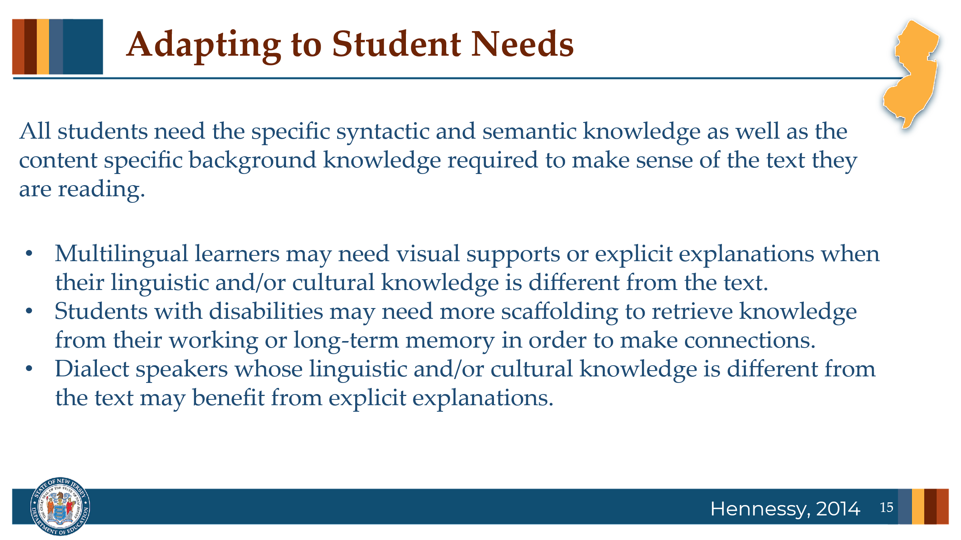

Facilitator Narration
Great discussion! As we close, let’s remember that all students need the specific syntactic and semantic knowledge as well as the content specific background knowledge required for the text they are reading. But not all students enter the classroom with the same prior knowledge or ability to access that knowledge. Multilingual learners, students with disabilities, and students who speak in a dialect variation that differs from the features in the text being read may need targeted support to draw both local and global coherence inferences. Explicit instruction helps ensure all students have an equal chance to draw the inferences needed to make sense of the text they are reading.

Slide 16: Thanks for participating!
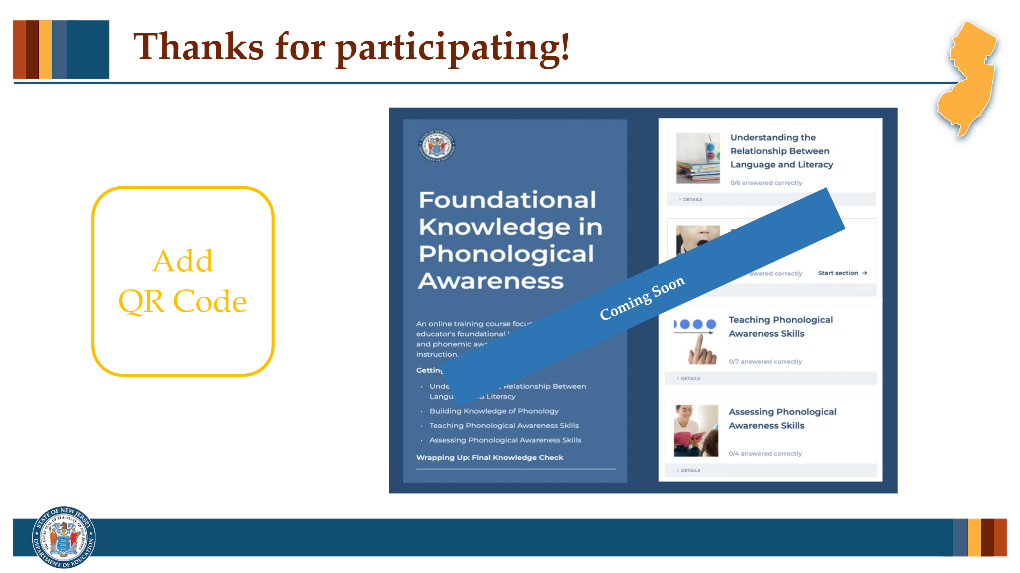

Facilitator Narration
This brings us to the end of our session today! If you are interested to learn more about inference strategies, keep an eye out for the NJ Department of Education’s upcoming free SISEP online learning modules.

Slide 17: Next Session in the PLC Series
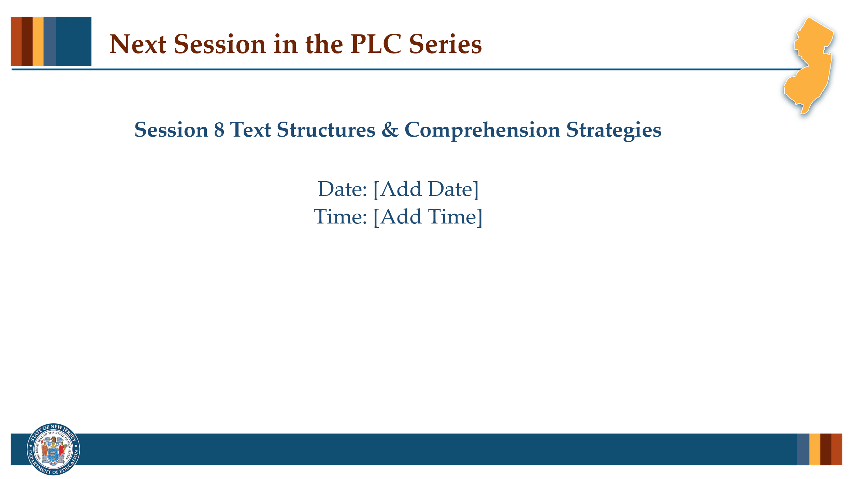

Facilitator Narration
Up next is Session 8 Text Structures & Comprehension Strategies. This PLC session will focus on text structures and the comprehension strategies that support students’ meaning making. We will meet on [add date and time]. See you then!

Slide 18: References
This slide lists references from the presentation.

Session Materials Needed
PLC Series Session 7 - Slide Presentation
If the session is being delivered virtually, use a virtual meeting space that allows for meeting participants to engage via both audio and video.

