

# LEARning about Literacy: Professional Learning Community (PLC) Series Session 8 Text Structures & Comprehension Strategies Facilitator Guide

This facilitation guide provides a structured approach to lead Session 8 Text Structures & Comprehension Strategies. The session aims to help educators understand text structures and comprehension strategies that support students’ ability to make meaning from varied texts. The facilitator is tasked with preparing materials, engaging participants, and ensuring active participation throughout the session.

## Step-by-Step Facilitation Process

1. **Send Pre-Work Email to Community Members:** Send the pre-drafted email with the pre-work assignment attached (e.g., reading or video) and session details (date, time, location/platform).
2. **Review Pre-Work and Session Presentation Materials:** Review the pre-work assignment, session slides, and facilitator notes to ensure familiarity with content.
3. **Prepare and Update Session Presentation Materials:** Update slides with relevant contextual information for the group, prepare all handouts and supplementary resources needed, and check on the room set up, materials needed for activities, and technology to ensure a smooth session. Test any video links in the presentation to confirm they are working properly.
4. **Deliver the Session:** Present the pre-drafted session presentation, engage participants with discussions and activities, and answer questions to ensure understanding.

1. **Invite Community Members to Next Session:** Thank participants, share details of the next session, and encourage ongoing engagement with additional resources.

## Draft Email

**Subject Line:** Join us for Session 8! Evidence-Based Literacy Instruction PLC Series

Dear [Staff Member],

This is a friendly reminder that the final session of the Learning Equity & Academic Recovery’s Evidence-Based Literacy Instruction Professional Learning Community (PLC) Series is coming soon!

### PLC Session 8: Text Structures & Comprehension Strategies

Date: [Insert Date]  
Time: [Insert Time]  
Location: [Insert Location/Platform Link]

In this session, we will focus on text structures, with an emphasis on comprehension strategies that support students’ ability to make meaning from varied texts. The session is designed to be interactive and collaborative, allowing you to engage with your colleagues and share ideas and best practices for supporting students’ literacy development.

Prior to our session together, please be sure to visit *Reading Universe* to download the [Graphic Organizers for Reading Comprehension](https://files.readinguniverse.org/Taxonomy/Language-Comprehension/graphic-organizers-for-reading-comprehension-reading-universe.pdf) to be prepared for our discussion and activities.

We look forward to seeing you there and working together to enhance our literacy instruction!

Best regards,

[Your Name]  
[Your Title]  
[School District Name]  
[Your Contact Information]

## Session Presentation Facilitation Notes

### Slide 1: Title Slide

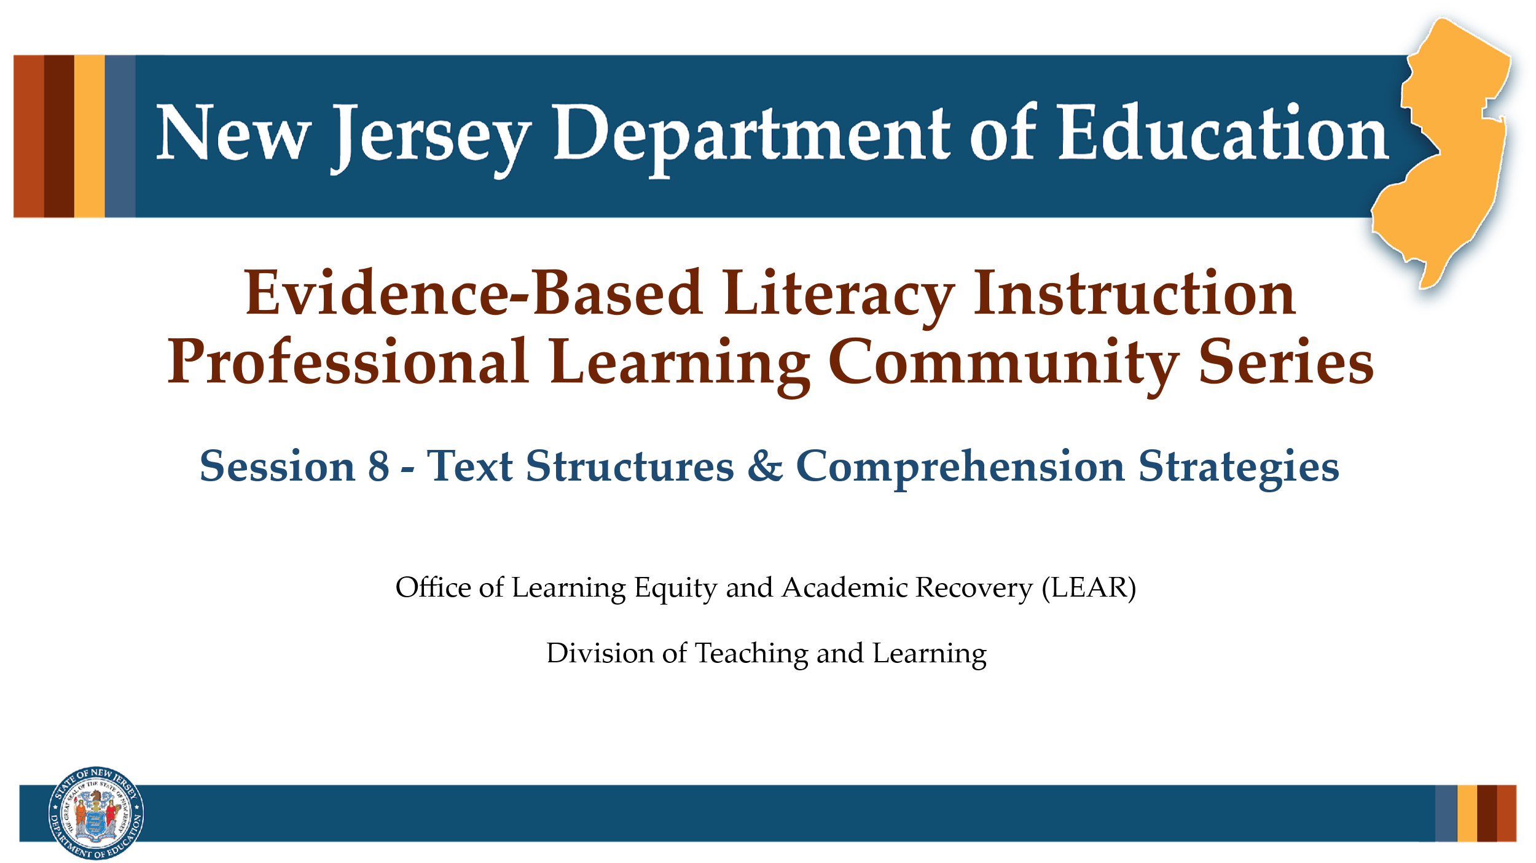

#### Facilitator Narration

Welcome! We’re excited to have you join us for this eighth and last session in our Professional Learning Community Series. Today, we’ll be looking to strengthen our instructional practices across various text structures, by focusing on the comprehension strategies best situated to help students make meaning from various kinds of texts.

### Slide 2: Session 8- Literacy Knowledge

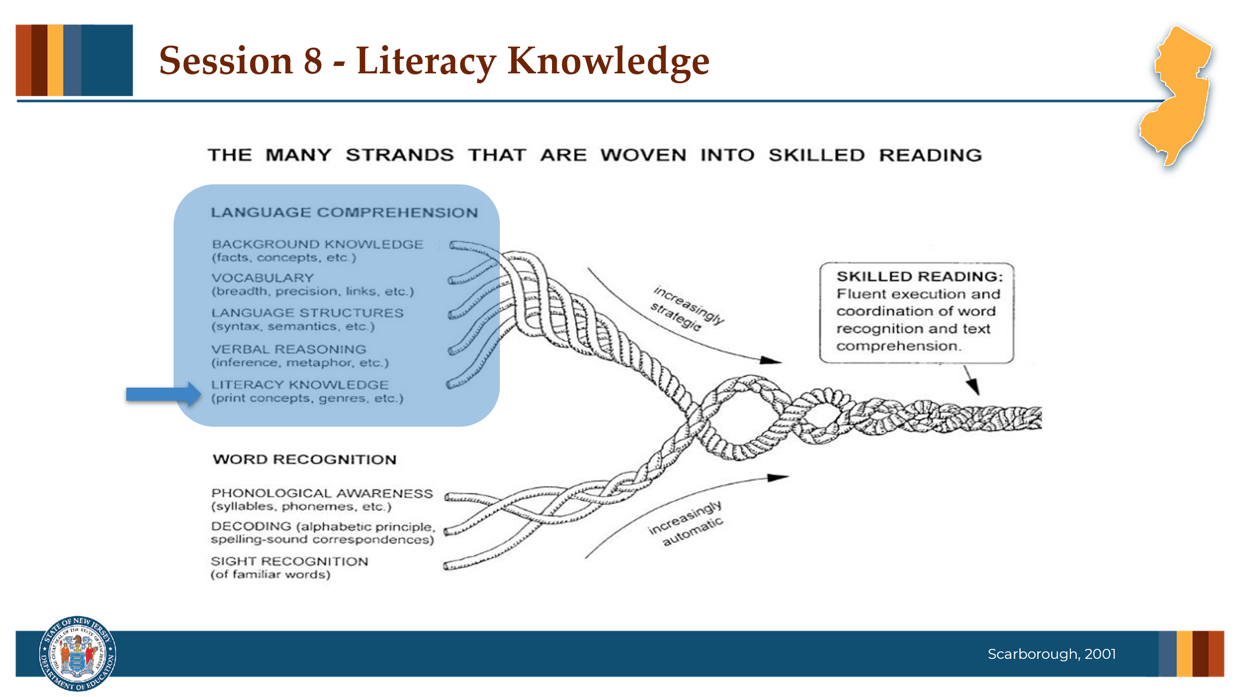

#### Facilitator Narration

Literacy knowledge is the specialized background knowledge that supports how students learn to read. Scarborough’s Reading Rope highlights literacy knowledge—like print concepts, genre, and text structures—as essential components of skilled reading.

### Slide 3: Text Version of Scarborough’s Rope

The text version is provided for people who cannot access the content in the image (e.g., someone who is blind or has low vision).

### Slide 4: Print Concepts

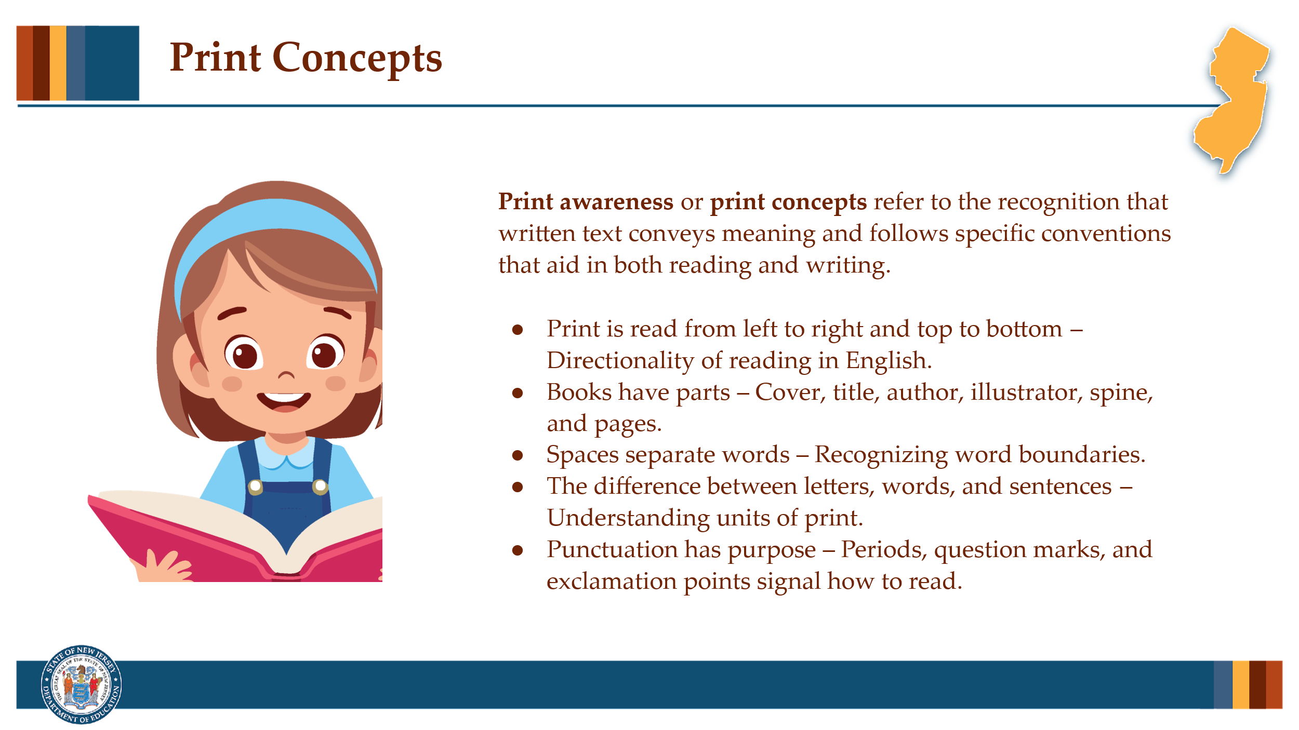

#### Facilitator Narration

One early and crucial element is print awareness (or print concepts), which develops through both early interactions with books and print materials and formal classroom instruction. Young students learn that print conveys meaning and follows specific conventions—like reading left to right, parts of a book, and recognizing units of print such as letters, words, and sentences. This critical awareness lays the groundwork for understanding how texts are structured.

Text structure will be the topic of our session today.

### Slide 5: Text Structures

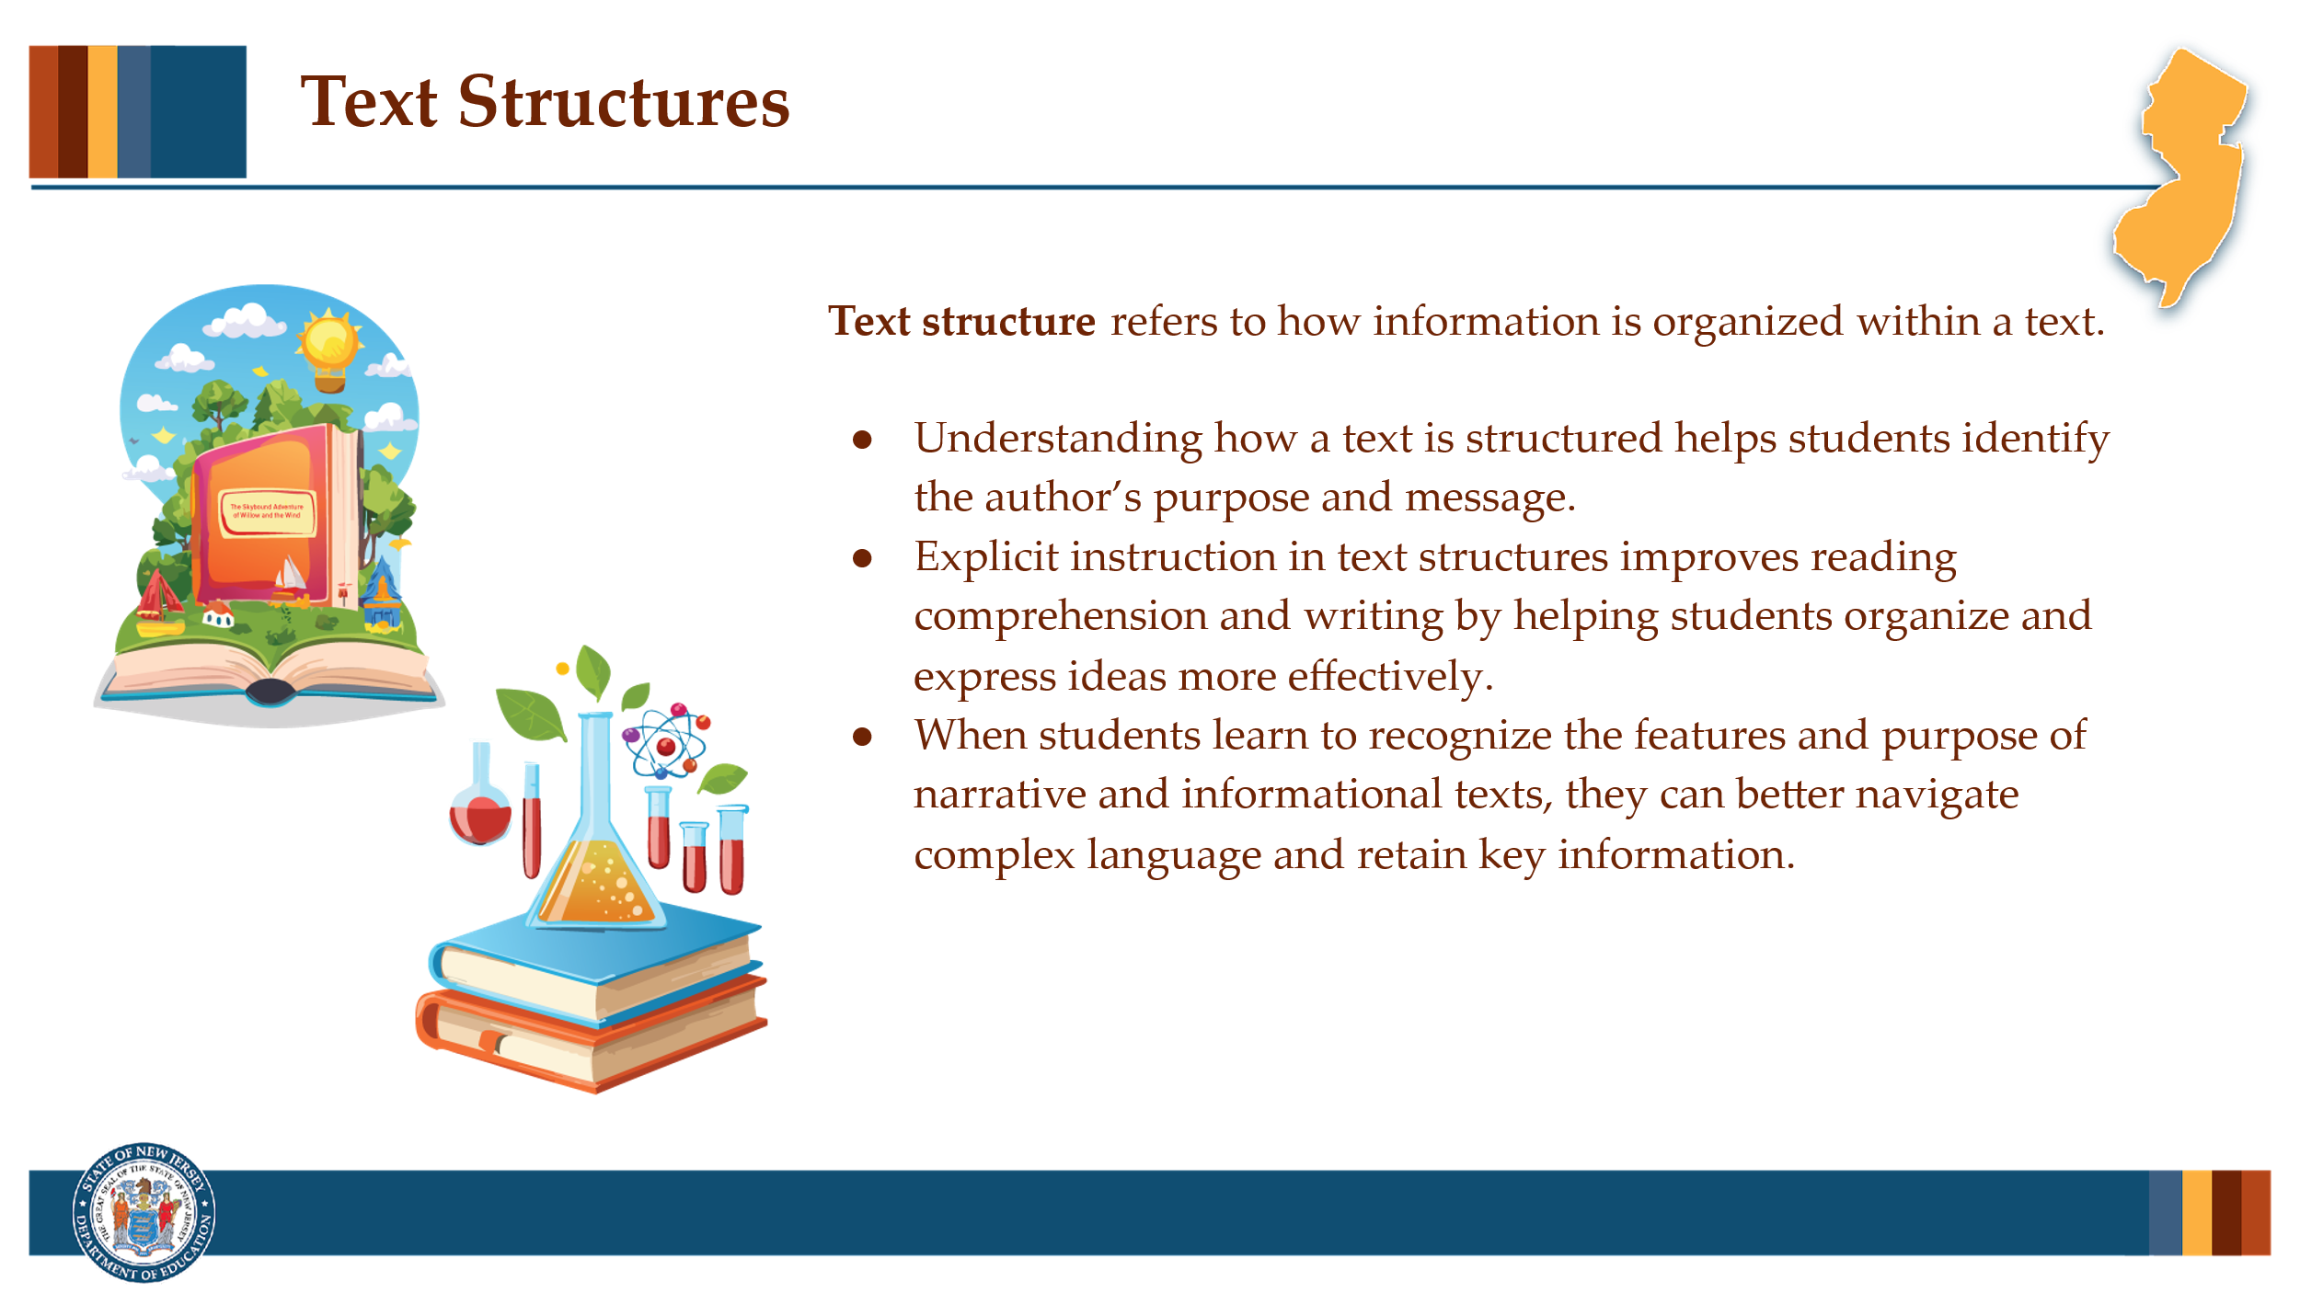

#### Facilitator Narration

Text structure refers to how information is organized within a text. Students who grasp how texts are constructed become more strategic readers and writers. Research shows that instruction in text structure improves both comprehension and written expression because an understanding of these structures helps students identify the author’s purpose and organize information effectively.

Academic texts both narrative and informational often contain complex sentence structures and academic language that can be challenging without explicit instruction. However, when students are taught the purpose and features of these text structures, they can better anticipate, locate, and retain key information.

### Slide 6: Reflection Activity

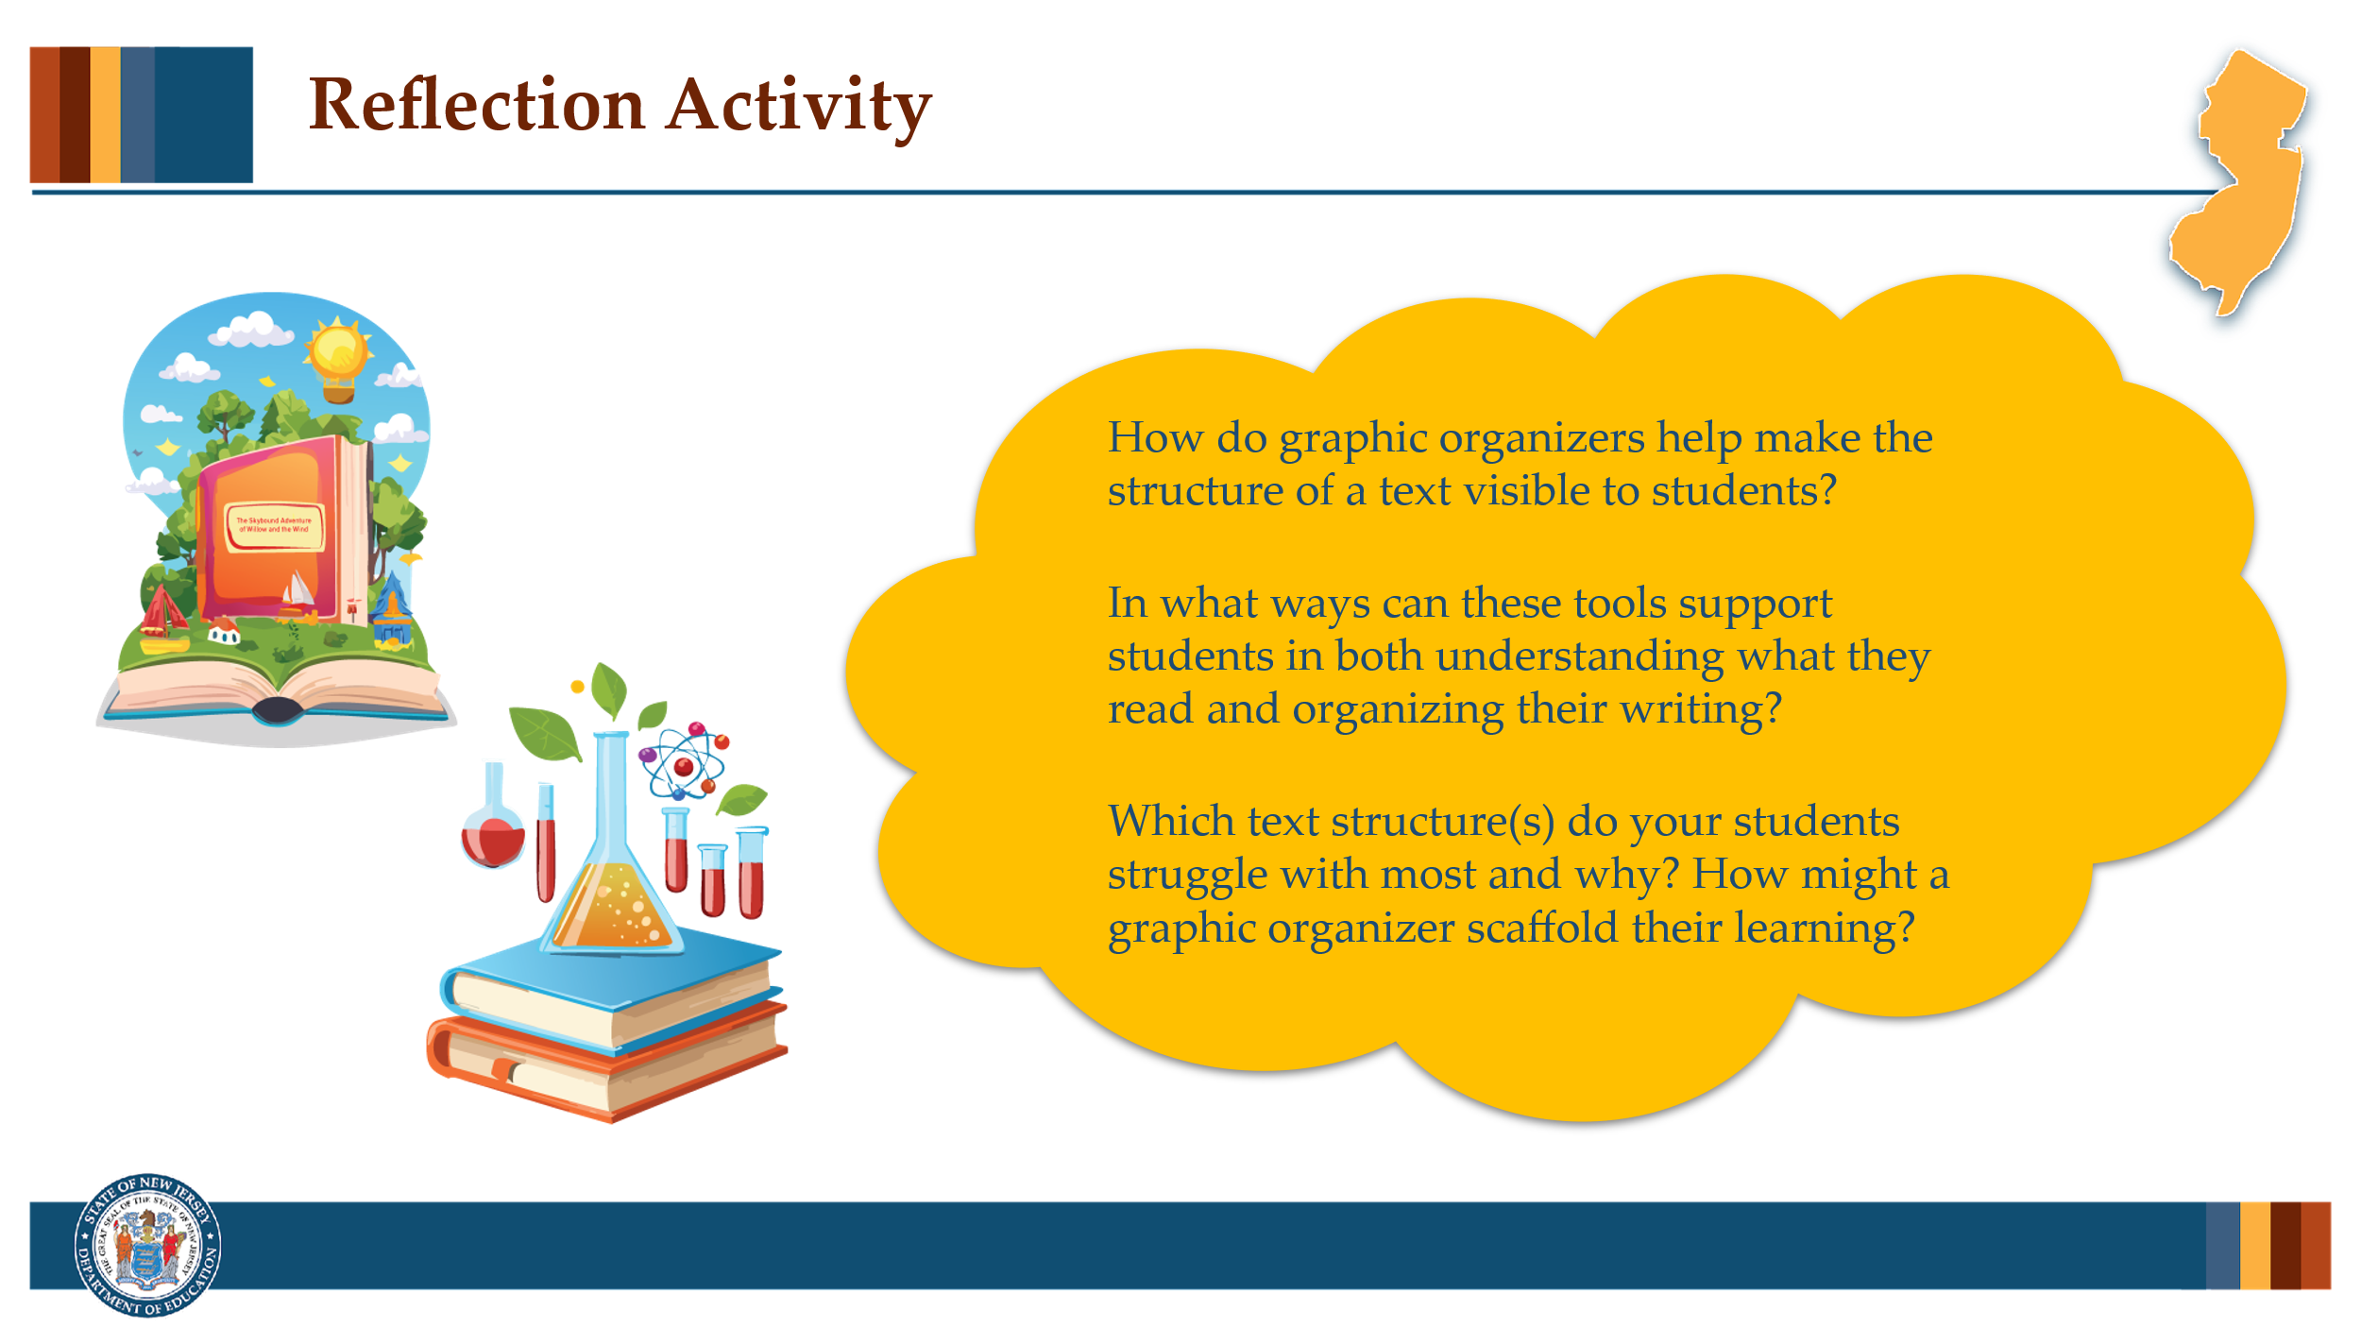

#### Facilitator Narration

As we’ve been discussing throughout this PLC Series, reading teachers should be planning lessons that integrate skill building within a broader goal of knowledge building. When it comes to explicit instruction in text structures, teaching it as a generic, stand-alone skill—disconnected from rich, complex texts—is a missed opportunity to deepen comprehension and build content knowledge. Instead, teachers should frame text structure as a strategic tool that helps students make sense of the content-rich, often complex texts they are expected to read across the curriculum—in science, social studies, and even math.

As a pre-work activity for this session, we looked at Reading Universe’s [Graphic Organizers for Reading Comprehension](https://files.readinguniverse.org/Taxonomy/Language-Comprehension/graphic-organizers-for-reading-comprehension-reading-universe.pdf). Let’s reflect on how graphic organizers can support student understanding of specific text structures in both reading comprehension and writing development.

#### Activity

(5 minutes)

Facilitate the discussion to prompt community members for the following points:

* How do graphic organizers help make the structure of a text visible to students?
* In what ways can these tools support students in both understanding what they read and organizing their writing?
* Which text structure(s) do your students struggle with most and why? How might a graphic organizer scaffold their learning?

### Slide 7: Teaching about Text Structures

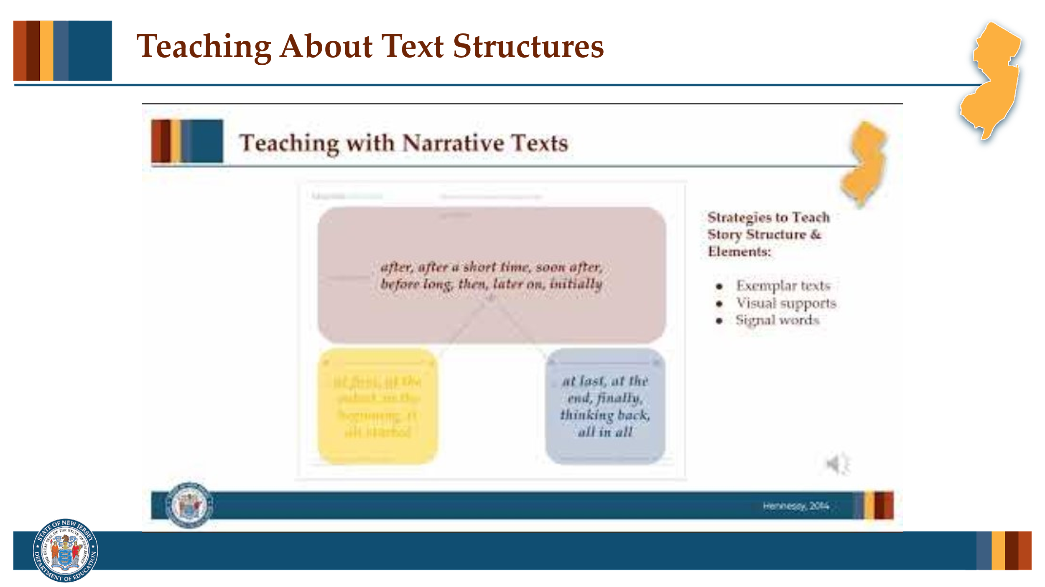

#### Facilitator Narration

Great discussion, we can see how graphic organizers—when intentionally matched to specific text structures—provide a visual scaffold that helps students see how structure can be used as a strategy for understanding text. Rather than simply labeling a passage as "compare and contrast" or "cause and effect," graphic organizers make the underlying logic of the text visible, helping students engage more purposefully with what they read. Let’s now watch this video on instructional strategies for teaching students about text structure.

### Slide 8: Practice Activity

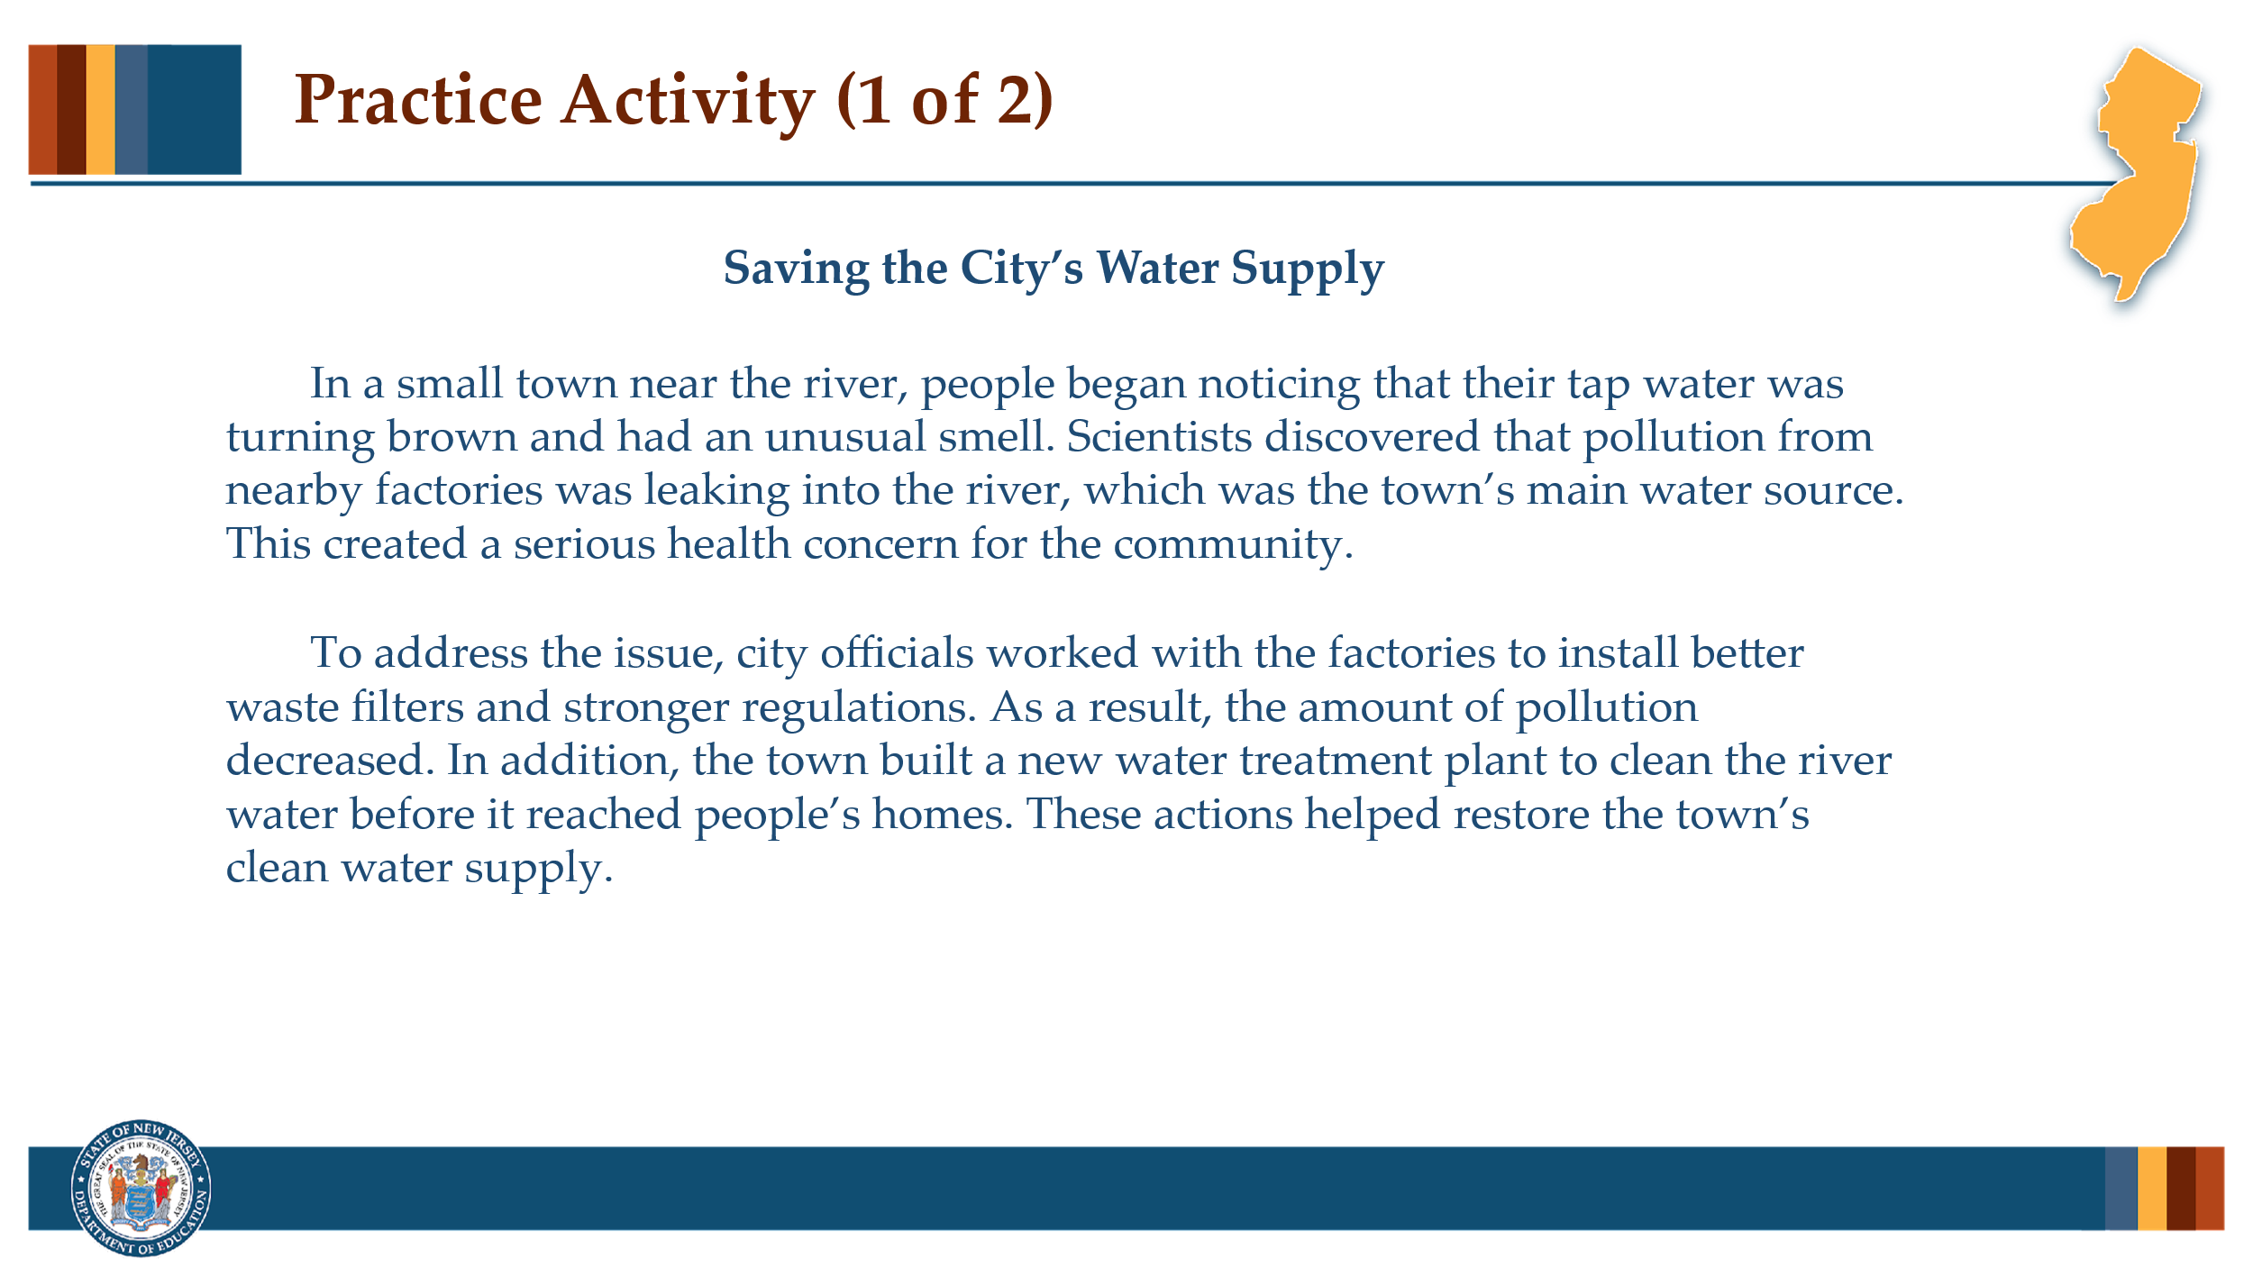

#### Facilitator Narration

Now that we’ve learned about the role text structure can play in supporting comprehension, let’s try this Practice Activity for Analyzing Informational Text Structure.

#### Activity

(5 –10 minutes)

Ask community members to read the passage "Saving the City’s Water Supply" shown on the slide and then ask for a volunteer to identify the type of text structure and explain what clues led them to that decision.

1. What text structure does this passage follow? [problem and solution]

2. How do you know? [signal words include *discovered that*, *concern, To address the issue,* and *As a result*.]

Once the structure is identified as problem and solution, ask:

3. Which visual organizer would best support students’ comprehension of this structure and how might you label its sections? [A Problem–Solution Organizer with labeled sections for Problem, Who/what it affects, Solutions, Result/Outcome. This may spark a conversation about how the organizer included in the Reading Universe template may need to be modified to more precisely scaffold this specific passage.]

Then, have community members, practice crafting guiding questions at both basic and advanced levels and share out their work.

* *Sample basic questions*: What problem did the town face? What were two things the town did to fix it?
* *Sample advanced questions*: Why did the city need to take multiple actions? How do the solutions reflect cooperation within the community?

### Slide 9: Practice Activity

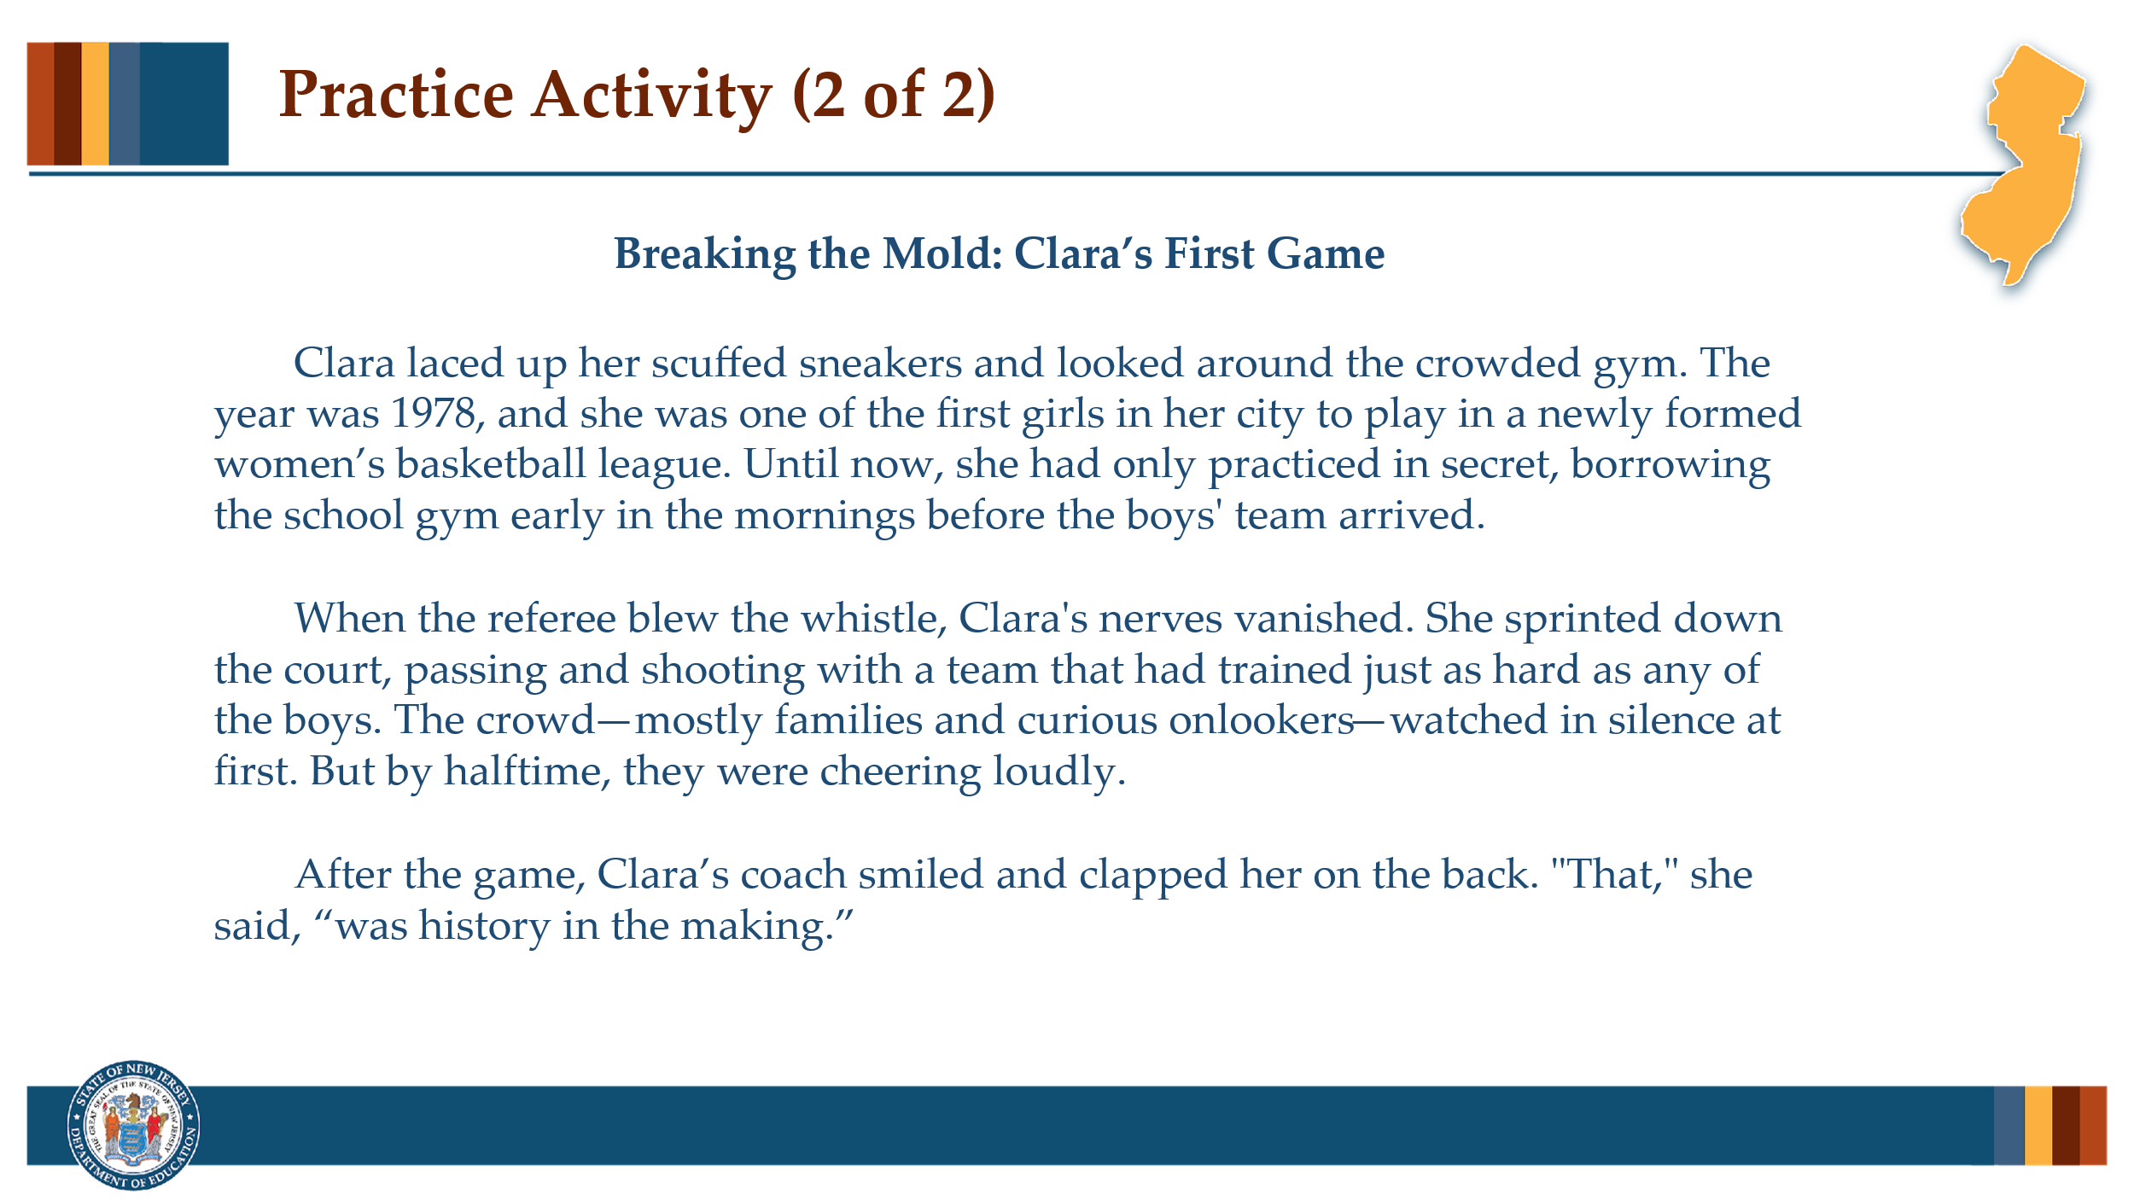

#### Facilitator Narration

Let’s try one more!

#### Activity

(5 –10 minutes)

Ask community members to read the passage "Breaking the Mold: Clara’s First Game" shown on the slide and then ask for a volunteer to identify the type of text structure and explain what clues led them to that decision.

1. What text structure does this passage follow? [narrative]

2. How do you know? [story grammar cues—such as characters, setting, and events]

Once the structure is identified as narrative, ask:

3. Describe the elements of story grammar that could be visualized in a narrative story map organizer?

* Background information:
  + Characters - Clara, her coach, the team, the crowd
  + Setting: Gym, 1978
  + Conflict: First girls’ basketball game, uncertainty about support
* Sequence of Events:
  + Rising action - Practice in secret
  + Climax - plays in game and crowd reaction
  + Falling Action: coach’s praise
* Outcome: Clara plays successfully; first step in women’s sports progress
* Theme: Courage, breaking barriers

Then, have community members, practice crafting guiding questions at both basic and advanced levels and share out their work.

* *Sample basic questions*: Who is Clara and what did she do in the story? What happened during the game?
* *Sample advanced questions*: What does Clara’s experience tell us about sports and gender roles at the time? How does the author build emotion and tension in the story?

### Slide 10: Reading and Writing: A Reciprocal Relationship

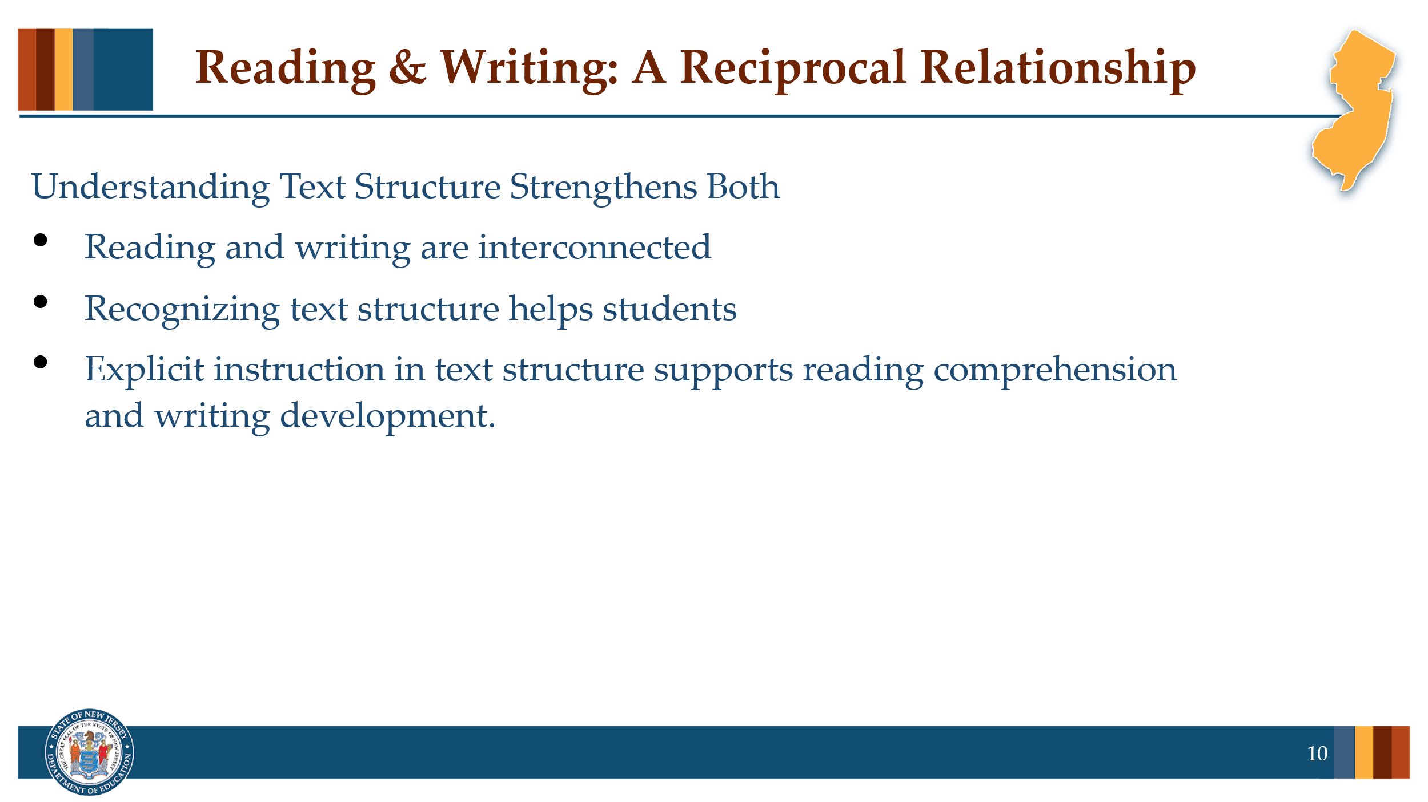

#### Facilitator Narration

Let’s take a moment to talk about the reciprocal relationship between reading and writing, and why understanding text structure is so powerful for students. When we teach students how to analyze the structure of a text—whether it’s cause and effect, sequence, problem and solution, or compare and contrast—we’re not just supporting their reading comprehension. We’re also giving them tools to become better writers. As students learn to recognize how authors organize their ideas, they internalize those patterns. This allows them to more effectively plan, organize, and express their own thinking when they write. In other words, the same structures that help them *make meaning* while reading also help them *communicate meaning* when writing. That’s why explicit instruction in text structure serves double duty—it helps students become strategic readers *and* confident, coherent writers. So as you model and discuss text structures in your classroom, consider how you can make that bridge to writing. Show students that the way a text is built is not just something to identify—it’s something they can use themselves to share their own ideas with clarity and purpose.

### Slide 11: Adapting to Student Needs

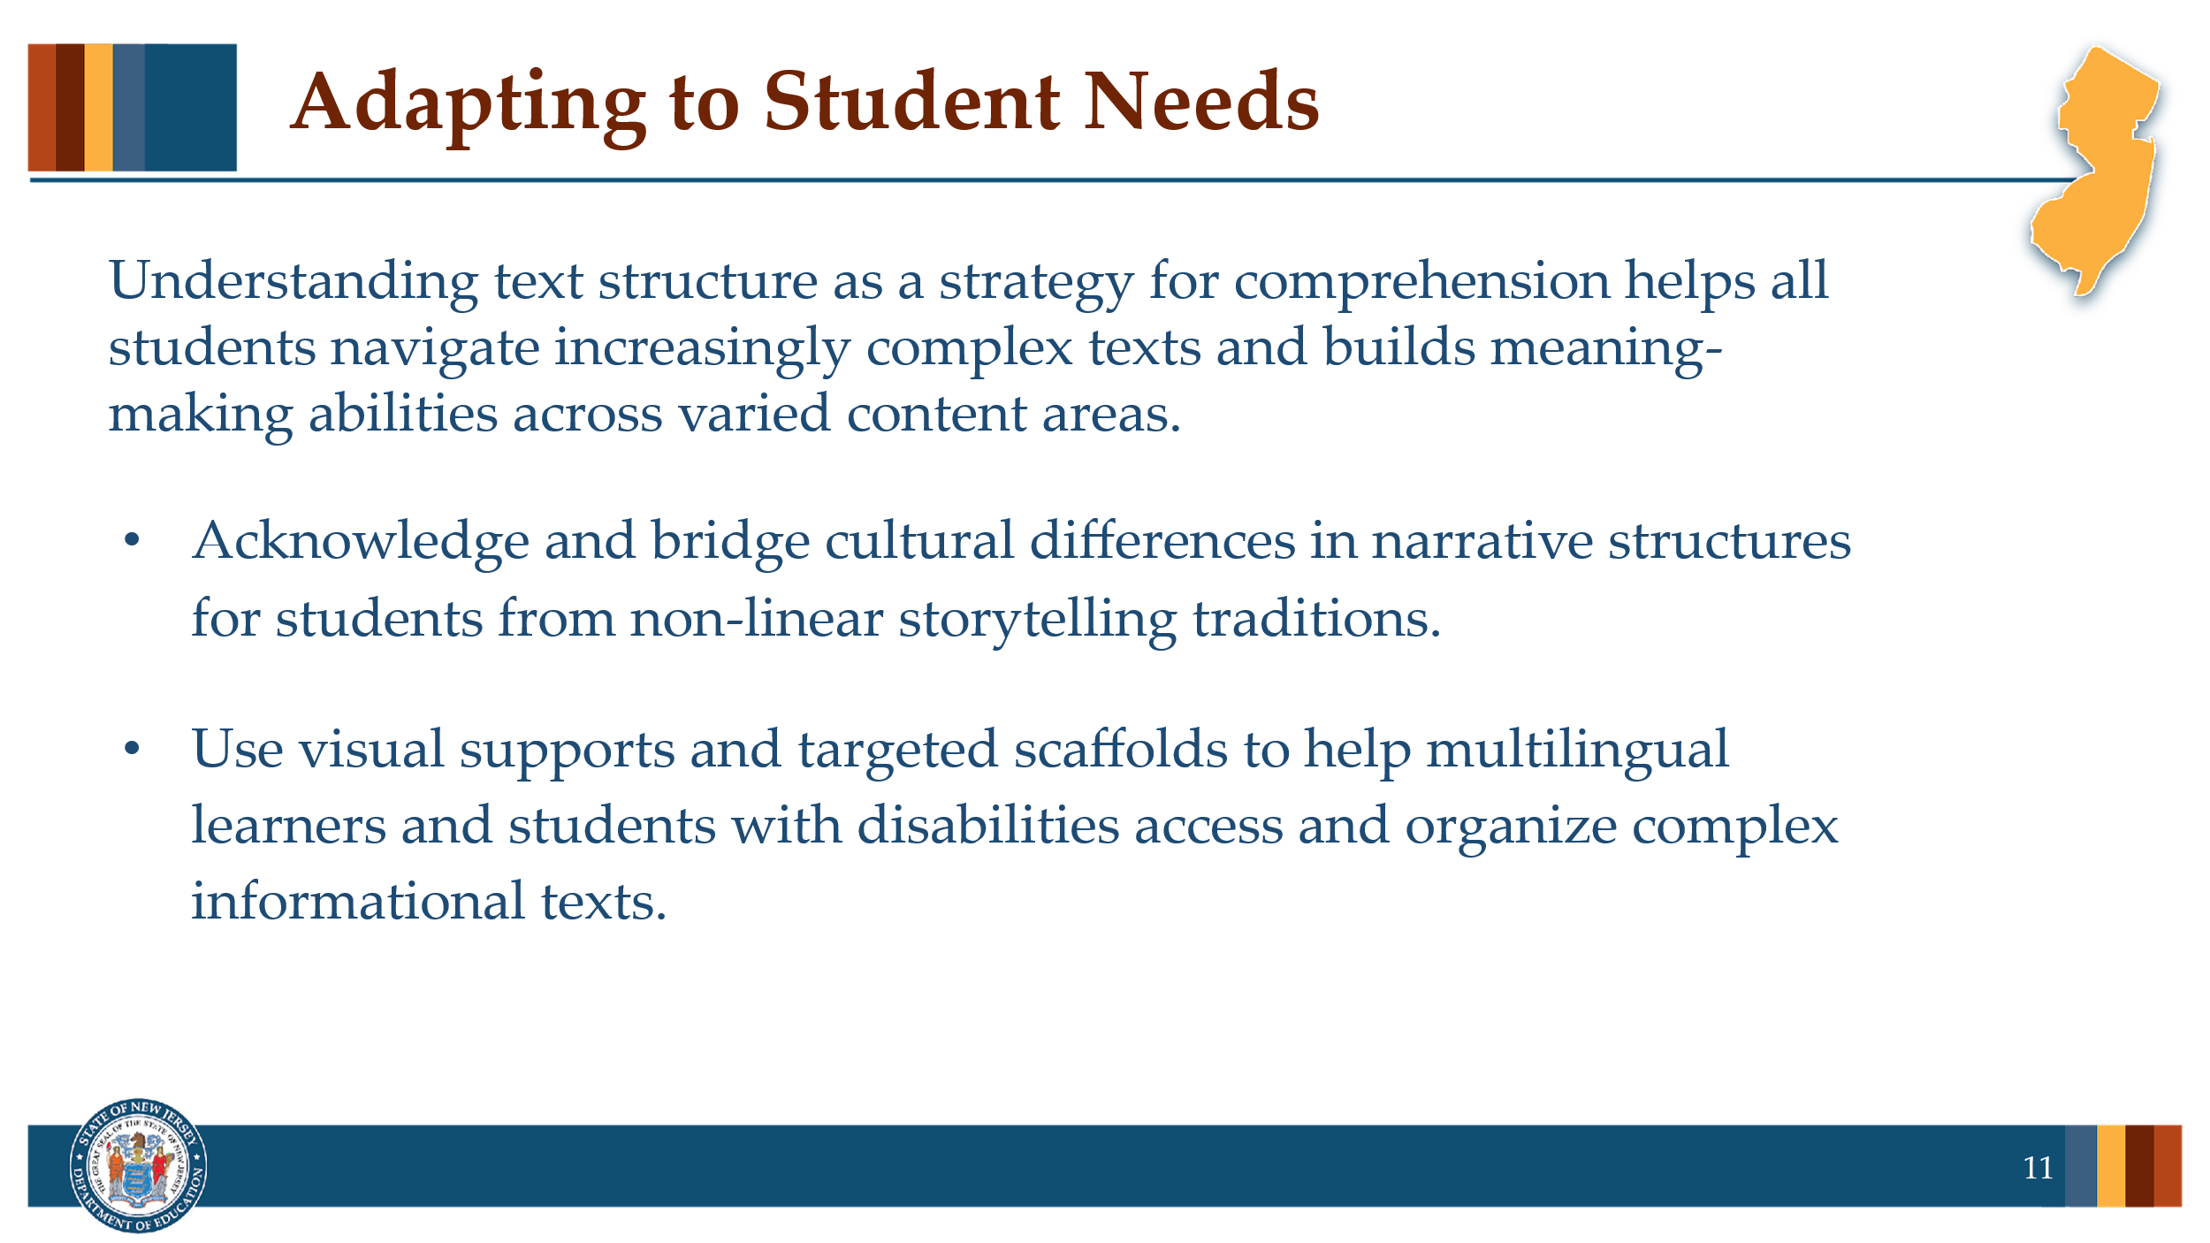

#### Facilitator Narration

Understanding text structure as a strategy for comprehension helps all students navigate increasingly complex texts and builds meaning-making abilities across varied content areas. To meet the needs of all learners:

Acknowledge diverse narrative experiences, especially for students who come from cultural and linguistic backgrounds where stories follow non-linear or cyclical patterns. These students may need explicit comparisons between familiar structures and those used in English texts to support their understanding.

Provide scaffolds to support multilingual learners and students with disabilities around informational text structures, which often include dense language, abstract ideas, and unfamiliar formats. Tools like sentence frames, signal word charts, and graphic organizers can help these students access, organize, and express their understanding more effectively across all content areas.

### Slide 12: Thank you for Participating

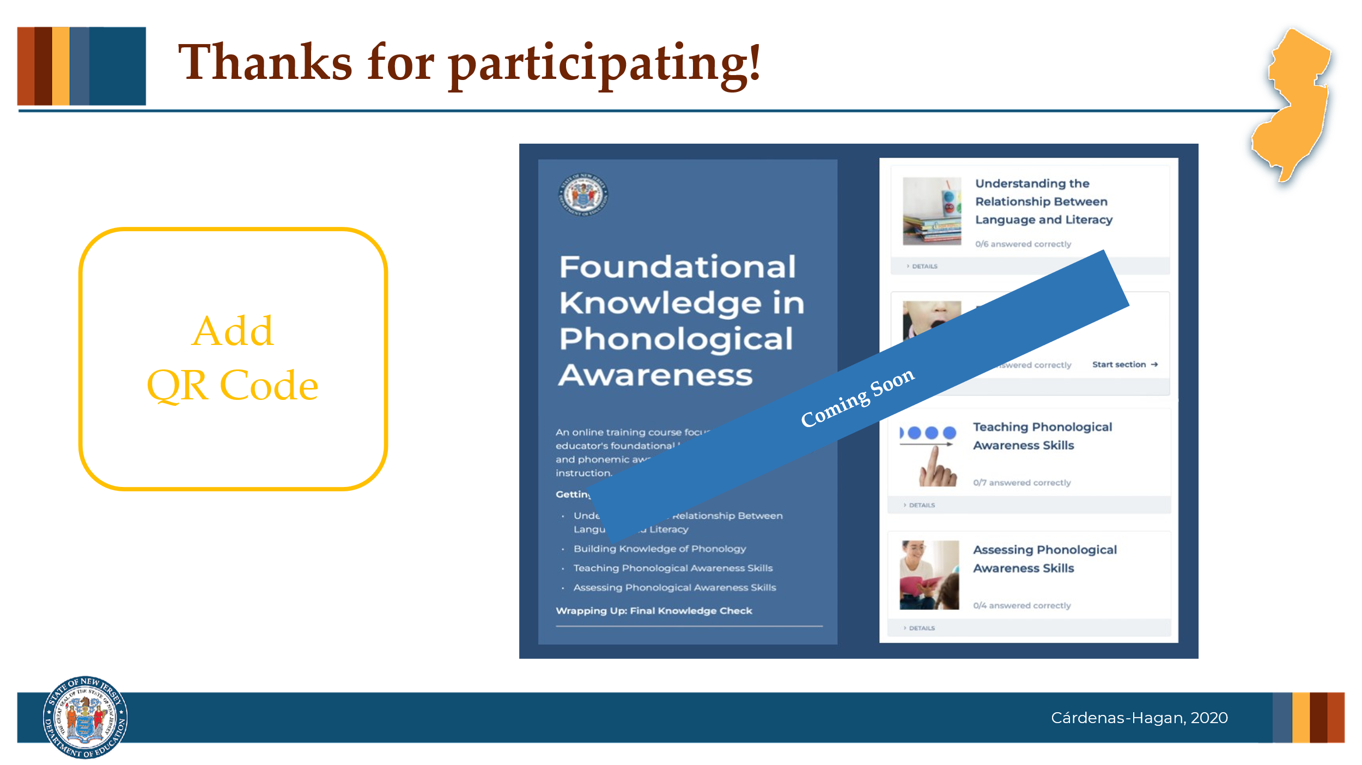

#### Facilitator Narration

This brings us to the end of our session today! If you are interested to learn more about strategies for teaching text structure, keep an eye out for the NJ Department of Education’s upcoming free SISEP online learning modules.

### Slide 13: Congratulations!

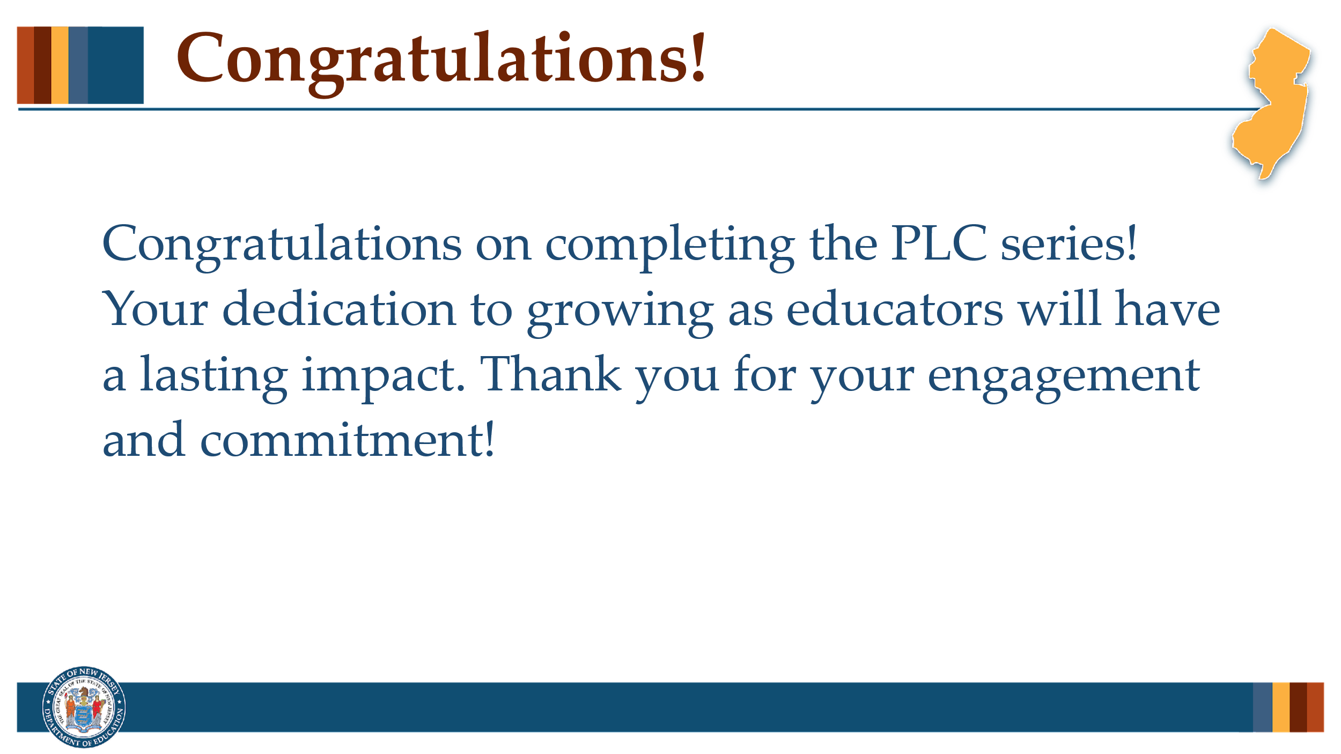

#### Facilitator Narration

Congratulations on completing our 8-part Professional Learning Community series! Your commitment to deepening your understanding and refining your practice is something to be proud of. We hope you leave this series feeling more empowered, equipped, and inspired to support all readers—especially those who need it most. Thank you for showing up, engaging fully, and being part of this learning journey. We can’t wait to see the impact you’ll make!

### Slide 12: References

This slide lists references from the presentation.

### Session Materials Needed

* PLC Series Session 8 - Slide Presentation
* Copies of Supplementary Resources for Community Members:
  + Reading Universe- Graphic Organizer for Reading Comprehension

If the session is being delivered virtually, use a virtual meeting space that allows for meeting participants to engage via both audio and video.