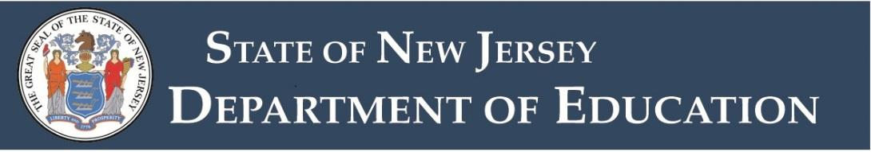

Physical Education
Standard Certificate
Endorsement Code: 1630
Note: this document is made in accordance with the rules currently in effect. Requirements, passing test scores, and fees are subject to change without notice.
This endorsement authorizes the holder to teach physical education in all New Jersey public schools.
The standard certificate is a permanent certificate issued to an individual who has completed the Provisional Teacher Process, holds a previously issued New Jersey standard instructional certificate, or meets reciprocity requirements for standard certification.

Degree Requirement
A minimum of a bachelor’s degree is required from an accredited college or university.

Cumulative Grade Point Average (GPA) Requirement
Note: Degree must be in an eligible baccalaureate degree program or higher.
Minimum GPA by Graduation Date
Candidate Graduation Date | Minimum Cumulative GPA  (when 4.00 equals an A)
Before September 1, 2016 | 2.75
On or after September 1, 2016* | 3.00
*There are GPA flexibility rules in place for those who graduated on or after September 1, 2016 where a Praxis test score may offset a GPA that is lower than 3.0, but higher than 2.75.

Subject Matter Preparation

Credit Requirements
- A minimum of 30 credits in a coherent sequence in physical education. At least 12 of the 30 credits must be at the advanced level of study (junior, senior or graduate level).
- Within the 30 credits, study in individual sports, team sports and adapted physical education must be completed.

Acceptable Courses
Courses in pedagogy or education are not acceptable.
The final determination as to which courses will be counted towards the physical education subject matter is based on content standards found in the New Jersey Student Learning Standards.

Praxis II Test Requirement
Test Requirements for Certification in New Jersey

Professional Teacher Preparation
- A coherent sequence of study in professional education courses which culminates in supervised clinical practice.

State Teaching Certificate
Submit a copy of a valid out-of-state teaching certificate that is equivalent to a New Jersey standard instructional certificate.

Record of Professional Experience
- After applying in NJEdCert, a Record of Professional Experience form will be emailed to the employers listed in your application.
- The New Jersey Department of Education will make the final determination as to whether the experience meets New Jersey reciprocity regulations.

Physiology and Hygiene Requirement
This requirement may be completed by choosing one of the following options:
- Present evidence of basic military training.
- Complete a course such as biology, health or nutrition that appears on an accredited two- or four-year college or university transcript.
- Complete an online test. You must have a tracking number and an application on file to take this test.

