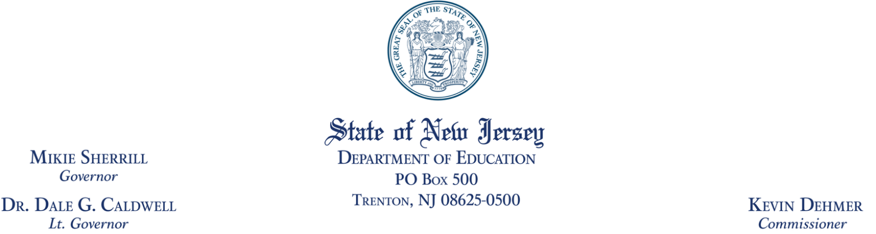
To: All Interested Bidders
From: Office of Budget and Accounting
Date: February 2, 2026
Re: Bid Solicitation (RFQ) # 26-006
PDF Remediation and Document Accessibility Training
Quote {Proposal} Submission Due Date: February 20, 2026 (2:00 p.m. ET)
Revised Quote {Proposal} Submission Due Date: March 6, 2026 (2:00 p.m. ET)

Bid Amendment {Addendum} #01
The following constitutes Bid Amendment {Addendum} #01 to the above referenced Bid Solicitation {RFP}:
- This Bid Amendment {Addendum} includes answers to questions.
It is the sole responsibility of the Vendor {Bidder} to be knowledgeable of all of the additions, deletions, clarifications, and modifications to the Bid Solicitation {RFQ} and/or the New Jersey Standard Terms and Conditions relative to this Bid Solicitation {RFQ} as set forth in all Bid Amendments {Addenda}.
All other instructions, terms, and conditions of the Bid Solicitation {RFQ} shall remain the same.

PDF Remediation and Document Accessibility Training
Bid Solicitation {RFQ} Number: 26-006

Answers to Questions
Note: Each question is referenced by the appropriate Bid Solicitation {RFQ} page number(s) and section where applicable.
# | Page # | RFQ Section Reference | Question (Bolded) and Answer
1 | 13 | Section 3.17  Financial Capability of the Bidder | The RFQ states: "For privately held companies the Bidder should provide the certified financial statement (audited or reviewed) in accordance with applicable standards by an independent Certified Public Accountant, including a balance sheet, income statement, and statement of cash flow, and all applicable notes for the most recent calendar year or the Bidder’s most recent fiscal year." Are bidders required to submit all three documents, i.e., balance sheet, income statement, and statement of cash flow?  Pursuant to Section 3.17 Financial Capability of the Bidder of the RFQ, the State requires that the Bidder should provide sufficient financial information to enable the State to assess the financial strength and creditworthiness of the Bidder and its ability to undertake and successfully complete the Contract. The Bidder is to determine what documents are needed to meet this requirement.
2 | 28 | Section 5.7 Procurement Efficiency Program | The RFQ states: "Procurement Efficiency Program Fee — For all purchases made under this Contract, that have been invoiced, the Contractor shall remit the Procurement Efficiency Program Fee in the amount of one percent (1%) of all Purchases to Periscope acting on behalf of the State of New Jersey." Please clarify this requirement. Should bidder factor in the Procurement Efficiency Program Fee in their pricing?  The Procurement Efficiency Program (PEP) was established through NJAC 17:12-1.5 to create a sustainable funding model for the State of New Jersey’s procurement operations. The PEP and related initiatives have been implemented in partnership with Periscope, an mdf commerce company. Pursuant to RFQ, Section 5.7, the Contractor shall remit the PEP Fee in the amount of one percent (1%) of all Purchases to Periscope acting on behalf of the State of New Jersey.  Please also note the Definition of Purchases:  Purchases - means the total gross purchases, less credits, taxes, regulatory fees and separately stated shipping charges not included in unit prices, made regardless of whether or not NJSTART is used as part of the purchase process.  All price lines presented in the State-Supplied Price Sheet are all items that fall within Section 4 – Scope of Work, of this RFQ. The Bidder should propose pricing in their State-Supplied Price Sheet that is reflective of the requirements as described in Section 4.
3 | 33 | Section 7.2.2 Cyber Breach Insurance | Please confirm that the awardee of this contract will be require to have a Cyber Breach Insurance.  As stated in Section 7.2.2 Cyber Breach Insurance of the RFQ, the Contractor shall carry Cyber Breach Insurance in an amount sufficient to protect the Contractor from any liability arising out of its performance pursuant to the requirements of this Contract.
4 |  |  | Can the State provide estimated annual volumes (based on historical data or projections) for the number of PDF documents and trainings expected each year?  An estimate cannot be provided as comprehensive data is not available regarding the total number of PDFs produced annually by all using agencies, nor the proportion of those documents that would be contracted out versus remediated in-house by agency staff. The New Jersey Department of Education (NJDOE) produces, at a minimum, approximately 1,000 PDFs each year, representing an estimated 7,500 pages.  NJDOE anticipates no more than six trainings per year. An estimate cannot be provided regarding the number of trainings for other using agencies that may utilize this contract.
5 | 20 | Section 4.4 Acceptance Criteria | Section 4.4 (Acceptance Criteria), page 20, states: “If the Using Agency is NJDOE, the training follows NJDOE guidelines outlined in 4.1.1 and 10.1–10.3.” However, Sections 1.1–10.3 do not appear in the document. Could the State please clarify whether there are specific NJDOE training guidelines that must be followed and, if so, provide or reference those sections?  Sections 10.1–10.3 were relocated to Exhibit A; however, the corresponding language in Section 4.4 was not updated accordingly. The New Jersey Department of Education (NJDOE) guidelines are outlined in 4.1.1 and Exhibit A. These guidelines are content authoring and document accessibility guidelines, not training guidelines. The intent of this language is that any document accessibility training for NJDOE does not conflict with NJDOE document accessibility guidelines. For example, NJDOE only uses all caps for acronyms, which is not specified under WCAG or Section 508 of the Rehabilitation Act. Consequently, to follow NJDOE guidelines, document accessibility training should not instruct attendees to use all caps for headings. As another example, NJDOE only uses one heading 1 in a document (which is not required under WCAG or Section 508). Therefore, document accessibility training should not instruct attendees to use multiple heading 1's in a document.
6 | 4 | Section 1.1.1 Background | What does "54151S" refer to. Would [NJDOE] accept "541511" or "611430" SIN's?  Yes, the NJDOE will accept SIN 611430 and SIN 541511. SIN 54151S covers Information Technology Professional Services.

