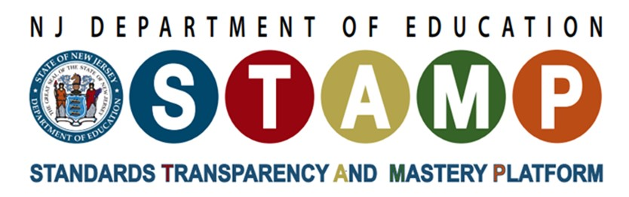

The Assessment Task Development Template
Introduction: The Assessment Task Development Template walks users through the steps necessary to develop high quality science assessment tasks. The template is based on STEM Teaching Tool 41. The content is used with permission from the UW Institute for Science + Math Education.

Assessment Task Development Template
Step 1.
Define what you will assess: It is important to define what students should understand and be able to do, prior to writing the task. By analyzing relevant sections of A Framework for K-12 Science Education, the NJSLS-S Performance Expectations, Foundation Boxes, and Evidence Statements the user can insure that the assessment focusses on the Disciplinary Core Ideas, Science and Engineering Practices, and Crosscutting Concepts. The 3 dimensions of the text are used to craft a learning claim. These resources are included in the Resource Page (p.3) of this template.
Original Framework Test | Claim
Record the 3 Dimensions here. | Write the claim statement here.

Step 2:
Brainstorm Possible Scenarios for Eliciting Student Understanding. What phenomena can be explained id the students can accomplish the claim? Prioritize and select a scenario that best fits the following criteria:
- it should allow students from non-dominant communities (e.g., ELLs, students from poverty-impacted communities) to fully engage with the task,
- it should involve a compelling phenomenon related to one or more of the DCIs being assessed—and not feel like a test-like task,
- it should be quickly understandable by students, and
- it should lend itself to a broad range of the science and engineering practices.
Claim | Possible Scenario
Record the claim statement here. | Record the scenario here.

Step 3:
Use Task Formats to Build Questions to Engage Students with the Scenario: Use Integrating Science Practices into Assessment Tasks, and Integrating Crosscutting Concepts into Assessment and Instruction in combination with the DCI elements to craft assessment tasks.
Possible Scenario | Questions (Using Task Formats)
Record the scenario here. | Write questions that integrate at least two complimentary science and engineering practice with the disciplinary core idea(s) and at least two complementary crosscutting concepts here.
Step 4:
Imagine the Range of Possible Student Responses to the Questions: It is valuable to imagine how a range of students might respond to each of the prompts.
Questions (Using Task Formats) | Hypothetical Student Responses
Record questions that integrate at least two complimentary science and engineering practice with the disciplinary core idea(s) and at least two complementary crosscutting concepts here. | Record sample student responses here.

Step 5:
Share, Review, and Revise: Assessment design requires many cycles of developing, testing, and revising tasks to ensure that you are getting an accurate picture of what students know and can do.

Resources
- SHORT COURSE: How to Develop 3D Formative Assessments for the Science Classroom: Formative assessment in the classroom is crucial because everyone engaged in complex learning benefits from timely and focused feedback. The process also promotes important processes of self-explanation, reflection, and learning (metacognition). This short course will help you learn how to develop and use 3D formative assessments in the classroom.
- Developing Assessments for the NGSS: Classroom Assessment National Research Council. (2013).
- Seeing Students Learn Science: Integrating Assessment and Instruction in the Classroom (2017).

Tools for developing local 3-D Assessments
- Integrating Science Practices into Assessment Tasks
- Integration Crosscutting Concepts into Assessment Tasks
- Earth and Space Sciences: A Compilation of the Framework and the NJSLS-S
- Life Sciences: A Compilation of the Framework and the NJSLS-S
- Physical Sciences: A Compilation of the Framework and the NJSLS-S

Examples of High-Quality Science Assessments
- Next Generation Science Assessment (NGSA) Task Portal: The portal provides access to classroom-ready assessments for teachers to use formatively to gain insights into their students' progress on achieving the NJSLS-S performance expectations.

