New Jersey Department of Education

Every Student Succeeds Act (ESSA) Accountability Profiles

Companion Guide

October 2018

Introduction
The Every Student Succeeds Act (ESSA) was passed in December 2015 with bipartisan congressional support. It replaced the No Child Left Behind Act (NCLB) of 2002 and reauthorized the Elementary and Secondary Education Act (ESEA) of 1965. Despite some key changes in the law, the purpose remains the same: to ensure all students have equitable access to high-quality educational resources and opportunities, and to close educational achievement gaps.
Annually, the New Jersey Department of Education (NJDOE) issues Accountability Profiles which enable schools and districts to review their progress toward achieving the intent of the law. School and district data for specific indicators are compared to annual targets and standards and reported by student group to identify gaps. With the implementation of the ESSA, these Accountability Profiles have been modified to provide additional data for schools and districts to analyze student performance and progress and to meet ESSA accountability requirements. The purpose of this document is to describe the accountability requirements and the data included in the Accountability Profiles to enable schools and districts to: 1) review the data for accuracy; and 2) begin to identify areas of need for planning.

New Jersey’s Accountability System

Accountability Requirements under ESSA
ESSA requires states to use a set of indicators to measure the performance of all schools for the purposes of identifying schools in need of support and improvement. These indicators were revised with the implementation of the ESSA.
The chart below shows the indicators required under the current law.
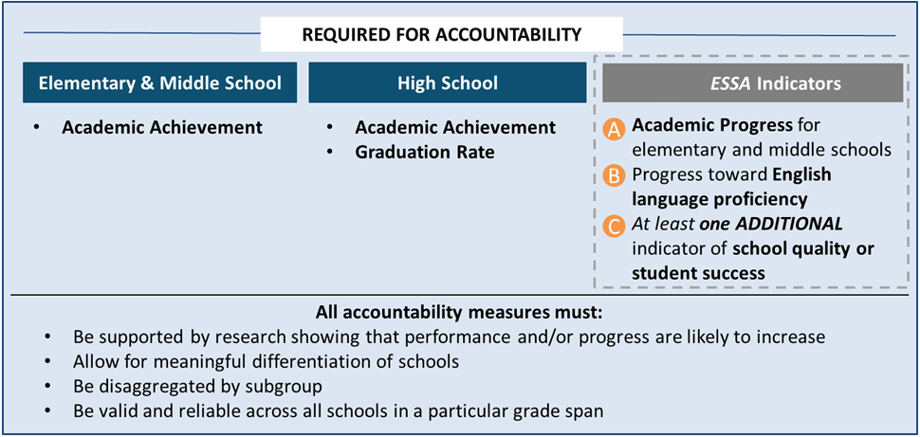

Uses of ESSA Accountability Profiles Data
Under ESSA New Jersey is required to use the data contained in the Accountability Profiles to identify schools in need of support or improvement. Categories and associated calculations and supports have changed from the prior system under NCLB (Priority and Focus Schools) to Schools in Need of Comprehensive Support and Improvement (CSI) and Schools in Need of Targeted Support and Improvement (TSI) as shown below:
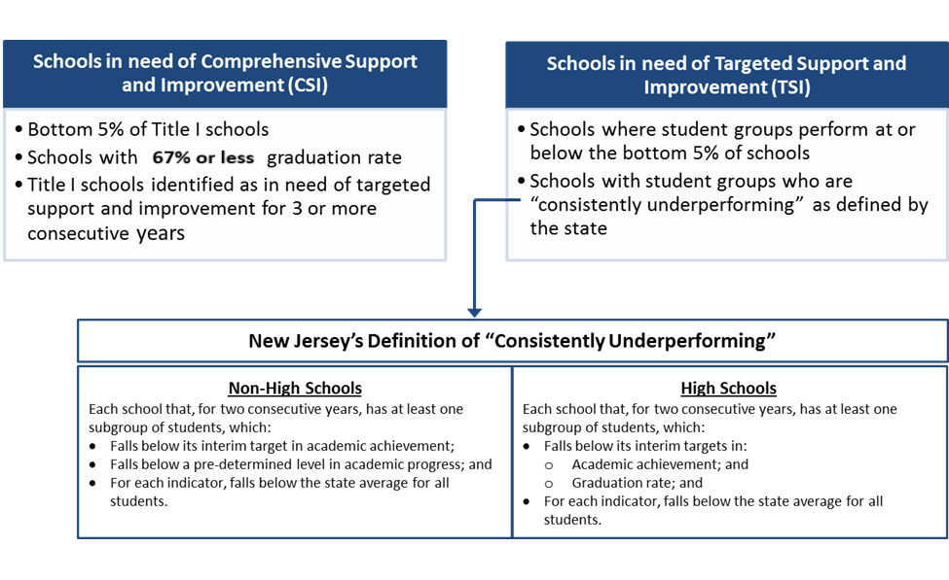The data provided in the Accountability Profiles will be used to calculate summative scores for each school to identify those school in need of comprehensive or targeted support. Additional information regarding the calculation of the summative score may be found in the New Jersey ESSA Plan.

Indicators Included in New Jersey’s ESEA Accountability System
The following indicators are incorporated into New Jersey’s accountability system under ESEA and will be used to determine the schools in need of support and improvement as described above:
Required Indicator | New Jersey’s Measure(s) | Description
Academic Achievement | Proficiency rates on annual statewide assessments | Percentage of students in the school who meet grade-level standards on annual statewide assessment in ELA and mathematics (grades 3-10)
Academic Progress (applicable to elementary and middle schools) | Student growth percentile (SGP) | Median SGP, which shows students’ growth from one year to the next in ELA (grades 4-8) and mathematics (grades 4-7)
Graduation Rate  (applicable to high schools) | Four-year and five-year graduation rates | Using the adjusted cohort methodology, percentage of students who graduate:  - within four years of entering ninth grade; and  - within five years of entering ninth grade
Progress Toward Achieving English Language Proficiency * | Progress on the ACCESS for ELLs 2.0 | Percentage of English learners making expected progress from one year to the next on the ACCESS for ELLs 2.0 summative assessment (K-12)
School Quality or Student Success | Chronic absenteeism | Percentage of the school’s students who are chronically absent. Chronically absent is defined as not present for 10 percent or more of the days that he or she was “in membership” at a school.
*English Language Learner progress is an indicator now required under ESSA. Data are reflected in the profiles for the first time this year.

Key Information for Accountability Profiles

Student Subgroups
The ESSA Profiles provide disaggregated accountability data for the following student groups:
- All students (referred to as “schoolwide” in the school level profiles);
- Economically disadvantaged students (i.e. eligible for free or reduced lunch program);
- Students with disabilities (i.e. students currently receiving special education services);
- English language learners, including former English language learners for four years after reclassification;
- American Indian or Alaska Native students;
- Asian, Native Hawaiian, or other Pacific Islander students;
- Black or African American students;
- Hispanic or Latino students (of any race);
- White students; and
- Two or More Races (also includes students whose race/ethnicity is not coded).
The racial and ethnic student groups are consistent with the requirements for federal reporting according to the most recent federal guidance published in the Federal Register (72 Fed. Reg. 59267).

Minimum N-Size
The minimum number of students (n-size) required for calculations and accountability purposes is twenty (20). This n-size applies to calculations at district, school, and student group levels for all indicators. An asterisk (*) appears on the profile if the group size is less than 20.
*Note, that for proficiency, the minimum n-size is based on the number of students required to take statewide assessments, not the number of valid test scores.

Statewide Assessment Data Included in the Profiles
Statewide assessment data for students in grades 3-10 is aggregated to calculate participation and proficiency rates in each content area: English Language Arts/Literacy (ELA/L) and mathematics. Rates are calculated for all students in a school or district and for each student group (meeting the minimum n-size) in a school or district and include students who participated in:
- PARCC ELA/L grades 3-10
- PARCC Mathematics grades 3-8 and end-of-course assessments for Algebra I, Algebra II, and Geometry taken by students in grades 3-10
- Dynamic Learning Maps ELA/Mathematics 3-8 and high school
- ACCESS for ELLs Assessment grades K-12

Participation Rate
Use of participation rates has changed considerably under the reauthorized ESEA. The participation rate itself is no longer an indicator itself, but rather the law requires states to factor participation into the measure of Academic Achievement as follows:
Under 1111(c)(4)(E) of ESSA, all states are required annually to measure the achievement of at least 95% of all students in each student subgroup. When measuring, calculating, and reporting proficiency rates, states are required to include either a denominator equal to 95% of all students (and of each student subgroup as the case may be) or the number of students participating in the assessments. For schools that fail to achieve 95% participation, the proficiency rate would be adjusted to account for 95% of students as required by 1111(c)(4)(E) of ESSA.
The use of student participation in the statewide assessment as a factor in the calculation of a school’s proficiency rate represents a significant shift from NCLB.

ESSA Accountability Profile

The 2018 ESSA Accountability Profiles provide a graphic representation of each school’s and each district’s status on the accountability indicators of:
- Academic Achievement;
- Academic Progress;
- Graduation Rate;
- English Language Learner Progress; and
- School Quality/Student Success (chronic absenteeism).
Below is a sample profile followed by a brief description of what is included for each indicator.
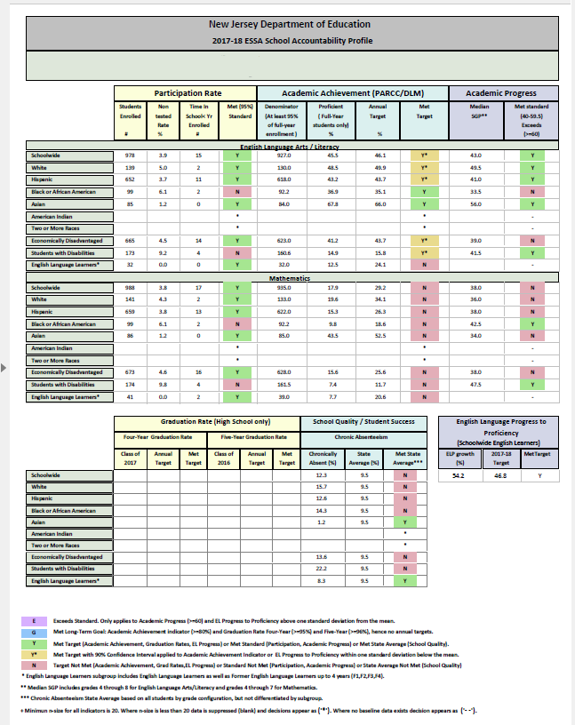

Participation Rate
- Students Enrolled: The number of students in tested grades in each student group as reported by the district in the final PARCC Fall/Spring and DLM summative files.

- Non-tested rate: The percent of students in tested grades, as reported by the district in the final PARCC Fall/Spring and DLM summative files that did not participate in the state assessment.

- Time In School<Year Enrolled: The number of students in tested grades who have not attended the same school for at least half a year. The date of December 1st was set for determining partial attendance.

- Met 95% Standard: Indicates whether at least 95% of students in the student group that are enrolled in tested grades as reported by the district in final PARCC Fall/Spring and DLM summative files and being enrolled prior to December 1st who participated in the statewide assessment.

Academic Achievement (PARCC/DLM)
- Denominator (at least 95 percent of full-year enrollment)
  - If the school met the 95% standard, this denominator reflects the number of students in the group enrolled in tested grades less the number of students in the group designated as Time In School < Year.
  - If the school did not meet the 95% standard, this number reflects 95% of students in the group enrolled in tested grades less the number of students in the group designated as Time In School < Year.

- Proficient Full-Year Students only: The percent of the student group enrolled in tested grades prior to December 1st that scored at either Level 4 or 5 on the PARCC assessment or Level 3 or 4 on the DLM.

- Annual Target: The percent of the student group that is expected to score at either Level 4 or 5 on the PARCC assessment or Level 3 or 4 on the DLM to ensure the school meets the long-term academic achievement goal of 80%.

- Met Target: Indicates whether the percent of students in the student group who scored at either Level 4 or 5 on the PARCC assessment or Level 3 or 4 on the DLM meets the annual target.

Academic Progress
- Median SGP: The median Student Growth Percentile of students in the group on the statewide assessment.

- Met Standard (40-59.5) Exceeds (60): Indicates whether the student group met the standard (median SGP >= 40 and <60) or exceeded the standard (median SGP ≥ 60).

Graduation Rate
- Four-Year Graduation Rate
- The percentage of Class of 2017 students in the group who entered ninth grade in the 2013-14 school year (with adjustments to the cohort) that graduated within four years, or by the end of the 2016-17 school year.

- Annual Target: The percentage of Class of 2017 students in the group who were expected to graduate within four years in order to meet the long-term four-year graduation rate goal of 95%.

- Met target: Indicates whether the percentage of Class of 2017 students in the group who graduated within four years met the annual target.

- Five-Year Graduation Rate
- The percentage of Class of 2016 students in the group who entered ninth grade in the 2012-13 school year (with adjustments to the cohort) that graduated within five years or by the end of the 2016-17 school year.

- Annual Target: The percentage of Class of 2016 students in the group who were expected to graduate within five years in order to meet the long-term five-year graduation rate goal of 96%.

- Met target: Indicates whether the percentage of Class of 2016 students in the group who graduated within five years met the annual target.

English Language Progress to Proficiency
- Progress Toward English Language Proficiency: The percent of English language learners in the school that demonstrated the expected amount of growth on the ACCESS for ELLs assessment. Students included are English language learners who have scored proficient in the first year of test administration or students who have two or more consecutive ACCESS for ELLs scores in their accountable district.

- Annual Targets: In year 1 of the ELP measure, this is the percent of English language learners in grades K-12 who have scored proficient in the first year of test administration, and the percent of ELL students in grades 1-12 who have two or more consecutive ACCESS for ELLs scores in their accountable district that have demonstrated the expected amount of growth on the ACCESS for ELL assessment.

  - Separate annual targets are derived for two groups of schools – those that contain grades 5th of lower and all other schools. In subsequent years for the ELP measure, the annual target will increase 1% a year to establish the long-term goal.

- Met target: Indicates whether the percent of English language learners in grades K-12 that demonstrated the expected amount of growth on the ACCESS for ELLs meets or exceeds the annual target.

- Exceeds Target: Indicates whether the percent of English language learners in grades K-12 that demonstrated the expected amount of growth on the ACCESS for ELLs exceeds the annual target by more than one standard deviation.

School Quality/Student Success: Chronic Absenteeism

- Chronic Absenteeism

- Chronically absent: The percent of students who were absent for 10% or more of the days for which they were enrolled in the school (based on students enrolled at the end of the school year with at least 45 days in membership).

- State Average: The statewide average of students enrolled in the grades represented in the school that were absent for 10% or more of the days for which they were enrolled.

- Met State Average: Indicates whether the student group’s rate of chronic absenteeism was below or above the state average for schools with the same grade configuration (e.g., for a school with grades 9 through 12, the chronic absenteeism rate would be compared to the average rate of all students across the state in grades 9 through 12). The designation of “N” indicates the student group’s rate was above the state average. A designation of “Y” indicates the student group’s rate was at or below the state average.

Understanding Each of the Accountability Indicators

Academic Achievement

Definition
Pursuant to Section 1111(c)(4)(B)(i)(I) of ESSA, the academic achievement indicator must reflect schools’ grade-level academic proficiency rates on statewide English Language Art/Literacy (ELA/L) and Mathematics assessments. In New Jersey’s school accountability system proficiency rates are calculated as the percentage of students meeting or exceeding grade-level standards on statewide assessments, including alternate assessments for students with the most significant intellectual disabilities, adjusted for participation pursuant to Section 1111(c)(4)(E) of ESSA (i.e., proficiency rates). Proficiency rates are calculated based on the assessment results of all students in grades three through 10 and the performance of all student subgroups. Students ‘meet the standard’ on PARCC by scoring at level ‘4.’ Students ‘exceed the standard’ on PARCC by scoring at level ‘5.’ Students ‘meet’ the standard on DLM by scoring at level ‘3’ and ‘exceed the standard’ by scoring at level ‘4.’ See the NJDOE web site for more information regarding the scoring of state assessments.

Purpose
The academic achievement indicator measures student mastery of the New Jersey Student Learning Standards (NJSLS). The NJSLS reflect the skills and knowledge that students need to achieve postsecondary success. Thus, this indicator informs the degree to which schools and school districts are successfully implementing appropriate strategies and interventions in ELA/L and mathematics to prepare their students to succeed in their chosen path after graduation.

Calculation
Students Exempt from Calculation:
First year English language learners in grades K-8 who enroll after July 1, 2016 are exempt from taking the ELA/L assessment. As a result, these students are not included in the calculation of academic achievement proficiency rates for accountability in either the numerator or denominator (this applies to ELA/L only for English language learners). The column entitled, ‘Time in School < Yr Enrolled’ on the profile lists the number of students with partial attendance for each school or district because of not meeting the time in school criterion.

Factoring in Participation Rate:
Under 1111(c)(4)(E) of ESSA, all states are required annually to measure the achievement of at least 95% of all students in each student group. When measuring, calculating, and reporting proficiency rates, states are required to include either a denominator equal to 95% of all students (and of each student subgroup as the case may be) or the number of students participating in the assessments. For schools that fail to achieve 95% participation, the proficiency rate would be adjusted to account for 95% of students as required by 1111(c)(4)(E) of ESSA.

The methodology NJDOE uses for calculating proficiency rates for the academic achievement indicator differs for schools and student groups based on whether they met minimum participation requirements:

- If 95% or more of all students in a school or student group (regardless of time in school status) received a valid score on either the PARCC or DLM, proficiency is calculated by dividing the number of proficient scores of students meeting the time in school criterion by the number of valid scores of students meeting the time in school criterion (i.e., not exempt for time in school less than a year). (See Example 1)

- If less than 95% of all students in a school or student group (regardless of time in school status) received valid scores (i.e. participation rate was below 95%), participation rates are calculated based on students meeting the time in school criterion.
  - If 95% or more of students meeting the time in school criterion in a district or student group received a valid score, proficiency is calculated by dividing the number of proficient scores of students meeting the time in school criterion by the number of valid scores of students meeting the time in school criterion. (See Example 2)

  - If less than 95% of time-in-school eligible students in a district or student group received a valid score, proficiency is calculated by dividing the number of proficient scores of students meeting the time in school criterion by 95% of the number of students meeting the time in school criterion enrolled in the district. (See Example 3)
Examples
The following examples reflect school-level scenarios. The same rules apply for district-level calculations and for each student group’s proficiency calculation. Thus, a school may meet the participation requirement for all students and not require an adjustment to the denominator, while some student groups within the school may not meet the participation requirement and will require an adjustment to the denominator. Similarly, a school or student group may meet the participation requirement for assessments in one content area and not the other.

Example 1: School A has 1,000 students registered to take statewide assessments, all of whom meet the time-in-school criterion. School A has valid scores for 960 students and 700 are proficient. The School’s participation rate is 96% (960/1000).

Since the school’s participation rate is above 95%, their proficiency rate is calculated by dividing the number of proficient students by the number of test-takers.

School A’s Denominator: 960
School A’s Proficiency Rate: 700 / 960 = 72.9%

Example 2: School B has 1,000 students registered to take statewide assessments, all of whom meet the time-in-school criterion. School B has valid scores for 800 students and 600 are proficient. The School’s participation rate is 80% (800/1000).

Since the school’s participation rate is below 95%, their proficiency rate is calculated by dividing the number of proficient students by the number of registered test-takers multiplied by 95%.

School B’s Denominator: 95% x 1000 = 950
School B’s proficiency rate: 600/950 = 63.2%

Example 3: School C has 1,000 students registered to take statewide assessments. School C has valid scores for 800 students and 600 are proficient. The School’s participation rate is 80%. However, School C experienced high mobility this year and many students do not meet the time-in-school criterion for inclusion in the proficiency rate calculation. Thus, participation must be recalculated based on students who meet the time-in-school criterion to determine their proficiency rate.

School C has 820 students who meet the time in school criterion. Of these students, 785 have valid scores, and 500 are proficient. The participation rate for students who meet the time-in-school criterion is 95.7%. Since the participation rate for students meeting the time in school criterion is over 95%, School C’s proficiency rate can be calculated by dividing the number of proficient scores for students meeting the time in school criterion by the number of valid scores for students meeting the time in school criterion.

School C’s Denominator: 785
School C’s Proficiency Calculation: 500/785 = 63.7%

Note: If the participation rate for students meeting the time-in-school criterion were below 95%, the denominator would be adjusted to reflect 95% of students meeting the time-in-school criterion.

Long-Term Goal
New Jersey’s approved ESSA plan states that by 2030, at least 80% of all students and at least 80% of students in each group in each tested grade will meet or exceed grade-level expectations on the statewide ELA/L and mathematics assessments. Building upon the NJSLS and early successes with PARCC and DLM, NJDOE and stakeholders sought to set ambitious, but achievable, goals for schools and students. A goal of 80% of all students and each student group meeting grade-level expectations by 2030 is realistic, yet ambitious, as it considers the more rigorous academic standards implemented in New Jersey. Accomplishing this goal will mean that the number of students demonstrating grade-level proficiency in ELA/L and mathematics (as currently indicated by achieving a Level ‘4’ or ‘5’ score on a PARCC assessment and Level ‘3’ and ‘4’ on the DLM) across the state will nearly double and will close New Jersey’s achievement gaps.

Annual Targets
Annual targets were calculated through the year 2030 for all districts, schools and student groups, based on performance during the 2015-2016 administration of the statewide assessments. Baseline proficiency rates for 2015-2016 may differ from the rates reported in the 2015-2016 Accountability Profiles. This is due to the federal requirement, under ESSA, that proficiency rates be adjusted to account for participation below 95%, as described above.
Beginning in 2016-2017, the NJDOE expanded the English language learner student group to include former English language learners for up to four years after exit from bilingual/ESL services. Baseline rates for the English language learner student group were calculated based on the subgroup data that was confirmed in the 2015-2016 data and reflect the performance of English language learners including former English language learners for up to two years after exiting services.
Annual targets were calculated to ensure that the 2030 long-term goal would be met while differentiating for baseline performance. Although schools and student groups have different starting points and annual targets, the long-term goal is the same for all schools and student groups. A description of how annual targets are calculated, and an example is below:
Example:
School A’s ELA proficiency rate in 2015-16 was 40%. The long-term goal of 80% must be achieved by the 2029-2030 school year. School A must make progress toward the goal (i.e. “goal progress”) of 40 percentage points to reach the long-term goal. School A’s annual target for ELA in the 2016-17 school year is 42%, which represents 5% of the progress necessary to reach the long-term goal.
Baseline + 5% Goal Progress = Year 1 Annual Target
40.0 + (.05 * 40.0) = 42.0
District and School - State Assessment Annual Accountability Targets
Baseline: | 2015-16 Performance
Year 1 (2016-17): | Baseline + 5% Goal Progress
Year 2 (2017-18): | Baseline + 10% Goal Progress
Year 3 (2018-19): | Baseline + 15% Goal Progress
Year 4 (2019-20): | Baseline + 20% Goal Progress
Year 5 (2020-21): | Baseline + 25% Goal Progress
Year 6 (2021-22): | Baseline + 32% Goal Progress
Year 7 (2022-23): | Baseline + 39% Goal Progress
Year 8 (2023-24): | Baseline + 46% Goal Progress
Year 9 (2024-25): | Baseline + 53% Goal Progress
Year 10 (2025-26): | Baseline + 60% Goal Progress
Year 11 (2026-27): | Baseline + 70% Goal Progress
Year 12 (2027-28): | Baseline + 80% Goal Progress
Year 13 (2028-29): | Baseline + 90% Goal Progress
Year 14 (2029-30): | GOAL: 80.0%

The rest of School A’s ELA Academic Achievement annual targets are listed below.
Base-line | Year 1 | Year 2 | Year 3 | Year 4 | Year 5 | Year 6 | Year 7 | Year 8 | Year 9 | Year 10 | Year 11 | Year 12 | Year 13 | Year 14
40.0 | 42.0 | 44.0 | 46.0 | 48.0 | 50.0 | 52.8 | 55.6 | 58.4 | 61.2 | 64.0 | 68.0 | 72.0 | 76.0 | 80.0

Academic Progress

Definition
Academic progress is measured with schools’ median SGP on statewide ELA/L and mathematics assessments. As the SGP describes a student’s academic progress from one year to the next compared to other students with similar prior test scores (academic peers), NJDOE uses SGP to show growth from the prior year for ELA/L in grades four through eight and for mathematics in grades four through seven. Mathematics in grades four through seven is used because a significant portion of eighth graders take Algebra I rather than the eighth-grade mathematics assessment. SGPs are calculated based on the performance of all students in all applicable tested grades and the performance of student groups.

Purpose
Academic progress indicates whether schools are successfully implementing strategies and interventions that foster individual students’ academic growth, as measured by performance on statewide assessments relative to their performance on the prior year statewide assessment (i.e. student growth percentiles). While the achievement indicator informs schools and districts of the percentage of students who have learned what is expected for their grade, SGPs enable schools to determine which students at every level of proficiency have made progress from year to year when compared to their academic peers.

Calculation
Calculations reflect the median SGP (mSGP) for all students and for students in each subgroup. Academic Progress is calculated separately for ELA and for mathematics. More information about the median SGP can be found on the NJDOE website.

Long-Term Goal and Annual Target
The academic progress indicator is unique in that its long-term goal and its annual targets are the same. Since SGP is a normative measure in which students’ progress is compared to their academic peers on an annual basis, the annual target is the same for each student group each year. The long-term goal and annual target for academic progress for all schools and student groups is a median SGP of 40. A median SGP of 60 or more means a student group in a school or district “exceeds standard” for academic progress. Schools and student groups with median SGPs between 40 and 59.5 will be designated as “met standard” while the median SGP below 40 indicates a school/student group has “not met standard” for academic progress in the specified content area.

Graduation Rate

Definition
Pursuant to 1111(c)(4)(B)(iii)(I)(bb) of ESSA, graduation rates must reflect the percentage of students who graduate within four years of entering ninth grade (“the four-year adjusted cohort graduation rate”) and may reflect an extended-year adjusted cohort graduation rate. At the strong request of stakeholders, NJDOE is exercising this option and including in the graduation rate indicator the percentage of students who graduate within five years of entering ninth grade. The four-year and five-year graduation rates will be weighted equally in the final summative rating. Including the five-year graduation rate allows New Jersey to maintain high standards for all students while recognizing it is important for some students to take additional time to master academic standards.

Purpose
The graduation rate of a school is an indicator of whether school districts are monitoring student progress toward graduation and implementing the necessary best practices and interventions to facilitate students’ successful completion of high school within four and five years.

Calculation
The calculation of the four-year and five-year graduation rates (1 yr. or 2 yr. lagged data respectively) are based on the adjusted cohort graduation rate calculation methodology. Graduation rates are calculated for each district, each school, and each subgroup. More information about the adjusted cohort graduation rate calculation can be found on the NJDOE website.

Long-Term Goal
New Jersey’s approved ESSA plan states that by 2030, at least 95% of all students and at least 95% of students in each student group will graduate within four years of entering ninth grade. In addition, at least 96% of all students and at least 96% of students in each group will graduate within five years of entering ninth grade.

Annual Targets
Annual targets were calculated through the year 2030 for all districts, schools and student groups, based on four-year graduation rates for students in the Class of 17 cohort and five-year graduation rates for students in the Class of 16 cohort. If baseline data was not available for the four-year cohort or the five-year cohort, annual targets will be based on the first year data was available after that cohort. Annual targets were calculated to ensure that the 2030 long-term goal would be met while differentiating for baseline performance. Although schools and student groups have different starting points and annual targets, the long-term goal is the same for all schools and student groups. A description of how annual targets are calculated, and an example are below:

District and School Graduation Rate Annual Targets
 | Four-Year Rate | Five-Year Rate
Baseline: | 4-Year Graduation Rate | 5-Year Graduation Rate
Year 1: | Baseline + 5% Goal Progress | Baseline + 5% Goal Progress
Year 2: | Baseline + 10% Goal Progress | Baseline + 10% Goal Progress
Year 3: | Baseline + 15% Goal Progress | Baseline + 15% Goal Progress
Year 4: | Baseline + 20% Goal Progress | Baseline + 20% Goal Progress
Year 5: | Baseline + 25% Goal Progress | Baseline + 25% Goal Progress
Year 6: | Baseline + 32% Goal Progress | Baseline + 32% Goal Progress
Year 7: | Baseline + 39% Goal Progress | Baseline + 39% Goal Progress
Year 8: | Baseline + 46% Goal Progress | Baseline + 46% Goal Progress
Year 9: | Baseline + 53% Goal Progress | Baseline + 53% Goal Progress
Year 10: | Baseline + 60% Goal Progress | Baseline + 60% Goal Progress
Year 11: | Baseline + 70% Goal Progress | Baseline + 70% Goal Progress
Year 12: | Baseline + 80% Goal Progress | Baseline + 80% Goal Progress
Year 13: | Baseline + 90% Goal Progress | Baseline + 90% Goal Progress
GOAL – Year 14: | 95% | 96%

Example:
School A’s baseline four-year graduation rate (for school year 2014-2015) was 85%. The long-term goal of 95% must be achieved by the 2029-2030 school year. School A must make progress of 10 percentage points to meet the long-term goal.

School A’s annual target for Year 1 is 85.5%, which represents having made 5% of the progress necessary to reach the long-term goal, based on its baseline performance.
Baseline + 5% Goal Progress = Year 1 Annual Target
85.0 + (.05 * 10.0) = 85.5
The rest of School A’s annual targets are listed below.
Base-line | Year 1 | Year 2 | Year 3 | Year 4 | Year 5 | Year 6 | Year 7 | Year 8 | Year 9 | Year 10 | Year 11 | Year 12 | Year 13 | Year 14
85.0 | 85.5 | 86.0 | 86.5 | 87.0 | 87.5 | 88.2 | 88.9 | 89.6 | 90.3 | 91.0 | 92.0 | 93.0 | 94.0 | 95.0
The same methodology may be applied to determine annual targets toward the five-year graduation rate goal of 96%.

English Language Progress to Proficiency

Definition
To establish student-level targets for English Language Proficiency (ELP), the NJDOE considered two student characteristics: the student’s initial level of ELP and the number of years the student has been enrolled in a district. Starting with the 2017-2018 assessment cycle, for currently identified English language learners in grade K through grade 12, the NJDOE will define increases in the percentage of all English language learners making progress in achieving ELP as measured by the assessments described in Section 1111(b)(2)(G) of ESSA, as “English language learners that demonstrate a pre-determined level of cumulative growth for five years or English language learners that meet the ELP cut score within the established timeframe that is consistent with the student’s ELP level at the time of identification as measured by the assessment described in Section 1111(b)(2)(G)”. Thus, the NJDOE will consider a student’s ELP level at the time of the first administration of the ACCESS for ELLs and the time enrolled in a district to determine the number of years that a student has to reach proficiency and set measurements of interim progress accordingly.

Purpose
The English language proficiency calculation for a school is an indicator of whether schools are creating an environment in which an appropriate percent of their English language learners are progressing toward English language proficiency at the rate established by the NJDOE in the ESSA state plan.

Calculation
All grade K-12 students are expected to meet an ELP score of 4.5, the proficient cut score on the ACCESS for ELLs test, within a maximum of 5 years after entering a district. If a K-12 student meets a 4.5 or higher in their initial year of administration, they are counted as proficient for the ELP indicator. English language learners in grades 1-12 who have two or more consecutive ACCESS for ELLs scores in their accountable district and have demonstrated the expected amount of growth on the ACCESS for ELL assessment are also counted as proficient for the ELP indicator. When calculating yearly, student-level growth targets, expected growth is rounded up from the hundredths place to the nearest tenth. To view information about the specific methods used to calculate student-level progress toward proficiency, see page 53 through 55 of the of New Jersey’s ESSA state plan.

English Language Proficiency Student Data Spreadsheets
Starting in fall 2018, school-level accountability information related to this indicator will be available for the first time. The ESEA ELP Student Data Spreadsheet can be found on the NJDOE Homeroom page at the “ELP Data” link. This folder will contain student-level data for all of the students included in the ELP Indicator. This report will only include English language learners in grades 1—12 who have two or more consecutive ACCESS for ELLs scores or English language learners in Kindergarten—grade 12 who meet proficiency during their first year in their accountable district. The district-level spreadsheet will contain students listed by accountable districts and school. All student-level ELP indicator calculations will be calculated using a 2017 or later baseline year, since 2017 was the first administration of the post-standards-setting ACCESS for ELLs assessment. The district Web User Administrator can request a district- or charter-specific login for their site.

The spreadsheet will include the following information at the individual student level:

- Student Identifiers
- Accountable District/School
- District Entry Date and Baseline Year
- Number of Years to Proficient Cut Score
- Baseline Composite Proficiency
- Growth Expectations
- Current Year Growth and Expected Composite Score
- Actual Composite Score
- Growth to Target Measure Status

As stated in the March 6, 2018 “Update on ACCESS for ELLs 2018 Test Administration” broadcast memo, any student-level ACCESS for ELLs data corrections needed to be made on or before May 17, 2018. Once the identified pre-reporting window has passed, student-level data cannot be corrected for accountability purposes.

Annual Target
Schools with an n-size of 20 or more eligible ELLs are included in accountability calculations. For these schools, the number of ELLs meeting the ELP progress target will be divided by the total number of ELLs to determine the percentage of ELL’s making progress to proficiency and used for accountability. Because of the significant difference in the percent of ELLs who made progress by grade, dichotomous targets are established for this indicator. One target is for schools ending with 5th grade or lower and a second target is for all other schools. Examples of schools ending with 5th grade or lower includes grades K-5 schools, grades PreK-3 schools, grades 4-5 schools, etc. Examples of all other schools includes grades PreK-8 schools, grades 9-12 schools, grades K-12 schools, and grades 5-8 schools.
The table below shows the mean percentage of ELLs meeting progress for schools with a n-size > 20 under the two configurations. The mean percentage for the K-5 schools is 60.7% with a standard deviation of 14.6% compared to all other schools with a percentage of 46.8% and a standard deviation of 17.0%. Using the mean and standard deviation, four performance categories are created for each of the two school configuration types: Exceeds (E), Met (Y), Met within 1 Standard Deviation (Y*), and Not Met (N).
School Type | Mean | Std. Dev.
School ends with grade 5 or lower | 60.7 | 14.6
All Other Schools | 46.8 | 17.0
All Districts | 56.6 | 14.5
The performance rating a school receives is determined by the mean and standard deviation in the school type category.
- For schools ending in grade 5 or lower, an “E” would be received if the percentage of ELLs making progress is greater than 75.3%; a “Y” represents a percentage of 60.7% to 75.3%; a “Y*” represents a percentage of 46.1% to 60.6%; and an “N” represents a percentage under 46.1%.

- For all other schools, an “E” would be received if the percentage of ELLs making progress is greater than 63.8%; a “Y” indicates a percentage of 46.8% to 63.8%; a “Y*” indicates a percentage of 29.8% to 46.7%; and an “N” indicates a percentage under 29.8%.

- Since virtually all of New Jersey’s school districts used for the ELP Indicator end with a grade higher than 5th, there is only one mean used for the district reports. An “E” would be received on the district report if the percentage of ELLs making progress is greater than 71.1%; a “Y” indicates a percentage of 56.6% to 71.1%; a “Y*” indicates a percentage of 42.1% to 56.5%; and an “N” indicates a percentage under 42.1%.

Long-Term Goals

Separate annual targets are derived for two groups of schools – those that contain grades 5th or lower and all other schools. In subsequent years for the ELP measure, the annual target will increase 1% a year to establish a long-term goal.

 | 2018  (Baseline Target) | 2019  (Year 1) | 2020  (Year 2) | 2021  (Year 3) | 2022  (Year 4) | 2023  (Long Term Goal)
End Grade of 5th or Lower | 60.7 | 61.7 | 62.7 | 63.7 | 64.7 | 65.7
End Grade is Greater Than 5th | 46.8 | 47.8 | 48.8 | 49.8 | 50.8 | 51.8

School Quality/Student Success: Chronic Absenteeism

Definition
School quality or student success is a required indicator under ESSA. With input from stakeholders, the NJDOE selected chronic absenteeism for this indicator. As described in the New Jersey State ESSA Plan, this indicator is being measured by the percentage of a school’s students or district’s students who are chronically absent in K-12 grade levels. A student is considered chronically absent when he or she is not present for 10% or more of the days that that he or she was “in membership” at a school. For the 2017-18 school year, only students who were enrolled at the end of the school year and were in membership at school for 45 or more days will be considered in the school chronic absenteeism rate calculation for accountability purposes. In future years, schools will be accountable for any student who had 45 days in membership at that school, regardless of whether that student was enrolled at the end of the year. Chronic absenteeism is applied to a student’s accountable school, not attending school. (Note: for over 95% of students, the attending and accountable school are the same school, but it should be noted that in some instances, these schools may differ, and it is the accountable school that is held responsible for a student’s chronic absenteeism.) A student who cannot be assigned to an accountable school for any reason can be assigned to a district and hence, included in a district profile but not a school profile.

Purpose
Chronic absenteeism provides important information about a school’s culture and climate. In addition, it is widely acknowledged that students who are in school are likely to be learning more than those who are absent. The measure of chronic absenteeism is an indicator of whether students are regularly attending school. Chronic absenteeism is actionable at the school level. When concerns with student attendance are identified, there are many actions schools can take to reverse the trend. Resources on strategies for addressing chronic absenteeism and guidance for reporting attendance are available on the NJDOE web site.

Calculation
Student-level absentee rate: Each student’s absentee rate is calculated based on the fields of Cumulative Days Present and Cumulative Days in Membership collected in NJ SMART (see the NJDOE’s Chronic Absenteeism Guidance for definitions). Cumulative Days Present (P) is subtracted from the Cumulative Days in Membership (M), and this number is divided by the Cumulative Days in Membership (M).
(M – P)/M

If the student-level absentee rate is equal to or greater than 10%, the student is chronically absent.
Examples:
- Student A’s record in NJ SMART reflects Cumulative Days in Membership (M) as 180 and Cumulative Days Present as 176. The calculation to determine if Student A’s absentee rate is (180-176)/180 or 2%. Student A is not chronically absent.
- Student B’s record in NJSMART reflects Cumulative Days in Membership (M) as 180 and Cumulative Days Present as 150. The calculation to determine Student B’s absentee rate is (180-150)/180 or 16.7%. Student B is chronically absent.

School-level chronic absenteeism: The school-level chronic absenteeism rate is calculated by dividing the number of chronically absent students during the school year by the total number of students enrolled in the school.

Example:
Anytown Elementary School has an enrollment of 350 students who were in membership for 45 days or more. At the school there are 15 students with an absentee rate equal to or greater than 10%. The school’s chronic absenteeism rate is 15/350 or 4.2%.

Long-Term Goal and Annual Target
Under ESSA, there is no long-term goal or annual target for chronic absenteeism. Instead, each school’s chronic absenteeism rate is compared to the calculated state average according to the school’s grade configuration (see explanation below). Each student group is also compared to the state average.

State Average – Total and Student Groups

Comparing Chronic Absenteeism to the State Average

A chronic absenteeism rate is calculated for each student according to the formula outlined in the prior section. Subsequently, a chronic absenteeism rate for the state is calculated by averaging the rates for all students in a given grade configuration. The chronic absenteeism rates for the state overall and for each grade are listed in the table below.

NEW JERSEY CHRONIC ABSENTEEISM RATES, 2017-18
 | Chronic  Absenteeism  (%) | Students  (n)
TOTAL* | 10.9 | 1,315,881
GRADE
PK** | 31.0 | 74,341
KG | 13.0 | 92,864
1 | 9.4 | 96,794
2 | 8.3 | 97,582
3 | 7.6 | 100,999
4 | 7.4 | 102,485
5 | 7.7 | 104,251
6 | 8.6 | 103,092
7 | 9.6 | 102,143
8 | 10.3 | 104,230
9 | 11.4 | 105,915
10 | 12.9 | 101,770
11 | 14.8 | 100,332
12 | 20.6 | 103,424
* Includes all K-12 students with 45 days in membership or more.
** PK not included in any chronic absenteeism calculations.

While about half of New Jersey schools can be neatly divided into elementary (K-5), middle (6-8) or high (9-12) schools, the other half of schools have different grade configurations. There are unique school grade configurations in the state. Therefore, in calculating a state average chronic absenteeism rate, the grades offered at a school are considered and the rate is calculated by averaging the chronic absenteeism rate for each grade offered at the school. Consequently, each grade configuration has its own state average chronic absenteeism rate. The state average for chronic absenteeism for districts are calculated similarly (The grade information for a school is based on data submitted to the New Jersey Directory of Schools). The following are a few examples for calculating the state average for chronic absenteeism. This process is used regardless of the school’s grade configurations.

Examples:
For all schools with grades 9 to 12, the state average is derived by summing up the chronic absenteeism rate for grades 9 through 12. In the table above, the rates for those grades are summed accordingly (11.4+12.9+14.8+20.6=59.7). This sum is then divided by the number of grades offered in the school (there are four grades in a school with grades 9 to 12). The result (59.7/4=14.9) is the state average for all schools with grades 9 to 12.

For a less common configuration, assume a school consists of students in grades 3 through 7. The state average is derived by summing up the chronic absenteeism rate for grade 3 through 7 in the chart above (7.6+7.4+7.7+8.6+9.6=40.9) and then dividing this by the number of grades in the school (there are 5 grades in a school with grades 3 to 7). The result (40.9/5=8.2) is the state average for all schools that include only grades 3 to 7.

To determine whether a school met the state average, the school's actual chronic absenteeism rate is then compared to the state average chronic absenteeism rate based on the grade configuration of the school. If a school’s actual chronic absenteeism rate is equal to or below the state average based on its grade configuration, the school would receive a Y. If the school’s actual chronic absenteeism rate is above the state average based on its grade configuration, it would receive an N.

For example, if a high school’s chronic absenteeism rate was 10.4%, this is below the state average of 14.9%, and hence, under “Met State Average”, the school would receive a Y.

Districts were asked to submit attendance data for inactive students (students who transferred out of district during the course of the school year) in SID Management for the 2017-18 school year. After reviewing the data, NJDOE determined additional instruction was necessary for districts on the proper submission of attendance data for these inactive students. The 2017-18 data on chronic absenteeism continues to only include students who are enrolled at a school at the end of the school year and have 45 or more days in membership.

