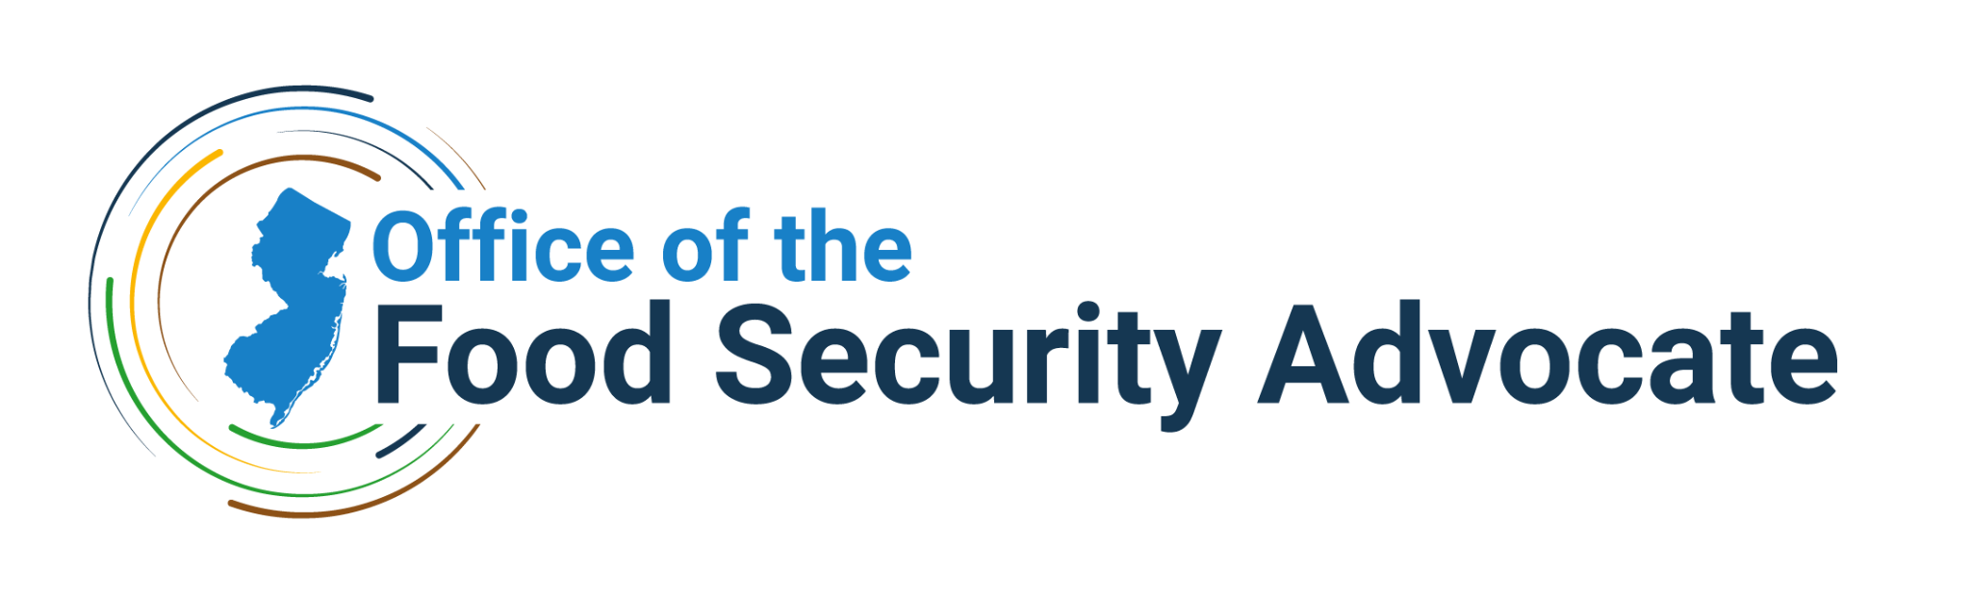

New Jersey Food Security ROOTED*

*Research, Outreach, and Organizing for Trusted (Community) Engagement and Data
APPLICATION TEMPLATE

All interested applicants should submit a completed ROOTED application template (outlined below) including an itemized budget in a single (combined) PDF file to ofsa@ag.nj.gov by Friday, April 24 at 5pm ET. Use the email subject line, “NJ Food Security ROOTED Application” when submitting the application. Multiple organizations collaborating on a project only need to submit one application. If you have any questions about this funding opportunity, please contact:

New Jersey Office of the Food Security Advocate
ofsa@ag.nj.gov

Section 1. Applicant Information

1.1 Applicant Organization
- Organization Name:
- Authorized Organization Representative (AOR) Title:
- Phone Number:
- Website:
- EIN:

1.2 Applicant Organization Physical Address
- Street:
- City:
- State:
- Zip:

1.3 Applicant Organization Mailing Address (If different from above)
- Street:
- City:
- State:
- Zip:

1.4 Primary Contact
- Name:
- Title:
- Email:
- Phone Number:

1.5 Budget Manager Contact
- Name:
- Title:
- Email:
- Phone Number:

1.6 Description of Applicant Organization (200 word max)
- Most Recent Year’s Annual Operating Budget: <Your response goes here.>
- Brief Narrative Description of Applicant Organization: <Your response goes here. 200 words max.>

Section 2. Project Summary

2.1 Narrative Summary
In 200 words or less, provide a brief summary overview of the project purpose, goals, and high-level activities.
<Your response goes here.>

2.2 Application Summary
- Project Title: <Your response goes here.>
- Project Duration (up to months): <Your response goes here.>
- Lead Applicant Organization Name: <Your response goes here.>
- Partner Organization Name(s) (if applicable): <Your response goes here.>
- Focus Areas 1 and/or 3 Strategy within the New Jersey Food Security Strategic Plan that this project is most aligned with: <Your response goes here.>
- Project Priority Population: List the population that will be impacted by the proposed project (e.g., older adults, families eligible for a certain program, pre-school-age children).
  - <Your response goes here.>
- Project Geographic Reach: List the New Jersey municipality, county, counties, or region that will be impacted by the proposed project, or indicate “state-wide” if reach is across all New Jersey counties.
  - <Your response goes here.>
- Total amount of funding requested (up to $20,000): <Your response goes here.>

Section 3. Project Need & Community Assets

Provide a brief description of the specific need this project will address and the community or population(s) that your project will work with and impact. Explain how the proposed project will address this need in the community. Describe how the project will leverage existing community knowledge, resources, and/or assets to inform and support the project. You may also use this section to discuss how your project advances equity and social justice for those who are underserved by or excluded from the current food system and associated programs in New Jersey.
<Your response goes here.>

Section 4. Project Design

4.1 Strategic Plan Alignment
State the broad strategy or strategies from Focus Areas 1 and 3 of the New Jersey Food Security Strategic Plan that best aligns with your project and describe how your project addresses or employs that strategy.
<Your response goes here.>

4.2 Project Tactic and Objectives
Describe your project’s tactic and list the objectives of your project. Explain how the proposed project will support the need(s) described in Section 3 of this Application Template.
- Your tactic is the specific method you will use to implement the strategy defined above.
- Objectives are statements that describe a clear input or activity and measurable change (outcome) within a defined timeline. Objectives should be Specific, Measurable, Attainable, Relevant, and Time-bound (i.e., SMART). We recommend that you have 2-3 key objectives.
<Your response goes here.>

4.3 Project Activities, Roles, & Timeline
In this section, please list each step/activity that you would take to achieve your goal(s) and objective(s), also list the name (if known) and position title of the person responsible for each activity and the proposed timeline in which that activity would be conducted. You may use the table template provided or complete this section in a narrative format or other format of your choice. Additional rows can be added as necessary.

<Your response goes here.>
Activity | Person Responsible (position title) | Timeframe in which Activity is Completed

4.4 Project Team Members
List each anticipated project team member and describe their main roles and responsibilities. List any intended partners for the proposed project and describe the plan for coordinating these partnerships. What is the role of each partner? Please describe whether partners engaged as part of this project will be compensated through a subcontract.
<Your response goes here.>

4.5 Community Engagement
Describe how you have/will engage the community in the planning and implementation of this project.
<Your response goes here.>

4.6 Project Sustainability & Transferability
Assuming success in achieving project goals, describe how the project will be sustained beyond the end of the grant period. Describe the steps you will take to ensure the project includes transparent project operations so that successful project activities could be scaled or transferred to other communities.
<Your response goes here.>

Section 5. Project Learnings

5.2 Process and Outcomes Measurement
Please briefly describe the methods you will use to measure progress toward your goals and objectives identified in Section 4.2 of this Application Template. How will you know you have achieved those goals and objectives? This section should include both process and outcome measures. As applicable, describe the data your organization collects about the populations you serve.
<Your response goes here.>

5.3 Project Requirements Acknowledgement
All grantees will be required to submit project and financial reports as well as participate in an overarching evaluation led by OFSA as described under the Grantee Requirements section of the RFA. Please include the following statement in your application to acknowledge these requirements: “[Enter lead applicant organization name here] and our project partners will participate in required reporting and evaluation activities.”
<Your response goes here.>

Section 6. Budget

6.1 Itemized Budget
Submit an itemized budget detailing anticipated project expenses adding up to the total amount requested. Applications must include an itemized budget to be considered for funding.

Download the Budget Template here.

6.2 Budget Narrative Justification
The budget narrative must provide enough detail for reviewers to easily understand how costs were determined and how they relate to the project activities and expected outcomes. The budget narrative should state the total requested amount and must show a relationship between planned work and the costs incurred.

Download the Budget Narrative Template here (located on the second tab of the excel).

Section 7. Risk Assessment
Complete a Risk Assessment form and include it in your Application. This form should be completed by someone in the applicant organization who is knowledgeable about the program and the accounting system, for example, the Director and/or CFO.

Download the Risk Assessment Form here.

