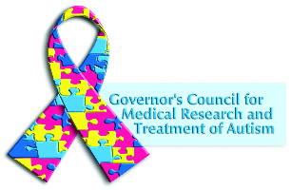


New Jersey Governor’s Council for
Medical Research and Treatment of Autism
New Jersey Department of Health
Request for Application (RFA)
2024

January 26, 2023 Autism TA Call

The FY23 SAGE TA Call for NJDOH Autism Applicants will take place on January 26, 2023 at 12PM. To register, please email NJGCA@doh.nj.gov with the following information:
- Name (with credentials)
- Organization
- Email
- Telephone

Registered individuals will receive confirmation in the form of a meeting notice that will include the agenda for the webinar. Meeting details are not to be shared; only registered individuals will be allowed to participate in the webinar.

