Genedits Plus set up
Metafile and edit set should be set up as shown below.

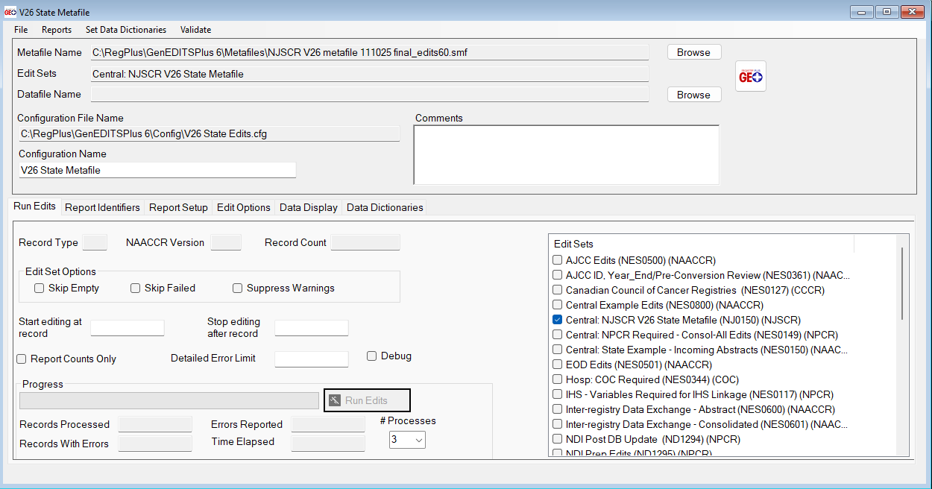

Base Dictionary also needs to be set to V26. This can be found on our website: https://www.nj.gov/health/ces/reporting-entities/njscr/

