**STATE OF NEW JERSEY**

**DEPARTMENT OF HEALTH**

**DIVISION OF BEHAVIORAL HEALTH SERVICES**

ANCORA PSYCHIATRIC HOSPITAL

**CLINICAL PSYCHOLOGY**

**INTERNSHIP TRAINING PROGRAM**

**2026-2027**

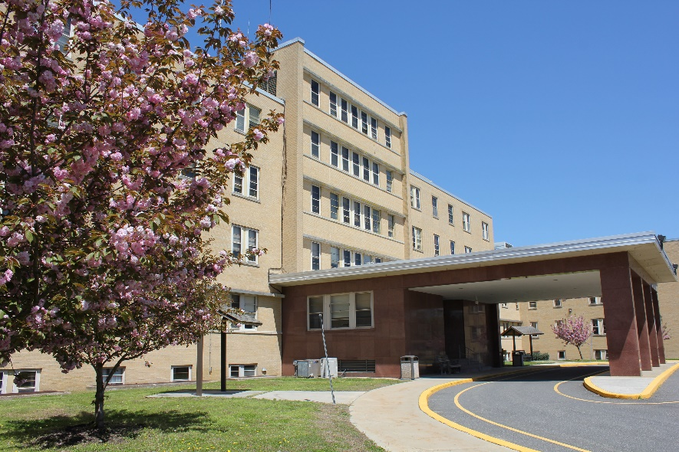

Philip D. Murphy, Governor

Tahesha L. Way, Lt. Governor

Jeffrey A. Brown, Acting Commissioner of Health

Deborah Hartel, Deputy Commissioner Integrated Health Services

Ann Marie Flory, RN, MSN, NE-BC, CPPS Assistant Commissioner, Integrated Health Services

Christopher Morrison, Chief Executive Officer of Ancora Psychiatric Hospital

Cynthia Vetrano MSW, LCSW, Deputy CEO

Louis C. Becker, PsyD, MSW, LCSW

Administrator of Psychological Services

Director of Internship Training

**TABLE OF CONTENTS**

INTRODUCTION 3

ABOUT ANCORA PSYCHIATRIC HOSPITAL 4

Hospital Organization of Patient Care 4

ANCORA PSYCHIATRIC HOSPITAL PSYCHOLOGY DEPARTMENT 7

PSYCHOLOGY INTERNSHIP PROGRAM OVERVIEW 7

Training Model and Philosophy 7

Structure of the Training Year 8

Primary Training Experiences 8

Training Goals and Objectives 11

Training Plan Development and Intern Competency Assessment 12

Internship Administrative Structure 13

Intern-Staff Relations and Conflict Resolution 14

Training Materials and Library Services 14

Administrative/Technical Support and Ancillary Services 15

Physical Facilities 15

Salary and Benefits 15

Requirements for the Successful Completion of the Internship 16

Internship Admission Requirements 16

Application Procedures 17

Intern Eligibility and Selection 18

Appendix A: PSYCHOLOGY INTERNSHIP PROGRAM TRAINING STAFF 20

Appendix B: INTERNSHIP PROGRAM TABLES…………………………………………...23

##### ANCORA PSYCHIATRIC HOSPITAL

# **CLINICAL PSYCHOLOGY INTERNSHIP TRAINING PROGRAM**

**INTRODUCTION**

Ancora Psychiatric Hospital’s (APH) Psychology Department offers a full-time, one-year doctoral internship program accredited by the American Psychological Association (APA). There are three positions available to eligible graduate students enrolled in accredited clinical or counseling psychology doctoral programs. The program is designed to provide a well-rounded, diverse training experience in the treatment and assessment of individuals with serious and persistent mental illnesses, equipping interns with the skills needed to function as entry-level psychologists in similar settings. The program guides interns in the development of competencies in evidence-based psychotherapy, psychological assessment, consultation and interdisciplinary healthcare, the evaluation and application of literature and research, professional conduct/ethics/legal matters, and individual and cultural diversity. Interns should expect a balance of clinical work, supervision, and didactic training within an environment that is both encouraging and challenging.

APH has been training psychology interns since 1970 and has been APA-accredited since 2000. Our most recent APA site visit was in 2019, and we were awarded accreditation for ten years. Questions related to the program’s accredited status should be directed to the Commission on Accreditation:

Office of Program Consultation and Accreditation

American Psychological Association

750 First St. NE, Washington, DC 20002-4242

Phone: (202) 336-5979 / Email: [apaaccred@apa.org](mailto:apaaccred@apa.org)

Web: [www.apa.org/ed/accreditation](http://www.apa.org/ed/accreditation)

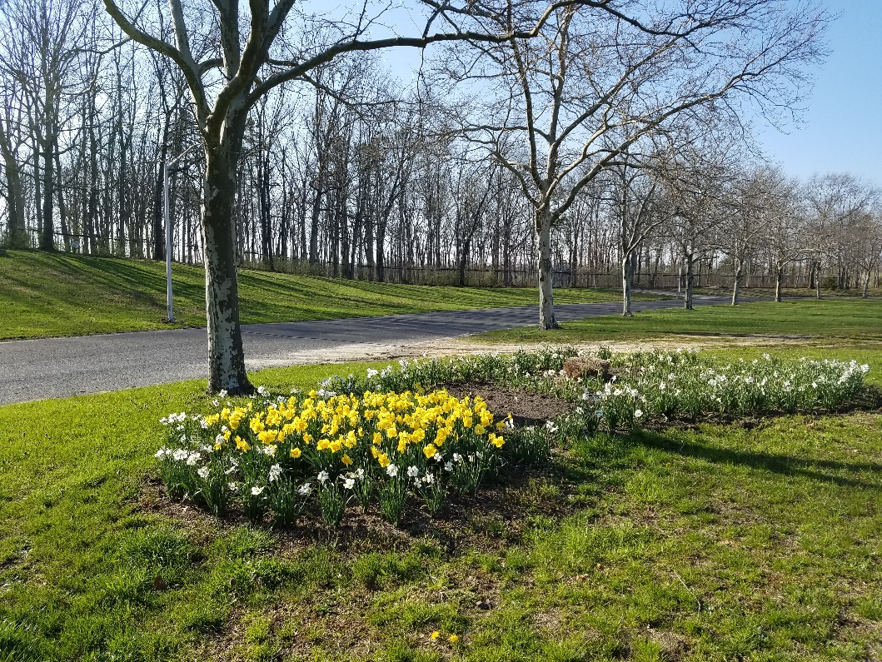

**ABOUT ANCORA PSYCHIATRIC HOSPITAL**

|  |  |
| --- | --- |
|  | Opened in 1955 on 650 acres of land in the Pinelands of South Jersey, APH is about 30 miles east of Philadelphia, PA, and 30 miles west of Atlantic City, NJ. With over 1250 full-time staff members serving approximately 300 patients, APH is the newest of three state psychiatric facilities operated under the auspices of the Division of Behavioral Health Services within the New Jersey Department of Health. The hospital is fully accredited by the Joint Commission on Accreditation of Healthcare Organizations (JCAHO) and certified by the Centers of Medicare and Medicaid Services (CMS). |

APH’s dedicated mission is to care and support each person’s journey toward wellness and recovery within a culture of safety. The hospital’s vision is to be recognized as a trusted leader in the provision of quality evidence-based inpatient care. Training and professional development are highly valued and viewed as integral to the overall mission of the hospital.

APH provides inpatient psychiatric, psychological, and support services for adults primarily from counties in Southern New Jersey. Services are also provided for selected forensic patients from across the state. Patients are referred for admission from community and county hospitals, community mental health screening centers, and from a variety of forensic settings through a centralized admission office. APH provides services to a diverse population including individuals with varying legal statuses, ethnic backgrounds, and socioeconomic statuses. Diagnoses vary through the spectrum of psychopathology and include schizophrenia, bipolar and other mood disorders, personality disorders, and neurocognitive disorders. As of December 2023, the racial profile of patients indicated that 61% were white, 37% were black, and 2% were of other races. Only individuals over the age of 18 years are admitted for treatment.

#### HOSPITAL ORGANIZATION OF PATIENT CARE

The hospital currently consists of five patient- occupied buildings (Main Building, Birch Hall, Larch Hall, Cedar Hall, and Holly Hall). There is a cafeteria, gymnasium, chapel, snack bar, swimming pool, greenhouse, and the Karen Burke Wellness Center, a community organized Self-Help Center. Patients have daily individualized schedules which include programs offered by almost all clinical disciplines to learn and build upon skills necessary for successful community living. Treatment teams work with patients to select groups and activities based on patient-identified goals.

|  |  |
| --- | --- |
| APH’s healthcare is organized according to four primary service divisions: Admissions/Acute Care, Extended Care, Geriatric-Psychiatric Care, and Forensic Care. Each building has one to four treatment units for a total of 13 operational patient care treatment units across the entire hospital. Services are provided to address a variety of client needs including the client’s legal status, level of functioning, level of care needs, and anticipated length of hospital stay. Additional special units meet the needs of patients who test positive, may have been exposed to COVID 19 or need to quarantine following admission. There is also a short-term respite unit for patients who temporarily need a calmer environment. | *Pathway to Maple Hall* |

Admissions/Acute Care Services: There are two admission units located in Birch Hall. Patients who have the potential to stabilize quickly proceed through the Admissions Intake Department and are then transferred to one of the Admission Units. The average length of stay is about 45 days. In that time, patients are either discharged or transferred to another treatment unit. While in admissions, efforts are made to stabilize the patient’s mental status and to provide appropriate medical care. Basic self-care needs are addressed. Psychologists in Admissions complete assessments, and they also provide both individual and group psychotherapy.

Patients who need longer care are typically transferred to one of the three acute care units in Larch Hall. Larch Hall has approximately 90 beds. Psychologists on these units provide a full range of psychological services including individual and group psychotherapy and psychological assessment. Larch Hall is home to the hospital’s Dialectical Behavior Therapy Unit. There is additional treatment and assessment for females who are adjudicated Incompetent to Stand Trial (IST).

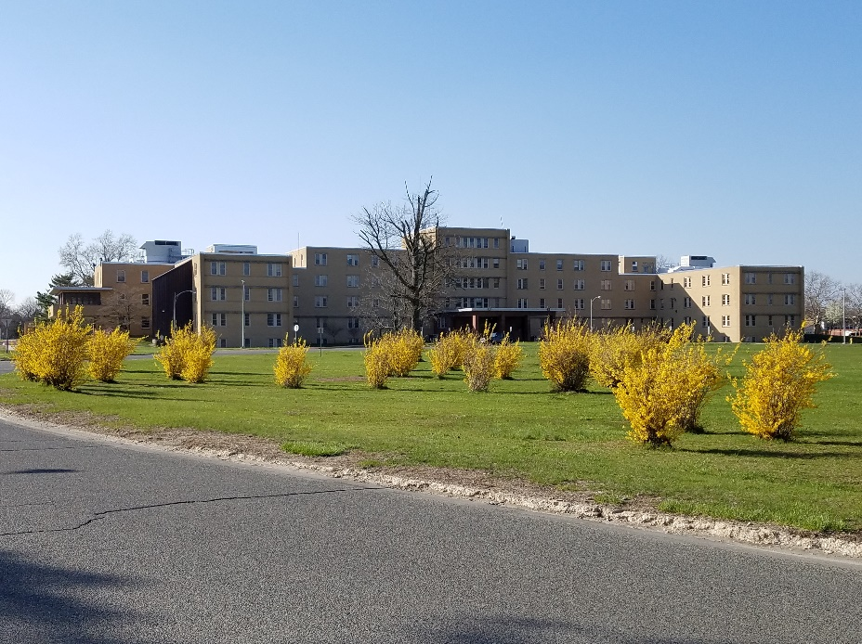

*Main Building*

Extended Care Treatment Services: Cedar Hall has approximately 90 beds on three units for both male and female patients. These units provide treatment options for patients with a variety of treatment and rehabilitative needs. It includes one all male, one female unit and one co- ed general psychiatric unit with patients who typically need longer care. Within these units (and throughout the hospital) individualized behavioral support is provided to those patients needing assistance. Patients present with a variety of psychological difficulties, legal statuses, developmental disabilities, levels of intelligence, and chronic mental illnesses. The co-ed unit maintains a program for people with discharge challenges and is organized to help facilitate their re-entry to life outside the hospital. The hospital is presently collaborating with the Beck Institute to provide Recovery Oriented Cognitive Therapy CT-R to those patients who are hesitant about leaving the hospital.

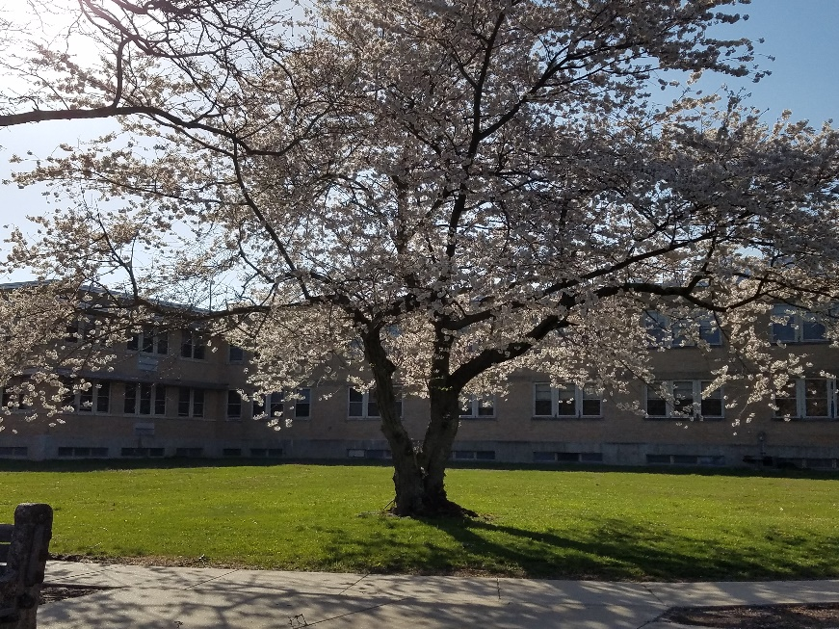

*Cedar Hall*

Forensic Services:The Secure Care Unit (Holly Hall) is a 110-bed unit that serves patients who have had some involvement with the legal system. The patient population generally includes patients on detainer status, patients with outstanding charges referred for treatment and stabilization prior to their court hearings, patients found Incompetent to Stand Trial (IST), patients who fall under the provisions of Megan's law, and those who have been adjudicated Not Guilty by Reason of Insanity (NGRI). State statutory provisions shape the forensic mission of each unit. Holly Hall A and Holly C are dedicated to the structure, support and care of Incompetent to Stand Trial (IST) patients. With a few exceptions, these units are primarily designed to assess competence and provide competency restoration treatment. Holly Hall B is dedicated to the specialized treatment of people who have committed sexual offenses. Holly D house patients predominately deemed NGRI or have current legal involvement and/or history.

Geriatric Services: Geriatric care services are in the Main Building and are provided on a co-ed unit. The geriatric unit has a bed capacity for 25 patients. Most of the geriatric population is 65 years of age or older and present with histories of psychiatric hospitalizations reflecting chronic mental illness. Additionally, many patient admissions are related to the behavioral manifestations of neurocognitive disorders. The Geriatric Services rotation provides a specialized opportunity to work with an interdisciplinary team of geriatric specialists in the disciplines of internal medicine, psychiatry, psychology, nursing, physical therapy, occupational therapy, nutrition, social workers, and recreational/rehabilitative staff.

#### ANCORA PSYCHIATRIC HOSPITAL PSYCHOLOGY DEPARTMENT

The APH Psychology Department is an independent department hierarchically organized under the supervision of the hospital’s Chief Executive Officer and the Deputy Chief Executive Officer of Clinical Services. Currently, the Psychology Department consists of 17 doctoral level psychologists. Ten psychologists are licensed in the state of New Jersey. There is one clinician assigned to each hospital unit, with the exception of the DBT unit which has two. Additionally, we have 2 clinician evaluators; one who completes comprehensive assessment batteries throughout the hospital, and one tasked with completing competency evaluations. There is a designated Psychology Service Coordinator for each building.

**PSYCHOLOGY INTERNSHIP PROGRAM OVERVIEW**

#### TRAINING MODEL AND PHILOSOPHY

The overarching goal of the clinical internship at APH is to recruit, select, and train qualified psychology interns whose career goals include the provision of evidence-based clinical services to a diverse adult population of patients with severe and persistent mental illness. We aspire to foster a strong professional identity for the entry-level psychologist and to encourage lifelong engagement in the dynamic process of professional excellence. APH interns may expect to develop knowledge and skills in the areas of evidence-based psychotherapy, psychological assessment and report writing, consultation in interdisciplinary healthcare, research, ethics/legal matters, individual and cultural diversity, professional values/behavior, professional communication and interpersonal skills.

The APH Psychology Department maintains a philosophy that effective internship training requires a balance of clinical experience, supervision, and didactic training in an environment that provides encouragement and challenge. This philosophy is formalized in an Integrative-Developmental-Practitioner Model, a training model that combines experiential and didactic learning as well as learning through mentorship and supervision. Our training model also aims to provide a well-rounded, diverse training experience. Interns benefit from the breadth and depth of experience from therapy training with two different psychologists on two different APH units, psychological assessment training on cases referred from throughout the hospital, and a didactic series offering a wide range of topics. The psychology department includes clinicians from varied backgrounds and theoretical orientations, and our interns have the opportunity to be exposed to different points of view and psychological methodologies.

#### STRUCTURE OF THE TRAINING YEAR

The full-time internship offers 2000 hours of training, consistent with the expectations of The American Psychological Association Commission on Accreditation. Interns maintain a five-day, 35-hour work week schedule. Interns work with their APH therapy supervisors at least two and a half days per week and with their diagnostic supervisor two days per week. Didactic trainings are provided with the Division of Behavioral Health Services Professional Staff and Psychology Intern Colloquium Series. Additional training is provided by APH staff.

#### PRIMARY TRAINING EXPERIENCES

APH Psychotherapy Training: Interns spend two days per week with their psychotherapy supervisor and two days with their diagnostic supervisor. After six months, they rotate to two different therapy/ diagnostic supervisors. The psychotherapy supervisor is considered the intern’s primary supervisor, and interns receive at least one hour per week of regularly scheduled individual supervision with this supervisor in the practice of individual and group psychotherapy. The psychotherapy supervisor assigns cases, and each intern is expected to carry a caseload of four to seven individual patients. No later than during the second rotation, interns are expected to develop and lead their own psychotherapy groups. Interns are also expected to co-lead, with their supervisors, one to two group therapy sessions per week. Some of the psychotherapy groups include Psychological Symptoms Management, Emotional Regulation, Managing Depression, Managing Anxiety and Panic, Cognitive Enhancement Therapy, Metacognitive Training, and forensic-specific group psychotherapy.

Interns may have the opportunity to complete their therapy rotations in two different service divisions (Admissions/Acute Care, Extended Care, Forensic/Secure Care, and Geriatric-Psychiatric Care). Incoming interns are asked to rank order their service division preferences prior to their entrance into the program. All efforts are made to match interns with their preferred rotations. However, depending on supervisor availability and cohort interests, assignment to a particular service division cannot be guaranteed.

APH Psychodiagnostic Training: Interns also spend two days per week with their diagnostic supervisor, and in this context, they work to improve their clinical interviewing skills and to gain or enhance their competence in administration, scoring, and interpretation of traditional projective and objective assessment instruments. It is the responsibility of the diagnostic supervisor to provide testing referrals and to demonstrate and/or observe the administration of a “core battery” of psychological tests at the beginning of the training year. Additional observation occurs whenever indicated by an intern’s specific need or when a new test is being introduced. The “core battery” currently includes a neuropsychological screening assessment, a cognitive measure, and objective and projective personality assessment measures. The specific tests utilized may include the Bender-Gestalt II Test, the House-Tree-Person, the WAIS-IV, the Stanford Binet, the Rorschach Inkblot Test, the TAT, and/or the MMPI-3 or MMPI-2-RF, the MCMI-IV, and the PAI. The intern may also be introduced to any number of other assessment instruments including specialized instruments used in the geriatric, intellectual disability, vocational and forensic settings. Most assessments are for the purpose of understanding the patient’s present mental status and/or personality styles, although other testing referrals may address narrowly defined questions. During the training year, the diagnostic focus is more on traditional evaluations requiring personality descriptions, differential diagnosis, and/or determinations of intellectual functioning more specific referral issues such as suicide, violence, or sexual dangerousness risk assessments, and the assessment of neuropsychological functioning. Increasing emphasis is placed on improving the intern’s skill in choosing appropriate diagnostic tools to answer referral questions, and in organizing and integrating interview and test data into a meaningful psychological report. Interns are expected to complete one comprehensive psychological testing evaluation per month for a total of **12** integrated testing batteries completed by the end of the year.

Interdisciplinary Healthcare: Clinical services at APH are organized around a multidisciplinary treatment approach to patient care. Consistent with this approach, each psychology intern has the opportunity to be a member of a treatment team together with his or her primary supervisor, a psychiatrist, social worker, nurse, and administrative program coordinator. Each treatment team provides multidisciplinary services to a single hospital unit of approximately 19-30 clients. In this setting, the intern can observe and work in an inpatient setting and interact in a professional capacity with staff from other disciplines.

Licensed Supervision: The process of supervision is consistent with the program’s Integrative-Developmental-Practitioner Model. Supervisors seek to help the interns integrate academic learning with their patient experiences and then assess the effectiveness of this integration through questions and observation. Supervisors also structure the interns’ training in such a way that learning is graduated and varied. Clinical supervisors encourage interns to interact with patients of different cultural backgrounds, at different levels of functioning, and representing various diagnostic categories. The process is developmental as it recognizes that the nature of supervision changes over time. Our supervisory process is also a practitioner-oriented process that encourages “learning by doing.” In this manner, the intern adopts the role of clinician by observing and modeling the behaviors of the supervisor while also receiving feedback on actual therapy/assessment cases. With supervision, the intern learns to formulate cases based on a sound theoretical foundation and to translate this formulation into appropriate diagnostic skills and therapeutic techniques.

All interns are provided with at least four hours of supervision weekly. Interns receive individual supervision each week between their APH therapy supervisor, and APH psycho diagnostic supervisor. Interns may receive additional hours of supervision in a group format. At least four hours of supervision each week is provided by a psychologist who has been licensed in New Jersey for more than two years. In group supervision, interns are assigned to present an in-depth therapy or testing case conceptualization to their peers and a supervising psychologist and to practice giving and receiving peer consultation and feedback. Group supervision will also facilitate the interns’ development in multicultural competence.

Training in Individual Differences and Cultural Diversity: The Department of Psychology at APH concurs with the central premise of the *APA Multicultural Guidelines: An Ecological Approach to Context, Identity, and Intersectionality* (APA, 2017). This guideline encourages psychologists to consider how knowledge and understanding of identity develops from and is disseminated within professional psychological practice. Endemic to this understanding is an approach that incorporates developmental and contextual antecedents of identity and how they can be acknowledged, addressed and embraced to engender more effective models of professional engagement. The 2017 Multicultural Guidelines incorporate broad reference group identities (e.g., Black/African American/Black American, White/White American, and Asian/Asian American/Pacific Islander) to acknowledge within-group differences and the role of self-definition in identity. With the 2017 Multicultural Guidelines, APA and its members are presented with an opportunity to participate directly, as professional psychologists, in engaging a fuller understanding of diversity and its considerations within practice, research, consultation and education (including supervision) to directly address how development unfolds across time and intersectional experiences and identities; and to recognize the highly diverse nature of individuals and communities in their defining characteristics, despite also sharing many similarities by virtue of being human. Our conscious awareness of what it means to think, feel, regulate, behave and create meaning has been enhanced by advances in research and clinical scholarship affording us a contemporary consideration of psychology that incorporates human differences across their varied elements.

Seminar Training: An important facet of this internship program is the integration of applied clinical experience with a sound base of theoretical knowledge. To accomplish this, interns participate in two seminar tracks. The first is a series of seminars sponsored by the APH Psychology Department**.** These in-house seminars are an adjunct to the regular clinical and professional training interns receive here at the hospital. The second set of seminars is offered through the New Jersey Department of Health and is referred to as the Professional Staff and Psychology Intern Colloquium Series. Here, interns participate in didactic seminars covering a broad range of topics relevant to the profession of psychology. The presenters are typically accomplished clinicians in their areas of expertise. Presentations may include specialized lectures on specific risk assessment measures, competency to stand trial assessments, providing court testimony, neuropsychology of severe mental illness, first episode psychosis, psychological services in the prison systems, developing a forensic private practice, harm-reduction approaches to substance abuse treatment, the different expressions of sexuality etc. Additionally, during the second half of the year, interns are required to present a comprehensive therapy or testing case at the Colloquium Series for a collegial round-table discussion.

Clinical Project and Presentation: In addition, interns are expected to complete a clinical project during the internship year. Projects are largely dependent upon the unique interests of the intern and how they would like to contribute to the hospital community. The intern project may be any activity that is outside of the normal training structure of the program. Interns may elect to complete a research project involving patients. In this case, they must prepare and present a research proposal to the Directors of Training and the Hospital Research Committee for pre-approval before proceeding towards the completion of their project. Interns have also worked alongside various members of the psychology department to complete larger hospital and/or departmental projects. Recent intern projects have included the development and presentation for APH nursing staff on basic behavioral principles/positive behavior supports, active membership and presentation on guardianship policy and law to the State’s Older Adult Committee, the collection and analysis of data related to employee support following on-the-job injuries based on surveys collected from over 500 APH staff, exploring ways to reduce staff burn out, and developing various assessment protocols. Time to conduct the clinical project is generally allocated during regular working hours but may also be completed after hours if a supervisor is onsite.

Finally, interns are also expected to present their dissertation research to the APH Psychology Department. This presentation is highly dependent on the intern’s dissertation status and may range from a theoretical justification and literature review of their topic, for the intern just beginning the dissertation process, to a synopsis of the dissertation defense for those who have defended their dissertations.

**TRAINING GOALS AND OBJECTIVES**

The APH Internship Program provides a guided clinical experience which affords the intern the opportunity to function in various roles associated with the practice of professional psychology. The two major roles emphasized are those of the psychotherapist and the psycho-diagnostician. The development and/or refinement of specific skills and competencies associated with these clinical roles form the basis for our program’s training goals. APH interns may expect to develop knowledge and skills in the areas of psychotherapy, psychological assessment, consultation in interdisciplinary healthcare, the application of literature and professional conduct/ethics/legal matters, and individual and cultural diversity. Training goals are focused on the following profession-wide competencies and the program objectives and elements associated with them:

1. Psychotherapeutic Intervention

* Safety and crisis management
* Risk assessment/Risk management
* Theoretical case conceptualization and treatment planning
* Therapeutic interventions
* Group therapy skill and preparation
* Effective use of emotional reactions in therapy (addressing countertransference)
* Patient rapport/Working relationships

1. Psychological Assessment

* Clinical interviewing skills
* Diagnostic skills
* Psychological test selection and administration
* Psychological test scoring and interpretation
* Assessment writing skills
* Feedback regarding assessment
* Patient risk assessment/Risk management
* Patient rapport/Working relationships

1. Consultation and Interdisciplinary Health Care:

* Consultative guidance
* Knowledge of treatment roles of other disciplines
* Professional interpersonal behavior

1. Application of Research and Literature to Clinical Work:

* Evaluation and dissemination of research
* General psychological knowledge
* Seeks current scientific knowledge
* Development and implementation of a research project
* Case presentation at the Colloquium Series
* Presentation of dissertation to department/peers

1. Supervision /Consultation and Interdisciplinary Skills

* Knowledge and effective application of providing Supervision
* Consultative guidance
* Knowledge of treatment roles of other disciplines
* Professional interpersonal behavior

1. Ethics, and Legal Matters

* Knowledge and conduct consistent with ethics and law
* Application of laws and ethical standards to real and hypothetical situation

1. Individual and Cultural Diversity

* Patient rapport and working relationship
* Sensitivity to patient and staff diversity

8. Communication and Interpersonal Skills

* Using positive coping strategies in dealing with personal challenges
* Consultative guidance
* Assessment writing skills
* Feedback regarding assessment
* Patient rapport/Working relationships

**TRAINING PLAN DEVELOPMENT AND INTERN COMPETENCY ASSESSMENT**

At the start of the internship year, each intern completes an Initial Self-Assessment of their prior experiences in order to establish a perceived skill level with specific theoretical and practice orientations, assessment measures, and treatment/assessment of specific problems or diagnoses. The information is used to help interns identify and clarify specific training and career goals. The intern then reviews the Initial Self-Assessment with each of their supervisors, and the supervisor and intern collaboratively develop an initial Training Plan of specific goals within the eight profession-wide competencies. This Training Plan becomes the touchstone for all training and supervision activities. If any adjustments to the training plan agreement are necessary to help interns maximize their training experience, they can be made at any time. At six months, a final Training Plan is similarly developed. Feedback regarding the intern’s progress toward his or her goals and level of competency is provided informally during the course of supervision and formally in written evaluations every three months. The intern, supervisor, and the Training Directors sign each evaluation. Copies of the evaluation forms are provided to the interns at the beginning of the training year and are available to any interested applicant upon request.

Clinical Competency Issues and Remediation Procedure: Good standing and satisfactory progress are required for retention in the APH Internship Program. It is consistent with APA’s Committee on Accreditation requirements that interns demonstrate intermediate to advanced levels of professional skills in selected areas relevant to competent practice. Good standing in the program is determined through a series of satisfactory ratings of the intern’s progress provided at three-month intervals throughout the internship period. The developmental nature of our training model assumes that each new skill or competency is built upon previously mastered skills and competencies. Our goals and competencies are oriented towards independent and ethical practice. Therefore, failure to achieve skills and/or competencies or failure to value those processes which lead to independent and ethical practice is unacceptable. If a problem is apparent, the supervisor develops a remediation plan and documents progress in resolving the problem. If a supervisor believes that an intern is not making acceptable progress despite their mutual efforts at remediation, the remediation effort is reviewed by increasingly higher levels of administration until remediation is successful or until some other decision is made regarding the intern’s ability to successfully complete the training program.

**INTERNSHIP ADMINISTRATIVE STRUCTURE**

Psychology Internship Program Training Staff: Please refer to Appendix A for a full description of the APH Internship Training Staff.

Director of Training: The Directors of Training are responsible for the administration and coordination of the various components of the APH Psychology Internship Program. Dr. Louis Becker serves as the Director of Internship Training. Dr. Becker is licensed in New Jersey. The Director of Training has an important role in the intern selection process and in the maintenance of supervisory and training standards. They coordinate with the APA, APPIC, and other New Jersey State Psychiatric Hospitals Directors of Internship Training.

APH Psychiatric Hospital Internship Committee: The Internship Committee is chaired by the Director of Training and includes all internship supervisors, the intern representative, and other psychologists. Members of this committee participate in the administration of the APH Internship Program and have input into intern selection and evaluation, supervisor selection, program development, and quality improvement. Members of the Internship Committee provide direct psychotherapy and diagnostic supervision for the interns and lead on-site training seminars.

Intern Representative: The Intern Representative is a psychologist and member of the Internship Committee but has no direct intern supervisory responsibility. He or she is an individual who acts in a supportive role for the interns and is regularly available for discussion about concerns, professional development, post-internship career options, and issues related to the internship year. The Intern Representative meets with interns as a group once or twice a month for open discussion and is available on an as-needed basis to the interns.

#### INTERN-STAFF RELATIONS AND CONFLICT RESOLUTION

Recognition of the Rights of Interns and Staff: The right of interns and staff to be treated with mutual courtesy and respect is foundational to the APH Internship. While a hierarchical structure is inherent in the internship training model, interns are provided many opportunities to make decisions about their training. Interns have a voice in determining their rotation placements within the hospital, and the content of their training plans. Ethical and appropriate behavior from supervisors is of the greatest importance and critical to the success of the internship program. Every supervisory appointment is jointly designated by the APH Internship Committee and reviewed by the Directors of Training.

Employment Conflict Resolution and Grievance Procedures: First and foremost, psychology interns are employees of the State of New Jersey. They are protected by the same general due process and grievance procedures that cover all state employees. Interns, like all employees, are informed of these rights, policies, and procedures during the New Employee Orientation. Interns can be terminated from employment with the State for violations of New Jersey State law, policies, or procedures. Participation with the internship does not exempt an intern from the general rules that all staff must follow. There is a formalized procedure for the resolution of employment disputes, conflicts, and/or concerns involving an intern in the Psychology Internship Program. A full description of the process is provided to interns at the start of their training year, and a copy of the Grievance Procedure and Due Process is available to any applicant upon request. If, at any point, there is a discussion with an intern regarding discipline, early withdrawal from the program and/or the possibility of an unsuccessful completion of the internship, a representative from the Department of Behavioral Health of the New Jersey Department of Health must be present.

#### TRAINING MATERIALS AND LIBRARY SERVICES

The APH Psychology Department provides sufficient training materials and equipment to ensure an exceptional learning opportunity. Each intern is provided access to his/her own testing kit for the year which includes materials to help form a core testing battery. Additional test materials are available to the interns through the department office, located directly across the hall from the intern office.

The psychology department maintains a professional library on the first floor of the Main Building. This contains extensive resources representing varied theories and treatment approaches. In addition, there is an extensive collection of CDs and DVDs on professional topics available for loan.

APH’s psychology department also has access to a wealth of information through the New Jersey State Library*.* As State employees, interns can apply online for a library card which will grant them access to the library’s electronic resources and databases (including PsycINFO) as well as ILLiad, an online system to request articles and books.

#### ADMINISTRATIVE/TECHNICAL SUPPORT AND ANCILLARY SERVICES

Psychology interns have access to the APH Portal, a computerized database of a select portion of patients’ medical records. Clerical and technical supports are available to the interns both within the Psychology Department and from other hospital-wide resources. Technical support for the interns and the internship program is also provided through programming expertise for the computers that are specifically designated for the Psychology Department. APH also maintains its own Security, Police, Fire Department, and infirmary staff that can respond to emergencies as needed.

#### PHYSICAL FACILITIES

The interns are provided a private office suite in the Main Building that include computers, printers, and a telephone with voicemail. One of these computers also provides access to electronic scoring programs for various psychological tests. Each treatment team room is equipped with a computer and a printer that are part of the Local Area Network (LAN) system. Interns can send and receive emails and have access to the APH Portal from any computer that is part of the LAN system in the hospital. There are also copy machines available for intern use throughout the hospital. Individual therapy and psychological testing are conducted in areas designated by the intern’s supervisor. Group therapy sessions may be held in conference rooms, or unit dayrooms.

2026 – 2027 SALARY AND BENEFITS

Salary for the 2026-2027 internship class is $43,981.93. The workweek consists of five days of clinical experience/training. Interns receive 13 State Holidays, 80.5 hours of vacation time, 89.25 hours of sick leave, and 42 hours of paid administrative leave. Medical/health insurance coverage is provided, and in the event of an injury, interns are eligible for Workman’s Compensation. Interns may also be enrolled in the pension plan. (If they do not continue with state employment after the internship, they may request a refund of any deductions.) Interns must maintain their own malpractice insurance and must provide proof of same prior to the beginning of the internship year.

REQUIREMENTS FOR THE SUCCESSFUL COMPLETION OF THE INTERNSHIP

Upon successful completion of the internship program, each intern will receive a certificate from APH’s CEO and the Director of Training. Satisfactory completion requires the following:

1. Completion of the full 12 months of training and clinical hours.
2. Successful clinical performance throughout the course of the internship year in their clinical work as evaluated by the intern supervisors’ completion of the Intern Interim Evaluations and mid-year and final Intern Competency Assessments.
3. Satisfactory completion of all written requirements to include completion of all assessments, testing batteries, progress notes, seminar presentation, and the intern project.
4. Attendance at all required APH seminar presentations. The Director of Training must excuse absences from required training.
5. Attendance at scheduled bimonthly colloquium series trainings as sponsored by the Department of Human Services. The Director of Training must approve absences from required training.
6. Successful completion of 12 psychodiagnostic batteries, ongoing individual therapy for at least four patients during each rotation, and the co-leading of at least two ongoing psychotherapy groups during the internship year. It is expected that the intern will develop, lead and maintain his or her own therapy group at least by the beginning of the second rotation, unless restricted by covid regulations.

The APH Internship Committee has the final approval in the granting of certificates. The decision is based upon evaluations from APH supervisors and consultation with the Director of Training.

#### INTERNSHIP ADMISSION REQUIREMENTS

Pre-doctoral applicants must have graduated from an accredited college or university with a Bachelor’s degree, supplemented by a Master’s Degree (or equivalent as certified by the applicant’s university training director) from an accredited college or university. Candidates must be enrolled in a doctoral program in applied psychology (clinical or counseling) at an accredited university or professional school and must be approved by their Training Director for the internship. Successful applicants should have completed graduate course training in each of the following areas:

1. Coursework in the following:
   * Personality development and psychopathology
   * Theories of learning
   * Objective and projective assessment
   * Psychotherapeutic intervention
   * Intellectual/cognitive assessment
   * Research design and statistical analysis
2. Minimum graduate practicum experience:
   * **50** doctoral assessment hours
   * **Three** integrated psychological reports
   * **Three** clinical reports that included the administration, scoring, and interpretation of the WAIS-IV
   * **One** clinical report that included the administration, scoring, and interpretation of the Rorschach Inkblot Test using empirically supported, systematic scoring is preferred
   * **500** doctoral intervention hours
   * Psychotherapy experience

**APPLICATION PROCEDURES**

Application materials to be submitted for consideration:

1. Transcripts of all graduate work
2. Three letters of recommendation (preferably from clinical supervisors)
3. A curriculum vitae or resume
4. A recent, integrated psychological evaluation
   * This work sample should be a copy of an integrated psychological evaluation, completed within the past 24 months, with the applicant’s name and the supervising psychologist’s name and title. All patient identifying information should be removed. An integrated psychological evaluation, for this purpose, is defined as an evaluation that organizes and integrates historical information, clinical interview findings, and testing results into one cohesive report which addresses a referral question and concludes with diagnoses and treatment recommendations.

Application materials must be submitted by November 1, 2025. We will make every effort to evaluate materials in order to notify applicants of their interview status by January1, 2024.

As a member of the Association of Psychology Postdoctoral and Internship Centers (APPIC), we recognize the benefits of a matching program as an effective and fair means of processing applications and implementing a standardized acceptance date. This internship site agrees to abide by the APPIC policy that no person at this training facility will solicit, accept, or use any ranking-related information from any intern applicant. Please follow the application procedures as they are listed and described at [www.appic.org](http://www.appic.org).Do not mail applications to APH. All supporting materials (transcripts, recommendations and work sample) are to be included as part of the APPIC application package.

#### INTERN ELIGIBILITY AND SELECTION

The APH Internship Program encourages applications from all qualified applicants regardless of race, sex, gender, sexual orientation, religion, or physical disability. A candidate who is considered eligible is invited for an online interview. In the past, we have required onsite interviews, but we are following the APA recommendation to minimize COVID risk by interviewing online. Because we believe that the cultural diversity of our staff and interns should reflect the same diversity found among our patients, minority status is given consideration during the ranking process.

**For the 2026-2027 intern class, interviews are scheduled for early January 2026.** Applicants assemble online and meet clinical supervisors and current interns. The Training Committee will make a formal presentation about the internship program to the group and answer questions from the applicants. Individual presentations will follow from several APH psychologists describing the range of available training opportunities. Applicants will then answer a series of questions presented to them in a group format. Each applicant is then interviewed individually by one or two supervisors in a process that takes about 45 minutes. The entire interview process should take no more than five hours. Our internship program is committed to providing access for all people with disabilities and will provide reasonable accommodations if notified within 10 days of the interview.

Appointment to the Psychology Intern title at APH is contingent upon satisfying certain eligibility requirements for employment with the State of New Jersey. Employment is contingent upon a satisfactory background check, drug testing, and health screening. After a student is matched to the internship program, they must complete a hospital application and declare all prior convictions. Fingerprinting is completed, and all convictions are subject to review by hospital administration and/or the Commissioner. Students must also undergo testing for controlled dangerous substances, at the expense of the applicant. Prescription drugs must be taken in accordance with the prescription, and any positive test results must be corroborated against the prescription. Persons with mental or physical disabilities are eligible as long as they can perform the essential functions of the job after reasonable accommodation is made.

Please contact the Director of Training if you have any specific questions or concerns.

Louis C. Becker PsyD, MSW

Ancora Psychiatric Hospital

301 Spring Garden Rd.

301 Spring Garden Rd.

609 567-7322

**APPLICATION INFORMATION IS SUBJECT TO CHANGE.**

*Please see the most current internship brochure for updates prior to submitting your application. The brochure may be found at:* <https://nj.gov/health/integratedhealth/dmhas/documents/hospitals/ancora/APH_Internship_Brochure.pdf>

**Appendix A**

**PSYCHOLOGY INTERNSHIP PROGRAM TRAINING STAFF**

\**Therapy/Primary Supervisors*

**\*Dr. Louis C. Becker** is the current Administrator of Psychological Services. He received his PsyD in Clinical Psychology from the Philadelphia College of Osteopathic Medicine in 2006. Additionally, he earned an MSW from the University of Pennsylvania School of Social Policy and Practice in 1994. He recently returned to APH after working for Ann Klein Forensic Center in the Community Competency/Sanity Evaluation program. His primary orientation is Cognitive Behavioral, and he has experience working in Clinical and Forensic Psychology. His interests include the treatment and assessment of sex offenders, Competency Evaluation and Clinical Training. Dr. Becker is a New Jersey Licensed Psychologist and was formerly the Director of Postdoctoral Residency Training for the State of New Jersey.

**\*Dr. Ann Marie Bescherer** received her Ph.D. in Clinical Psychology from Walden University in 2012. She completed her pre-doctoral practicum at APH (Larch Hall) in 2008, pre-doctoral internship at Voorhees Pediatric Facility in 2012, and post-doctoral training with Center for Family Services, Inc. (Substance Abuse Program) in 2015. Her primary orientation is a blend of CBT, Motivational Interviewing (MI), and EMDR through which safety and trust are nurtured and cultivated for the journey ahead. Tailoring specific needs to specialized approaches leading to upward growth and development is the primary goal as well as overall stability in both mental health and addiction issues. Ann Marie trained at The EMDR Institute, Inc. in 1995 (under Dr. Francine Shapiro) and in 2022, updated basic training for Levels I and II, and is a member of EMDRIA (International Association) as a full member. She attained her M.A. in Counseling Psychology from Immaculata College in 1996, and her M.B.A. (with a concentration in Health and Medical Services Administration) from Widener University in 2007. Additional credentials include the NCC (Nationally Certified Counselor) since 2009, NJ LPC (Licensed Professional Counselor) since 2010, NJ LCADC (Licensed Clinical Alcohol and Drug Counselor) since 2004, and ACS (Approved Clinical Supervisor) since 2017. Specialty areas encompass treating complex co-occurring psychopathology including trauma, substance use, and personality disorders. Ann Marie returned to APH in 2024 serving the forensic population on Holly Hall D Ward.

**Dr. Britney Fontes** earned her Psy.D. in Clinical Psychology in 2024 and her Master of Science in 2020 from Chestnut Hill College. Dr. Fontes completed her internship here at Ancora Psychiatric Hospital and is now the psychologist for Birch Hall D. This is a coed admissions unit for individuals with acute, serious and persistent mental illness. Her orientation is informed by psychodynamic and family systems theories, but she utilizes an integrative approach to psychotherapy, meeting each patient where they are, providing unique interventions to each person. She has worked in a variety of settings, including impatient, school, and private practice (specializing in OCD and anxiety related disorders). Her clinical interests include personality disorders, severe and persistent mental illness, family systems and the treatment of autism. She also published a book called Treating Families on the spectrum. This book outlines how therapists and families who have a child with autism can use an ecological systems approach, which offers a holistic and nuanced model that treats the entire family system rather than just the individual.

**\*Dr. Donna Gilles** received her Psy.D. in Clinical Psychology from La Salle University in 2005, with a specialization in child-clinical and family studies. She is licensed in New Jersey and has been working at APH since June 2008. Her primary theoretical orientation is cognitive-behavioral. She has worked in community mental health, outpatient, inpatient, residential, and school-based settings with a variety of client populations. She has experience working with eating disordered clients, children and adolescents, geriatric and medical populations. She serves our geriatric unit.

**\*Dr. Troy Heckert** received his Psy.D. in Clinical Psychology from the Philadelphia College of Osteopathic Medicine in 2006. His primary orientation is cognitive-behavioral, and he has experience working in a variety of settings including correctional facilities, community mental health, partial hospital, residential treatment facilities, outpatient (family, couples, group, and individual therapy), family-based (in-home) services, and a university setting. His clinical interests include personality disorders, health psychology, forensic psychology, and CBT. He is an Admissions Unit Psychologist. Dr. Heckert is licensed in New Jersey.

**\*Dr. Dana Kiess** received her Psy.D. in Clinical Psychology from LaSalle University in 2014 and is licensed in New Jersey.  She completed her pre-doctoral internship at Friends Hospital in Philadelphia, PA, and postdoctoral residency at APH.  Her primary orientation is cognitive-behavioral, and she has experience working in psychiatric hospitals, community mental health, outpatient substance abuse programs, and college counseling.  Her professional interests include SPMI, trauma, trauma-informed care, and behavioral interventions.  Dr. Kiess is currently the psychologist on Cedar Hall B. This is a male unit for individuals with mental illness and developmental and/or intellectual disabilities and is one of the positive behavior support units in the hospital.

**\*Dr. Karen Kohaut** is a licensed psychologist and certified school psychologist in New Jersey and Pennsylvania. She received her Psy.D. in Clinical Psychology from the Institute for Graduate Clinical Psychology at Widener University in 2009. She has been a psychologist for the State of New Jersey since 2010. Dr. Kohaut’s primary orientation is cognitive behavioral, and she has worked in inpatient, residential and school settings with a variety of patient populations. Dr. Kohaut has expertise in working with dually diagnosed, mentally ill, and substance abusing patients.

**\*Dr. Natasha Moore** joined the Ancora Psychiatric Hospital’s Psychology Department immediately after completing her pre-doctoral internship at Greystone Park Psychiatric Hospital in December of 2002. She received her Ed.D. in Counseling Psychology from Rutgers, The State University of New Jersey. Dr. Moore has 20 years of experience working with an inpatient geriatric psychiatric population with specialized training in geriatrics, women’s trauma, program development and evaluation, and multicultural competence training/supervision. In addition to her extensive experience note above she has received extensive training in Forensic evaluation. Dr. Moore’s current position is the hospital competency (IST) evaluator.

**\*Dr. Kyle Osbourne** earned his Doctorate of Psychology (2019) and Master of Sciences in clinical psychology from Philadelphia College of Osteopathic Medicine. He also earned his Master of Arts in Professional Counseling Psychology from La Salle University. Dr. Osbourne completed his Postdoctoral Fellowship and clinical psychology internship at Friends Hospital in 2019, with an externship at the Behavioral Medicine Division of Cooper University Hospital in Camden, NJ in 2018, as well as a practicum experience at the Lebanon Veterans Affairs Medical Center in 2017. He has experience providing short-term, long-term clinical psychotherapy as well as psychological assessment to a diverse adult and child inpatient psychiatric population. He is also actively involved in clinical research, preventative patient care, and teaching of students, residents and mentees. Dr. Osbourne’s clinical research is focused on Systemic Lupus Erythematosus. His recently completed research dissertation involved The Influence of Cognitive Distortions, Coping Skills and Social Support on Quality of Life in female Lupus patients. He also has particular expertise in the diagnosis and management of patients experiencing trauma and addiction related issues.

**\*Dr. Kayleen Palmucci** graduated from the APH internship in 2022 with a doctorate from Chestnut Hill University. She has extensive experience in neuropsychological assessment and enjoys working with the geriatric population. She continues to expand her range of skills by working in the Larch B DBT program. Dr. Oliver became the psychology department intern representative immediately after completing her internship. She has provided guidance and support to incoming interns. She is also an active member of the internship selection committee.

**\*Dr. Maria Pendondjis** received her Psy.D. from Immaculata University in 2020, after earning an M.A. in Psychological Counseling from Monmouth University in 2012. Dr. Pendondjis completed her internship here at Ancora Psychiatric Hospital and is the hospital’s assessment psychologist conducting evaluations to assist treatment teams throughout the hospital. She has worked in a variety of settings, including community mental health, college counseling, and private practice focused on neuropsychological assessment. Dr. Pendondjis uses an integrative approach to therapy with an emphasis on cognitive behavioral and psychodynamic principles. Her clinical interests include personality disorders, forensic psychology, neuropsychology, assessment, and severe and persistent mental illness and treatment.

**\*Dr. Neil Rigney** earned his doctorate in clinical psychology (2019) and his Master of Science from Chestnut Hill College. He is proficient in therapy, assessment and research. His orientation is informed by psychodynamic principles, but he utilizes an integrative approach to psychotherapy, tailoring treatment to the needs of each patient. He has experience across multiple settings, providing psychological services to a wide range of treatment populations. Previous experiences include community outpatient, college counseling, private practice (neuropsychological assessment), partial-care, and rehabilitation settings. Areas of interest include psychological assessment, health psychology, veteran’s issues, and personality disorders. He is currently working on Holly B with males who have a history of sexual offenses.

**\*Dr. Jacob Stier**completed his internship at APH in 2021 with a doctorate from Kean University. Prior to obtaining his doctoral degree, Dr. Stier acquired extensive experience working with individuals who have been diagnosed with developmental disabilities and comorbid mental health disorders. Currently, he works with a forensic population on Holly A that recently transitioned to a competency to stand trial restoration unit. Dr. Stier also works as a local outpatient provider. His clinical interests include psychodynamic therapy, personality disorders, severe mental illness, and personality assessment. Since 2022 he has been providing assessment supervision to Ancora interns, focusing on assessment in a forensic setting.

**Dr. Morgan Tannoia** earned her Doctorate in Clinical Psychology from Chestnut Hill College in 2024. She has clinical experience working in forensic settings, college counseling, and community mental health. She completed her internship at Ancora Psychiatric Hospital, interacting mainly with the all-male forensic population. She is currently assigned to Holly Hall C, which is a male forensic unit. Her clinical interests include psychodiagnostic assessment, forensic psychology, social psychology, and trauma. Dr. Tannoia was trained under a psychodynamic and systems orientation. She currently endorses an integrative approach, with a relational focus.

**\*Dr. Oswald Thomas** has a doctorate in Counseling Psychology from Pacific University (2001), a doctorate in General Psychology from Northcentral University (2018) and a Master of Science in Public Administration from Metropolitan College of New York. He has extensive experience in therapy, administration and teaching in the United States and abroad. His experience spans all age groups, with particular interest in family issues, gender issues and substance abuse. He has multiple certifications in hypnotherapy. He is the unit psychologist on Larch C, a female general population unit.

**\*Dr. Kaitlin Weldon** received her Psy.D. from Immaculata University in 2017, after earning an M.S. in Clinical/Counseling Psychology from Chestnut Hill College in 2012 and is licensed in New Jersey and Pennsylvania. She has worked in a variety of settings, including community mental health, outpatient (family, couples and individual therapy), college counseling, inpatient, partial hospitalization programs and residential substance abuse programs, utilizing an integrative approach to therapy with an emphasis on cognitive behavioral and psychodynamic principles. Her professional interests include severe and persistent mental illness, trauma and relationships. She is currently the unit psychologist on Larch Hall A, a male general population unit.

**Dr. Heidi Zapotocky** received her Ph.D. in Clinical Psychology with a specialization in Forensic Psychology from Drexel University in 2025. She has prior experience in community mental health and inpatient hospital settings, and much of her experience has been with diverse and underserved populations. She utilizes an integrative approach to therapy with an emphasize on cognitive behavioral principles.  Dr. Zapotocky's research and scholarly publications have focused on improving community-based interventions for justice-involved populations, reducing barriers to community reintegration, and improving the principles and guidelines for forensic mental health assessments. She has a particular interest in forensic mental health assessment and has prior experience with juvenile waiver, federal and state mitigation, Miranda rights waiver, and adjudicative competency. Dr. Zapotocky completed her internship at Ancora Psychiatric Hospital and is now the unit psychologist on Birch Hall A, a male admissions unit.

**Appendix B**

**INTERNSHIP PROGRAM TABLES**

Date Program Tables were updated: April 27, 2023

**Internship Program Admissions**

|  |
| --- |
| *Briefly describe in narrative form important information to assist potential applicants in assessing their likely fit with your program. This description must be consistent with the program’s policies on intern selection and practicum and academic preparation.* |
| The Ancora Psychiatric Hospital (APH) Clinical Psychology Internship Program is designed to provide a well-rounded, diverse training experience in the treatment and assessment of individuals with serious and persistent mental illnesses, equipping students with the skills needed to function as entry-level psychologists in similar settings. The program aims to foster a strong professional identity for the entry-level psychologist and to encourage lifelong engagement in the dynamic process of professional excellence. The full-time internship offers 1750 hours of training, consistent with the licensing requirements of the State of New Jersey. The program is able to accommodate those individuals who would like to accrue 2000 hours during the year in order to meet the requirements of their graduate program or state licensing board.  The program provides experiential training in the following areas of professional competency: psychotherapy, assessment, consultation and interdisciplinary healthcare, supervision, research, professional conduct and attitudes, professional communication and interpersonal behavior, ethics/legal matters, and individual and cultural diversity. Interns should expect a balance of clinical work, supervision, and didactic training within an environment that is both encouraging and challenging. To promote the greatest breadth and depth of experience, the intern’s week generally includes two days of therapy training, two days of assessment training, and typically one day in didactic training.  Application materials to be submitted for consideration by November 1**,** 2023:   1. Transcripts of all graduate work 2. Three letters of recommendation (preferably from clinical supervisors) 3. A curriculum vitae or resume 4. A recent, integrated psychological evaluation    * This work sample should be a copy of an integrated psychological evaluation, completed within the past 24 months, with the applicant’s name and the supervising psychologist’s name and title. All patient identifying information should be removed. An integrated psychological evaluation, for this purpose, is defined as an evaluation that organizes and integrates historical information, clinical interview findings, and testing results into one cohesive report which addresses a referral question and concludes with diagnoses and treatment recommendations. |

|  |  |  |
| --- | --- | --- |
| *Does the program require that applicants have a minimum number of hours of the following at time of application? If yes, indicate how many.* | | |
|  | *Yes/No* | *Amount* |
| Total Direct Contact Intervention Hours | YES | 500 |
| Total Direct Contact Assessment Hours | YES | 50 |

|  |
| --- |
| *Describe any other required minimum criteria used to screen applicants.* |
| Applicants must have graduated from an accredited college or university with a Bachelor’s Degree, supplemented by a Master’s Degree (or equivalent as certified by the applicant’s university training director) from an accredited college or university. Candidates must be enrolled in a doctoral program in applied psychology (clinical or counseling) at an accredited university or professional school and must be approved by their Training Director for the internship. Successful applicants should have completed graduate course training in each of the following areas:   1. Coursework in the following:    * Personality development and psychopathology    * Theories of learning    * Objective and projective assessment    * Psychotherapeutic intervention    * Intellectual/cognitive assessment    * Research design and statistical analysis 2. Minimum graduate practicum experience:    * Psychotherapy experience    * **500** doctoral intervention hours    * **50** doctoral assessment hours    * **Three** integrated psychological reports    * **Three** clinical reports that included the administration, scoring, and interpretation of the WAIS-IV    * One clinical report that included the administration, scoring, and interpretation of the Rorschach Inkblot Test using an empirically supported scoring system is preferred, but not required. |

**Financial and Other Benefit Support for Upcoming Training Year**

|  |  |
| --- | --- |
| Annual Stipend/Salary for Full – Time Interns | $43,981.93 |
| Annual Stipend/Salary for Half-Time Interns | n/a |
| Program provides access to medical insurance | Yes |
| Paid Vacation Time | Yes |
| Paid Administrative Leave Time | Yes |
| Paid Sick Time | Yes |
| In the event of medical conditions and/or family needs that require extended leave, does the program allow reasonable unpaid leave to interns/resident in excess of personal time off and sick leave? | Yes |
| Other Benefits (please describe)  Interns enjoy 13 Paid Holidays.  In the event of an injury, interns will receive Workman’s Compensation.  Interns may also be enrolled in the pension plan.  Access to State discount programs | |

**Initial Post-Internship Positions**

Aggregate Tally for the Preceding Three Cohorts

|  |  |  |
| --- | --- | --- |
| Total number of interns who were in the three cohorts | 10 | |
| Total number of interns who did not seek employment because they returned to their doctoral program/are completing doctoral degree |  | |
|  | **Post-Doc** | **Employment Position** |
| Community mental health center | 1 |  |
| Federally qualified health center |  |  |
| Independent primary care facility/clinic |  |  |
| University counseling center |  |  |
| Veterans Affairs medical center |  |  |
| Academic health center |  |  |
| Other medical center or hospital |  | 1 |
| Psychiatric hospital | 1 | 5 |
| Academic university/department |  |  |
| Community college or other teaching setting |  |  |
| Independent research institution |  |  |
| Correctional facility |  | 2 |
| School district /system |  |  |
| Independent practice setting |  |  |
| Other |  |  |
| Not currently employed |  | |
| Changed to another field |  | |
| Unknown |  | |