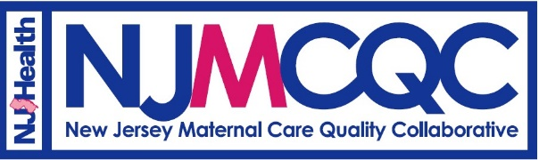

New Jersey Maternal Care Quality Collaborative (NJMCQC) Launch Meeting
Funded by the Human Resources and Services Administration (HRSA)’s State Maternal Health Innovation Program

Tuesday, September 28th, 2021
10:00am – 12:30pm
Via Microsoft Teams
Click here to join the meeting
Or call in (audio only)
+1 856-338-7074, Phone Conference ID: 435 614 953#

Meeting Purposes:
- To formally ratify the NJMCQC by-laws, which govern the Collaborative and business moving forward
- To outline NJMCQC committee officer positions
- To review background data and logistical information from the Maternal Mortality Review Committee (NJMMRC)
- To review background data and learnings from NJMCQC members on identified consensus areas for future NJMCQC activities
- To continue building synergy with state, public and private collaborators on key issues that will be the focus of the first year of the NJMCQC

Agenda Item | Lead Speaker
Call to Order | Brandie Wooding, NJMCQC Nurse Consultant
Welcome, Attendance, Objectives and Agenda Review | Abiola Animashaun-Amutah, NJMCQC Project Manager
Meeting Housekeeping Rules | Abiola
Vote on the June 2021 Meeting Minutes | Abiola
NJMCQC By-Laws Discussion | Brandie
NJMCQC By-Laws Confirmation Voting process | Dr. Damali Campbell Oparaji, NJMCQC Medical Director
NJMCQC Strategic Plan Discussion and Voting Process | Abiola
Break
NJDOH Ethics Presentation | Rachel Hammond, NJDOH Chief Ethics & Data Privacy Officer
Level-Setting and Background Data from the NJMMRC | Renee Kraus and Adwoa Nantwi
Learnings from NJMCQC Members and Discussion about Consensus on Priority Areas | Brandie
Meeting Recap, Next Steps and Meeting Adjourn Motion | Abiola

Next Meeting (Tentative Date): December 2021 from 10:00am to 12:30pm (final date to be determined)
Email address for inquiries: DOH-MCQC@doh.nj.gov
NJMCQC Website: https://nj.gov/health/maternal/mcqc/

