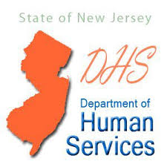
New Jersey Department of Human Services
Division of Deaf and Hard of Hearing
Training Request Form
Submit request to DDHH.communications2@dhs.nj.gov or fax to 609-558-2528

Organization: | City:
Name of Contact Person: | Title:
Phone Number: | Email Address:

Training Requested:
- Deaf and Hard of Hearing Sensitivity Training
- Assistive Listening Devices
- Language Acquisition & Development Services ages 0-5
- Overview of Programs and Services

Date, time, and location of training – please submit at least 4 -6 weeks prior to requested date for training:
Number of participants:
Date:
Time:
Location (Virtual or In Person):

DHS/DDHH Use Only
Date Received:______________________________
Scheduled For:______________________________
Communication Team:______________________________
Approved by Director:___________________________ Date:____________________

