This job aide provides guidance to help you avoid several common application errors.
- Update information about your organization
  - In the black bar near the top of the screen, click Organization. That will bring up the Organization section. It’s open to the Organization Information tab.
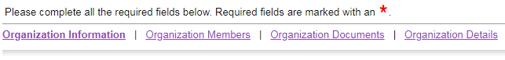
  - Update this page and Save.
  - Click on the Organization Members tab.
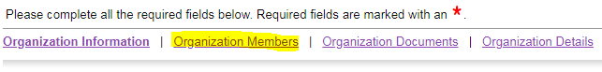
  - Check the people assigned to your organization.
    - Does anyone no longer work for you? If so, is there an end date?
Pro Tip: Both “AO” staff should be listed on the Standardized Board Resolution.
    - Are there at least 2 people with the role of “Authorized Official”? If not, your application will be denied until there are.
    - Should anyone else have access, perhaps at the Agency Administrator or Agency Staff role? For example, is there a biller who can do the entry of the payment voucher?
Pro Tip: Any staff who will be submitting items in SAGE, such as expenditure reports, must be listed on the Standardized Board Resolution. Names can be written in with specific roles, such as “billing only”.

  - Click on the Organizational Details tab.
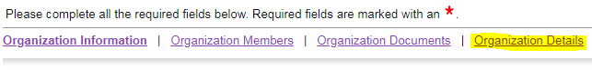

  - Click on the Department of Human Services option.

  - Update this page.
    - There is no certificate of need for this program.
    - There is no license for this program. If your agency is also a service provider (such as a home care agency), the home care license is NOT relevant to the coordination of this program, so there is no need to upload.
  - After saving, click on Home or Documents to exit.
- Choose the Opportunities tab
  - Search for Alzheimer Disease Program Initiative 2025.
  - Choose, and begin application.
- Navigation
  - Once the application has been initiated, it can be found under Documents.
  - Within the contract application, all pages for completion are found under Forms.
  - To submit the application when completed, go to Status Changes. Click Submit, then click Yes. The status will change to Submitted.
  - All pages MUST be completed, using the specifications located in the RFP.
    - Additional Grantee Requirements page and Local Aid & Legislative Districts are the exceptions. You will not have a Save button on those pages.

