Effective February 17, 2020, IdentoGO by IDEMIA (formerly MorphoTrust), changed from using the Process Control Number (PCN) to using a Transaction Control Number (TCN) and a Universal Enrollment Identification Number (UEID).

The IdentoGO receipt will no longer display the applicant’s PCN or TCN, but will instead display the applicant’s UEID. The UEID is 10 characters long and will have the prefix of “UZNJ” for New Jersey submissions. The remaining 6 characters will be alpha or numeric, randomly assigned by the system.

Agencies can retrieve applicant’s TCN by entering the applicant’s UEID number and DOB on the IdentoGO website https://uenroll.IdentoGO.com/.

Once you have retrieved the TCN enter the following information on the Fingerprint Approval Retrieval Application (FARA) website https://fara.dhs.state.nj.us (Microsoft Edge web browser is required) to access the applicant’s results:

- Applicant’s TCN
- Agency’s Contributor Case Number
- Date the applicant was fingerprinted
Note:
- Applicants will need to retain their IdentoGO receipt.
- Applicants will need to provide their IdentoGO receipt to their Agency.
- Agencies will need to retain the applicant’s TCN for archiving or other purposes.
- Agencies are required to look up the applicant’s TCN on the IdentoGO website.
- The Employment Control and Compliance Unit (ECCU) cannot provide an applicant’s TCN to agencies or applicants.
- Fingerprint applicants are not authorized to access results from FARA, only agency personnel should access results from FARA.

If you need assistance, please send an email to the FARA Helpdesk at ECCU.FARA@dhs.nj.gov.

See the illustration below for retrieving applicant’s TCN.

IdentoGO receipt with UEID number.
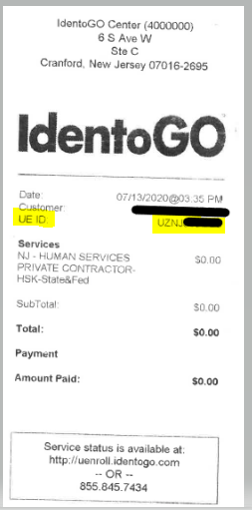

Visit IdentoGO’s website https://uenroll.IdentoGO.com
Click on “Check the Status of your Service.”
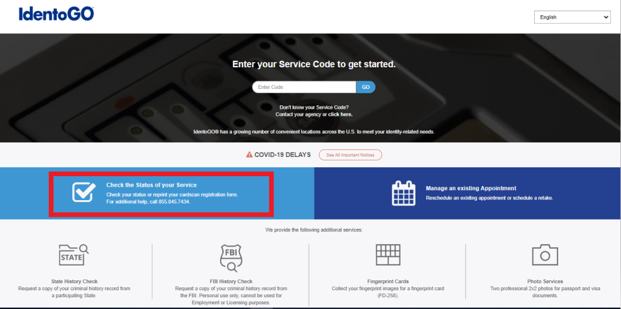

Enter the applicant’s UEID and DOB.
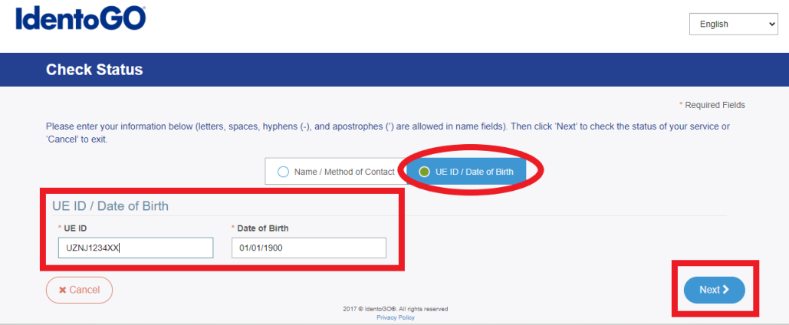

The Service Summary page list the applicant’s TCN which starts with the numbers 4966.
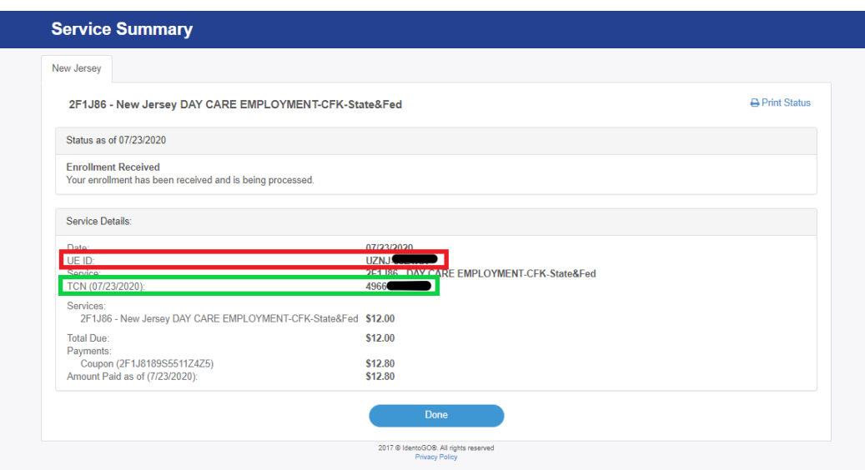

Visit FARA website https://fara.dhs.state.nj.us (Microsoft Edge web browser is required).
Enter the Applicant’s TCN, Agency’s Contributor Case Number and Date the applicant was fingerprinted. Click Submit. The Search Results will display below and then Click ‘Print Letter.’
