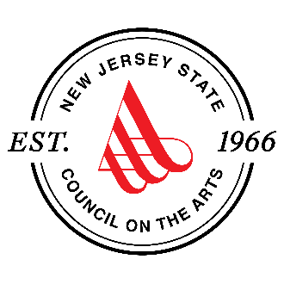
New Jersey State Council on the Arts
New Jersey Heritage Fellowship
Fiscal Year 2024 Notice of Intent to Nominate

Please complete all information and questions. Incomplete nominations will not be accepted.
Please note: This form must be submitted and completed in English.

Nominator Information:
Name: Click or tap here to enter text.
Address: Click or tap here to enter text.
Phone: Click or tap here to enter text.
Email: Click or tap here to enter text.

Artist Nominee Information:
Name: Click or tap here to enter text.
Nominee’s email address: Click or tap here to enter text.
Nominee’s phone number: Click or tap here to enter text.
Nominee’s address: Click or tap here to enter text.
City, State Zip: Click or tap here to enter text.
What is the nominee’s art form? Click or tap here to enter text.
How long has the nominee been practicing their art form? Click or tap here to enter text.
Website where examples of the artists’ work can be viewed: Click or tap here to enter text.
Is the nominee a current, permanent NJ resident? Y☐ N☐
Is the nominee an active and contributing member of the community and currently practicing and/or teaching the art form? Y☐ N☐
Are you able to provide, or is the nominee able to demonstrate artistic excellence via support materials? Y☐ N☐

*continued on next page
Please provide a two-page letter of support that responds to the questions below. If the Intent to Nominate is approved, you may wish to use this letter as one of the required support letters.

- Please thoroughly describe the nominee’s community, their engagement with their community, and the community connection of the art form that they currently practice. Be specific in describing how this is a cultural, folk and/or traditional arts community. (Do not just describe where they live geographically.)

- What is the background of this traditional art in the nominee’s culture? Please detail the history and evolution of the art form to the best of your ability.

- How is this art or craft important to their community?

- How long has the nominee been learning this art or craft? When, where, and from whom have they learned and developed their art form?

- Describe their activities, involvement, and contributions with this and other traditional arts in their cultural communities. Please list key events and activities that they have performed, presented, taught, or impactful services.

- What is your relationship with the nominee and your background relative to the art form (community member, art form expert, artistic peer, the artist, etc.)?

Submit the Notice of Intent to Nominate form via email, as two attachments - this form, and the letter of support described above. Send these to kim.nguyen@sos.nj.gov, and cc rachelle.rivera@sos.nj.gov. Use the subject line “Heritage Fellow Nomination”.

Optional: If the information is not included as a weblink or in the nomination letter, please also attach a PDF document of a résumé or short biography that outlines the career of the nominee(s), a list of major public appearances or exhibitions by the nominee(s), and the titles of published works, if any.

The deadline to submit this Notice of Intent to Nominate is 1/5/23 at 4:00 PM EST.

Notice of Intent to nominate submissions will be reviewed for completeness, and against the rubric provided in the Special Guidance document. All nominators will be contacted with the outcomes of the review by January 24, 2023. Successful nominators will be contacted by email with the information needed to submit a full nomination packet in SAGE.

