Plan Endorsement Recommendation Report

Township of Commercial

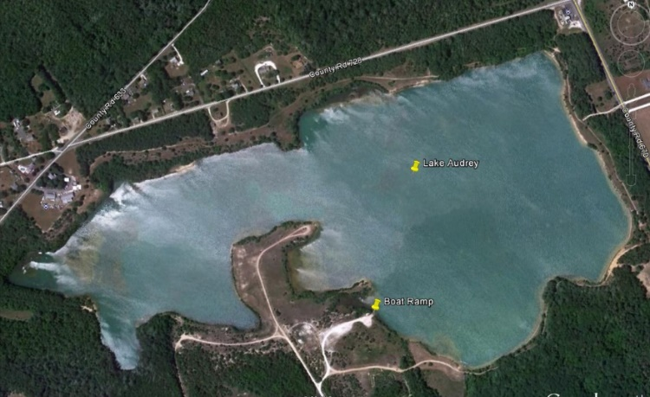
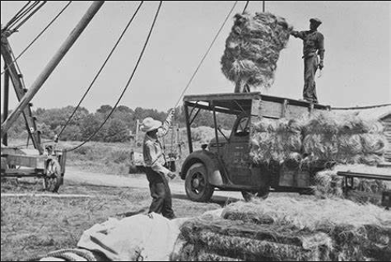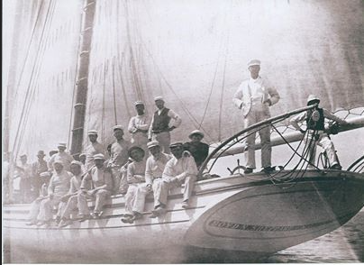
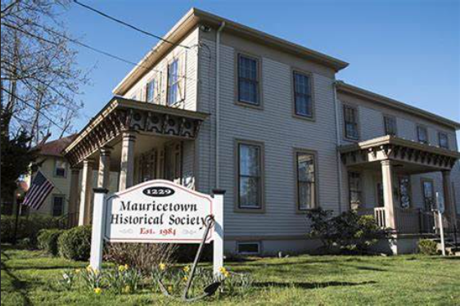

New Jersey Department of State
Office of Planning Advocacy
Meghan Wren, AICP, CFM, Area Planner
October 14, 2022

This document is a recommendation report prepared by the Office for Planning Advocacy (OPA) as staff to the State Planning Commission (SPC or Commission), based on input of our partner agencies, Township of Commercial, Cumberland County and members of the public. OPA will post this report and other material related to the Township of Commercial Plan Endorsement petition on our website. You can contact our office by email regarding petitions for Plan Endorsement by providing contact information, including name, organization, address, and e-mail address to osgmail@sos.state.nj.us.

Documents submitted by the Township of Commercial for Plan Endorsement can be found here: https://nj.gov/state/planning/plan-endorsement.shtml and include the Township’s Master Plan, Amendments, Redevelopment Plans, etc.

Contents

INTRODUCTION 3
BACKGROUND/CHRONOLOGY …………………………………………………………………………………………………..3
PUBLIC PARTICIPATION 4
LOCATION & REGIONAL CONTEXT 4
LAND USE, DEMOGRAPHICS AND BOROUGH OF RIVERTON’S FUTURE 4
INFRASTRUCTURE 7
Wastewater 7
Waters 8
FUTURE LAND USE MAP 8
PROPOSED MAP AMENDMENTS 9
STATE PLAN GOALS REVIEW
GOAL 1: Revitalize the State’s Cities and Towns 13
GOAL 2: Conserve the State’s Natural Resources and Systems 14
GOAL 3: Promote Beneficial Economic Growth, Development and Renewal for all Residents of New Jersey 15
GOAL 4: Protect the Environment, Prevent and Clean Up Pollution 15
GOAL 5: Provide Adequate Public Facilities and Services at a Reasonable Cost 16
GOAL 6: Provide Adequate Housing at a Reasonable Cost 16
GOAL 7: Preserve and Enhance Areas With Historic, Cultural, Scenic, Open Space and Recreational Value 16
GOAL 8: Ensure Sound, Integrated Planning and Implementation Statewide 17
RESILIENCY…………………………………………………………………………………….………………………………………...17
STAFF RECOMMENDATION……………………………………………………….………………………………………………18
PLANNING AND IMPLEMETAION AGENDA……………………………………………………………………ATTACHED

INTRODUCTION
The Township of Commercial (hereafter Commercial or Township) first had its centers designated February 2000 and June 2002, prior to when the formal Plan Endorsement process was in place. It received various extensions over the ensuing years that are scheduled to expire on March 31, 2023.

The Township’s interest in pursuing formal Plan Endorsement was discussed on March 17, 2020 at a prepetition meeting with representatives from the state agencies and the Cumberland County Planning Department. Commercial’s primary objective in seeking Plan Endorsement was to plan and grow in a manner consistent with the State Plan; to update the map with resiliency and equity considerations; to have the working waterfront recognized as a Node, and to gain assistance from the State as the community strives to redevelop resilience and sustainably, revitalize the local economy, increase pedestrian safety, improve circulation, stormwater management and quality of life.

The local goals, objectives and vision for the Township remain consistent with the State Plan, though some of the Center, Node and Planning Area boundaries are being amended to reflect current habitat data and resiliency considerations. The Township is diligently working on its fair share housing obligation, completed a Master Plan Reexamination in 2017, has made great strides in its redevelopment efforts and is diligent at implementing its vision for future quality of life, economic viability, and land use stewardship.

BACKGROUND/ CHRONOLOGY
The Mayor forwarded the Township of Commercial’s petition for endorsement in October 2019.

In March, 2020, a Prepetition meeting was held, the Township authorized a Plan Endorsement Advisory Committee in December 2021; and submitted a their Municipal Self-Assessment Report in December, 2021. OPA co-hosted a local visioning session in person on March 14, 2022.

Commercial Township has been steadily building on its planning foundation, with efforts toward sustainability and smart growth as follows:

Event(s) | Date | Notes
Centers Designated | 2000, 2002 | Through Cross Acceptance
Master Plan | 2006
Fair Share Plan | 2006
Cumberland County Bike/Ped Plan | 2007
Open Space and Recreation Element | 2008
Comprehensive Recycling ordinance | 2010
Landfill Redevelopment Plan | 2011
Recreation & Open Space Inventory | 2012
Cumberland Co Transportation Plan | 2013
Tree Protection Ordinance | 2013
NJ Delaware Bayshore Recovery Plan | 2014 | W/FEMA, Cumb Co & Partners
Flood Hazard Protection Ordinance | 2016
Cumb Co Wastewater Mgt Plan | 2019 | With Build out analysis
Natural Resource Inventory | 2017 (1993)
Official Map | 2017
Submitted PE Petition | February, 2020
Master Plan Reexamination | 2016/17
Zoning Map | 2017
Stormwater Ordinance | 2005 | Recently updated
Cumb Co Hazard Mitigation Plan | 2021
Prepetition Meeting | March, 2020
Appointed PE Advisory Committee | December 2021
Submitted MSA | December 2021
Visioning Sessions | March 2022 | With Cumb Co & OPA support
PIC Recommendation (Scheduled) | October 19, 2022
SPC ADOPTION (scheduled) | November 2, 2022

PUBLIC PARTICIPATION
As part of the Plan Endorsement process the Township appointed a PE Advisory Committee in December 2021 and hosted a local visioning session in person on March 14, 2022 in addition to its visioning conducted as part of its master plan reexam.

LOCATION & REGIONAL CONTEXT
Situated along the banks and marshlands of the Maurice River, Commercial Township, in southeastern Cumberland County, is first and foremost a community evolved from its natural setting. The existing land use patterns of its three villages and the several corridors of residential and commercial activity connecting them are subject to the natural sensitive environment with which they coexist. Significant tidal marshes, woodlands, and freshwater wetlands have and continue to dictate the community's pattern of development. The land use activity has been developed based on these natural conditions, the commercial opportunities they offer, and the historical settlement patterns so intertwined with them. The community's traditional industries are dependent upon the natural environment. Earth extraction, shell fishing (historically oysters), sand barging, and farming have and continue to be sources of employment.

LAND USE, DEMOGRAPHICS AND FUTURE
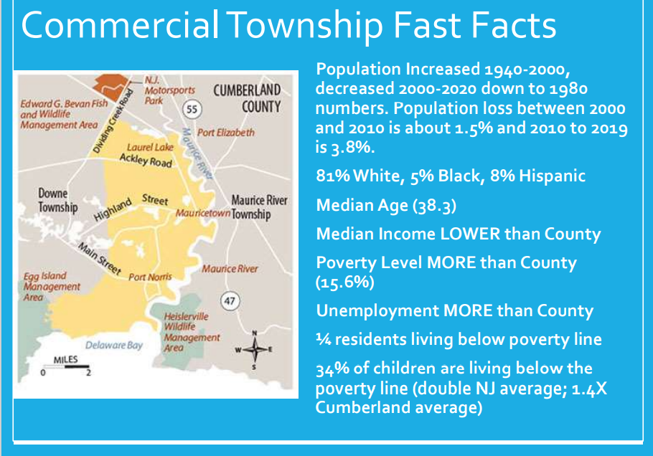

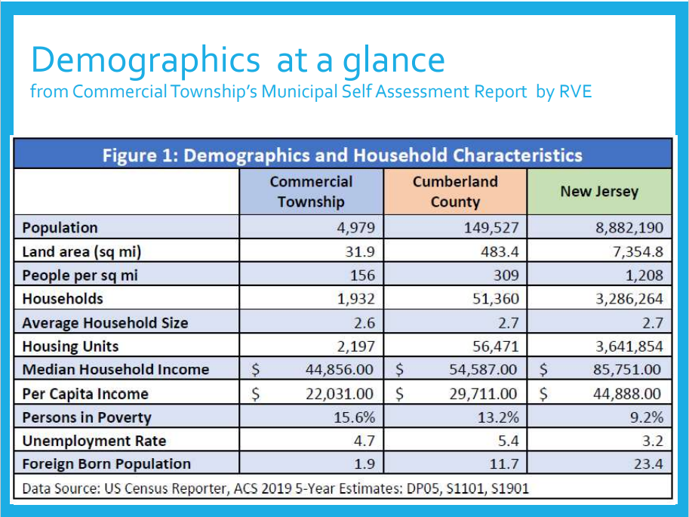

The unemployment rate in Commercial Township remains significantly higher than the state average to date. Commercial Township has historically had significantly higher unemployment rates than even Cumberland County as a whole, which has one of the highest rates of unemployment in the State. The workforce industry in Commercial Township shows high educational services, health care, and social assistance programs, which lines up with County and State trends. The next largest industry in the Township remains retail trade, where as the County tends to have more manufacturing. An industry to note is the agriculture, forestry, fishing and hunting, and mining being a predominate industry within the Township. This industry has the lowest impact on the State totals, which in turn reflects the significant industry of agriculture throughout the Township.

Another demographic concern for the Township is the low household income. The 2010 census lists Commercial as below the County average in all indicators of income and poverty, including household income, family income, per capita income and mean social security income. Commercial's median household income of $44,856 was one of the lowest in Cumberland County which, in turn, is the poorest county in New Jersey with a median income of only $54,587; $31,164 below the median of $85,751 statewide. The Township average is significantly lower than both the County and State.

One quarter of Commercial Township's population is living below the federal poverty level. In addition, over one third (34%) of children under 18 years are living in poverty in Commercial. This is double the New Jersey level and almost 1.4 times the County level.

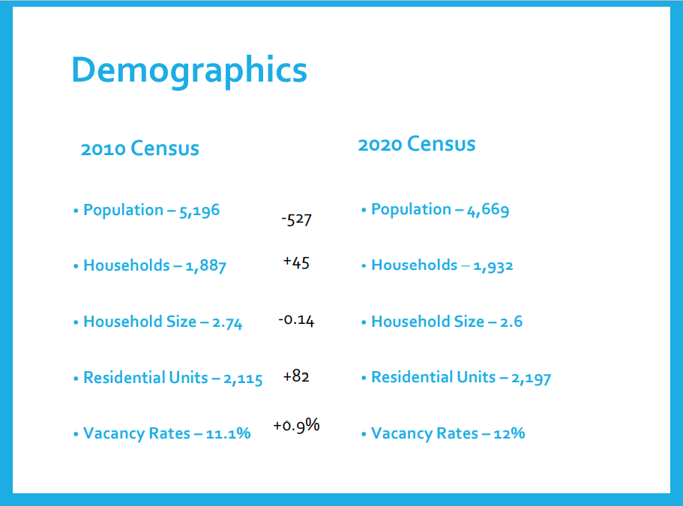

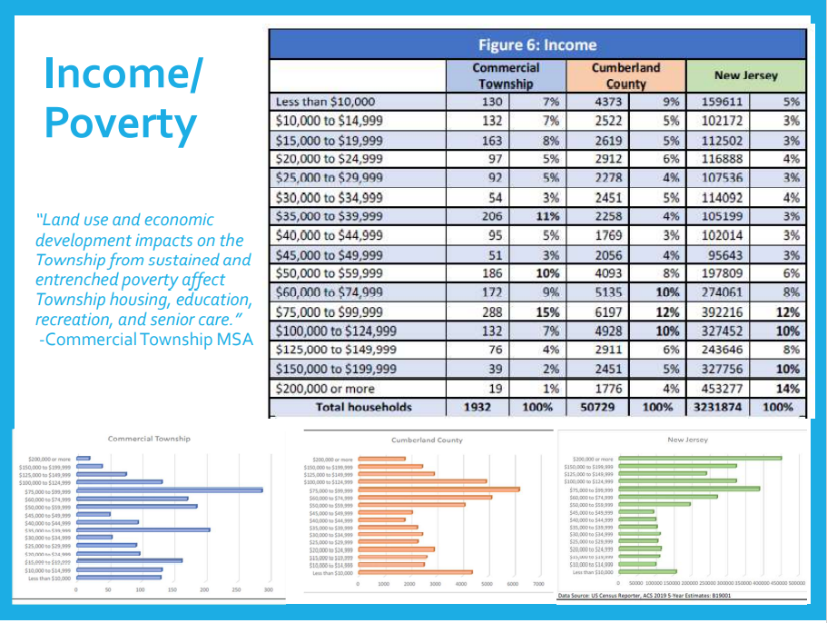

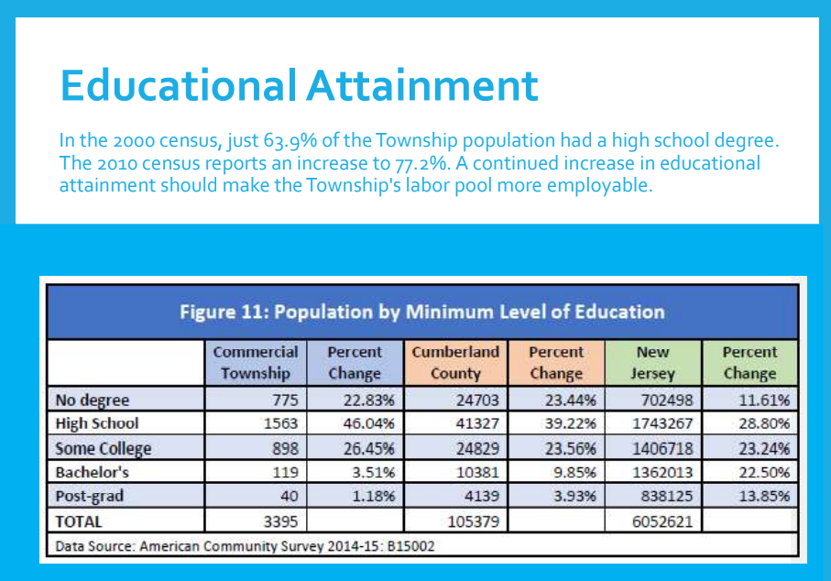

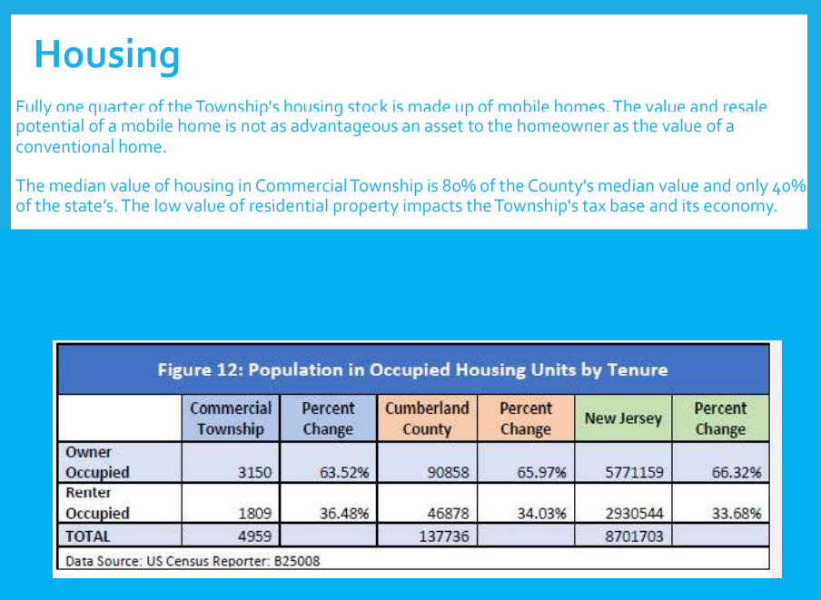

INFRASTRUCTURE

Waste Water Treatment - Commercial is fully served by private septic systems and private wells except for several sand mines and seafood processors with individual systems. Residential wastewater management is Commercial Township in the Rural District consists of individual subsurface septic systems under the jurisdiction of the Cumberland County Health Department. Some commercial and industrial facilities have their own sewage facilities and the lack of wastewater infrastructure in Commercial Township to date has been because of economic and environmental constraints and limited demand. However, to serve the existing community and industry in Port Norris, a wastewater treatment plant was under consideration for Port Norris at one time that would discharge more than 600,000 GPD of treated wastewater to the Maurice River.

The Township of Commercial would like to pursue the potential construction of a wastewater treatment facility. This would include securing funding and determining a way to get public buy-in to the idea as it will greatly benefit the Township. Non-compliant septic systems are a major problem that stimulate development in the Township and prevent the sale of properties and cause many to lie vacant and abandoned. Many lots in Laurel Lake are too small to allow for the construction of a compliant septic system and this makes it impossible to develop these areas and/or sell older existing properties.

The densely populated village of Laurel Lake has been mapped as PA2 as it connects with the other half of the village across the bridge in the City of Millville. This is intended to make it easier for Commercial Township to utilize some of Millville’s excess wastewater capacity should that prove to be a feasible plan.

Water - Commercial Township has no public service area for potable water supply. The Township is served by private wells. According to the Well Permitting section of the Bureau of Water Allocation and Well Permitting (Bureau), approximately 618 permits to drill domestic wells have been issued in Commercial Township. There would need to be analysis of the health of the Kirkwood Cohansey Aquifer in this area should a public water source be pursued, and the vulnerability assessment should speak to the safety of the private wells in light of sea level rise.

FUTURE LAND USE /ZONING MAP (Below)
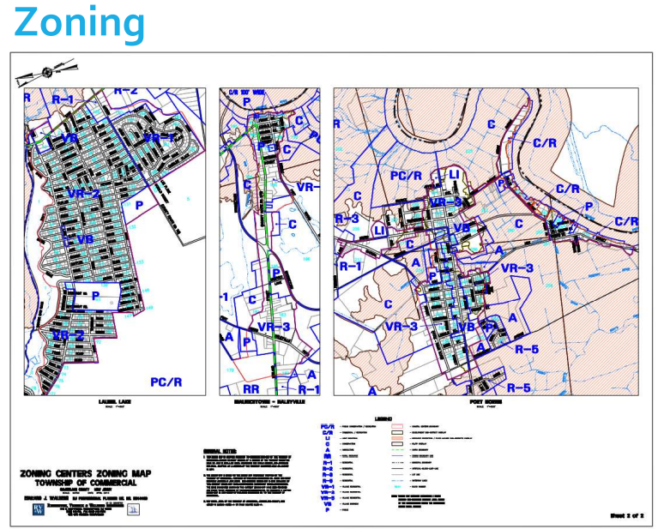
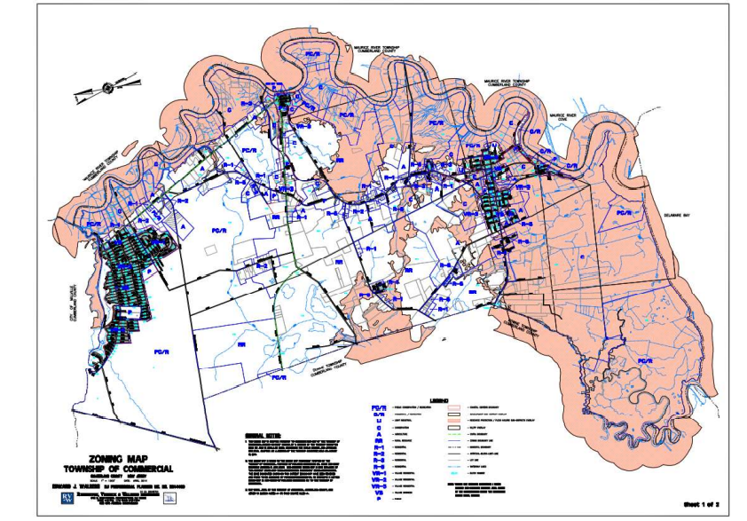

PROPOSED MAP AMENDMENTS
Commercial Township has reached consensus on their map’s Planning Areas and Center/Node boundaries. Existing SDRP mapping is below: Existing Planning Areas (PA4, PA5 and Open Space) and Centers (in Pink).
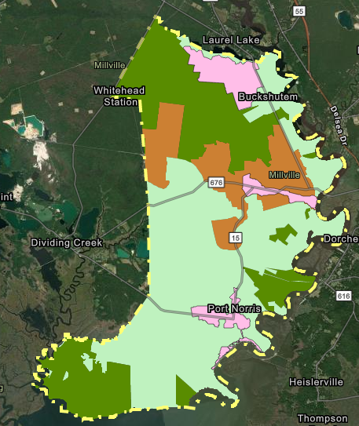
Port Norris Bivalve existing Center
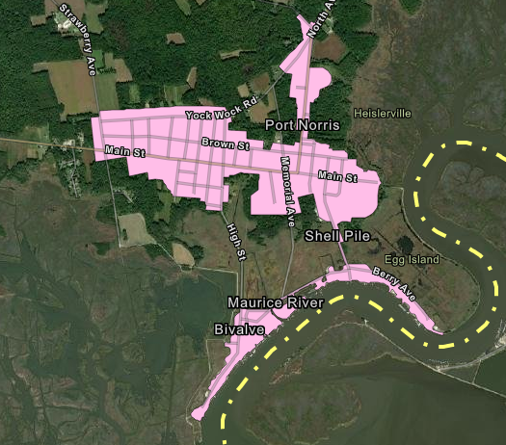

Proposed Planning Areas, Centers and Working Waterfront Node
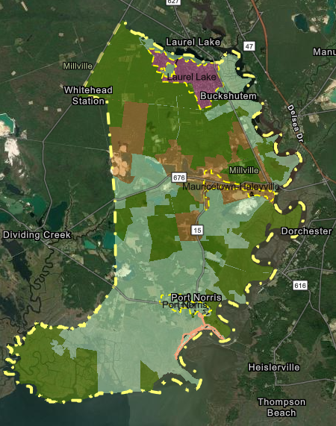

Laurel Lake Center
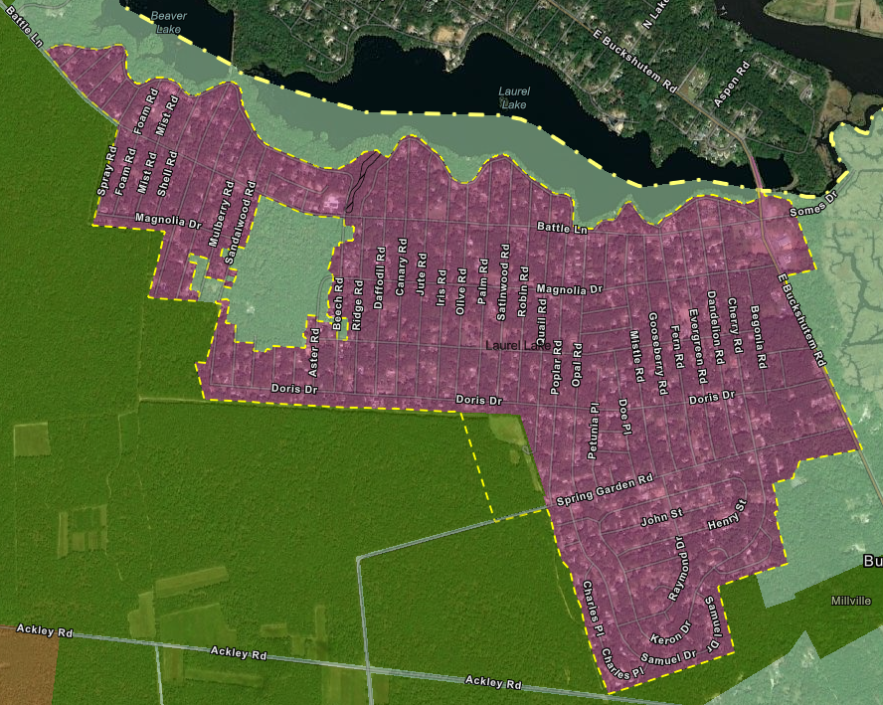

Mauricetown/Haleyville Cneter
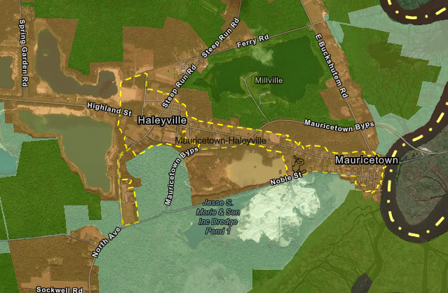
Port Norris Center and Bivalve/Shellpile Node
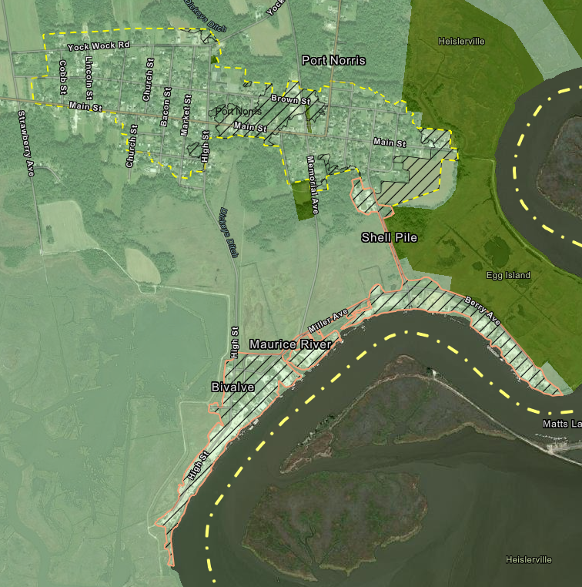

STATE PLAN GOALS REVIEW
Goal #1 Revitalize the State’s Cities and Towns - The overall vision of the Master Plan is to preserve and carry on the quality of life which embodies the Township. The Master Plan sums up this perception of community character as:
A sensitive natural environment within which a rural community has existed and prospered by coexisting and utilizing that environment.
Maintenance of the historical village center development pattern and rural character with emphasis on their ability to evolve and grow and develop a sustainable economic base based on their environment.
The revitalization of the Towns within Commercial Township remains a key element of its vision and goals.
The Township has established the goal of maintaining the historic development pattern centered around the three villages of Mauricetown-Haleyville, Port Norris, and Laurel Lake, while allowing reasonable growth elsewhere if it respects the natural environment. The objectives to establish this are:
1. Support and encourage development within existing villages, providing infrastructure can be constructed which prevents environmental harm.
2. Preserve historic village character in new development.
3. Cluster new development if outside villages and only allow development where the environment can accommodate it.
4. Balance reclamation of mining sites to create commercial/public uses and conserved lands.
5. Direct commercial activities, other than farming, mining, and fishing, into the 3 villages.
6. Create development standards that recognize a site's natural features in terms of intensity of permitted use and establish controls which respect natural, historical and cultural features of the Township.

Goal #2 Conserve the State’s Natural Resources and Systems - Commercial Township has a prominent wetlands conservation priority and is committed to the preservation of its waterways that contribute to the Maurice River, which has a federal Scenic Designation. Additionally, the Township has a very prominent shellfish and agricultural industry and therefore values the conservation of natural resources, lands and opens spaces. Commercial Township is rich in natural beauty, bordered as it is by the Maurice River to the east and the Delaware Bay to the south. These two water bodies have extensive coastal marshes providing natural habitats for a wide variety of wildlife which is of importance both locally and globally. Inland, the Township also has a significant amount of environmentally sensitive lands including stream corridors, ponds and man-made bodies of water, tidal and freshwater wetlands, flood plains, and soils with high water tables. The Township has also received Bronze Certification in the Sustainable Jersey Certification Report in January 2021; key accomplishments include:
- install energy efficient lighting in municipal buildings and the installation of solar panels in three municipal buildings in the township.
- Community Education and Outreach in Climate Change
- Municipal On-Site Solar System - Since 2017 solar panels have been placed at three public facilities: The township hall, both senior centers. A fourth site is being considered.
- Green Building Policy
- conducted an energy audit of its buildings and installed more efficient heaters, HVAC systems and lights.
- installed 83 energy efficient LED street lighting to replace the old high intensity discharge lighting along township owned roadways
- installed 26 tree identification signs and various other signs indicating boat ramp, parking, and walking trail at Lake Audrey a 120 acre state park
- Sustainable Land Use Pledge adopted Feb. 21, 2013 to reinforce our commitment to land use decisions that will increase the sustainability of our municipality.
- Environmental Commission Site Plan Review using the NRI
- Tree Protection Ordinance - 2014
- Prescription Drug Safety and Disposal
- Non-Mandated Materials Recycling – single use plastic bag recycling program
- Recycling Depot - with the Cumberland Improvement Authority and expanding recyclable
- Plant 500 milkweed plants for Monarch butterfly habitat
Goal #3 Promote Beneficial Economic Growth, Development and Renewal for all Residents of New Jersey - Although Commercial Township does not have substantial farming activity or areas of high-quality agricultural soils, farming was and remains an integral part of this rural coastal community. From its settlement to the present, woodlands and farms have been important land use activities with notable salt hay farming of continuing importance. Preserving these woodlands and farms and assuring their economic well-being is important for maintaining the community's rural character. The Township Master Plan encourages economic development that least intrudes on environmentally sensitive areas and the traditional pattern of village development. Three objectives were formulated for economic development:
1. Encourage natural resource industries while requiring appropriate preservation controls.
2. Commercial activities in villages should fit its historic nature in size, scale, and design.
3. Use development regulations to encourage ecotourism and associated economic activities.
The 2006 Master Plan recommendations for Agricultural Preservation were a variety of conservation techniques including cluster development and farm activity protection regulations.
1. Encourage farming by reducing intrusion of non-agricultural uses into quality soil areas.
2. Cluster residential development where proposed for farmland.
3. Sustain the farm economy by permitting farm related businesses.
Goal #4 Protect the Environment, Prevent, and Clean Up Pollution - Commercial Township's coastal areas are highly environmentally sensitive lands requiring protection from the encroachment of development and careful land use management practices to preserve their ecology and maintain their natural beauty as viewed from land or river.
Environmental Protection -The Township Master Plan resolved that the "highly environmentally sensitive" coastal area must be protected from development for both ecological and aesthetic reasons.
1. The Township must protect and preserve its extensive wetlands whether publicly or privately owned.
2. Use innovative zoning to minimize adverse impacts of development on environmentally sensitive areas
3. Use development regulations, such as buffer and setback requirements and conservation easements, to offset the direct and indirect impacts of development.

Master Plan Recycling Objectives
1. Adopt the recycling goals of the County and State.
2. Undertake the necessary municipal actions to accomplish County and State goals.
Goal #5 Provide Adequate Public Facilities and Services at a Reasonable Cost - The Township has operates a senior center, a community center, a school system with one consolidated school, one firehall per village (3), a rescue squad a small library and is committed to providing its residents with efficient services and quality programs while keeping its taxes reasonable.
Goal #6 Provide Adequate Housing at a Reasonable Cost - Commercial Township received certification from the Council on Affordable Housing (COAH) for its fair share affordable housing plan under the Second Round rules in 2001. The certification expired in 2005. The Township formulated a new 2005 Housing Plan but a petition for certification under the third round rules was never submitted to COAH. The 2006 Master Plan listed three objectives related to affordable housing. 1. Provide sufficient housing to meet the Township's fair share requirement. 2. Petition the Council on Affordable Housing for certification of the housing element. 3. Monitor housing and undertake programs to assure renovation, rehabilitation and, where necessary, removal of dilapidated units.
Goal #7 Preserve and Enhance Areas with Historic, Cultural, Scenic, Open Space, and Recreational Value - There are a number of historically significant structures within the Township’s three villages. Such structures consist of restored homes, old commercial structures, churches, restored oyster shucking wharves, and a restored oyster schooner. The Township recognizes the importance of preserving these historically significant structures and explains the benefits in the “Historic Preservation” subsection of the Land Use chapter of the Township Master Plan. The Master Plan explains that care should be taken to assure that new development is not detrimental to such sites or structures and does not create nuisances or problems for them. The Township also recognizes the economic benefit of maintaining these historic sites because they offer education about the Township’s history and serve as focal points to attract visitors. The historic sites, as listed on the state and national register, that exist within the Township include the following:

• Berry-Gibson Salt Hay Farm
• Bird Island Site
• Bivalve Oyster Packing Houses and Docks
• ‘Cashier’
• Edward Compton House
• Historic Marine and Architectural Resources of Maurice River Cove
• Caesar Hoskins Log Cabin
• Mauricetown Historic District
- Port Norris Historic District
• Schooner A.J. Meerwald

In addition to historic places, the Township has a large portion of its municipality dedicated to open space and farmland preservation. The Township contains approximately 11,000 acres of open space land within its municipal boundary. The Township itself is about 22,000 acres in total area. Therefore, approximately half of the entire Township is dedicated to open space and farmland preservation.

Commercial Township partners with PSEG on their Estuary Enhancement Project. Situated along the southern New Jersey shoreline of the Delaware Estuary, the Commercial Township Salt Hay Farm Wetland Restoration Site covers approximately 4,171 acres in Cumberland County and is the largest EEP wetland restoration site. The site includes the preservation of 339 acres of upland buffer habitat and the preservation, restoration and/or enhancement of 2,894 acres of previously diked wetlands. Enhancement began in 1996 and was completed in 1997 with the return of daily tidal flow to the site. The EEP also provided the township with two boardwalks, an observation platform, nature trail, car-top boat launch, and three parking areas.
Goal #8 Ensure Sound and Integrated Planning and Implementation Statewide - The Township of Commercial has always promoted development that is consistent with the State Plan. The Townships follows the precepts of the planning policies for Rural Planning Area and the Environmentally Sensitive Planning Areas and concentrate development in an around the Township’s existing villages and existing developed nodes. The Township is now seeking Plan Endorsement to further align its planning goals, objectives and policies by demonstrating its commitment to comprehensive planning, and its continuing commitment to working with surrounding municipalities, the County, and State Commissions.

The Township also works closely to ensure consistency with these surrounding municipalities as well as the County and State on planning and zoning regulations and plans such as:
• Western/Southern Cumberland Region plan
• State Development and Redevelopment plan
• County Solid Waste Management plan
• NJ Delaware Bayshore Council which coordinates planning, projects and advocacy with adjoining Bayshore communities, the county and regional NGOS
• Participation in the county wide Hazard Mitigation Plan and Waste Water Management Plan as well as other county lead initiatives like the Bike plan, etc.
• Maurice River Management Plan (Wild & Scenic)
• Cumberland County Delaware Bayshore Recovery Plan

RESILIENCY

Commercial Township participated in the NJ Bayshore Recovery Plan after Sandy and has undertaken several efforts to support a more sustainable and resilient municipality and is preparing to undertake more:

The Township is working to update and amend its Flood Hazard Ordinance and is considering becoming a CRS community.

- Commercial Township has a dedicated and active Environmental Commission/Green Team that is increasingly engaged in resiliency issues.

- The 2021 Cumberland County All Hazard Mitigation Plan, including the Commercial Annex, identifies vulnerable assets and actions to mitigate defined vulnerabilities.

- Commercial has been paired with a Rutgers Climate Corp Fellow to undertake its Climate Change Related Vulnerability Assessment required by the PE (and MLUL).

- In 2019 Commercial Township hosted a workshop, in partnership with ANJEC and the Bayshore Discovery Project on global warming.

- The Township has undergone a series of infrastructure improvements in a handful of its most flood prone areas. These efforts included raising the roads and installing significantly updated and increased drainage structures and facilities.

STAFF RECOMMENDATION
The Township of Commercial has diligently and regularly planned and implemented measures to ensure that their centers, and environs remain sustainable and grow using smart-growth principles. Based on this work, they have demonstrated that their actions and plans, including with the items identified in the PIA, are aligned with the State Plan. It is staff’s recommendation that the Commission adopt the Resolution for Plan Endorsement. Please see the attached PIA for details of their implementation agreement.

