
(Owner’s logo)

State of New Jersey
NEW JERSEY DEPARTMENT OF TRANSPORTATION
1035 PARKWAY AVENUE
P.O. Box 600
TRENTON, NEW JERSEY 08625-0600
(Owner’s name and address)

UNDERWATER BRIDGE EVALUATION SURVEY REPORT

STRUCTURE NO. ####-###
NJ ## OVER XX ROAD AND XX RIVER OR RAILROAD
XX BOROUGH AND/OR TOWNSHIP
XX COUNTY

MONTH DD, YYYY

Prepared By

XXX Consultant
101 Main Street
Trenton, New Jersey 08625-0600

TABLE OF CONTENTS
 |  | Page No.
1 | Structural Data | ##-##
2 | Summary | ##-##
3 | Conclusions and Recommendations | ##-##
4 | Soundings and Photographs | ##-##
5 | Field Notes | ##-##
6 | Priority Repairs | ##-##

N.J.D.O.T. - STRUCTURAL EVALUATION AND BRIDGE MANAGEMENT
UNDERWATER BRIDGE EVALUATION SURVEY REPORT

STRUCTURAL DATA:
Bridge No.: | #### - ### | Year Built: |  |  | Widened/ Rehab:
Route No.: | ## | Length: |  |  | Width:
Mile Point: | XXX.XX | Inspection Begin Date: |  |  |  | MM/DD/YYYY
Name: | NJ ## over XX Road and XX River or Railroad | Inspection Completion Date: |  |  |  | MM/DD/YYYY
Structure Type: |  | By:
 |  | Date of Previous Inspection: |  |  |  | MM/DD/YYYY
 |  | By:
WORK DONE: | (Reference a Photo)
OVERALL BRIDGE CONDITION (ITEM B.C.13): (Indicate which Item(s) controls: B.C.01, B.C.02, B.C.03 or B.C.04)

UNDERWATER INSPECTION CONDITION (ITEM B.C.15):

SUMMARY:

Number of Substructure Units in Water: |  |  | Abutments: |  | Piers:

Type of Underwater Inspection:

Underwater Inspection Equipment Used (Item B.IE.12):

Substructure Elements Cleaned:
Water Flow Velocity: |  |  | Soil Type:
Diving Mode: |  |  | Dive Team Members:

Diving Hazard Analysis / Assessment / Confined Space Entry:

Reference Information:

COMPONENT / MATERIAL | GENERAL REMARKS
ABUTMENTS  (Material) | South Abutment:  Southwest wingwall:  Southeast wingwall:  North Abutment:  Northwest wingwall:  Northeast wingwall:
PIER  (Material) | Center Pier:
PROBING/SCOUR | South and North Abutments:  Center Pier:
COUNTERMEASURES

FENDERS/ BULKHEADS

CONCLUSIONS & RECOMMENDATIONS:
Provide the Underwater Inspection Condition Rating (Item B.C.15). Include a general summary of the defects, if the condition rating is 6 or less.

Provide the Channel Condition Rating (Item B.C.09) and Channel Protection Condition Rating (Item B.C.10). If applicable due to scope of services of the bridge, provide Substructure Condition Rating (Item B.C.03), Culvert Condition Rating (Item B.C.04), Superstructure Condition Rating (Item B.C.02), and Underside of Deck. Include a general summary of the defects, if the condition rating is 6 or less.

Provide comments on the Scour Condition Rating (Item B.C.11). Include a general summary of the findings of the probing performed

Provide comments on the Scour Vulnerability (Item B.AP.03) of the bridge. Reference the results from the Scour Evaluation Program, if applicable.

Indicate any significant changes since the previous underwater inspection.

Indicate any required priority repair work, and reference priority repair letter at end of report.

Provide underwater inspection frequency recommendation as per below:
Underwater Inspection Condition (Item B.C.15) ≤ 3 = 24 months
Channel Condition (Item B.C.09) ≤ 3 = 24 months
Channel Protection Condition (Item B.C.10) ≤ 3 = 24 months
Scour Condition Rating (Item B.C.11) ≤ 3 = 24 months
Scour critical bridge = 24 months
Non-scour critical bridge = 48 months
Low freeboard = 24 months

DRAWINGS
Insert Sketch

Photo No: UW-01
Location:
Description:
Photo No: UW-02

Location:
Description:

Photo No: UW-03
Location:
Description:
Photo No: UW-04

Location:
Description:

NEW JERSEY DEPARTMENT OF TRANSPORTATION

STRUCTURAL EVALUATION AND BRIDGE MANAGEMENT

FIELD NOTES
NJDOT (Owner’s name)

Name: |  |  |  |  | NJ ## over XX Road and XX River or Railroad
Diver:
Company:
Team leader:
NCBI:
Company:
Temperature: |  |  |  |  | ##ºF |  |  |  |  |  | Weather:
RATINGS: (Highlight or bold the applicable rating which is coded for underwater inspection condition).
N | Not applicable – Component does not exist.
9 | Excellent Condition – Isolated inherent defects.
8 | Very Good Condition – Some inherent defects.
7 | Good Condition – Some minor defects.
6 | Satisfactory Condition – Widespread minor or isolated moderate defects.
5 | Fair Condition – Some moderate defects; strength and performance of the component are not affected.
4 | Poor Condition – Widespread moderate or isolated major defects; strength and/or performance of the component is affected.
3 | Serious Condition – Major defects; strength and/or performance of the component is seriously affected.
2 | Critical Condition – Major defects; component is severely compromised.
1 | Imminent Failure Condition – Bridge is closed due to component condition. Repair/ rehabilitation may return bridge to service.
0 | Failed Condition – Bridge is closed due to component condition and is beyond corrective action.
GENERAL
Type of Bridge:
Type of Substructure:
No. of Lanes: |  |  | On |  |  |  |  |  |  |  |  | Under |  |  | N/A (waterway)
Number of substructure units in water: |  |  |  |  |  |  |  |  |  | Abutments: |  |  |  |  |  |  | Piers:
Overall condition of substructure:
WATERWAY:

Type: |  |  |  |  |  |  |  |  |  |  |  |  |  | Velocity:
Streambed material:
For all field note sheets, a text description must be provided for any element with a condition rating of 6 or lower. Any item with a rating of 9 through 7 shall either state “No significant defects” or state any minor defects observed. Components that are coded “N” shall state “None” or whatever other statement applies (the idea being that all rows of the field notes have associated Remarks text).

Each span MUST have its own field notes sheet. Do not combine spans into a single sheet. Likewise, you cannot lump substructure units together in a single table. Each pier and abutment require its own set of condition ratings.

UNDERWATER DIVING INSPECTION

DECK |  |  | Item B.C.01 Deck Condition:
SPAN #
RATING | COMPONENT | REMARKS
N | Wearing Surface /  Top of Deck | Not inspected as part of underwater evaluation.
 | Underside of Deck
N | Median | Not inspected as part of underwater evaluation.
N | Curbs | Not inspected as part of underwater evaluation.
Sidewalks /
Safetywalks

N | Parapets/  Balustrades | Not inspected as part of underwater evaluation.
N | Railings /  Fencing | Not inspected as part of underwater evaluation.
N | Deck Joints /  Filler Material | Not inspected as part of underwater evaluation.
N | Drains and  Scuppers | Not inspected as part of underwater evaluation.
N | Light Stands | Not inspected as part of underwater evaluation.
 | Utilities
 | Others
 | Additional Remarks:

Note: Inspection of Underside of DECK, underside of SIDEWALK/SAFETEYWALKS and UTILITIES (within superstructure) field notes are ONLY applicable when in the scope i.e. there is low freeboard.

UNDERWATER DIVING INSPECTION

CULVERT |  |  | Item B.C.04 Culvert Condition:
SPAN #
RATING | COMPONENT | REMARKS
 | Roof Slab
Side Walls/
Center Walls

 | Floor Slabs
 | Headwalls
 | Wingwalls
 | Others
 | Additional Remarks:

UNDERWATER DIVING INSPECTION

SUPERSTRUCTURE |  |  |  | Item B.C.02 Superstructure Condition:
SPAN #
RATING | COMPONENT |  | REMARKS
## Girders/
Stringers/
Floorbeams/
Trusses/
P/S Beams

(Girders numbered XXXX to XXXX)
Diaphragms /
Cross Frames

 | Bearings
Deflection and
Vibration

 | Others
 | Additional Remarks:

FATIGUE DETAILS |  | Estimated percentage of large trucks in ADT = | #%
Category | Detail Description and Location
N/A

Note: SUPERSTRUCTURE field notes are ONLY applicable when required in Scope.
UNDERWATER DIVING INSPECTION

SUPERSTRUCTURE |  |  | Item B.C.02 Superstructure Condition:
(ARCH)
SPAN #
RATING | COMPONENT | REMARKS
Intrados of Arch
(Soffit) Arch Ribs

Spandrel Columns /
Extrados

 | Spandrel Walls
 | Others
 | Additional Remarks:

Note: SUPERSTRUCTURE field notes are ONLY applicable when required in Scope.
UNDERWATER DIVING INSPECTION

SUPERSTRUCTURE |  |  | Item B.C.02 Superstructure Condition:
(RIGID FRAME)
SPAN #
RATING | COMPONENT | REMARKS
 | Intrados of Frame
 | Legs of Frame | As per BIRM, Legs of Frame are only considered superstructure components for multi-span frames. For single-span frames, code Legs of Frame as substructure component.
 | Spandrel Walls
 | Others
 | Additional Remarks:

Note: SUPERSTRUCTURE field notes are ONLY applicable when required in Scope.

UNDERWATER DIVING INSPECTION
PAINT INSPECTION | *Environment:
Environments:  1. Rural or Industrial, Mild exposure  2. Industrial, Severe Exposure  3A. Marine, Mild Exposure  3B. Marine, Severe Exposure  *Ref. NJDOT Design Manual Sec. 1.24.19 | Date of Last Painting:
Note: Code Item GA “N” if weathering steel does not require painting; however, if there are steel painted rocker bearings, or if beam ends are painted, then code “Y”. Also code “Y” when portions of encased steel members are exposed due to deterioration.

9 8 7
.

.
.

. .
.
.
.
.
. .



Notes: Blistered Paint areas
are counted as rust

10 = 0% Rust
0.03% 0.1% 0.3% 0 = 100% Rust

6 5 4 Use the closest rating to
the actual field



condition based on the
average for the bridge.
Indicate any areas of
severe rusting in
remarks.

For structures composed
1% 3% 10% of weathering steel, this
sheet should be used to rate the effectiveness of
3 2 1 the iron oxide coating
(see Appendix G from



the state coding guide).
For beam ends, use the
Q controlling rating (paint
or oxide coating).

16% 33% 50%
FIG. 1 Examples of Area Percentages

INSPECTION RATINGS (0 THROUGH 10 OR N/A)
Fascia Beam: |  | Fascia Bottom Flange: |  | Beams Ends:
Interior Beam: |  | Interior Bottom Flange: |  | Connections:
Bracing: |  | Substructure: |  | Railings/Fence:
Bearings: |  | Above Deck Superstructure:
Remarks 1:
Remarks 2:
Note: SUPERSTRUCTURE/PAINT field notes are ONLY applicable when required in Scope.
UNDERWATER DIVING INSPECTION

TYPICAL FATIGUE DETAILS (Highlight applicable detail(s), remove sheet if none are applicable)
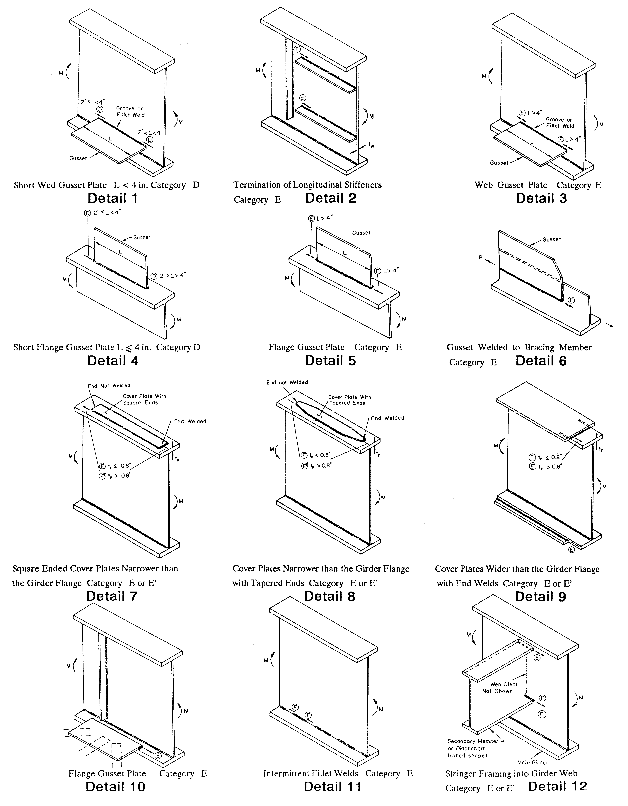
Note: SUPERSTRUCTURE field notes are ONLY applicable when required in Scope.
UNDERWATER DIVING INSPECTION

TYPICAL FATIGUE DETAILS (Highlight applicable detail(s), remove sheet if none are applicable)
13. Field Weld Repairs - Proper welding procedures may not have been used; testing of weld by non-destructive methods was usually not done, therefore, the possibility of large flaws exists. Check carefully on the main structural members (stringers, floorbeams, girders).

14. Tack Welds - Check carefully on riveted members constructed in 1940’s and 1950’s as these welds were sometimes used to hold the plates together during riveting.

15. Plug Welds - Check at bolted connections on welded structures. These welds may have been used to fill-in incorrectly drilled holes (see sketch).

16. Backing Bars - These welds are possibly not full penetration. Check carefully on box girders if accessible and at butt (groove) welds made in the field.

17. Details with 2 or 3 Intersecting Welds (Slot Welds) - Incomplete penetration of the second and third welds is possible.

18. Butt (Groove) Welds on Horizontal Web Stiffeners - NDT of the weld was not always required on the stiffener in the tension zone. If the weld is not good, this will be an “E” detail or worse which can exist in a high stress area (This would be the same as or worse than typical detail 3).

19. Detail Without Proper Welding Clearance - Poor welding can result if proper clearance for the welding rod is not maintained by the designer (such as a horizontal web stiffener placed too near the bottom flange of a girder; fillet weld at bottom of stiffener is difficult due to a lack of clearance for the welding rod).

20. Coped or Blocked Flanges - Check carefully when these details exist on main structural members (stringers and floorbeams). Coped flanges are a typical detail on movable spans.

21. Distortion (Bending) at Small Gaps - For typical details which exhibit damage due to this, see “Inspecting Steel Bridges for Fatigue Damage” (see sketches).

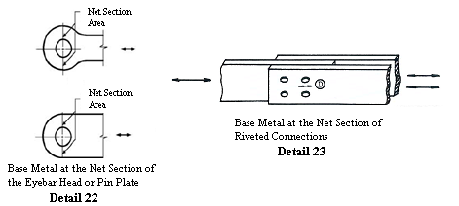

Note: SUPERSTRUCTURE field notes are ONLY applicable when required in Scope.
UNDERWATER DIVING INSPECTION

TYPICAL FATIGUE DETAILS (Highlight applicable detail(s), remove sheet if none are applicable)
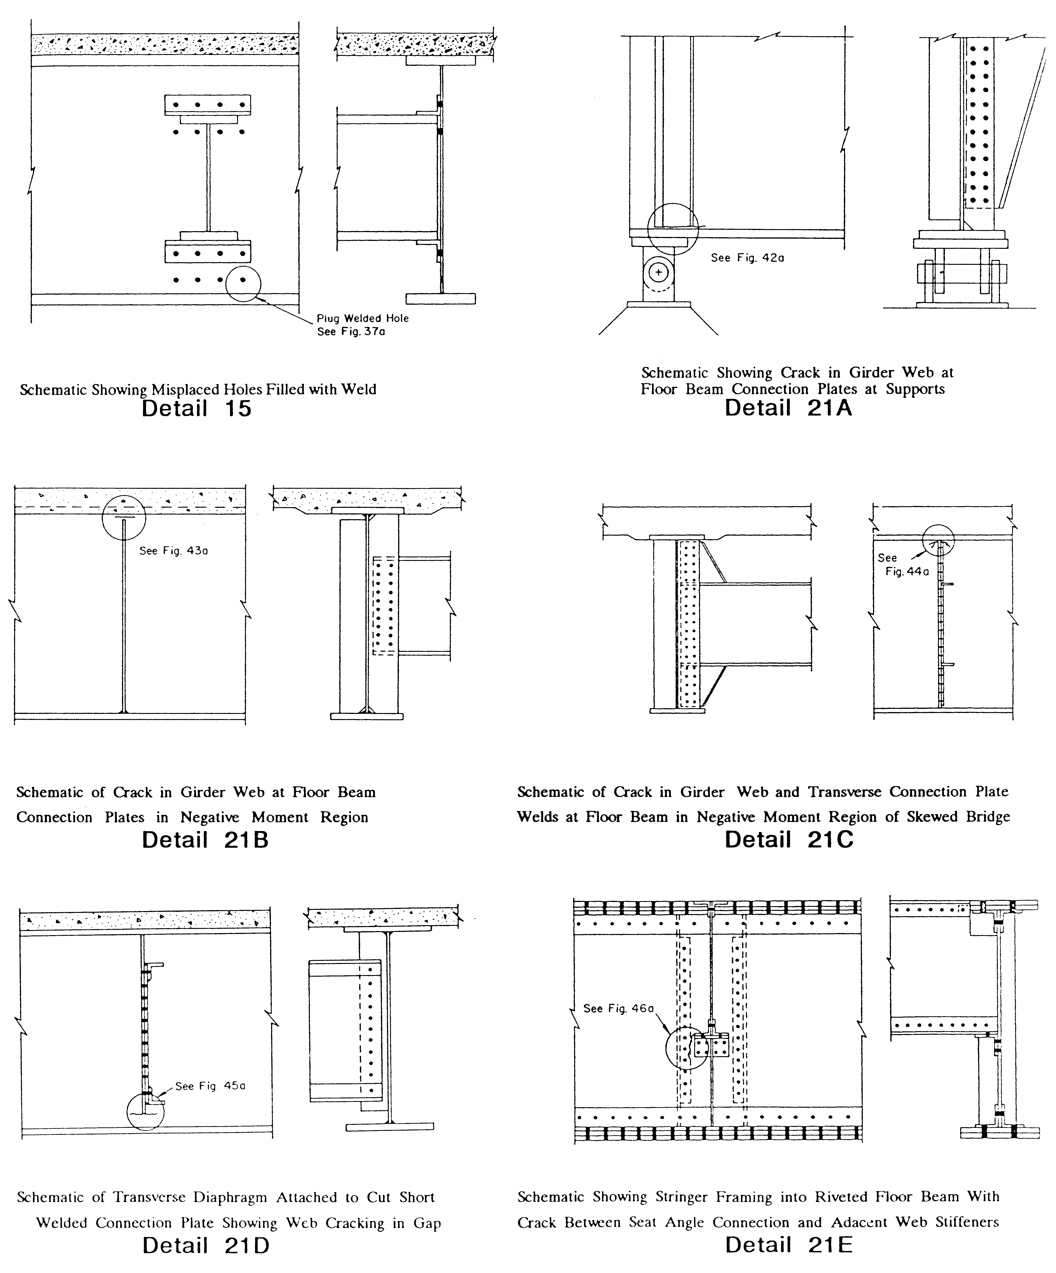
Note: SUPERSTRUCTURE field notes are ONLY applicable when required in Scope.
UNDERWATER DIVING INSPECTION

SUBSTRUCTURE |  |  |  | Item B.C.03 Substructure Condition:
ABUTMENT
RATING | COMPONENT |  | REMARKS
 | Breastwall
 | Backwall
 | Bridge Seat
Wingwalls /
Retaining Walls

Embankment /
Slope Protection

 | Others / Footings
 | Additional Remarks:
ABUTMENT
RATING | COMPONENT |  | REMARKS
 | Breastwall
 | Backwall
 | Bridge Seat
Wingwalls /
Retaining Walls

Embankment /
Slope Protection

 | Others / Footings
 | Additional Remarks:

UNDERWATER DIVING INSPECTION

SUBSTRUCTURE |  |  |  |  | Item B.C.03 Substructure Condition:
TIMBER ABUTMENT
RATING | COMPONENT |  | REMARKS
 | Sheeting
 | Piles
 | Pile Cap
 | Wales
 | Header
SW Wingwall
Sheeting

SW Wingwall
Piles

SW Wingwall
Wales

 | XX Wingwall  Sheeting |  | XX = either SE or NW as appropriate.
 | XX Wingwall Piles
 | XX Wingwall Wales
 | Others
 | Additional Remarks:
UNDERWATER DIVING INSPECTION

SUBSTRUCTURE |  |  |  |  | Item B.C.03 Substructure Condition:
TIMBER ABUTMENT
RATING | COMPONENT |  | REMARKS
 | Sheeting
 | Piles
 | Pile Cap
 | Wales
 | Header
 | YY Wingwall  Sheeting |  | YY = either SE or NW as appropriate.
YY Wingwall
Piles

YY Wingwall
Wales

NE Wingwall
Sheeting

 | NE Wingwall Piles
 | NE Wingwall Wales
 | Others
 | Additional Remarks:

UNDERWATER DIVING INSPECTION

SUBSTRUCTURE |  |  | Item B.C.03 Substructure Condition:
PIER
RATING | COMPONENT | REMARKS
Columns/
Stem
Crashwall

 | Pier Cap
 | Bridge Seat
 | Others/Fender
 | Additional Remarks:

PIER
RATING | COMPONENT | REMARKS
Columns/
Stem
Crashwall

 | Pier Cap
 | Bridge Seat
 | Others/Fender
 | Additional Remarks:
UNDERWATER DIVING INSPECTION

SUBSTRUCTURE |  |  | Item B.C.03 Substructure Condition:

BENT
RATING | COMPONENT | REMARKS
 | Bent
 | Cap
 | Posts/Piles
 | Foundation
 | Cross Bracing
 | Horizontal Bracing
 | Longitudinal Bracing
 | Girts
 | Others
 | Additional Remarks:

UNDERWATER DIVING INSPECTION

SUBSTRUCTURE |  |  |  | Item B.C.03 Substructure Condition:
(ARCH/FRAME)
ABUTMENT
RATING | COMPONENT |  | REMARKS
 | Legs of Frame |  | As per BIRM, Legs of Frame are only considered substructure components for single-span frames. For multi-span frames, code Legs of Frame as superstructure component.
Footings/
Skewbacks

Wingwalls/
Retaining Walls

 | Others
 | Additional Remarks:
ABUTMENT
RATING | COMPONENT |  | REMARKS
 | Legs of Frame |  | As per BIRM, Legs of Frame are only considered substructure components for single-span frames. For multi-span frames, code Legs of Frame as superstructure component.
Footings/
Skewbacks

Wingwalls/
Retaining Walls

 | Others
 | Additional Remarks:
UNDERWATER DIVING INSPECTION

SUBSTRUCTURE/SCOUR |  |  |  | Item B.C.11 Scour Condition:
ABUTMENT
RATING | COMPONENT |  | REMARKS
 |  |  | COUNTERMEASURES
 | Description
 | Condition
 |  |  | PROBING/SCOUR
 | Findings
 | Changes Since Prior Inspection
 | Debris
 | Repair Quantities:
ABUTMENT
RATING | COMPONENT |  | REMARKS
 |  |  | COUNTERMEASURES
 | Description
 | Condition
 |  |  | PROBING/SCOUR
 | Findings
Changes Since
Prior Inspection
 | Debris
 | Repair Quantities:
UNDERWATER DIVING INSPECTION

SUBSTRUCTURE/SCOUR |  |  | Item B.C.11 Scour Condition:
PIER
RATING | COMPONENT | REMARKS
 |  | COUNTERMEASURES
 | Description
 | Condition
 |  | PROBING/SCOUR
 | Findings
 | Changes Since Prior Inspection
 | Debris
 | Repair Quantities:
PIER
RATING | COMPONENT | REMARKS
 |  | COUNTERMEASURES
 | Description
 | Condition
 |  | PROBING/SCOUR
 | Findings
Changes Since
Prior Inspection
 | Debris
 | Repair Quantities:
UNDERWATER DIVING INSPECTION

WATERWAY/CHANNEL |  |  |  |  | Item B.C.09 Channel Condition Rating:
 |  |  |  |  | Item B.C.10 Channel Protection Rating:
WATERWAY |  |  |  |  | Item B.AP.02 Overtopping Likelihood:

SPAN(S)
RATING | COMPONENT |  | REMARKS
FLOW CONDITIONS
 | Direction
 | Magnitude
 | Velocity
EMBANKMENTS
 | Upstream
 | Downstream
Channel
Countermeasures

CHANNEL MOVEMENT AND CHANGES
Horizontal
Location

Cross
Section

 | Alignment
 | Changes Since Previous Inspection
 | Navigation Clearances
 | Waterway Opening
Other/Debris in
Channel

 | Repair Quantities:

UNDERWATER DIVING INSPECTION

The following reports, files and memos are associated with this document:

PRIORITY REPAIRS:
The following Priority Letter(s) have been included for this structure:
Each Priority Letter has been submitted as a separate PDF file.

PDF Filename(s):
#######_YYYYMMDDcy##_PR#_01.pdf
####### _YYYYMMDDcy##_PR#_02.pdf

(Note: Replace ####### with Bridge Number, YYYYMMDD with Date, and ## with 2-digit Cycle Number)
(Replace # with E or 1 or 2)

For all Priority Memos, please make sure to include a photo that clearly indicates the location of each defect. Additional close-up photo(s) should follow to demonstrate the extent of the defect(s).

